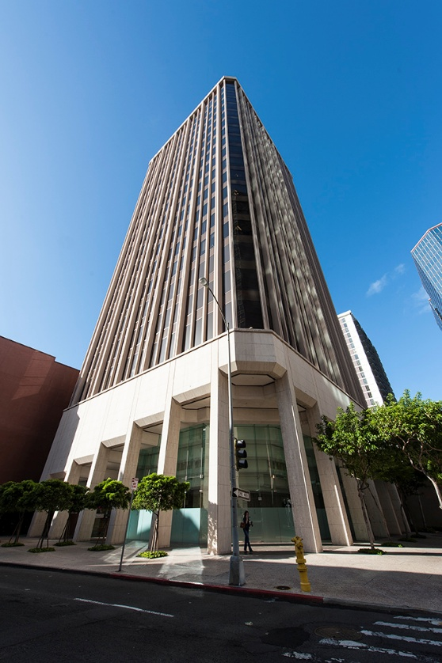
Frequently Asked Questions
The Department of Health, Vital Records Office, is entering an exciting new chapter as we move to our new location. Below are answers to common questions.

Where & When is the Office of Health Status Monitoring (Vital Records) moving?
We are moving from Kinau Hale to the ground floor of the City Financial Tower in downtown Honolulu, located at the corner of Alakea and Merchant Streets. We anticipate our move will be completed in September/October 2026.
New address:
City Financial Tower
201 Merchant Street, Suite 100
Honolulu, HI 96813
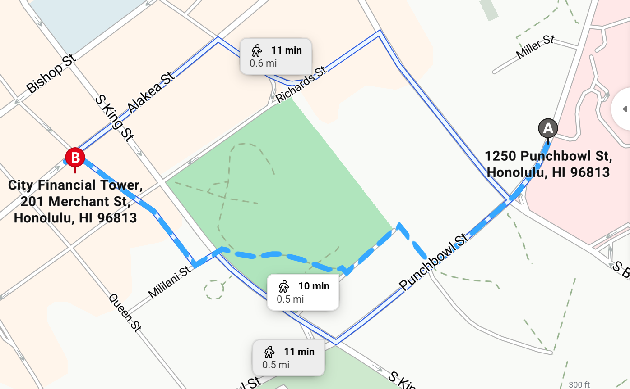

Can I go to the old office at 1250 Punchbowl Street to pick up my certificates?
For a short transition period, both locations will remain open. Once the move is complete, all services will be offered exclusively at the new City Financial Tower location. We will provide updates online and post signage as the transition date approaches.

How will the new space affect customer service?
Certificate Issuance, Marriage License, and Corrections services will all be housed in one integrated space. This consolidation allows better coordination and faster service. Whereas previously each section had a separate office in Kinau Hale.

What are the hours of operation?
Our office hours have been 7:45 AM to 2:30 PM, but after the move, we will be open from 7:45 AM to 4:00 PM, Monday thru Friday, (except on State Holidays).

Where can I park when visiting the new location?
Parking downtown can be expensive. While we encourage online orders to minimize time required for parking, there are some reasonable rates near the intersection of Merchant & Alakea in downtown Honolulu:

1. Alii Place Garage (1099 Alakea St, just west of Merchant & Alakea)
Operated by ABM, it offers a variety of hourly rates Monday–Thursday (6:00 am–8:00 pm) and reduced weekend/evening pricing 🕒: Monday–Friday (6 am–8 pm)
- 30 min – $0.75
- 1 hr – $1.50
- 90 min – $2.25
- 2 hrs – $3.00
- Each additional 30 min – $1.50
- Daily max – $21.00

2. Nearby Garages (~2–5 minutes walk)
According to Parkopedia and BestParking, here are other hourly options:
- Pacific Guardian Center (739 Alakea St) – $4 for 2 hours
- First Hawaiian Center (190 Merchant St) – ~$20 for 2 hours
- Bishop Square (1078 Alakea St) – ~$6.25 for 2 hours
- Chinatown Gateway Plaza (1031 Nuuanu Ave) – ~$3 for 2 hours
- Harbor Court Garage (821 Bethel St) – ~$2 for 2 hours
- Street Meters near Richards Street – $2 for 2 hours

👉 Recommendation: For short-term weekday parking, Alii Place is the most convenient and cost-effective at $1.50/hour. For the lowest hourly rate, Harbor Court offers roughly $1/hour but requires a short walk.

Can I reach the new location by bus?
Yes. Multiple bus routes serve the downtown area, including major stops at King & Alakea.
🚌 Nearby Bus Stops & Routes
Queen St + Richards St — ~2 min walk 🚶
Bus lines:
- Local: 4 (Nuuanu–Punahou–Mānoa), 6 (Pauoa–Woodlawn), 7 (Kalihi Valley–Kahala)
- Express: 80, 82, 85 (Windward Express lines)
S King St + Alakea St — ~3 min walk
Bus lines:
- Local & Limited: 1L (Hawaii Kai–Aloha Stadium Limited), 2L (Kalihi–Waikīkī–Kahala Limited)
- Regular: C CountryExpress, 40 (Honolulu–Makaha), 42 (Ewa Beach–Waikīkī)
Alakea St + S King St — ~3 min walk
Bus lines:
- Express: PH6 (Hawaii Kai–Pearl Harbor Express), 60, 65, 66, 67 (Downtown–Windward routes)
S King St + Punchbowl St (West) — ~3 min walk
Bus lines:
- A Line (Aiea–UH Mānoa via Downtown)
Transit Hub – Kahauiki Kalihi Transit Center
- Skyline Metro: nearest station, 0 min walk
- Bus lines also connect here

Will the move cause service disruptions?
We expect to remain open throughout the move. However, because this relocation involves transporting and setting up more than a century and a half of Hawaiʻi’s documented history, some delays in mail orders, genealogical processing, and book searches may occur. Our staff is working carefully and respectfully as we transition our collection of vital records—some dating back to the mid-1800s—into their new home. We appreciate your patience during this truly historic occasion, as we safeguard the continuity of a recordkeeping tradition that has served generations of Hawaiʻi’s people.
Are any other changes coming to Vital Records?
Yes. Following the move, we will begin using new yellow certificate paper. Certificates issued on the current green paper will continue to be fully valid as long as they contain the certification statement signed by the State Registrar. This change reflects an ongoing evolution in how Hawaiʻi preserves and protects official records—an effort that has continually adapted over the past century and a half to maintain accuracy, security, and public trust.
Over the next year, we will also transition our vital records operations to a new database. This modernization represents the next step in the long lineage of Hawaiʻi’s recordkeeping systems and will allow us to process orders more quickly and automate many of the manual steps that have been part of operations for decades. These improvements will help us better serve the community by speeding fulfillment of birth, marriage, and death certificates, carrying forward the State’s longstanding commitment to stewardship of its vital history.

