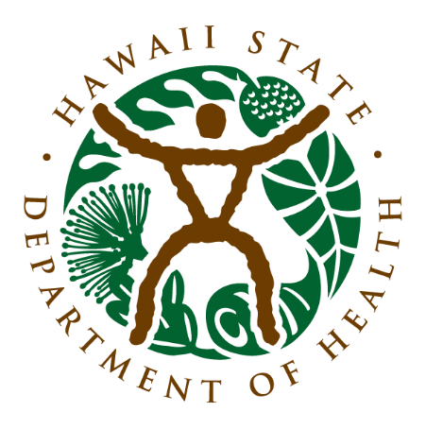
Office of Health Status Monitoring
Vital Records
Birth ● Marriage ● Death ● Certificates
201 Merchant Street, Suite 100
Honolulu, HI 96813

FOR IMMEDIATE RELEASE
Office of Health Status Monitoring (Vital Records) Announces Relocation, New Certificate Paper and Extended Service Hours

Honolulu, HI — The Hawaiʻi Department of Health’s Office of Health Status Monitoring (Vital Records) is pleased to announce that it will be relocating from its long-time home at Kinau Hale, at the corner of Punchbowl and Beretania, to its new office at City Financial Tower on Alakea and Merchant Streets. The anticipated completion of the move is scheduled for September, 2026.

New Certificate Paper - The move is part of the department’s ongoing efforts to improve service accessibility, modernize operations, and provide a more comfortable experience for the public. In addition to its new location, the office’s certified copies of Birth, Marriage and Death Certificates will be changing, too. The long-used green certificate paper will be replaced with a new warm yellow certificate. The certificate papers in both colors will remain valid, as long as they are affixed with the signature of the State Registrar and the embossed seal of the Department of Health.

Extended Hours - Along with the new location and certificate paper, Vital Records will be extending its public service hours. The office is currently open from 7:45 a.m. to 2:30 p.m., Monday through Friday. After the move, the hours will be extended from 7:45 a.m. to 4:00 p.m. This change will provide the public with additional time each day to obtain birth, death, and marriage certificates, or receive assistance with other vital records services.

More information — including the official move date, parking details, and updated service procedures — will be shared soon.

For questions, please contact:
Office of Health Status Monitoring (Vital Records)
Hawaiʻi Department of Health
[(808) 586-6000]

