System Login/Navigation
System Login, System Navigation, and Advanced Find
SECURITY: Provider – Treatment

System Login and Navigation
- Log into the Application using this link
hawaiidepartmentofhealthadaduat.crm9.dynamics.com/
- Before continuing to the app, you will receive a warning message saying “WARNING. Access to this system is restricted to authorized users only. Violators subject to imprisonment and/or fine. Continuing beyond this point certifies your understanding and compliance with all applicable restrictions and regulations.”
  - 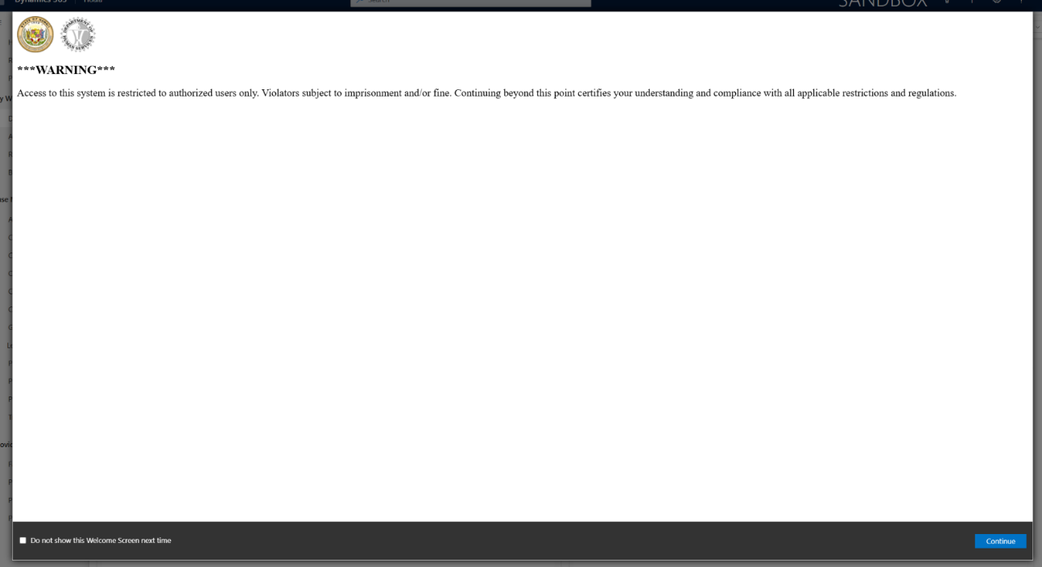
- Press Continue
  - 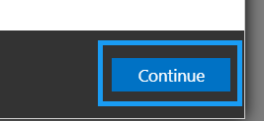
- To move between apps, click on the current app name in the top blue ribbon.
  - 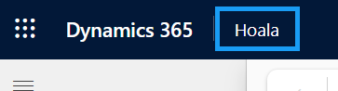
- Choose the app that is relevant to your team. If you are a Treatment Provider, select Hoala.
  - 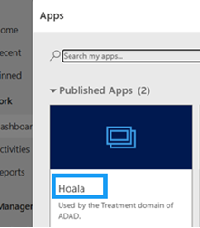
- On the left-hand side of the screen, you will see the Site Navigation. This is how you move across different entities in the app. It will look different for Hoala and Pulama.
  - 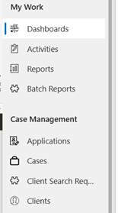
- To change areas, move to the bottom of the site navigation.
  - 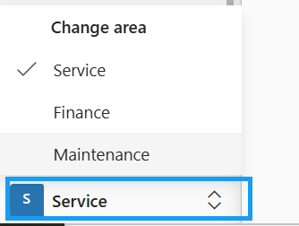
- To sign out of the application, press the person icon in the top right corner of the screen and press “Sign Out”
  - 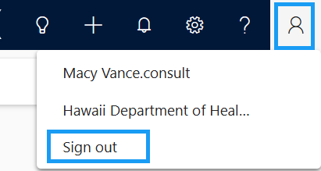
- To view your personalized settings, press the settings gear in the top right corner of the screen and press “Personalization Settings.” (note: Only administrators will have access to update system settings, but you can update your personal settings)
  - 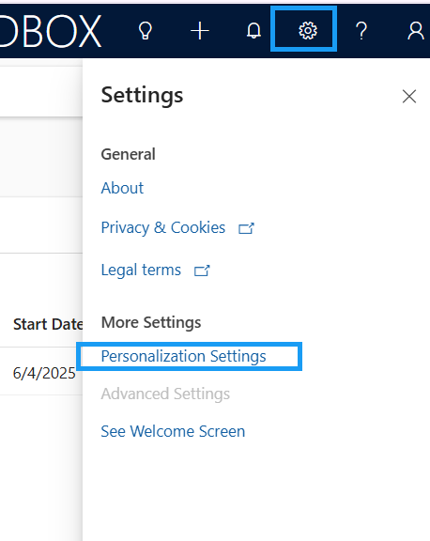
- To navigate to Microsoft Learn, press the question mark icon in the top right corner of the screen.
  - 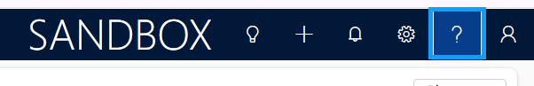
- This brings you to the Microsoft Learn homepage.
  - 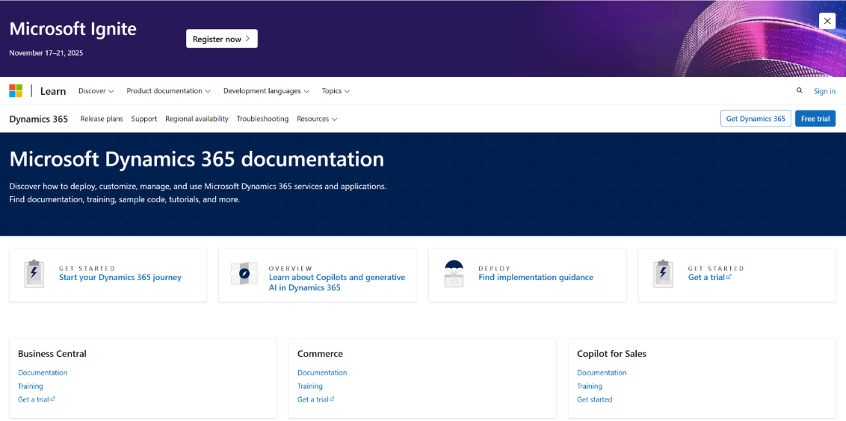

Using Advanced Find in INSPIRE+
Using Advanced Find in INSPIRE+ is a good way to search for records in the app, especially if the table is not directly featured in the site map.
- Login to Hoala
  - 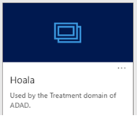
- In the top ribbon, navigate to the Search bar
  - 
- Press “Search for rows in a table using advanced filters”
  - 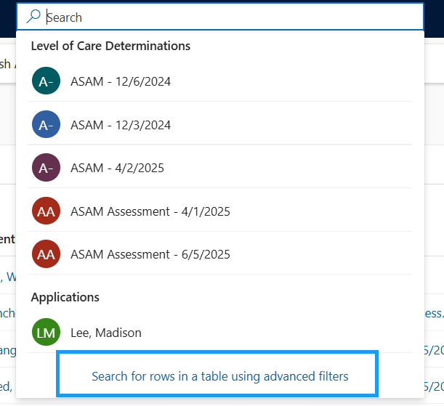
- Search the specific table you would like to search within
  - 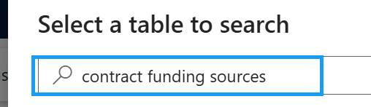
- Check the circle checkbox to the left of the table name and press Continue
  - 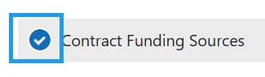
  - 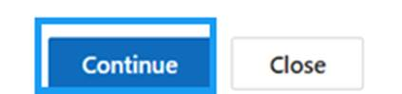
- You will be brought to the default view of that table with the filters pop-up
  - 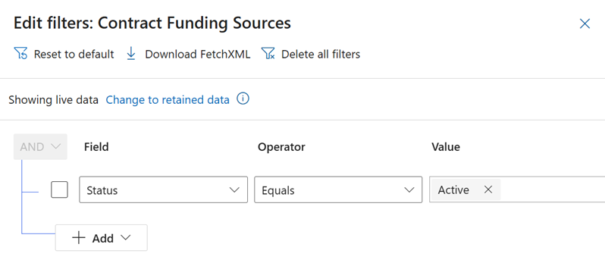
- Add any additional filters to the filters view
  - 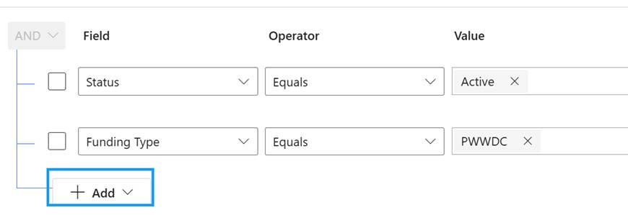
- Press Apply
  - 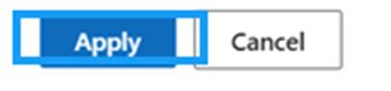
- The filtered view will now appear with results (if any)
  - 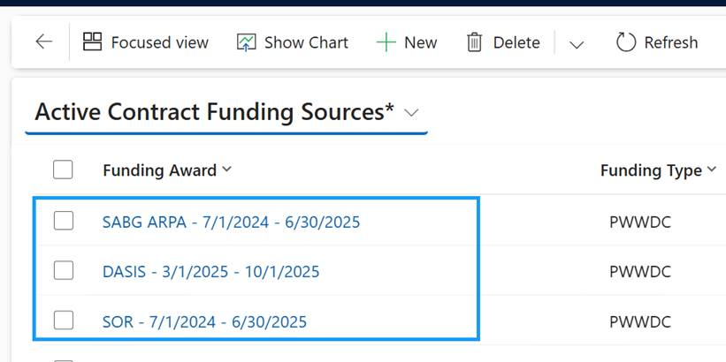
The Advanced Find search in INSPIRE+ can be done for any table that is in the application, even if it is not in the site map.

Fee-for-Service Invoicing
Create Invoice (Fee-for-Service), Automatic Invoice Service Creation. Automatic Invoice Funding Source Creation, Find Billable Progress Notes (Batch & Bill), Submit Invoice to ADAD, Invoice Submission Validation Message
SECURITY: Provider – Finance
APP: Hoala

View Provider Contracts
- In the site map, navigate to Providers
  - 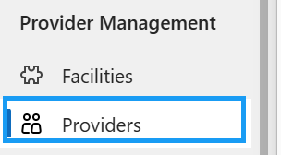
- Open your Provider Agency record
  - 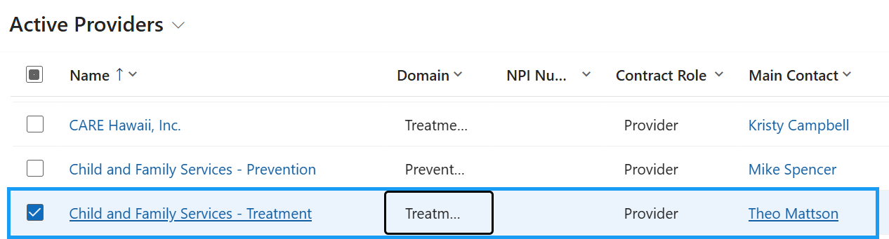
- Navigate to the Provider Contracts tab
  - 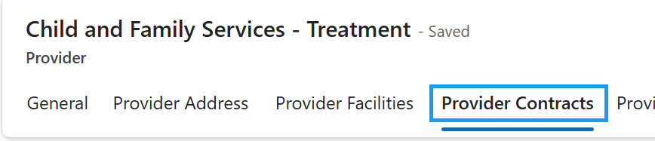
- The contract for the current fiscal year will appear in the “Active Provider Contract” lookup field.
  - 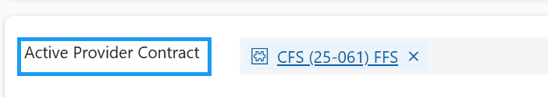
- All other contracts (or those that are no longer active or not part of the current fiscal period) will be listed in the “Provider Contracts” sub-grid.
  - 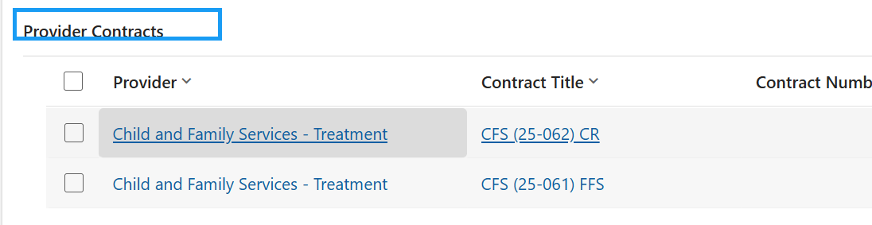
- Open the Active Provider Contract
  - 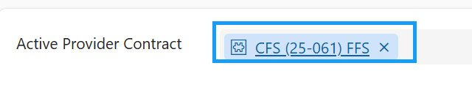
- Here, you will be able to view all of the provider contract details, including:
  - Contract Title
  - Branch/Office
  - Contract Number
  - Domain
  - Contract Type
  - Invoice Type
  - Monthly Capitated Amount Eligibility (capitated rate contracts)
  - Start Date & End Date
  - State Accountant
  - Contract Manager
  - NTE Amount
  - All other amount details defined below (authorized amount, amount available to be authorized, pre-encumbered amount, encumbered amount, expended amount, amount available to spend)
  - 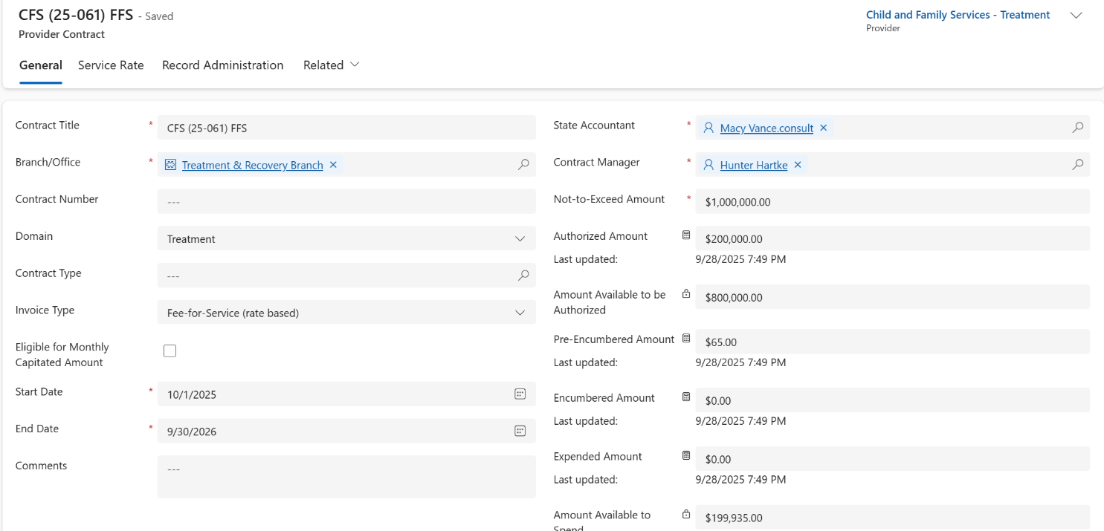

Create a Fee-for-Service Invoice
- In the site map, navigate to Provider Invoices
  - 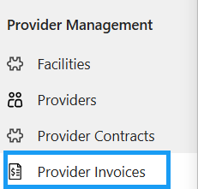
- Press + New in the top ribbon
  - 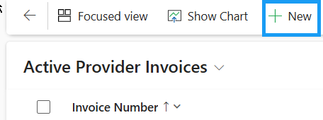
- Notice that the Provider that your user is associated with populates in the top right corner
  - 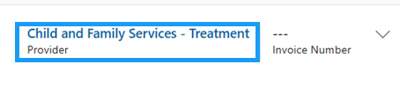
- Select the Provider Contract with an Invoice Type of Fee-for-Service
  - Based on the type of Provider Contract selected, the Invoice Type is populated (Invoice Type = Fee-for-Service)
  - 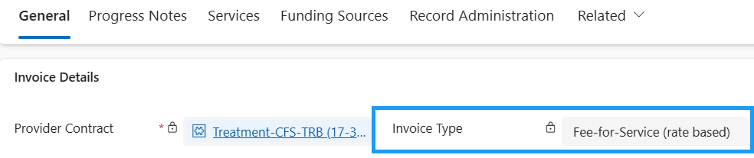
- Fill in the rest of the required fields.
  - Start Date
  - End Date
  - Invoice Date
  - DO NOT FILL IN THE INVOICE AMOUNT YET
  - 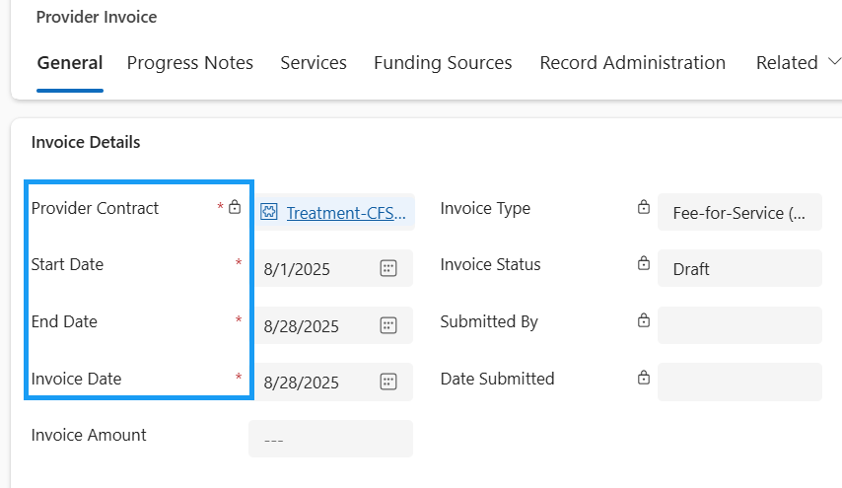
- Save the record
  - 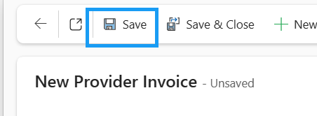
- Once the record is saved, you will be able to view all of the Contract Details, including:,
  - Authorized Amount, Pre-Encumbered Amount, Encumbered Amount, Expended Amount, and Available Amount to Expend
  - 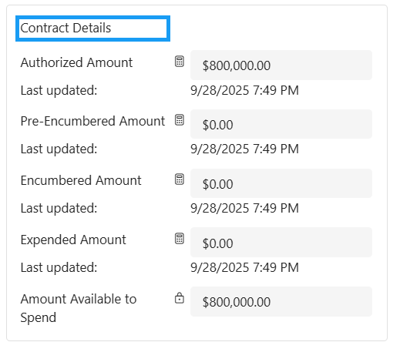
- Here are the definitions for all of the Contract Details:
  - Authorized Amount
    - The total funding allocated to a contract from the Purchase Order Funding Allocations (represented by the Contract Funding Sources)
    - The initial budgeted amount that has been formally approved and made available for use under a specific contract.
  - Pre-Encumbered Amount
    - The total money from validated progress notes that are not yet tied to a submitted or paid invoice
    - These validated progress notes may be on a Provider Invoice that may still be in draft status
    - The funds that are pre-encumbered are reserved and cannot be used anywhere else
    - It represents anticipated spending that hasn’t formally entered the billing cycle
  - Encumbered Amount
    - The total money being invoiced for on submitted invoices
    - This does not include drafts, revisions required, or paid invoices
    - Encumbered means committed but not yet paid—the funds are reserved and cannot be used elsewhere.
  - Expended Amount
    - The total money from paid provider invoices.
    - The final stage where funds have been fully processed
  - Amount Available to Spend
    - The remaining uncommitted and unreserved money from the total authorized amount.
    - The Authorized Amount that:
      - Has not yet been paid (Expended),
      - Is not currently committed to submitted invoices (Encumbered)
      - Is not reserved for validated progress notes (Pre-Encumbered)
    - It is the true available balance that can still be allocated or spent under the contract.
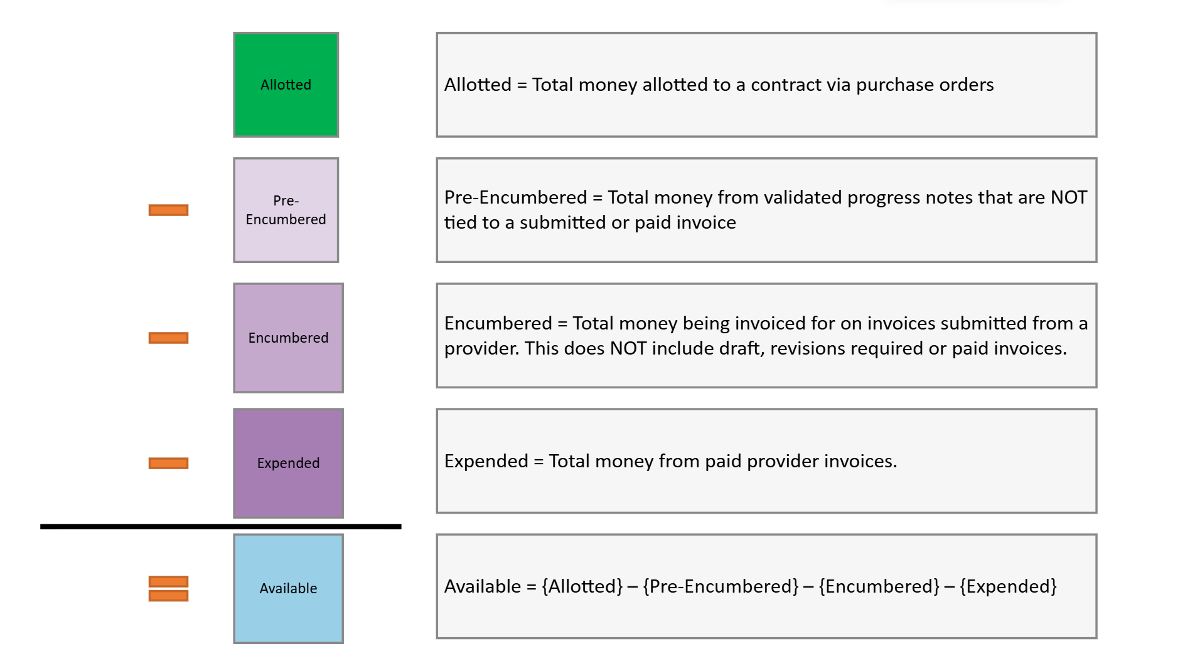

Automatic Invoice Service Creation
- Upon saving the new Provider Invoice record, Invoice Services are automatically created
- Navigate to the Services tab
  - 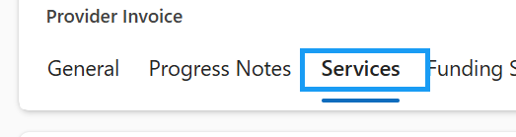
- The Services are automatically pulled from the Service Rates on the related Provider Contract
  - They are then created as Invoice Services
  - 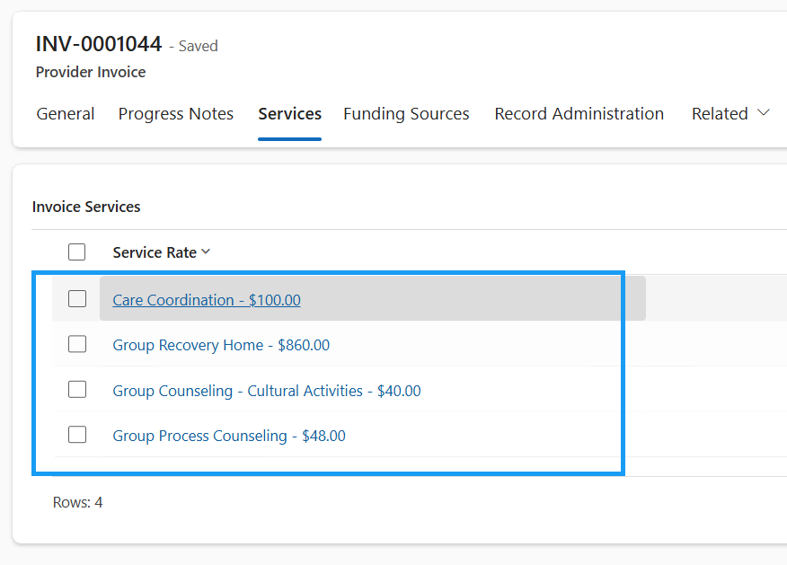

Automatic Invoice Funding Source Creation
- Upon saving the new Provider Invoice record, Invoice funding Sources are also automatically created
- Navigate to the Funding Sources tab
  - 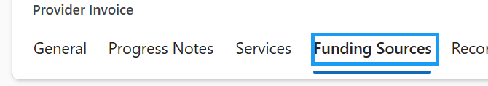
- Contract Funding Sources are also pulled from related the Provider Contract
  - They are then created as Invoice Funding Sources
  - 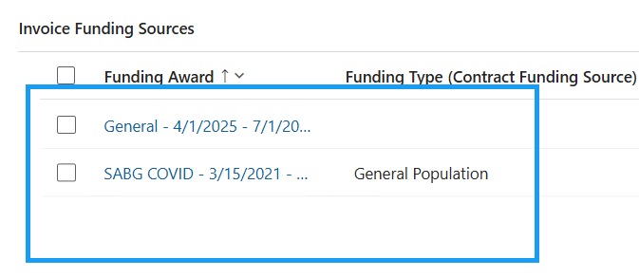

Find Billable Progress Notes
Formally known as the Batch & Bill process
- In the top ribbon, press the Flow button
  - 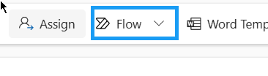
- Run the Find Billable Progress Notes flow
  - 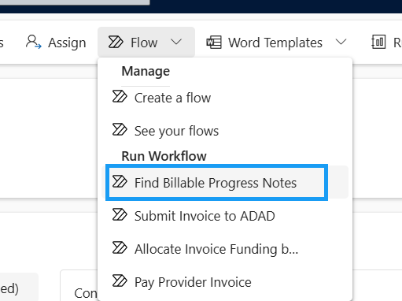
- Press OK
  - 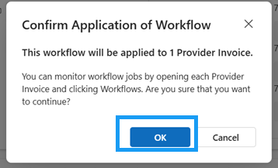
- Navigate to the Progress Notes tab
  - 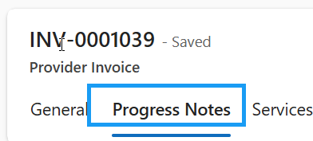
- All billable Progress Notes associated to the Provider Contract that have been validated will appear in the sub-grid
  - 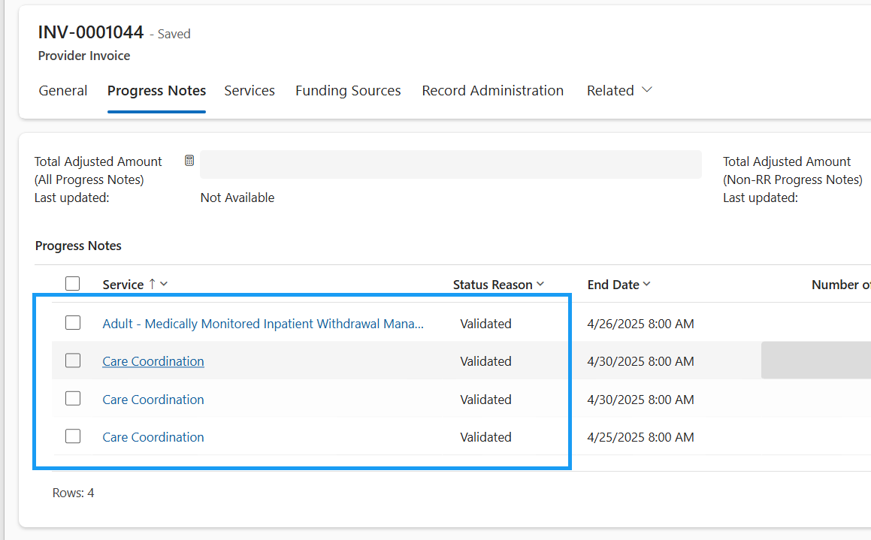

Submit Invoice to ADAD
- Navigate to the Funding Sources tab
  - 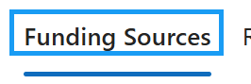
- Take note of the Total Invoice Amount (Invoice Funding Sources)
  - 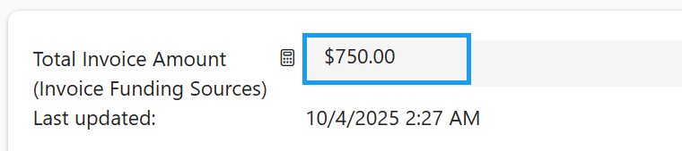
- Navigate back to the general tab and fill in the invoice amount you noted above.
  - 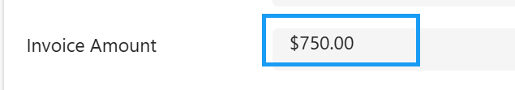
- Save the record
  - 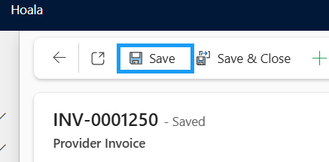
- To submit the invoice to ADAD for review, you need to attest all billing information provided is correct and accurate. Check “I acknowledge and agree to the above attestation” on the general tab of the Provider Invoice record.
  - 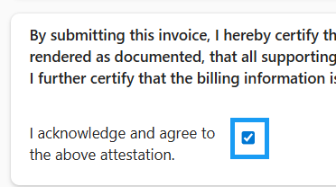
- Save the record. Attesting User and Attestation Date will be auto-populated
  - 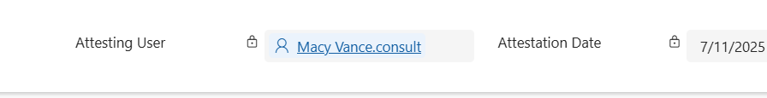
- Press Flow in the top ribbon
- Run the Submit Invoice to ADAD flow
  - 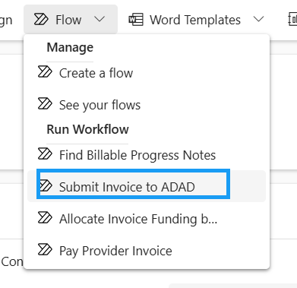
- Press OK.
  - 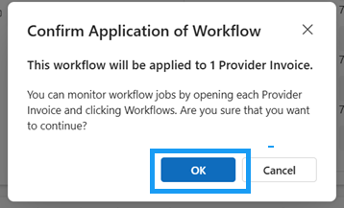
- The Invoice Status will update to “Program Review”
  - 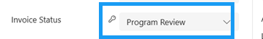
- You will also get a pop-up notification letting you know that the Invoice has been successfully submitted to ADAD for review.
  - 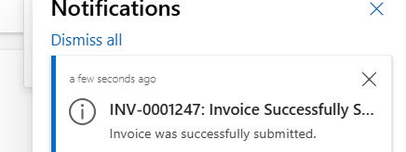

It is now in the hands of the ADAD Fiscal team to review. They can move the status to either Fiscal Review or send it back to the Provider user for revisions.

Billing Errors/Revisions
Funds Exceeded Error, Invoice Returned for Revisions, Re-Submit Invoice to ADAD
SECURITY: Provider – Finance
APP: Hoala
When submitting the Invoice to ADAD, the system may stop you if there are not enough funds in the funding sources.

Funds Exceeded
- If there are not enough funds in one of your Invoice Funding Sources, you will receive this error: “Funds Exceeded: There is not enough money in one of your funding sources in order to submit this invoice.”
  - 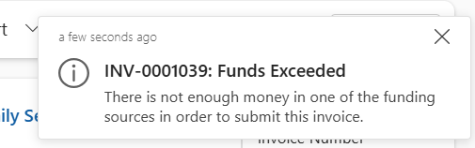
- To address the issue, navigate to the Funding Sources tab
  - 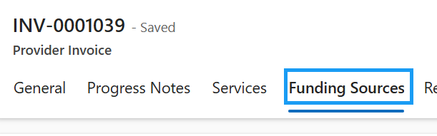
- Open each of the Invoice Funding Sources to see which Invoice Amount exceeds the Amount Available to Encumber
  - 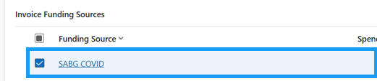
- We are getting this error because the Amount Available to Encumber for the Invoice Funding Source is less than the amount we are trying to invoice for.
  - Because the Invoice Amount cannot exceed the Amount Available to Encumber, we are not able to submit the invoice to ADAD yet
  - 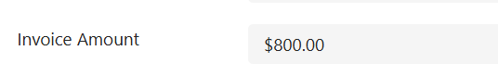
- Adjust the invoice amount to be lower than the Amount Available to Encumber
  - 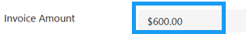
- Save and Close the record to navigate back to the Provider Invoice
  - 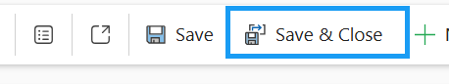

Note: ADAD Fiscal staff may adjust funds for each Contract Funding Source as needed. Providers will only be able to re-submit an invoice to ADAD if they reduce the invoice amount for any funding sources that exceed the available encumbered limit.
Resubmit Invoice to ADAD
- To resubmit the invoice to ADAD, press Flow in the top ribbon
- Run the Submit Invoice to ADAD flow
- Press OK.
  - 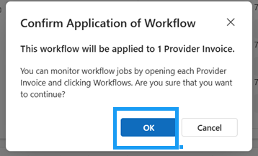
- The Invoice Status successfully updated to “Program Review”
  - 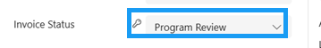
- You will also get a pop-up notification letting you know that the Invoice has been successfully submitted to ADAD for review.
  - 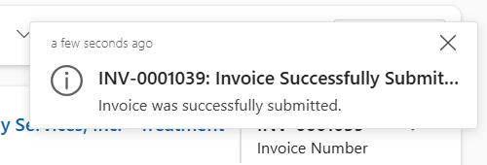

It is now in the hands of the ADAD Program Staff to review. They can move the status to either Fiscal Review or send it back for revisions.

Invoice Returned for Revisions
If ADAD Program Staff sends the Provider Invoice back for Revisions, it will be returned in the state of Revisions required.
- Navigate back to the General tab of the Provider Invoice
  - 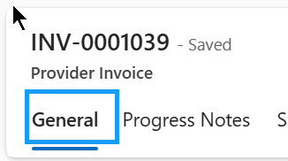
- Notice that the Invoice Status is now in Revisions Required along with a Justification
  - 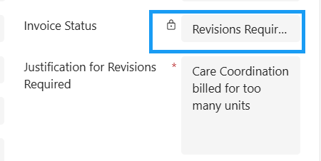
- Once the status of an invoice is flipped to Revisions Required, the system will send an email to the Provider who submitted the invoice to ADAD
  - This can be found in the timeline or in your Outlook Inbox
  - 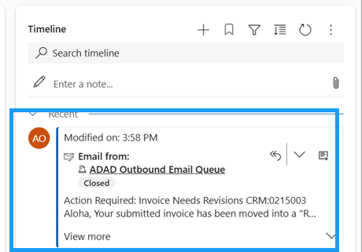
- To view the entire email within Dynamics, press the “Open Record” icon
  - 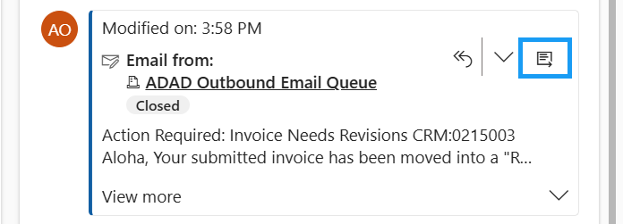
- Here, you will see all of the email details including:
  - Who the email is from, who it was sent to, anyone CC’d, the Subject, the Invoice Number, the Submission Date, the Revision for Submission, and next steps.
  - The regarding field also is a hyperlink directly to the Provider Invoice. This can also be opened directly within Outlook. That link will guide you to INSPIRE+.
  - 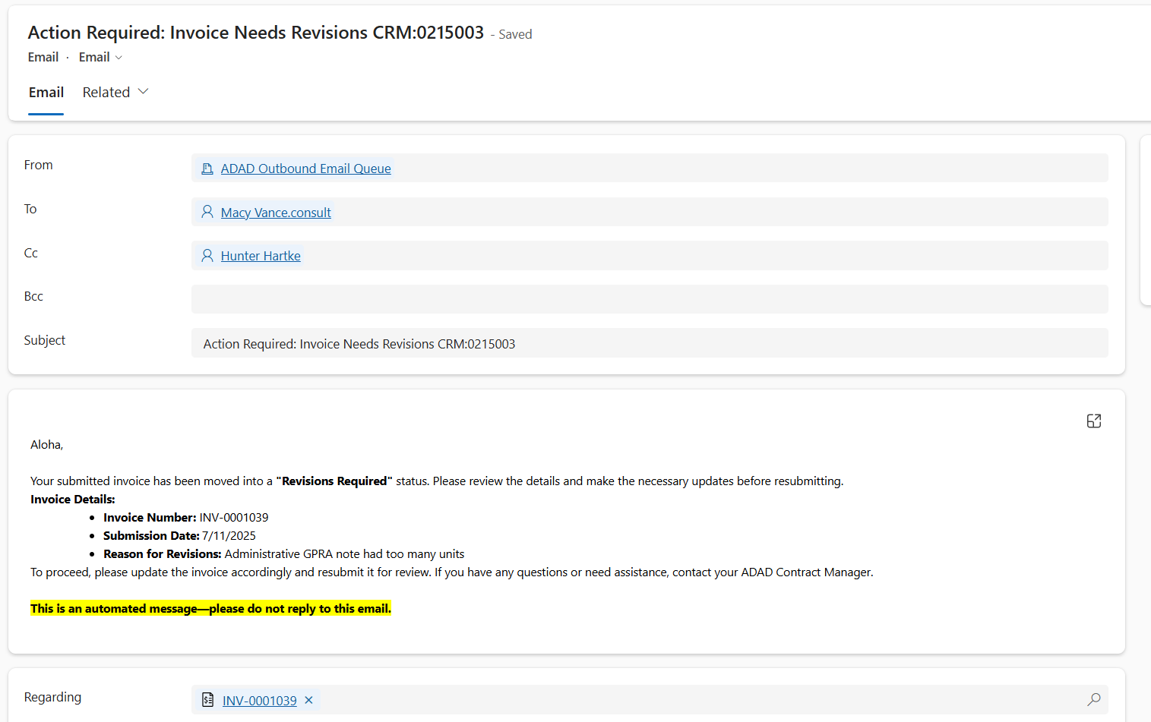
- Save & close the email to navigate back to the Provider Invoice
  - 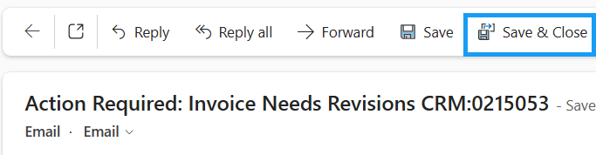
Individual Progress Notes can also be sent back to Revisions Required by ADAD
- Navigate to the Progress Notes tab
- The Progress Note marked with the status reason ‘Revisions Required’ is the one that needs to be updated.
  - 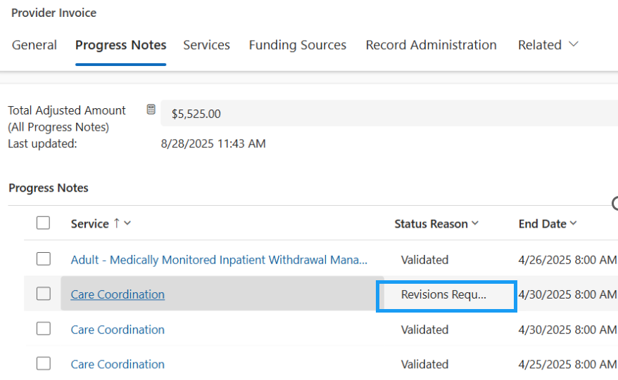

Re-Batch & Bill
IMPORTANT: The Treatment Clinical Staff will need to un-validate the specific Progress Note that needs revisions. Once that Progress Note’s changes have been made, the batch and bill progress will need to be re-run by the Billing team.

Un-Validate Progress Notes – Clinical Staff Only
(Treatment Clinical Users ONLY)
- Open the Progress Note in the Revisions Required status
  - 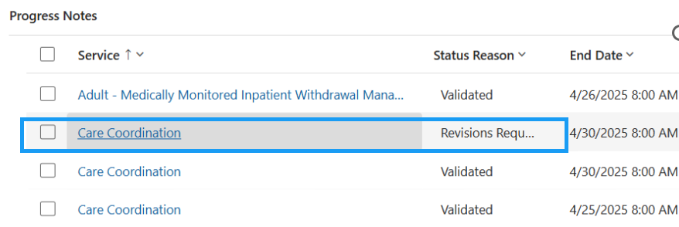
- In the top ribbon, press the Flow button
  - 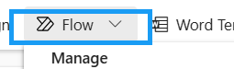
- Run the Un-validate Progress Note Flow
  - 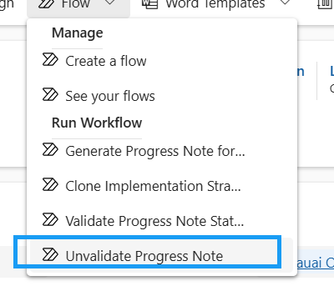
- Press OK
  - 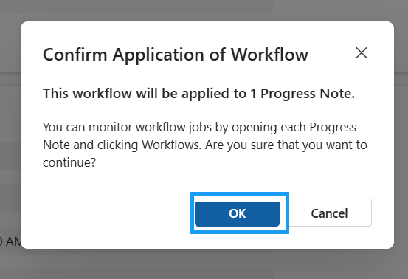
- The Status reason will be updated to Draft
  - 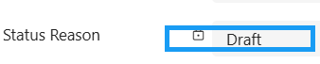

Re-Validate Progress Notes – Clinical Staff Only
(Treatment Clinical Users ONLY)
An invoice cannot be submitted to ADAD if there are any progress notes that are in "Draft" status. Before submitting the invoice to ADAD for payment, the Treatment Clinical Provider will need to re-validate the progress notes. A progress note will need to be "re-validated" if it was "un-validated" before the invoice can be submitted.
- Update the Adjusted Service Units Amount
  - 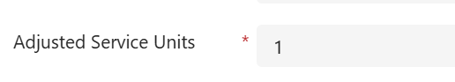
- Save the Progress Note record
  - 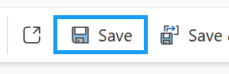
- In the top ribbon, press the Flow button
  - 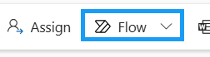
- Run the Validate Progress Notes flow
  - 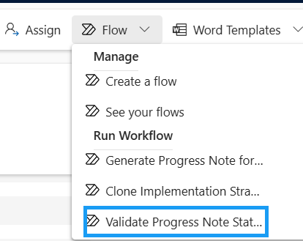
- Press OK
  - 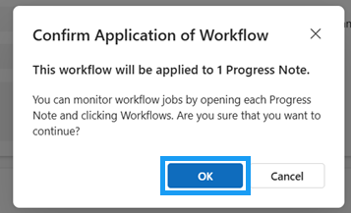
- If the Progress Note passes all 3 validation checks, the Status Reason will update to Validated and Authorized On and Authorized By will be populated
  - 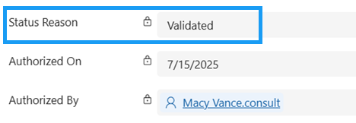

Once all the Progress Notes are re-validated, you will need to run the batch process again to add those Progress Notes back to the Provider Invoice.

Re-Batch and Bill – Billing Users
(Billing User)
- In the top ribbon, press the Flow button
  - 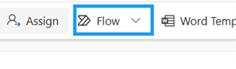
- Run the Find Billable Progress Notes flow
- Press OK
- Navigate to the Progress Notes tab
- All billable Progress Notes associated to the Provider Contract that have been re-validated will now appear in the sub-grid
  - 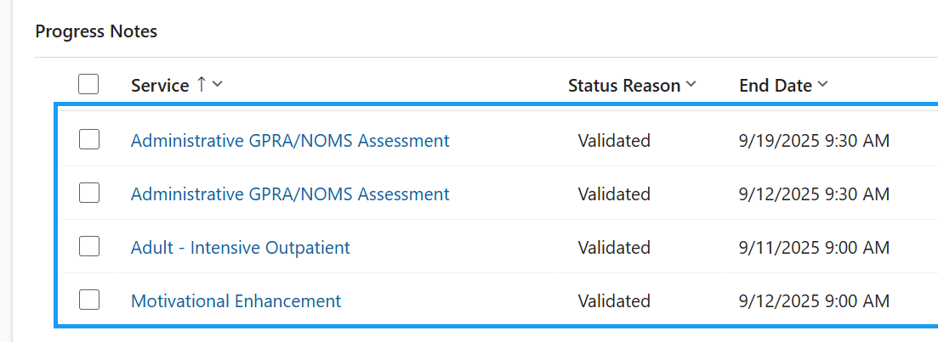
- The Total Adjusted Amount (All Progress Notes) field will be updated to accurately reflect the new progress note adjusted amounts

Re-Submit Invoice to ADAD
Once the necessary adjustments have been made and the batch and bill progress has been rerun, re-submit the invoice to ADAD Program Staff.
Once the adjustments are made, you can resubmit the Invoice back to ADAD.
- Press Flow in the top ribbon
- Run the Submit Invoice to ADAD flow
- Press OK.
- The Invoice Status successfully updated to “Program Review”
  - 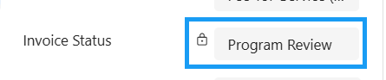
- You will get a pop-up notification letting you know that the Invoice has been successfully submitted to ADAD for review.

It is now once again in the hands of the ADAD Program Staff to do their final review. Once it is reviewed, the ADAD Program staff will flip the status of the Provider Invoice to “Fiscal Review”

Capitated Rate Provider Invoices
Create Invoice (Capitated Rate)), Automatic Invoice Service Creation. Automatic Invoice Funding Source Creation, Find Billable Progress Notes (Batch & Bill), Monthly Capitated Amount Eligibility, Self Attest to Meet Requirements, Capitated Rate Split Between Invoice Funding Sources, Submit Invoice to ADAD, Invoice Submission Validation Message
SECURITY: Provider – Finance
APP: Hoala

Create Invoice (Capitated Rate)
- In the site map, navigate to Provider Invoices
- Press + New in the top ribbon
- Notice that the Provider that your user is associated with populates in the top right corner
  - 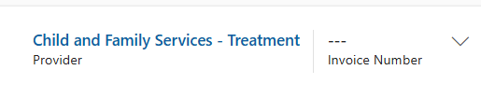
- Fill in the required fields
  - Provider Contract
    - Select a Provider Contract that is eligible for the Monthly Capitated Amount
      - 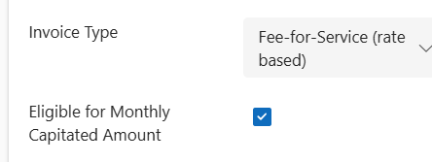
  - Start Date
  - End Date
  - Invoice Date
  - DO NOT ENTER AN INVOICE AMOUNT
- Save the record.
  - 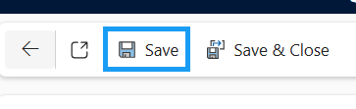
- Upon saving, the field “Did you meet the capitated amount eligibility requirements” field will appear. Leave it unchecked for now
  - 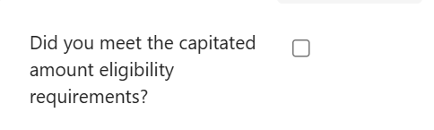

Automatic Invoice Service Creation
- Upon saving the new Provider Invoice record, Invoice Services are automatically created
- Navigate to the Services tab
  - 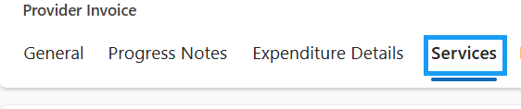
- The Services are automatically pulled from the Service Rates on the related Provider Contract
  - They are then created as Invoice Services

Automatic Invoice Funding Source Creation
- Upon saving the new Provider Invoice record, Invoice funding Sources are also automatically created
- Navigate to the Funding Sources tab
  - 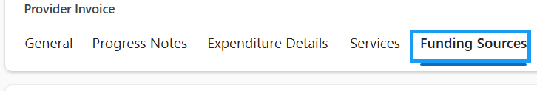
- Contract Funding Sources are also pulled from related the Provider Contract
  - They are then created as Invoice Funding Sources

Find Billable Progress Notes
Formally known as the Batch & Bill process
- In the top ribbon, press the Flow button
- Run the Find Billable Progress Notes flow
- Press OK
  - 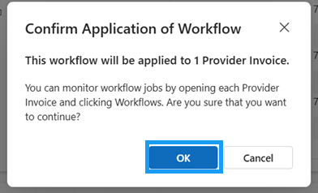
- Navigate to the Progress Notes tab
  - 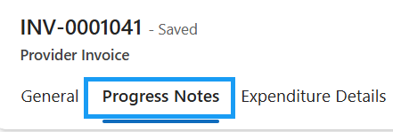
- All validated billable Progress Notes will appear in the sub-grid if their end date falls before the Provider Contract’s end date.

Check if Your Agency is Eligible for Monthly Capitated Rate
- Navigate to the General tab of the Provider Invoice
  - 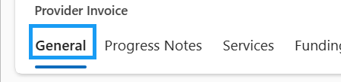
- Click the blue hyperlink to open the Provider Contract.
  - 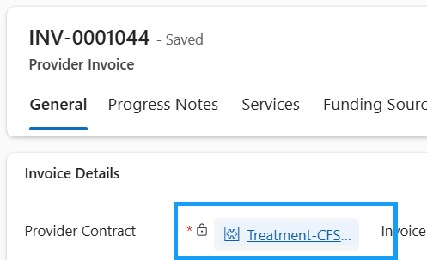
- Here, you will see if you are eligible to receive a monthly capitated amount
  - The monthly maximum amount and if eligible will be established by ADAD
  - 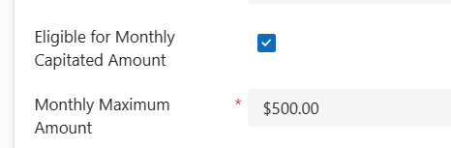
- Navigate back to the Provider Invoice
  - 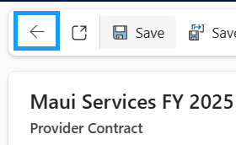

Self-Attest You Have Met the Capitated Amount Eligibility Requirements
- If your Provider agency is eligible for the monthly capitated amount, the “Did you meet the capitated amount for eligibility requirements?” field will appear on the Provider Invoice.
  - 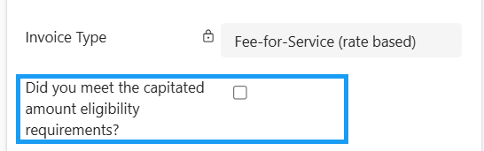
- Check that field to self-attest.
  - 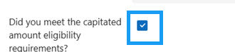
- Save the Record
  - 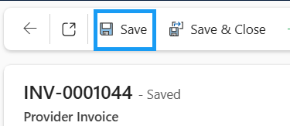
- Navigate to the Funding Sources tab
  - 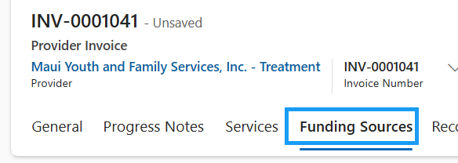
- Open an Invoice Funding Source record
  - 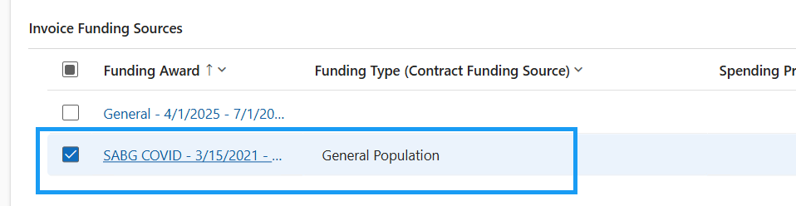
- The following fields will appear:
  - Total Adjusted Amount (Non-RR Progress Notes)
  - Capitated Amount
  - 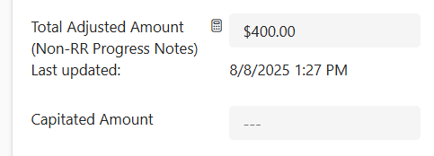
- The Total Adjusted Amount (Non-RR Progress Notes) field will be the sum all of the associated non-Rural Remote Progress Notes on the Provider Invoice
  - Sum of non-RR Progress Notes Adjusted Amounts:
    - 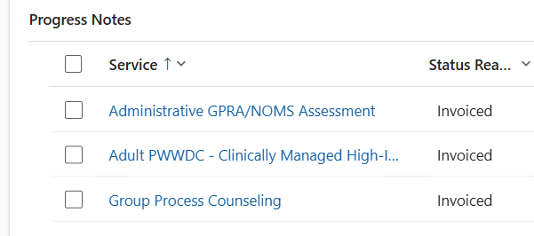
    - 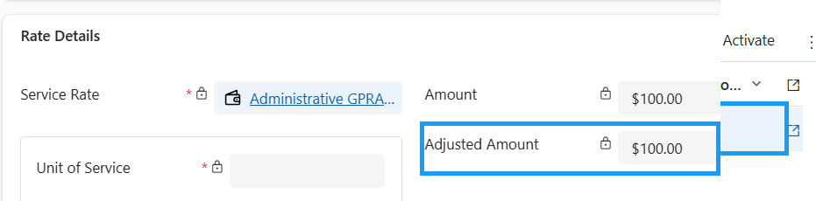
- Navigate back to the Provider Invoice
  - 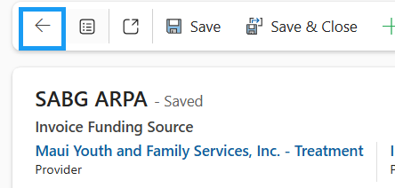

Spit Funds Between Invoice Funding Sources
- Note the Maximum Capitated Amount on the general tab
  - 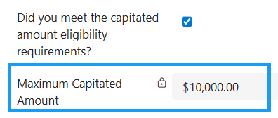
- Navigate to the Funding Sources tab
  - 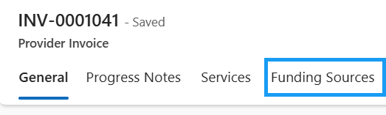
- Open each Invoice Funding Source
  - 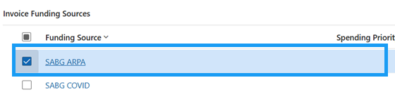
- Distribute the Maximum Capitated Amount from step one between the Invoice Funding Sources
  - Make sure the Capitated Amount on each Invoice Funding Source does need exceed the Amount Available to Encumber
  - 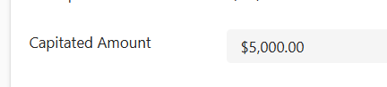
  - 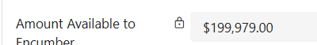
- Once the Maximum Monthly amount is distributed between Invoice Funding Sources, the Total Invoice Amount should equal the Maximum Capitated Amount on the General tab
  - 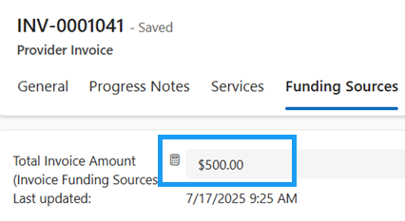
  - 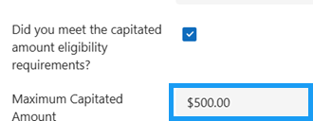

Submit Invoice to ADAD
- Navigate to the Funding Sources tab
- Take note of the Total Invoice Amount (Invoice Funding Sources)
- Navigate back to the general tab and fill in the invoice amount you noted above.
  - 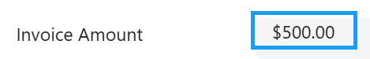
- Save the record
- To submit the invoice to ADAD for review, you need to attest all billing information provided is correct and accurate. Check “I acknowledge and agree to the above attestation” on the general tab of the Provider Invoice record.
- Save the record. Attesting User and Attestation Date will be auto-populated
  - 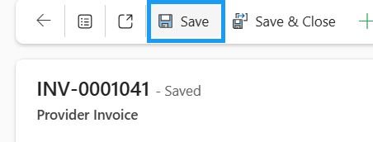
- Press Flow in the top ribbon
- Run the Submit Invoice to ADAD flow
- Press OK.
- The Invoice Status will update to “Program Review”
- You will also get a pop-up notification letting you know that the Invoice has been successfully submitted to ADAD for review.
  - (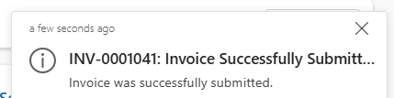

Mixed Batch Invoicing

Create Invoice
- In the site map, navigate to Provider Invoices
- Press + New in the top ribbon
- Notice that the Provider that your user is associated with populates in the top right corner
- Fill in the required fields
  - Provider Contract
    - Select a Provider Contract that is eligible for the Monthly Capitated Amount
  - Start Date
  - End Date
  - Invoice Date
  - DO NOT ENTER AN INVOICE AMOUNT
- Save the record.
- Upon saving, the field “Did you meet the capitated amount eligibility requirements” field will appear. Leave it unchecked for now

Automatic Invoice Service Creation
- Upon saving the new Provider Invoice record, Invoice Services are automatically created
- Navigate to the Services tab
- The Services are automatically pulled from the Service Rates on the related Provider Contract
  - They are then created as Invoice Services

Automatic Invoice Funding Source Creation
- Upon saving the new Provider Invoice record, Invoice funding Sources are also automatically created
- Navigate to the Funding Sources tab
- Contract Funding Sources are also pulled from related the Provider Contract
  - They are then created as Invoice Funding Sources

Find Billable Progress Notes (“Mixed Batch” – RR and non-RR)
Formally known as the Batch & Bill process
- In the top ribbon, press the Flow button
- Run the Find Billable Progress Notes flow
- Press OK
- Navigate to the Progress Notes tab
- All validated billable Progress Notes will appear in the sub-grid if their end date falls before the Provider Contract’s end date.
  - If this is a Mixed Batch invoice, then the Rural Remote column will have some rows set to “Yes” and some to “No” or {Blank}
  - 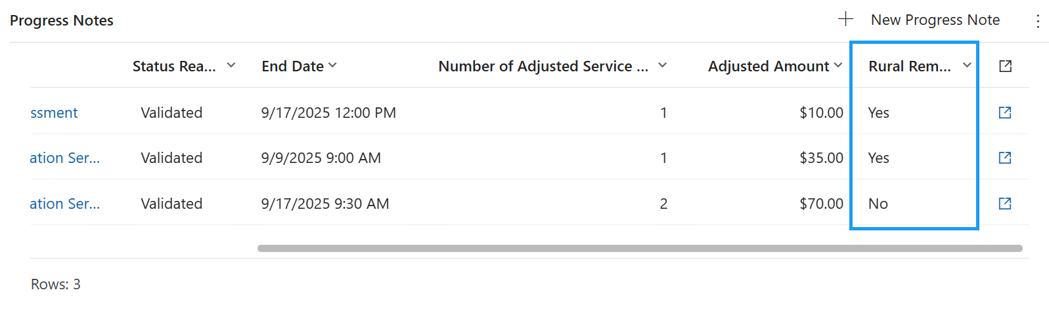
- There are now going to be two rollup fields on the Progress Notes tab
  - The first one is going to be the amount for ALL progress notes if they used the contracted service rate and NOT the rural remote amount at all
  - The second one is going to be just the amount of non-RR progress notes. I.e., These are the ones that are using the contracted service rate
  - 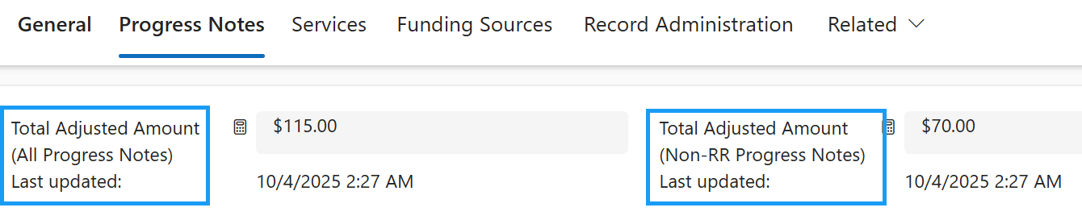

Check if Your Agency is Eligible for Monthly Capitated Rate
- Navigate to the General tab of the Provider Invoice
- Click the blue hyperlink to open the Provider Contract.
- Here, you will see if you are eligible to receive a monthly capitated amount
  - The monthly maximum amount and if eligible will be established by ADAD
- Navigate back to the Provider Invoice

Self-Attest You Have Met the Capitated Amount Eligibility Requirements
- If your Provider agency is eligible for the monthly capitated amount, the “Did you meet the capitated amount for eligibility requirements?” field will appear on the Provider Invoice.
- Check that field to self-attest.
- Save the Record

Enter Capitated Amount in Funding Sources
- Navigate to the Funding Sources tab
- Open each Invoice Funding Source
  - You will notice that the “Capitated Amount” field is now visible
  - And the “Non-RR Adjusted Amount” field is now visible
    - This totals the amount of the progress notes related to the funding source that are not Rural Remote.
  - 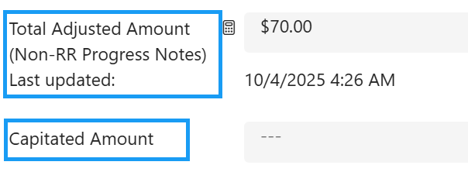
- Enter the “Capitated Amount” in the Invoice Funding Source(s). The capitated amount can all go into a single funding source or may be split across multiple.
  - 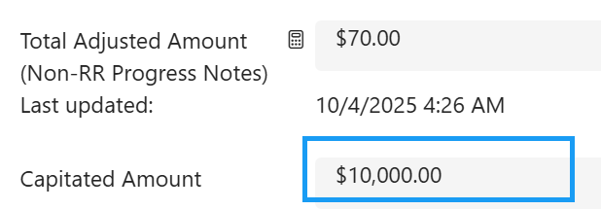
  - The Capitated Amount will come from the “Monthly Capitated Amount” field on the general tab
  - 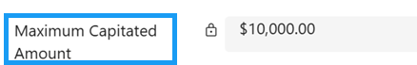\
- Save & Close the Invoice Funding Source record to navigate back to the Provider Invoice
  - 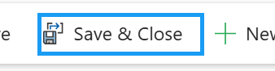
- On the Invoice Funding Sources tab, the “Invoice Amount” will be a sum of the “Non-RR Adjusted Amount” & “Capitated Amount”
  - 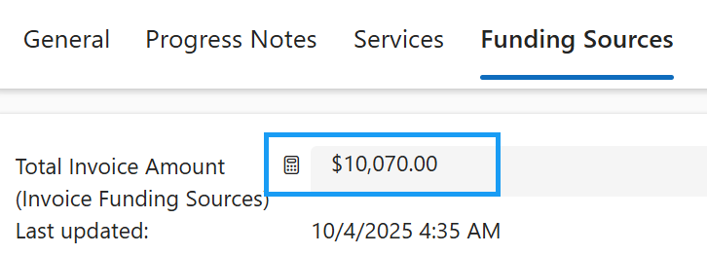

Submit Invoice to ADAD
- Navigate back to the General tab
  - 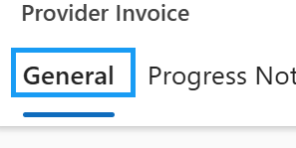
- Manually enter the Invoice Amount on the general tab
  - This will come from the “Total Invoice Amount (Invoice Funding Sources)” field on the Funding Sources tab
  - 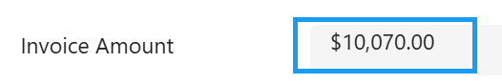
- Save the record
- To submit the invoice to ADAD for review, you need to attest all billing information provided is correct and accurate. Check “I acknowledge and agree to the above attestation” on the general tab of the Provider Invoice record.
- Save the record. Attesting User and Attestation Date will be auto-populated
- Press Flow in the top ribbon
- Run the Submit Invoice to ADAD flow
- Press OK.
- The Invoice Status will update to “Program Review”
- You will also get a pop-up notification letting you know that the Invoice has been successfully submitted to ADAD for review.
  - (

Provider Invoice Template
- ADAD will provide the Billing team with a Provider Invoice Template that must be filled out and attached to each Provider Invoice
  - 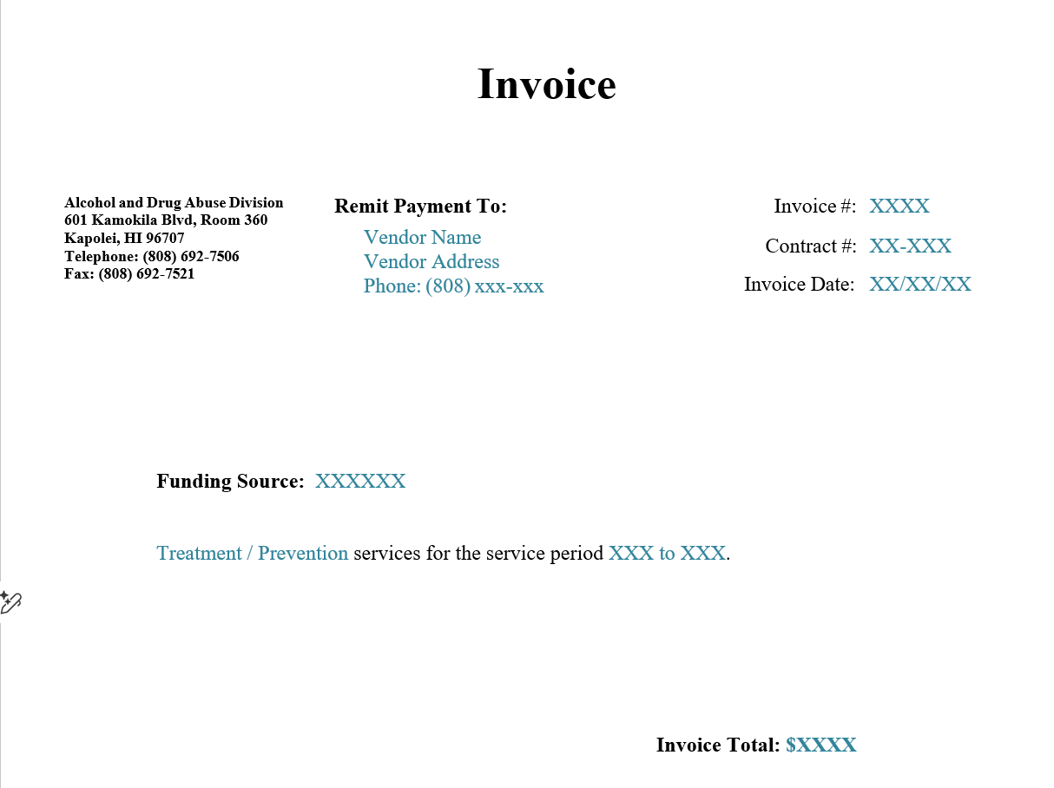
b. Fill in all fields marked in blue - these are editable. The black text is static and should not be changed.

Upload Documents to a Provider Invoice
External documents can be uploaded and associated with the Provider Invoice record. They will then be linked to SharePoint and stored in the corresponding SharePoint folder. Upon creating a Provider Invoice record, a SharePoint document location is automatically created within the INSPIRE+ System.
NOTE: Documents can be uploaded to Case, Group, or Provider Invoice Records
- Navigate to the related tab and open documents
  - 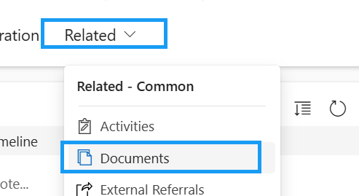
- Open the folder you would like to upload the document to
  - 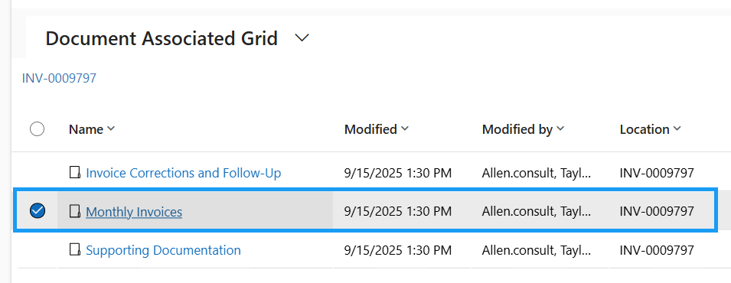
- Once you’re in the appropriate folder, press “Upload”
  - 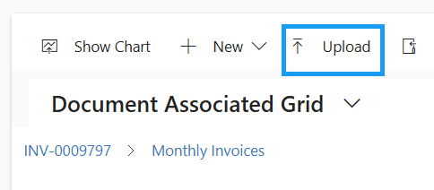
- Press Choose File to upload a file from your local computer or one drive
  - One file you will need to upload in the Provider Invoice template above
  - 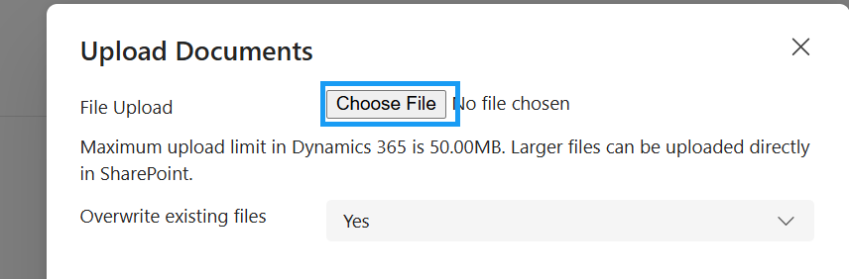
- Choose the document from your computer and press “Open”
  - 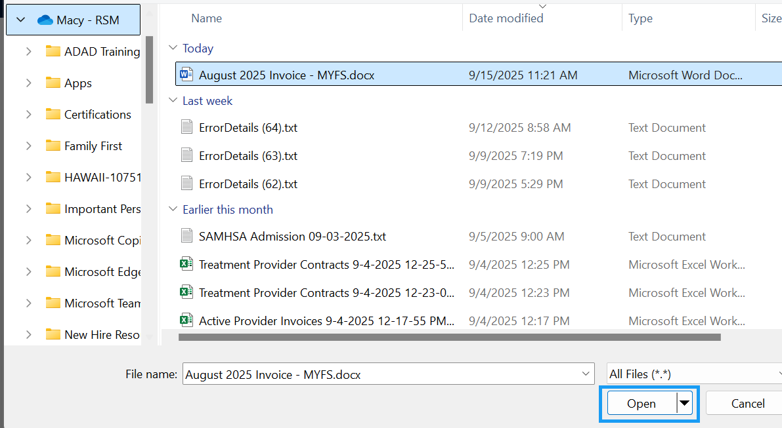
- Once the file has been uploaded, press OK
  - 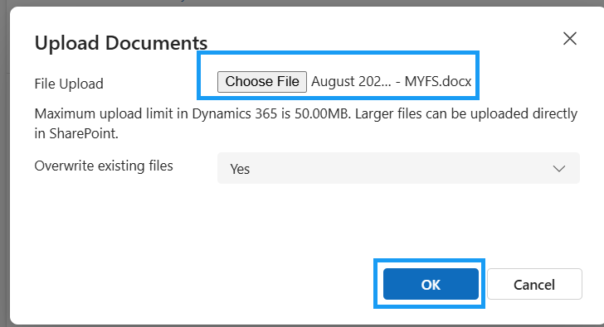
- The file has now been uploaded to the designated SharePoint site, location, and Group folder. SharePoint is seamlessly integrated with the INSPIRE+ System.
  - 