Site Navigation & Log In
System Login, System Navigation, Advanced Find
Prevention Programs and Coalitions
SECURITY: Provider – Prevention Line Staff + Provider - Prevention Supervisors

Log into INSPIRE+
- Log into the Application using this link
  - https://hawaiidepartmentofhealthadaduat.crm9.dynamics.com/
- To move between apps, click on the current app name in the top blue ribbon.
  - 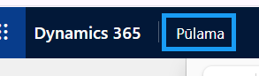
- Choose the app that is relevant to your team. If you are a Prevention Provider, select Pulama.
  - 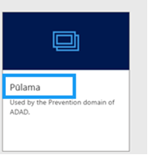
- Before continuing to the app, you will receive a warning message saying “WARNING. Access to this system is restricted to authorized users only. Violators subject to imprisonment and/or fine. Continuing beyond this point certifies your understanding and compliance with all applicable restrictions and regulations.” Press Continue.
  - 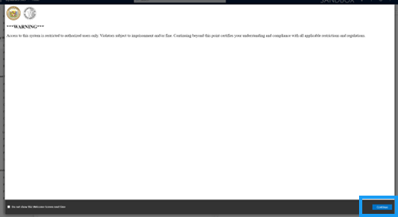

Site Navigation
- On the left-hand side of the screen, you will see the Site Navigation. This is how you move across different entities in the app. It will look different for Hoala and Pulama.
  - 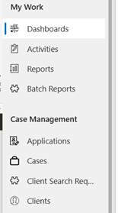
- To change areas, move to the bottom of the site navigation.
  - 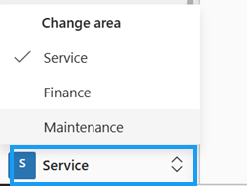
- To sign out of the application, press the person icon in the top right corner of the screen and press “Sign Out”
  - 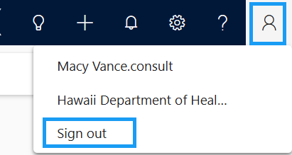
- To view your personalized settings, press the settings gear in the top right corner of the screen and press “Personalization Settings.” (note: Only administrators will have access to update system settings, but you can update your personal settings)
  - 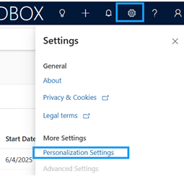
- To navigate to Microsoft Learn, press the question mark icon in the top right corner of the screen.
  - 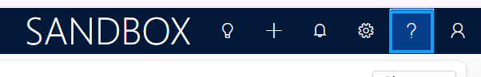
  - 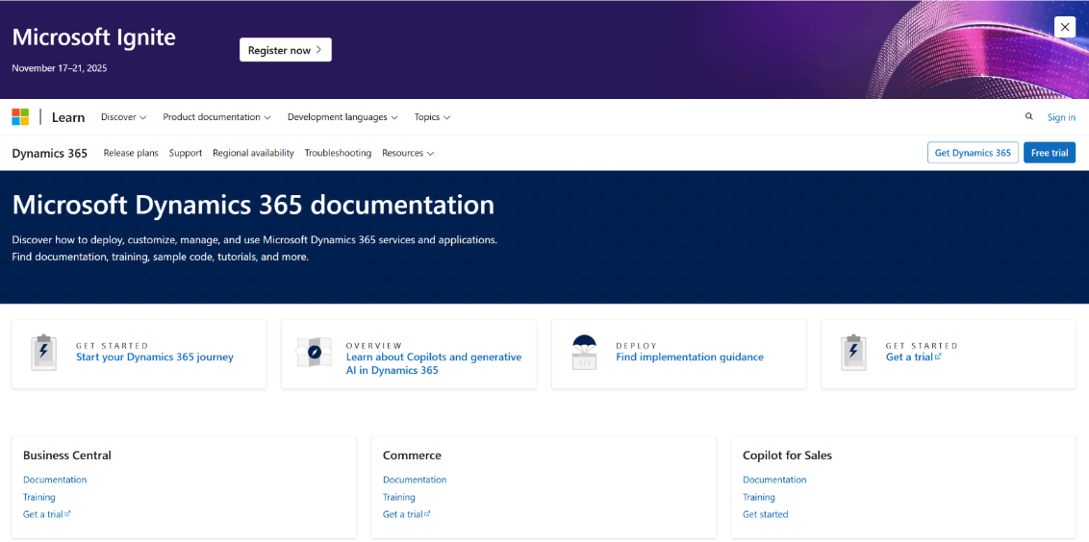

Using Advanced Find in INSPIRE+
Using Advanced Find in INSPIRE+ is a good way to search for records in the app, especially if the table is not featured in the site map.
- Log into the Pulama App
  - 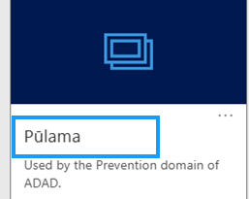
- In the top ribbon, navigate to the Search bar
  - 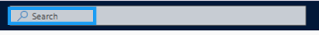
- Press “Search for rows in a table using advanced filters”
  - 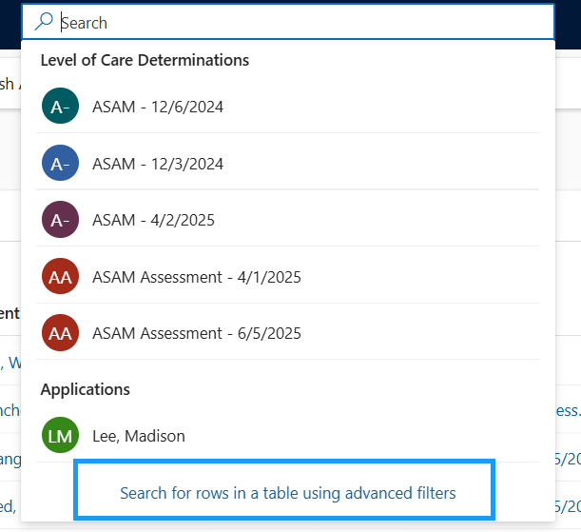
- Select the specific table you would like to search within
  - 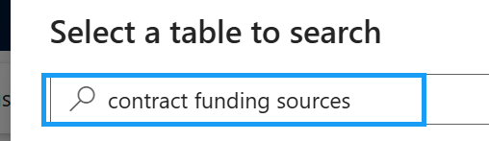
- Check the circle checkbox to the left of the table name and press Continue
  - 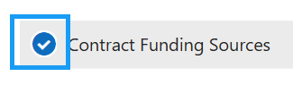
  - 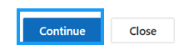
- You will be brought to the default view of that table with the filters pop-up
  - 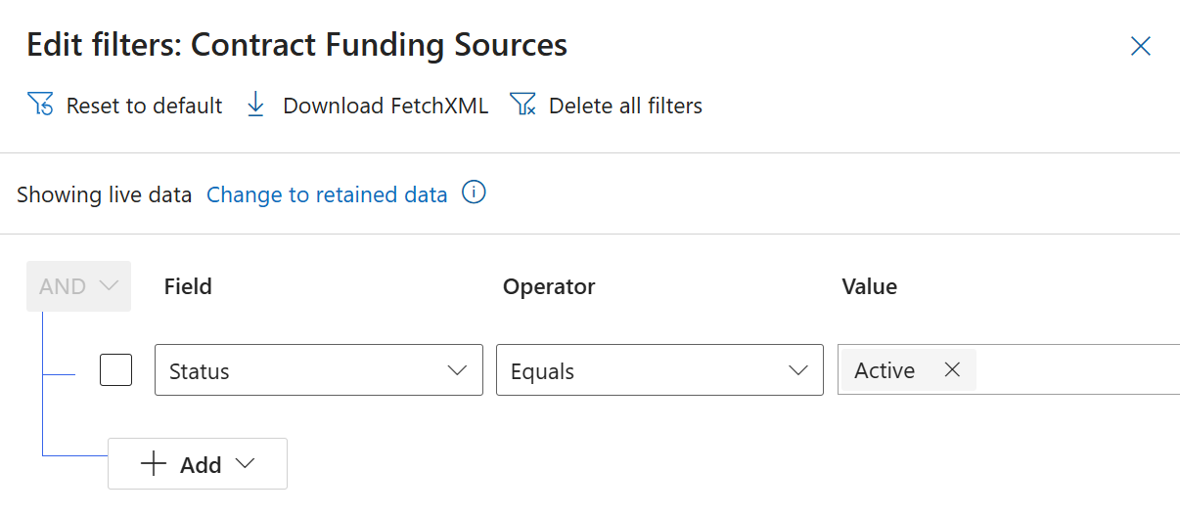
- Add any additional filters to the filters view
  - 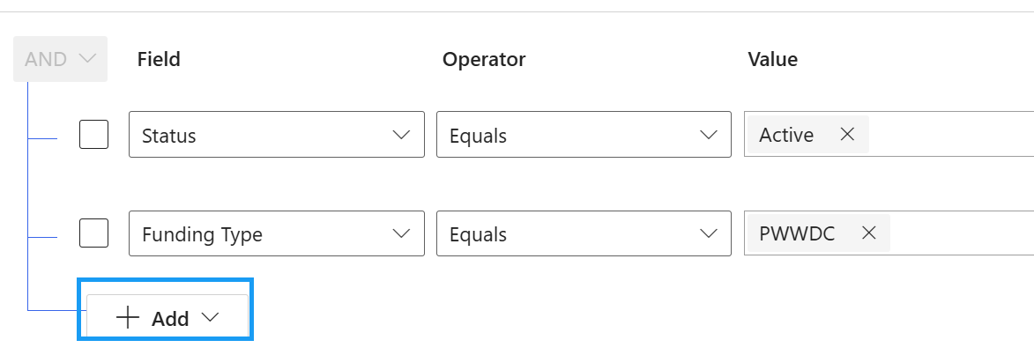
- Press Apply
  - 
- The filtered view will now appear with results (if any)
  - 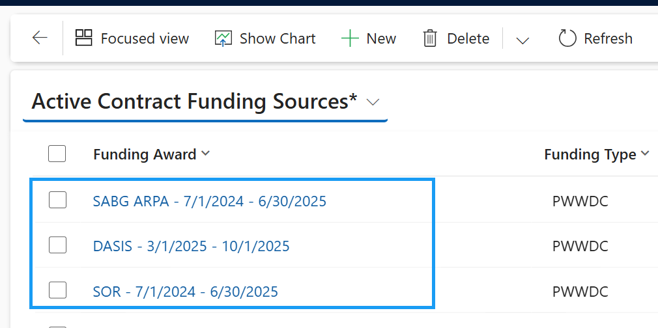
The Advanced Find search in INSPIRE+ can be done for any table that is in the application, even if it is not in the site map.

Provider Invoices
Create Invoice (Fee-for-Service), Automatic Invoice Service Creation. Automatic Invoice Funding Source Creation, Find Billable Progress Notes (Batch & Bill), Allocate Funding by Priority, Submit Invoice to ADAD, Invoice Submission Validation Message
SECURITY: Provider – Finance
APP: Pulama

View Provider Contracts
- In the site map, navigate to Providers
  - 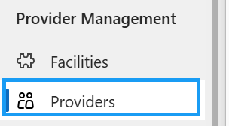
- Open your Provider Agency record
  - 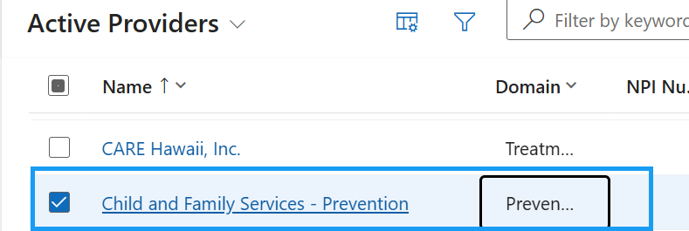
- Navigate to the Provider Contracts tab
  - 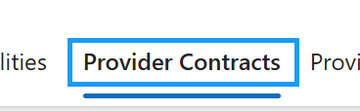
- The contract for the current fiscal year will appear in the “Active Provider Contract” lookup field.
  - 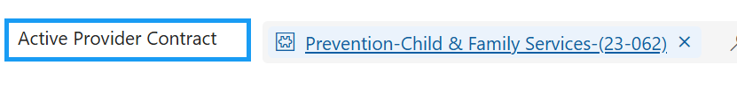
- All other contracts (or those that are no longer active or not part of the current fiscal period) will be listed in the “Provider Contracts” sub-grid.
  - 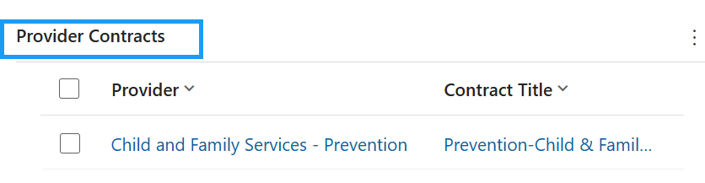
- Open the Active Provider Contract
  - 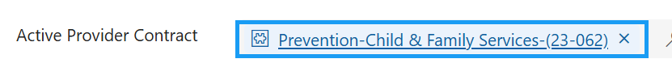
- Here, you will be able to view all of the provider contract details, including:
  - Contract Title
  - Branch/Office
  - Contract Number
  - Domain
  - Contract Type
  - Invoice Type
  - Monthly Capitated Amount Eligibility (capitated rate contracts)
  - Start Date & End Date
  - State Accountant
  - Contract Manager
  - NTE Amount
  - All other amount details defined below (authorized amount, amount available to be authorized, pre-encumbered amount, encumbered amount, expended amount, amount available to spend)
  - 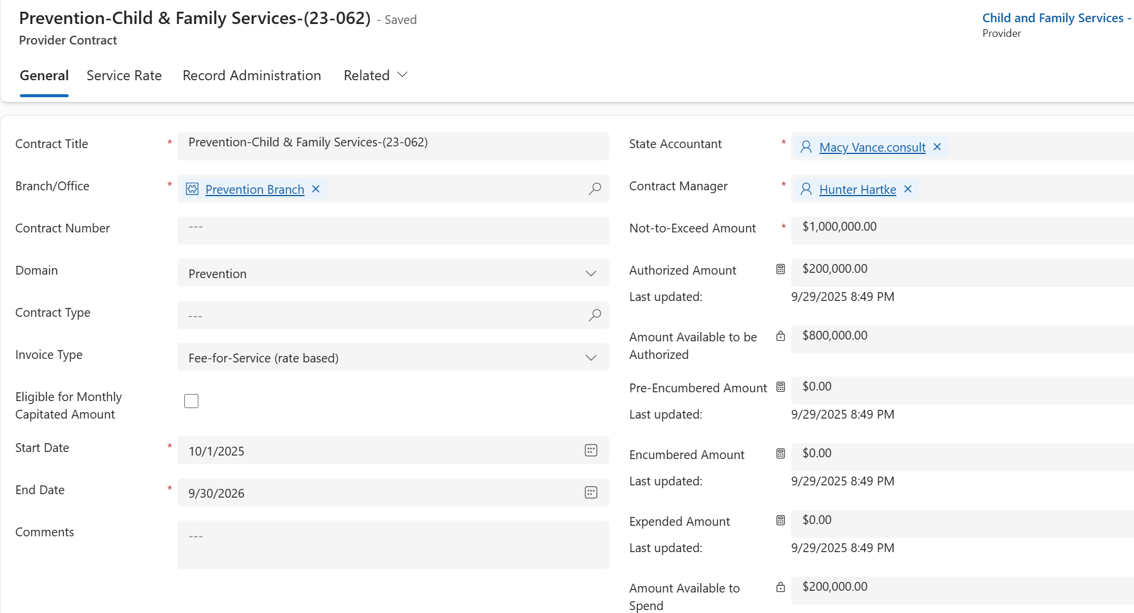

Create an Invoice
- In the site map, navigate to Provider Invoices
  - 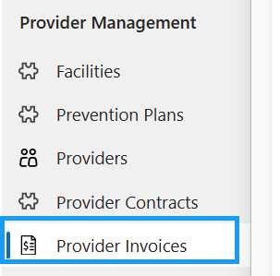
- Press +New in the top ribbon
  - 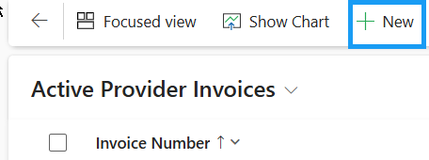
- Notice that the Provider that your user is associated with populates in the top right corner
  - 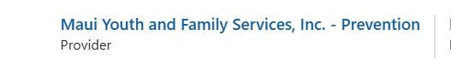
- Fill in the required fields and save the record.
  - Provider Contract
    - Based on the type of Provider Contract selected, the Invoice Type is populated
  - Start Date
  - End Date
  - Invoice Date
  - DO NOT FILL IN THE INVOICE AMOUNT YET
  - 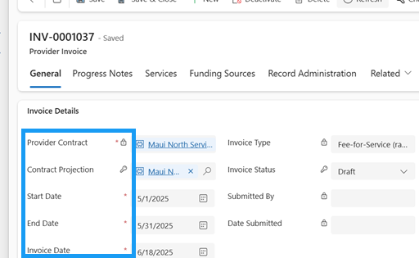
- Save the record
  - 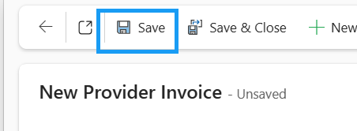
- Once the record is saved, you will be able to view all of the Contract Details, including:,
  - Authorized Amount, Pre-Encumbered Amount, Encumbered Amount, Expended Amount, and Available Amount to Expend
  - 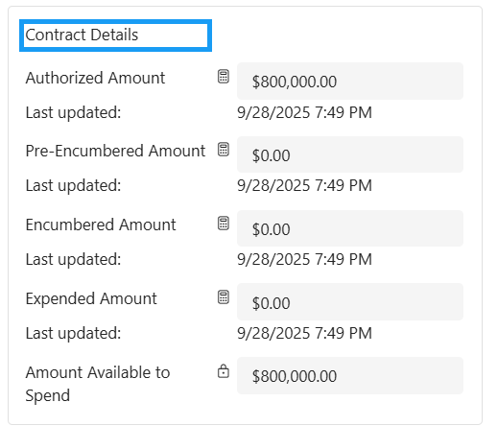
- Here are the definitions for all of the Contract Details:
  - Authorized Amount
    - The total funding allocated to a contract from the Purchase Order Funding Allocations (represented by the Contract Funding Sources)
    - The initial budgeted amount that has been formally approved and made available for use under a specific contract.
  - Pre-Encumbered Amount
    - The total money from validated progress notes that are not yet tied to a submitted or paid invoice
    - These validated progress notes may be on a Provider Invoice that may still be in draft status
    - The funds that are pre-encumbered are reserved and cannot be used anywhere else
    - It represents anticipated spending that hasn’t formally entered the billing cycle
  - Encumbered Amount
    - The total money being invoiced for on submitted invoices
    - This does not include drafts, revisions required, or paid invoices
    - Encumbered means committed but not yet paid—the funds are reserved and cannot be used elsewhere.
  - Expended Amount
    - The total money from paid provider invoices.
    - The final stage where funds have been fully processed
  - Amount Available to Spend
    - The remaining uncommitted and unreserved money from the total authorized amount.
    - The Authorized Amount that:
      - Has not yet been paid (Expended),
      - Is not currently committed to submitted invoices (Encumbered)
      - Is not reserved for validated progress notes (Pre-Encumbered)
    - It is the true available balance that can still be allocated or spent under the contract.
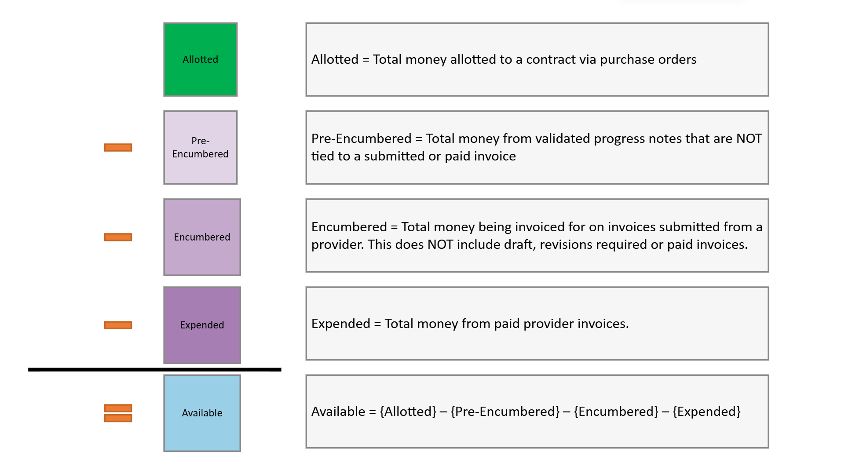

Automatic Invoice Service Creation
- Upon saving the record, Invoice Services are automatically created
- Navigate to the Services tab
  - 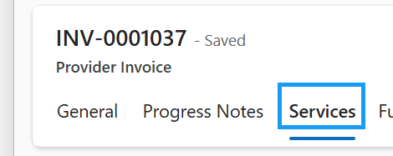
- The Services are automatically pulled from the Service Rates on the related Provider Contract
  - They are then created as Invoice Services
  - 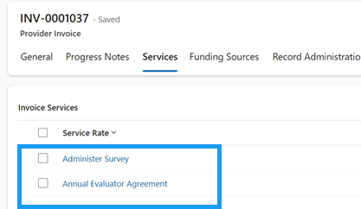

Automatic Invoice Funding Source Creation
- Upon saving the record, Invoice funding Sources are also automatically created
- Navigate to the Funding Sources tab
  - 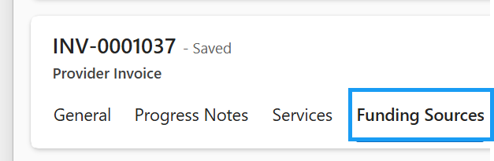
- Contract Funding Sources are also pulled from related the Provider Contract
  - They are then created as Invoice Funding Sources
  - 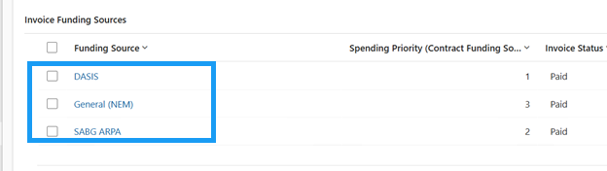
- Each Invoice Funding Source has a Spending Priority tracked. This will determine how invoice funding is allocated. (This will be covered later in the lesson)
  - 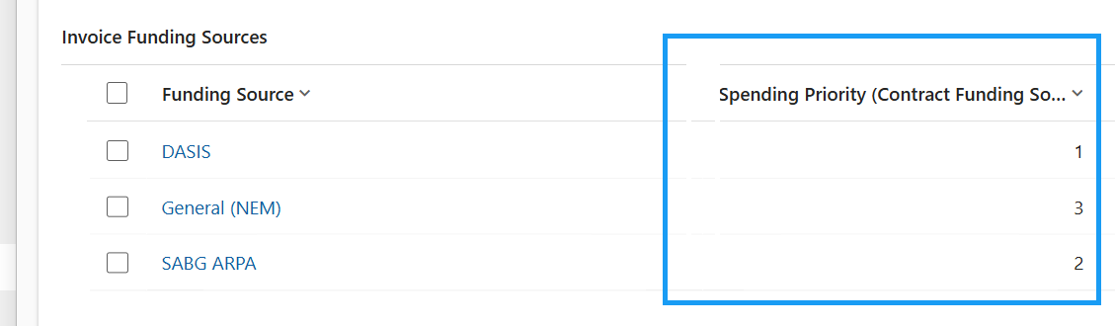

Find Billable Progress Notes
Formally known as the Batch & Bill process
- In the top ribbon, press the Flow button
  - 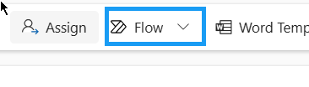
- Run the Find Billable Progress Notes flow
  - 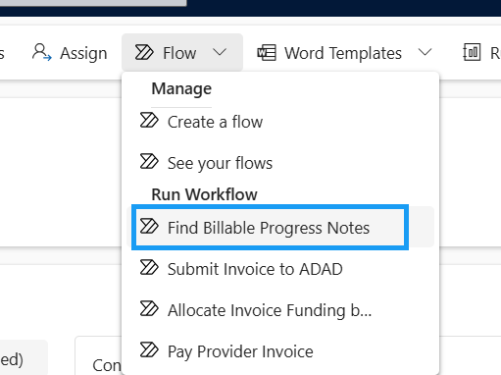
- Press OK
  - 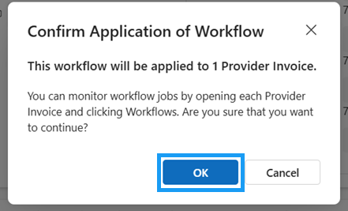
- On the general tab, you will notice that the most recently reviewed Contract Projection associated with the Provider Contract is populated
  - 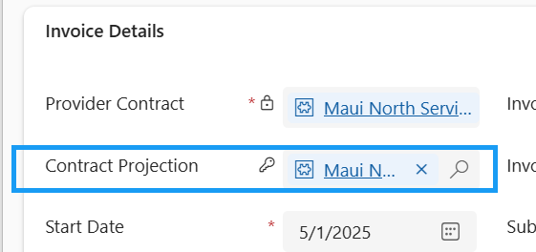
- Navigate to the Progress Notes tab
  - 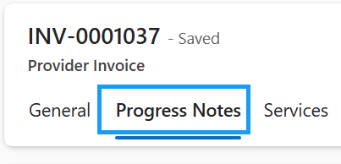
- All billable Progress Notes associated to the Provider Contract that have been validated will appear in the sub-grid
  - Only Progress Notes with an end date on or before the Provider Invoice’s end date will be included in the batch. 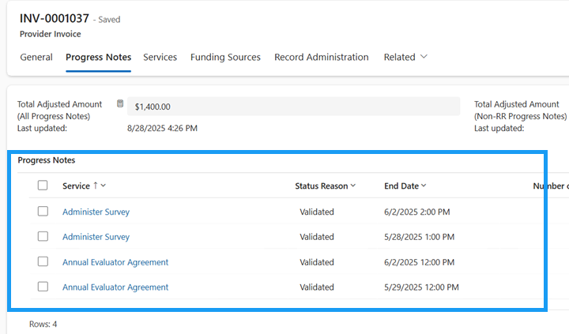
- Navigate to the Services tab
- The Total Adjustment Amount and Total Adjusted Units per Service are also populated from the billable progress notes that were pulled in above
  - 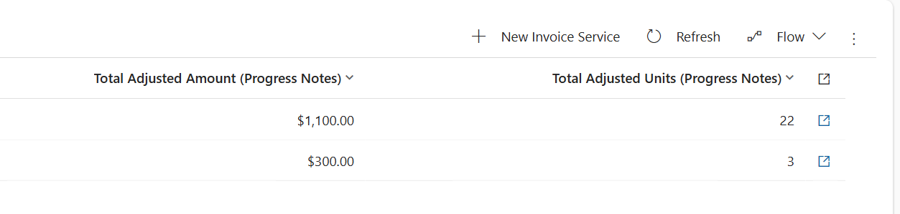

Allocate Invoice Funding by Priority
- Navigate to the Progress Notes tab
  - 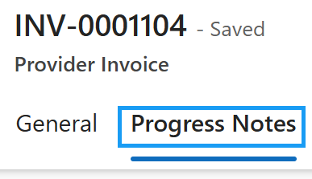
- Take note of the Total Invoice Amount (Invoice Funding Sources)
  - 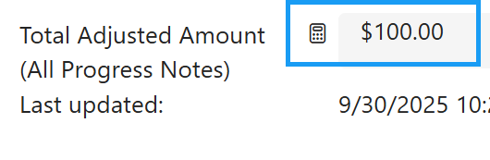
- Navigate back to the General tab
  - 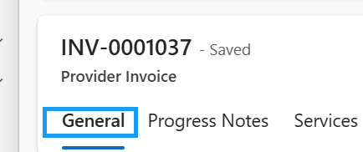
- Manually enter the Invoice amount from Funding Sources tab
  - 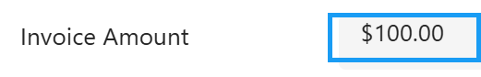
- Save the record
  - 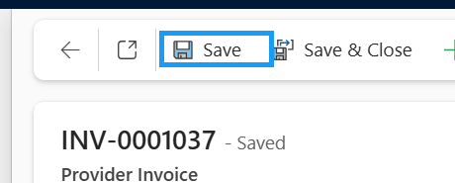
- In the top ribbon, press the Flow button
- Run the Allocate Invoice Funding by Priority flow
  - 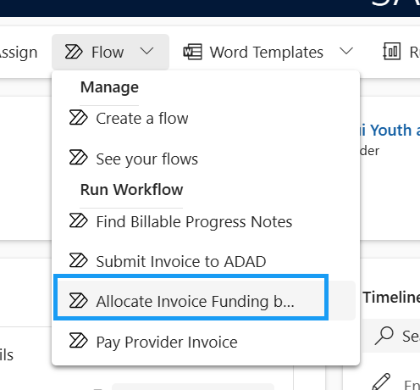
- Press Ok.
  - 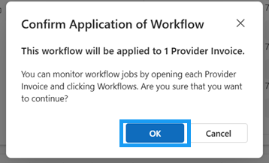
- Navigate to the Funding Sources tab
  - 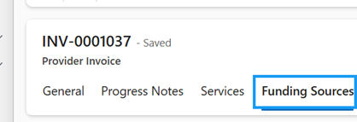
- Review the Invoice Amount across all funding sources
  - The total invoice amount was allocated among the available funding sources based on spending priorities. 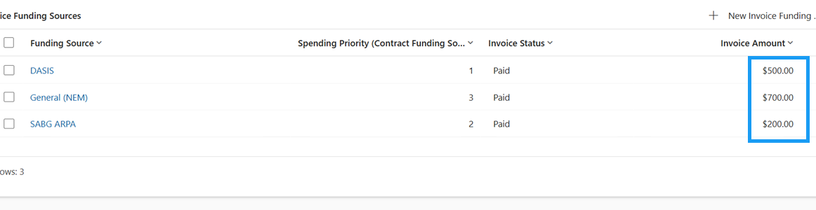
- Open the Invoice Funding Source with the Spending Priority of 1
  - 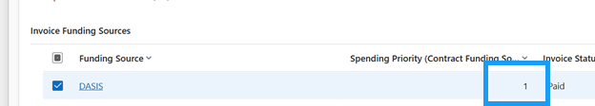
- Review the Amount Available to Encumber
  - A portion of the invoice was committed to the first priority
    - 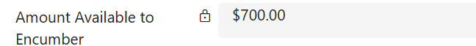
- Open the Invoice Funding Source with the Spending Priority of 2
  - 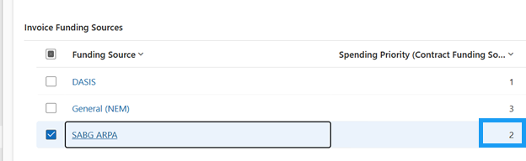
- Review the Amount Available to Encumber
  - Another portion of the invoice was committed to the second priority
  - 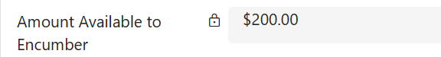
- Open the Invoice Funding Source with the Spending Priority of 3
  - 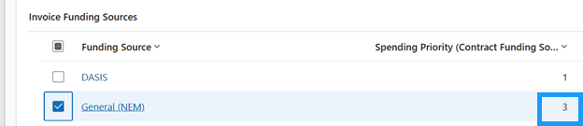
- You will notice that there is still a balance for the Amount Available to Encumber
  - Because only a portion of the invoice remained unpaid, the remaining balance of the invoice was covered in the third priority.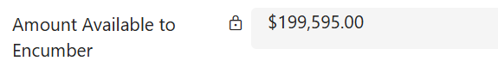

Submit Invoice to ADAD
- Navigate to the Funding Sources tab
  - 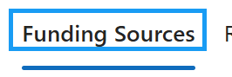
- Take note of the Total Invoice Amount (Invoice Funding Sources)
  - 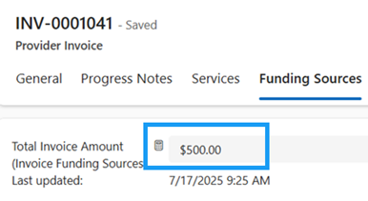
- Navigate back to the general tab and fill in the invoice amount you noted above.
  - 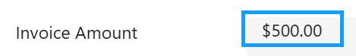
- Save the record
  - 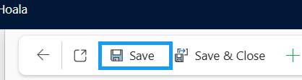
- To submit the invoice to ADAD for review, you need to attest all billing information provided is correct and accurate. Check “I acknowledge and agree to the above attestation” on the general tab of the Provider Invoice record.
  - 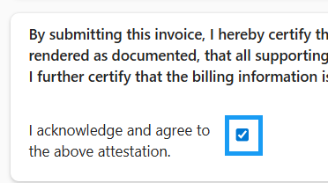
- Save the record. Attesting User and Attestation Date will be auto-populated
  - 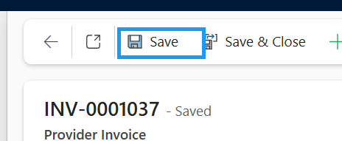
  - 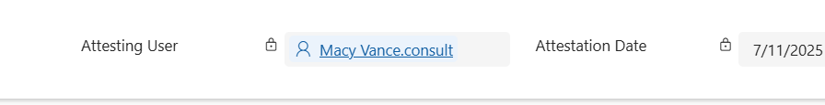
- Press Flow in the top ribbon
- Run the Submit Invoice to ADAD flow
  - 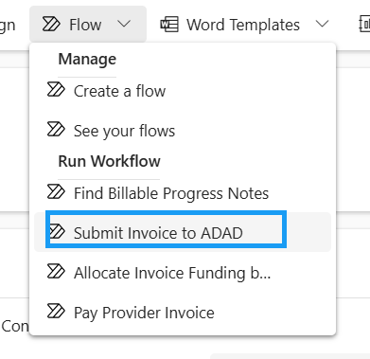
- Press OK.
  - 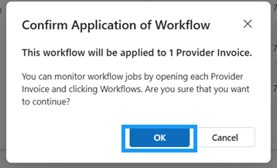
- The Invoice Status will update to “Program Review”
  - 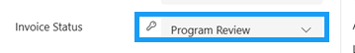
- You will also get a pop-up notification letting you know that the Invoice has been successfully submitted to ADAD Program Staff for review.
  - 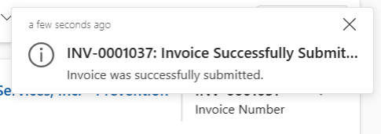
It is now in the hands of the ADAD Fiscal team to review. They can move the status to either Fiscal Review or send it back for revisions.

Upload Documents to a Provider Invoice Record
External documents can be uploaded and associated with the Provider Invoice record. They will then be linked to SharePoint and stored in the corresponding SharePoint folder. Upon creating a Provider Invoice record, a SharePoint document location is automatically created within the INSPIRE+ System.
NOTE: Documents can be uploaded to Case, Group, or Provider Invoice Records
- Navigate to the related tab and open documents
  - 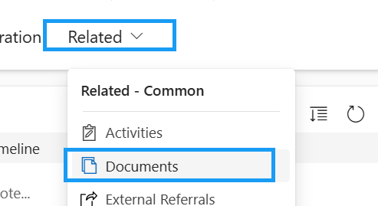
- Open the folder you would like to upload the document to
  - 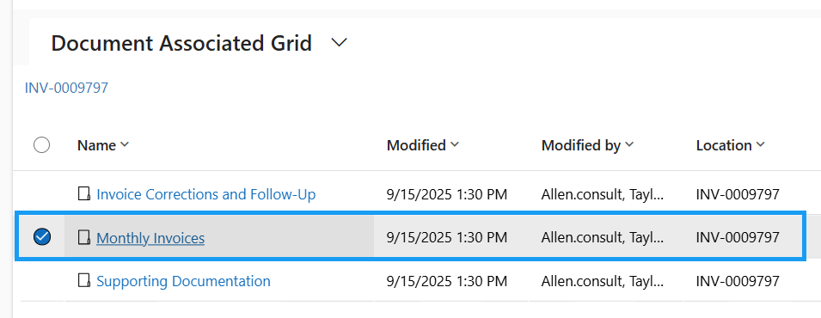
- Once you’re in the appropriate folder, press “Upload”
  - 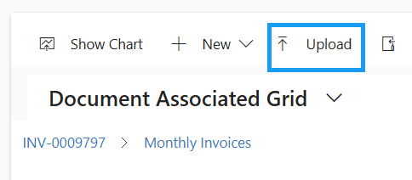
- Press Choose File to upload a file from your local computer or one drive
  - 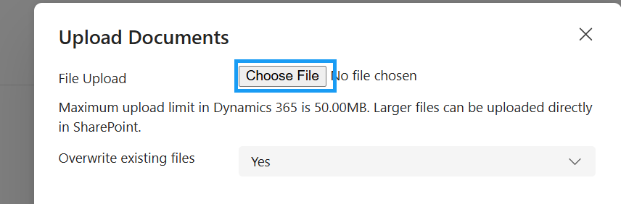
- Choose the document from your computer and press “Open”
  - 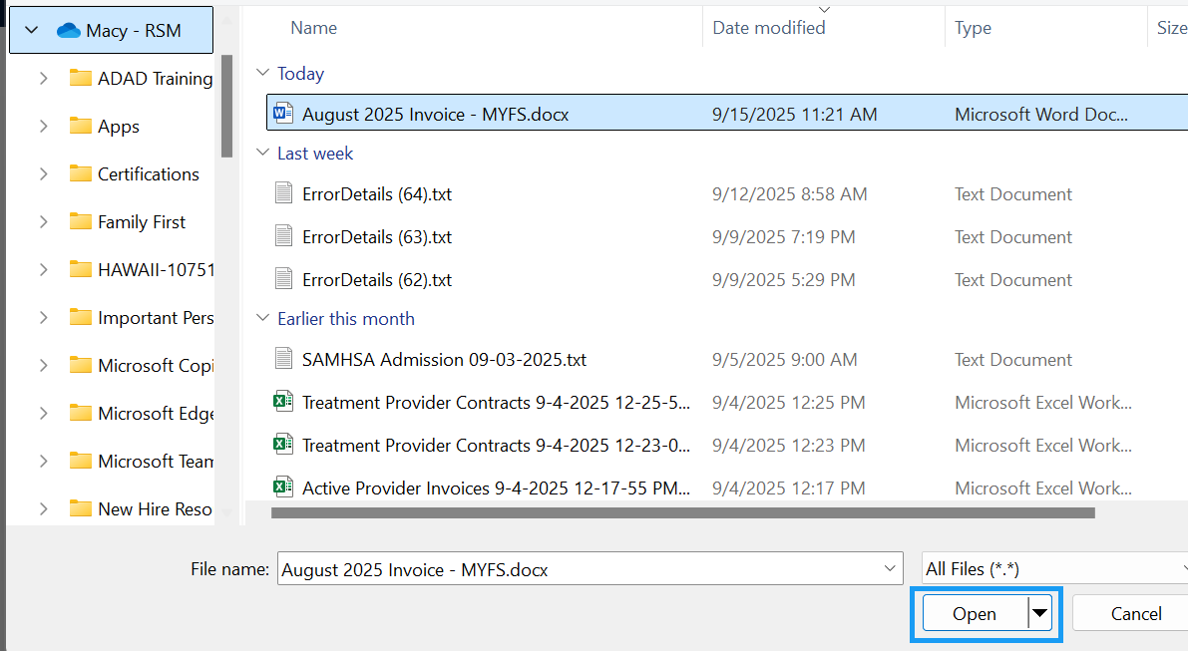
- Once the file has been uploaded, press OK
  - 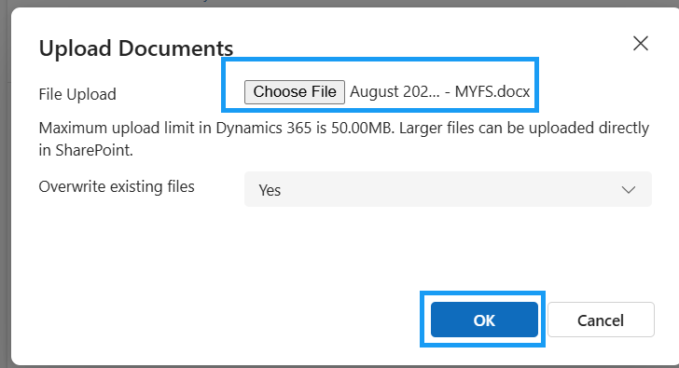
- The file has now been uploaded to the designated SharePoint site, location, and Group folder. SharePoint is seamlessly integrated with the INSPIRE+ System.
  - 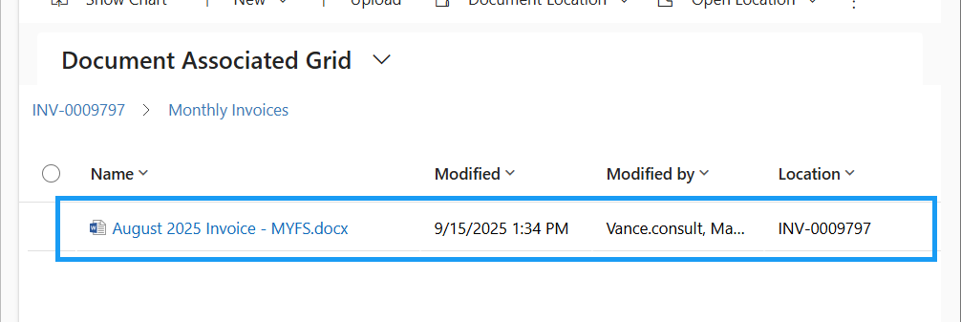

Billing Errors/Revisions
Submit Invoice to ADAD, Funds Exceeded Error, Invoice Returned for Revisions, Re-Batch and Bill (Prevention Providers) Re-Submit Invoice to ADAD (then ADAD Pay)
SECURITY: Provider – Finance
APP: Pulama
When submitting the Invoice to ADAD, the system may stop you if there are not enough funds in the funding sources.

Funds Exceeded
- If there are not enough funds in one of your Invoice Funding Sources, you will receive this error: “Funds Exceeded: There is not enough money in one of your funding sources in order to submit this invoice.”
  - 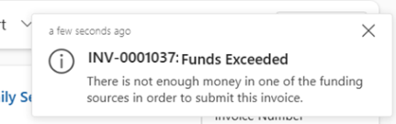
- To address the issue, navigate to the Funding Sources tab
- Open each of the Invoice Funding Sources to see which Invoice Amount exceeds the Amount Available to Encumber
  - 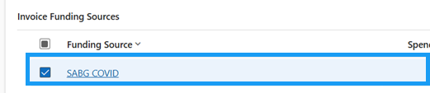
- We are getting this error because the Amount Available to Encumber for the Invoice Funding Source is less than the amount we are trying to invoice for.
  - Because the Invoice Amount cannot exceed the Amount Available to Encumber, we are not able to submit the invoice to ADAD yet
  - 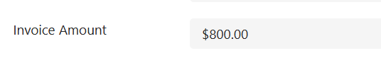
- Adjust the invoice amount to be lower than the Amount Available to Encumber
  - 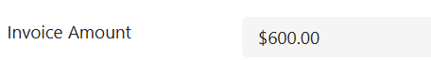
- Save and Close the record to navigate back to the Provider Invoice
  - 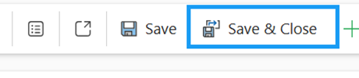

Note: ADAD Fiscal staff may adjust funds for each Contract Funding Source as needed. Providers will only be able to re-submit an invoice to ADAD if they reduce the invoice amount for any funding sources that exceed the available encumbered limit.
Resubmit Invoice to ADAD
- To resubmit the invoice to ADAD, press Flow in the top ribbon
  - 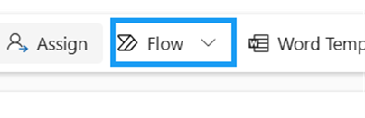
- Run the Submit Invoice to ADAD flow
- Press OK.
  - 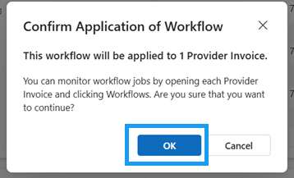
- The Invoice Status successfully updated to “Program Review”
- You will also get a pop-up notification letting you know that the Invoice has been successfully submitted to ADAD for review.

It is now in the hands of the ADAD Program Staff to review. They can move the status to either Fiscal Review or send it back for revisions.

Invoice Returned for Revisions
If ADAD Program Staff sends the Provider Invoice back for Revisions, it will be returned in the state of Revisions required.
- Navigate back to the General tab of the Provider Invoice
  - 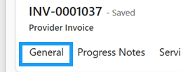
- Notice that the Invoice Status is now in Revisions Required along with a Justification
  - 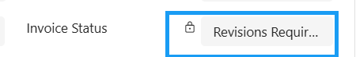
  - 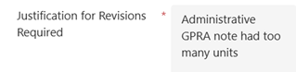
- Once the status of an invoice is flipped to Revisions Required, the system will send an email to the Provider who submitted the invoice to ADAD
  - This can be found in the timeline or in your Outlook Inbox
  - 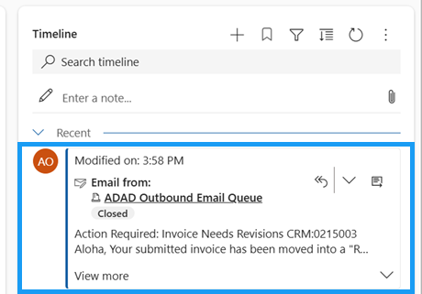
- To view the entire email within Dynamics, press the “Open Record” icon
  - 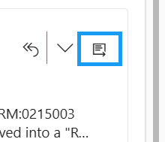
- Here, you will see all of the email details including:
  - Who the email is from, who it was sent to, anyone CC’d, the Subject, the Invoice Number, the Submission Date, the Revision for Submission, and next steps.
  - The regarding field also is a hyperlink directly to the Provider Invoice. This can also be opened directly within Outlook. That link will guide you to INSPIRE+.
  - 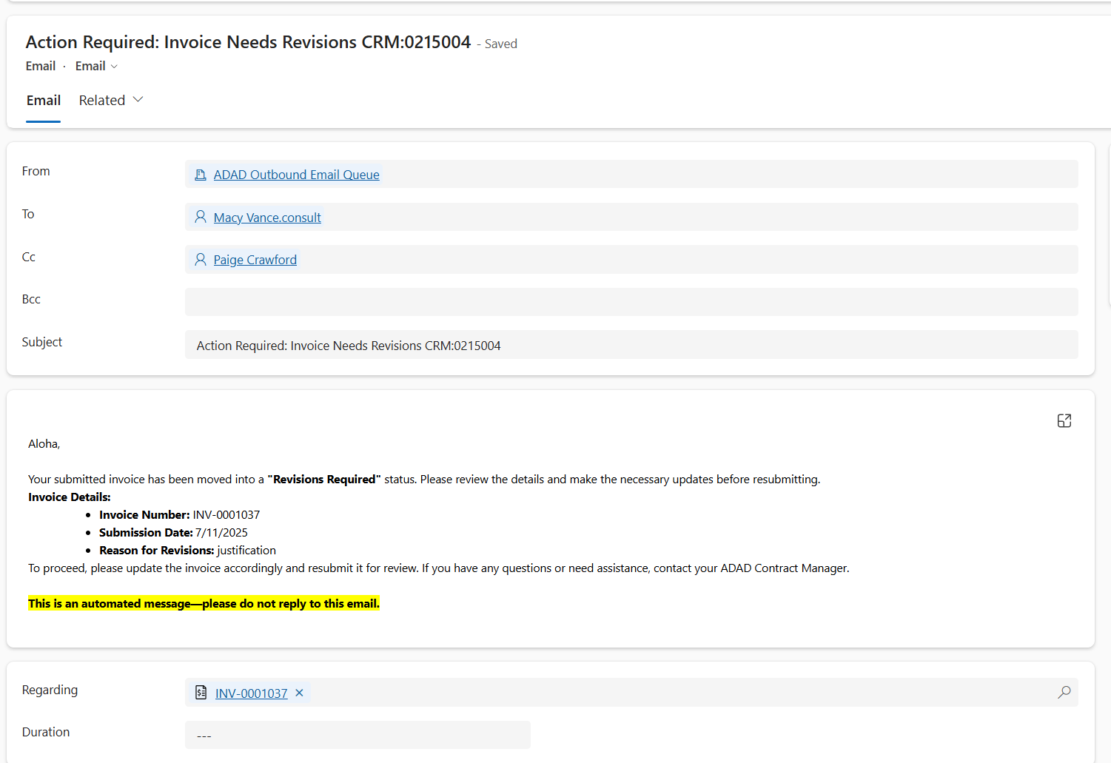
- Save & close the email to navigate back to the Provider Invoice
  - 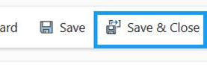

Individual Progress Notes can also be sent back to Revisions Required by ADAD
- Navigate to the Progress Notes tab
  - 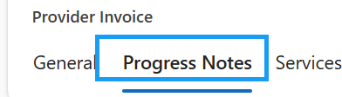
- The Progress Note marked with the status reason ‘Revisions Required’ is the one that needs to be updated.
  - 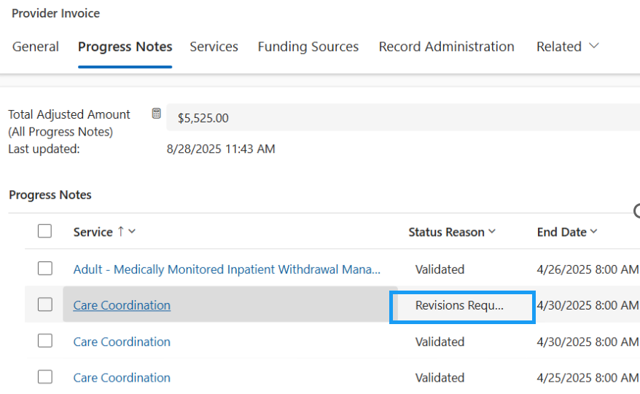

Re-Batch & Bill
IMPORTANT: The Prevention Provider Staff will need to un-validate the specific Progress Note that needs revisions. Once that Progress Note’s changes have been made, the batch and bill progress will need to be re-run.

Un-Validate Progress Notes – Prevention Provider Staff Only
(Prevention Providers Users ONLY)
- Open the Progress Note in the Revisions Required status
  - 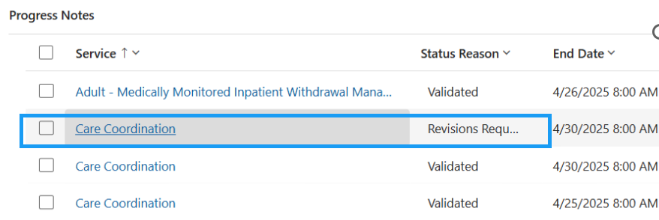
- In the top ribbon, press the Flow button
  - 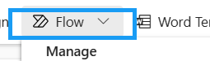
- Run the Un-validate Progress Note Flow
  - 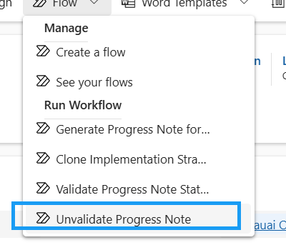
- Press OK
  - 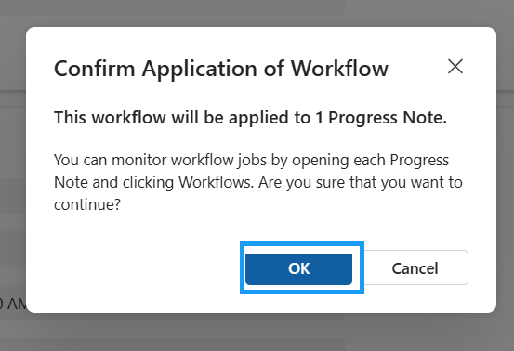
- The Status reason will be updated to Draft
  - 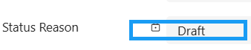

Re-Validate Progress Notes – Prevention Provider Staff Only
(Prevention Providers Users ONLY)
An invoice cannot be submitted to ADAD if there are any progress notes that are in "Draft" status. Before submitting the invoice to ADAD for payment, the Prevention Provider will need to re-validate the progress notes. A progress note will need to be "re-validated" if it was "un-validated" before the invoice can be submitted.
- Update the Adjusted Service Units Amount
  - 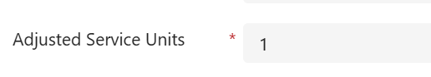
- Save the Progress Note record
  - 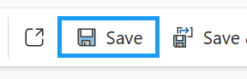
- In the top ribbon, press the Flow button
  - 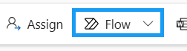
- Run the Validate Progress Notes flow
  - 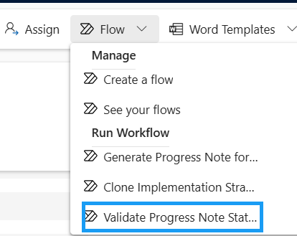
- Press OK
  - 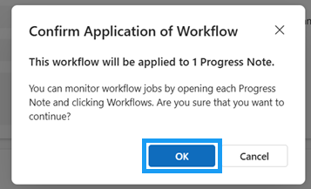
- If the Progress Note passes all 3 validation checks, the Status Reason will update to Validated and Authorized On and Authorized By will be populated
  - 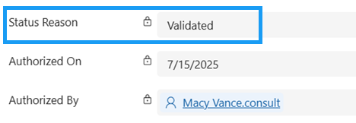

Once all the Progress Notes are re-validated, you will need to run the batch process again to add those Progress Notes back to the Provider Invoice.

Re-Batch and Bill – Billing Users
(Billing User)
- In the top ribbon, press the Flow button
  - 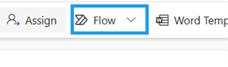
- Run the Find Billable Progress Notes flow
- Press OK
  - 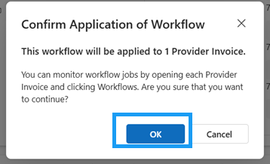
- Navigate to the Progress Notes tab
- All billable Progress Notes associated to the Provider Contract that have been re-validated will now appear in the sub-grid
  - 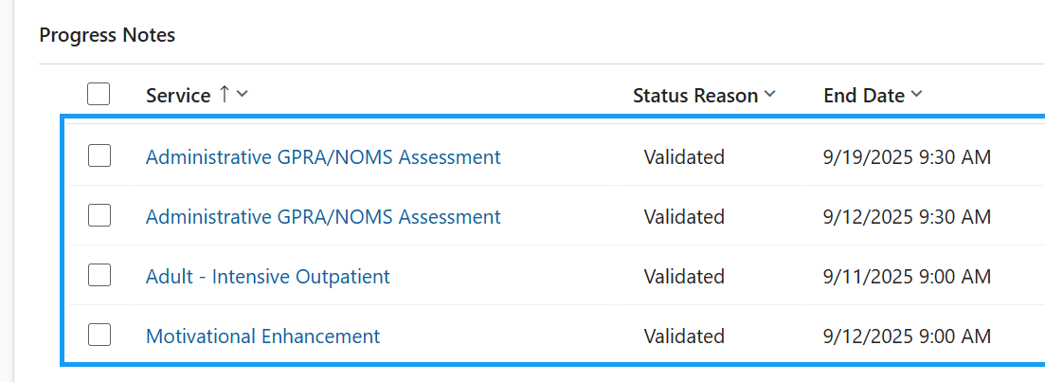
- The Total Adjusted Amount (All Progress Notes) field will be updated to accurately reflect the new progress note adjusted amounts

Re-Submit Invoice to ADAD
Once the necessary adjustments have been made and the batch and bill progress has been rerun, re-submit the invoice to ADAD Program Staff.
Once the adjustments are made, you can resubmit the Invoice back to ADAD.
- Press Flow in the top ribbon
- Run the Submit Invoice to ADAD flow
- Press OK.
  - 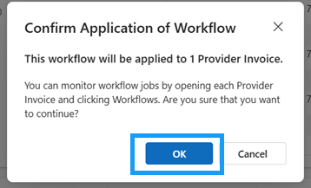
- The Invoice Status successfully updated to “Program Review”
  - 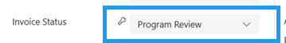
- You will get a pop-up notification letting you know that the Invoice has been successfully submitted to ADAD for review.
It is now once again in the hands of the ADAD Program Staff to do their final review. Once it is reviewed, the ADAD Program staff will flip the status of the Provider Invoice to “Fiscal Review”

Contract Projections (Fee-for-Service)
Contract Periods, Contract Projection, Monthly Contract Projections, Automatic Planned Service Creation, Submit Projection to ADAD
SECURITY: Provider – Prevention Supervisor ONLY
APP: Pulama

Contract Projection
Only Prevention Supervisors will have the ability to create contract projections.
- In the site map, navigate to Provider Contracts
  - 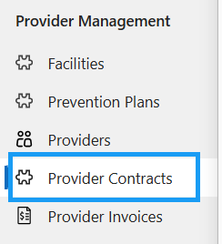
- Open an existing fee-for-service (rate-based) Provider Contract
  - 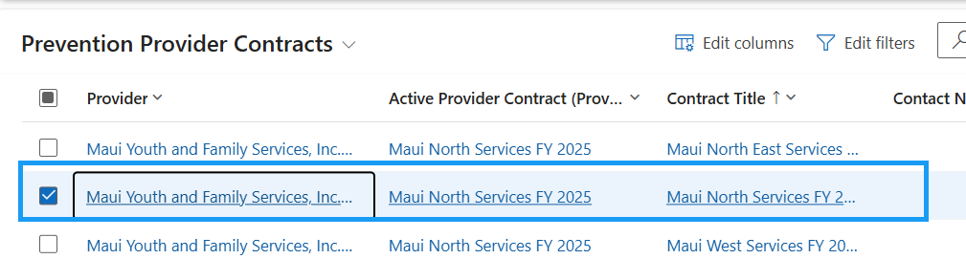
- Open an existing Contract Period created by ADAD Fiscal Staff
  - 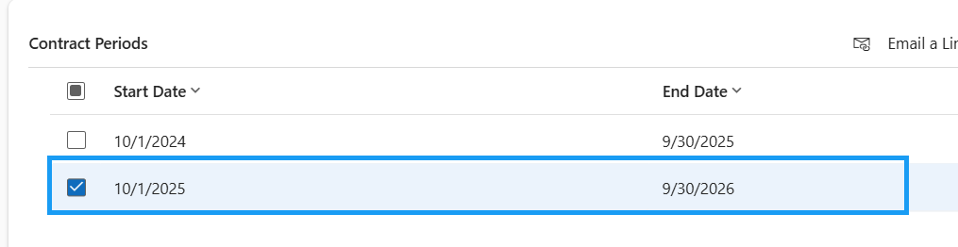
- To create a new contract projection, press + New Contract Projection on the Contract Period record
  - 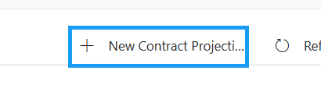
- Fill in the required fields
  - Prepared By and Prepared On are the required fields
  - The Invoice Type should be Fee-for-Service (rate based)
  - 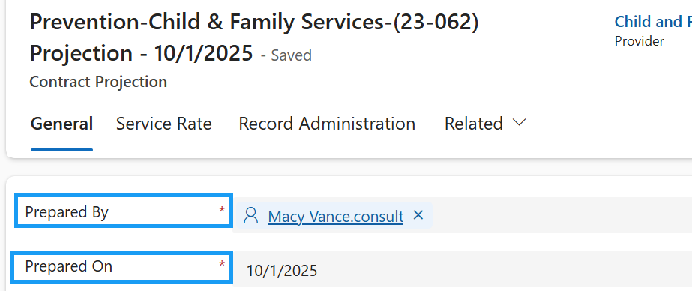
- Save the record
  - 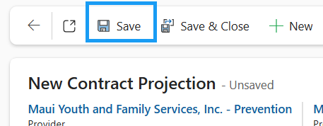

Monthly Contract Projections
- Upon saving the Contract Projection, the Contract Projection Month sub-grid appear
  - 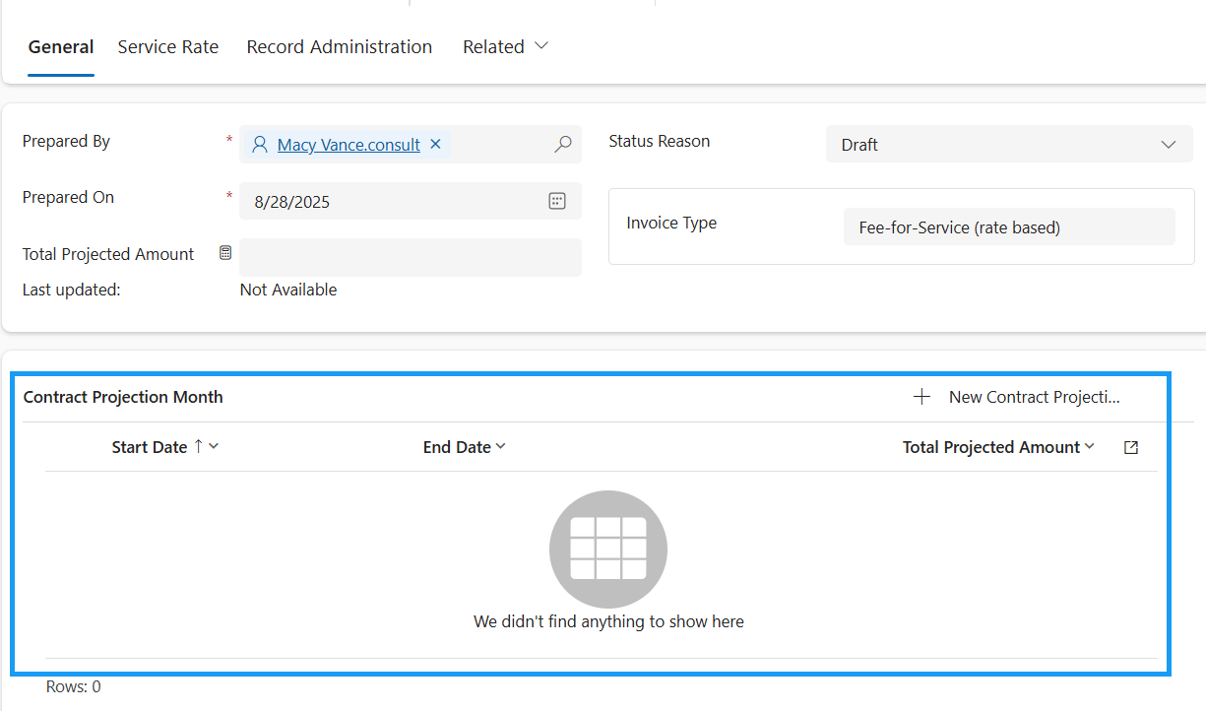
- To create a new monthly contract projection, press + New Contract Projection Month
  - 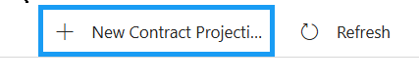
- Fill in the Start and End Date
  - 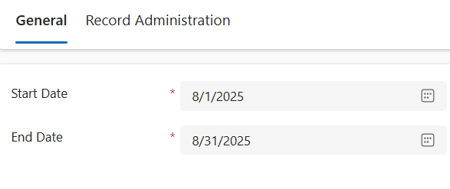
- Save the Record
  - 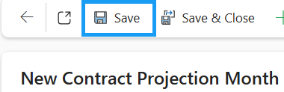

Automatic Planned Service Creation
- Upon saving the Contract Projection Month record, Planned Service records are automatically created
  - 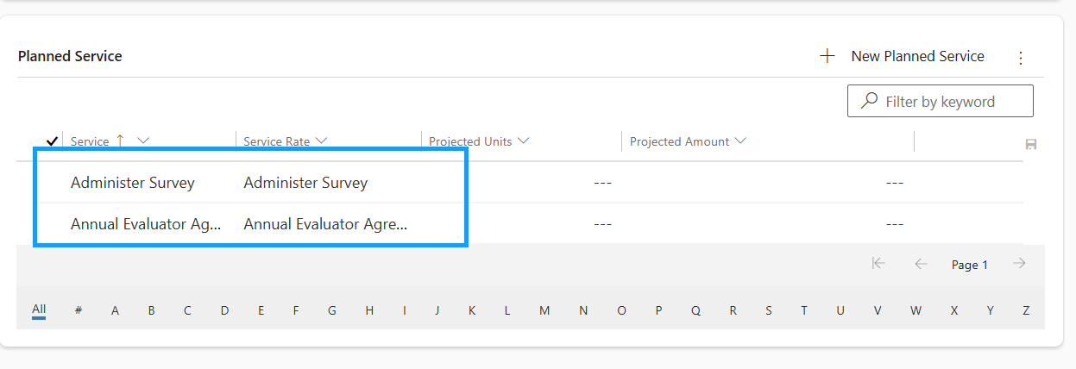
- The Planned Service Records are based on the Services associated to the Provider Contract
  - Navigate back to the Provider Contract and switch to the Service Rate tab to view this
  - 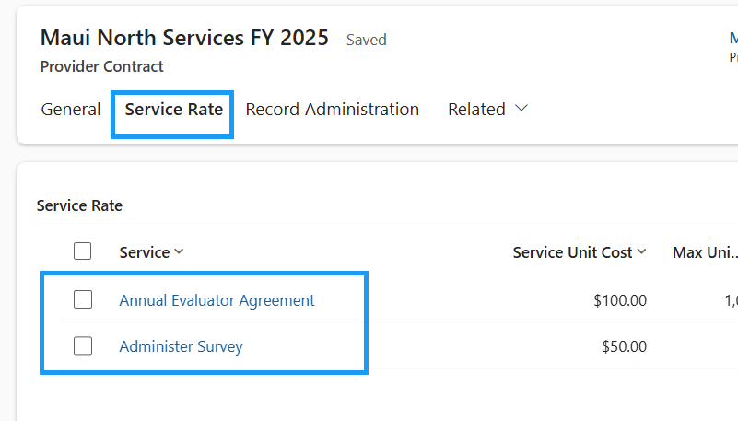
- Press the back arrow to navigate back to the Contract Projection Month
  - 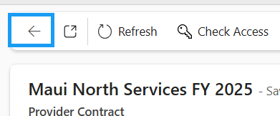
- Within the Planned Service sub-grid, you can also enter Projected Units per service
  - The Projected Amount is automatically calculated by the Service Rate x Projected Units
  - 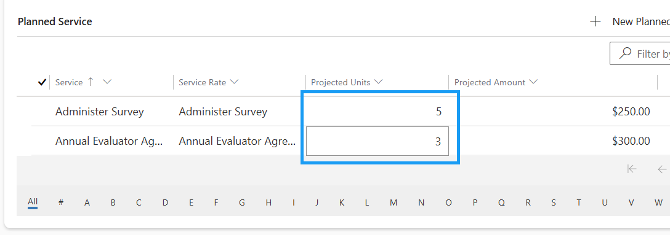
- The Projected Amount on the Contract Projection Month is automatically calculated based on the sum of all Planned Service Projected Amounts
  - Total Projected Amount
  - 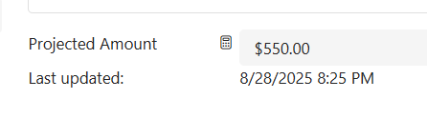
  - Projected Amount per Planned Service
  - 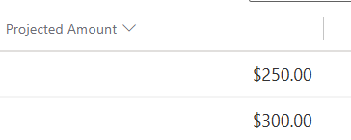
- Save & Close the Contract Projection Month
  - 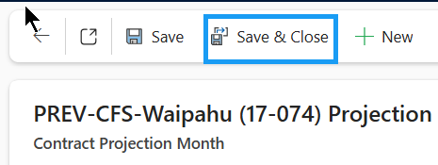
  - The Total Projected Amount on the Contract Projection is calculated based on the sum of all Total Projected Amounts from the Contract Projected Months. 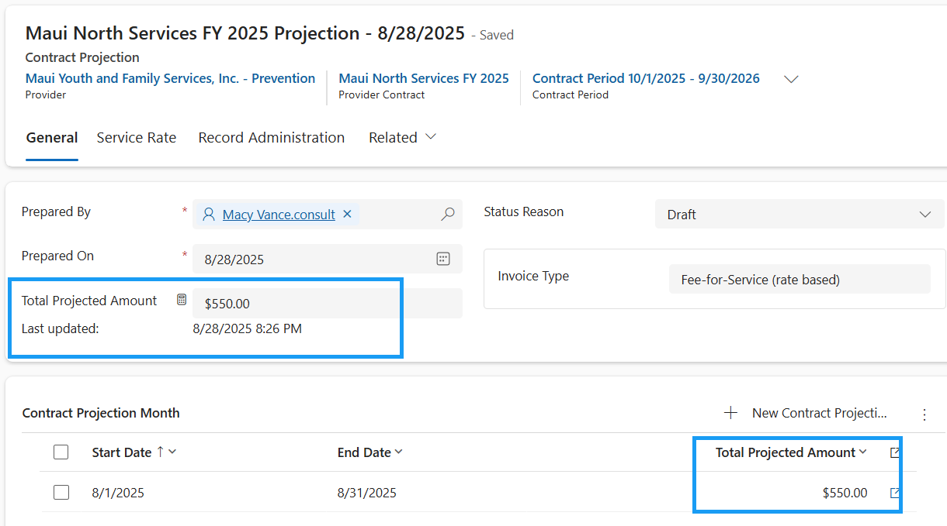

Submit Projection to ADAD
- On the Contract Projection record, update the status reason to Ready for Review
  - 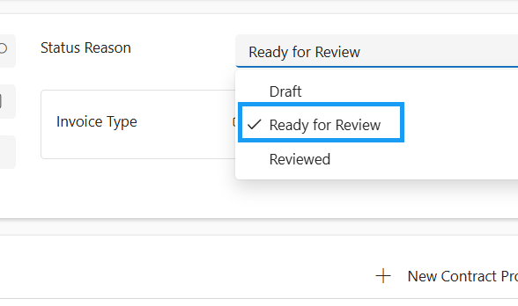
- Save the record
  - 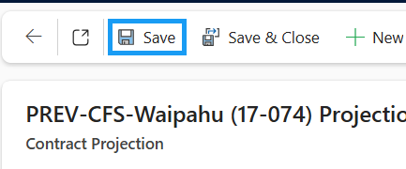
- The Monthly Service Projection is now submitted to ADAD for Review
- Once it is reviewed by the ADAD Fiscal Staff, the status reason will be updated to Reviewed
  - 