Provider Portal – Individual Assessors
Individual Assessors
As an Independent Assessor
- Navigate to the Provider Portal using this URL: Provider Portal URL: https://adaduatproviderportal.powerappsportals.us/

Contact Us Form Provider Portal - ADAD Help Desk
Whether you are logged in or not, you will have the ability to contact ADAD through a Contact Us form.
- In the top right corner, click “Contact Us”
  - 
- Fill in the following fields:
  - First Name, Last Name, Email, Phone Number, Topic and Message
  - 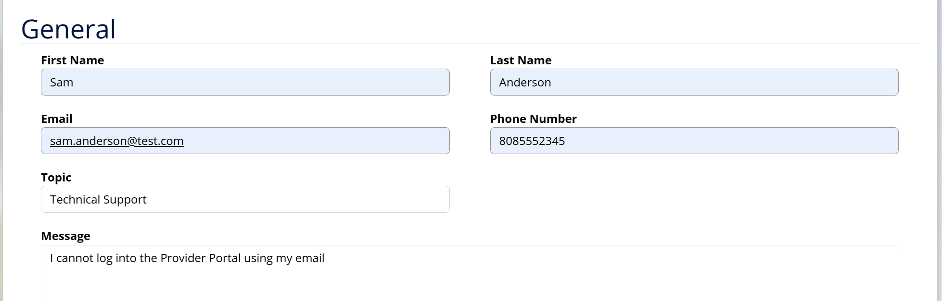
- Enter the CAPTCHA combination
  - 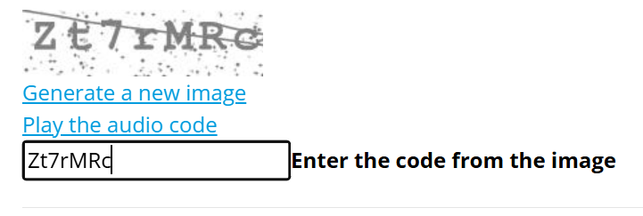
- Press Submit your message to the ADAD Help Desk
  - 

Login/Register
- Navigate back to the Home page
  - 
- Click the Login/Register Button
  - 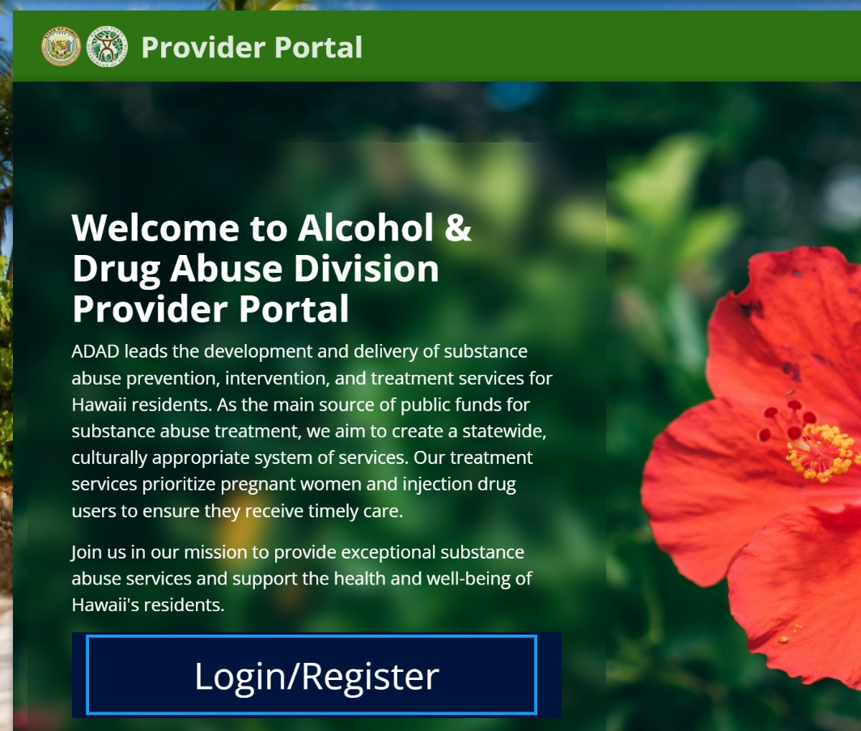
- Login through the Multi-Factor Authentication (MFA)
  - 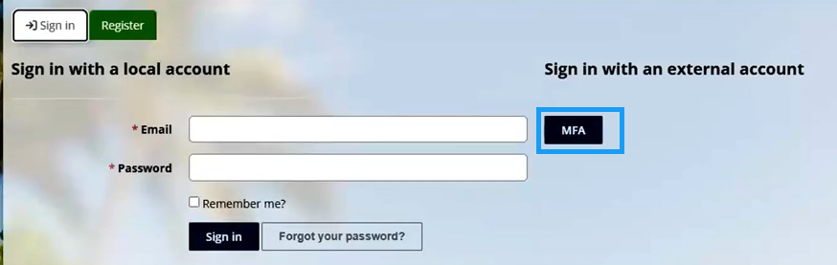
- If you do not have an account, press “Sign Up Now”
  - 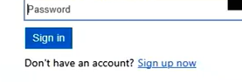
- Enter your email, password, first name, and last name
  - 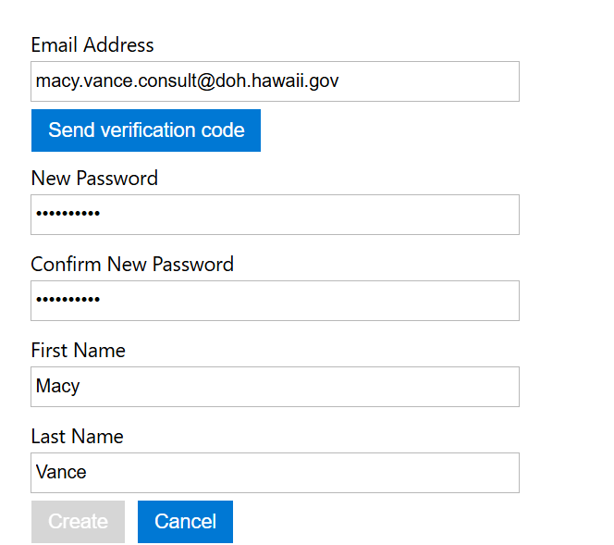
- Press Send Verification Code under the email address
- Enter the verification code from your email, press Verify Code and then create your account
  - 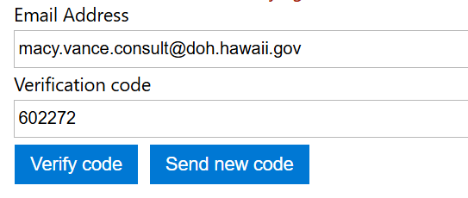
- Enter your email and password to Log into the Provider Portal (and verify via phone)
  - 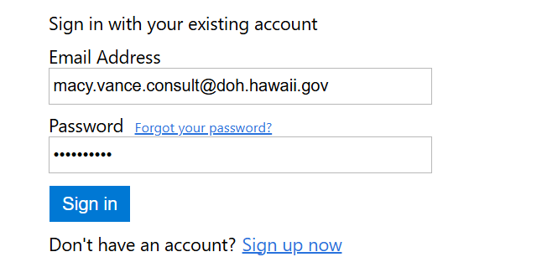
- Verify your login with a code sent to your phone and press Enter
  - 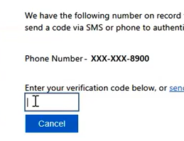
- Once you are successfully logged in, you will be taken to your profile
  - 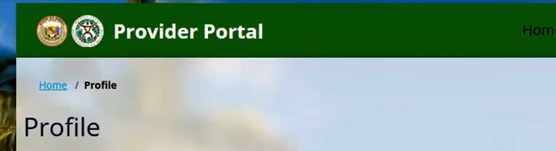

Request Access
When you are logged into the Portal, you will have to then request access to fill out any independent assessments, download the assessments, etc.
Once it is reviewed and approved, you will be able to fully access the Portal
- In the top ribbon, press Request Access
- Press New Request
  - 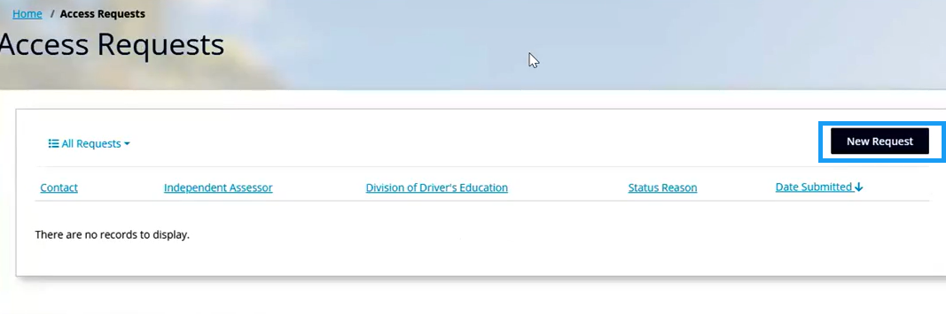
- You will be brought to this New Access Request Form where you can request two access levels – Independent Assessor or Division of Driver’s Education
  - 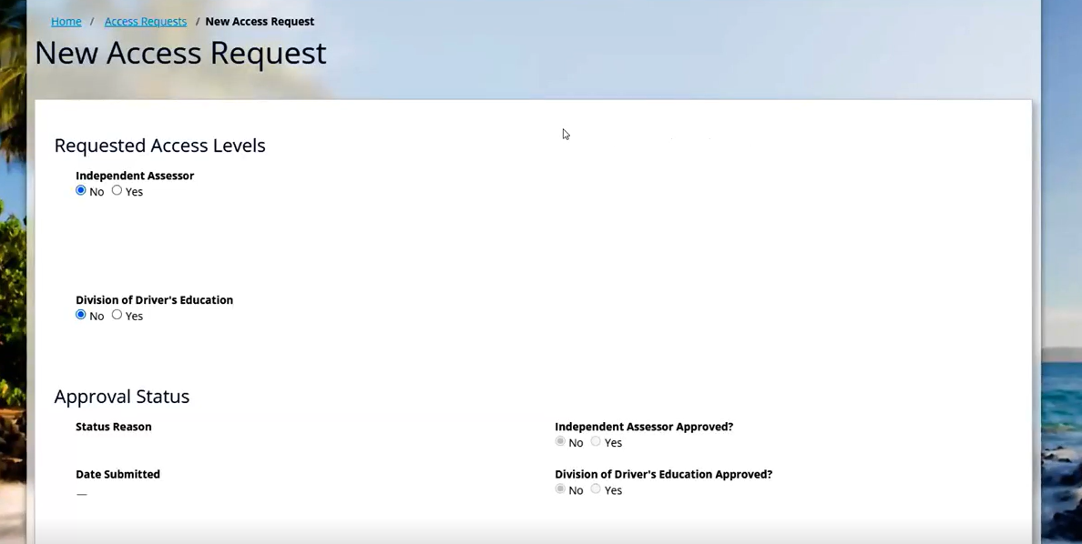
- You will then need to fill out Justification for each level of access you are requesting
  - 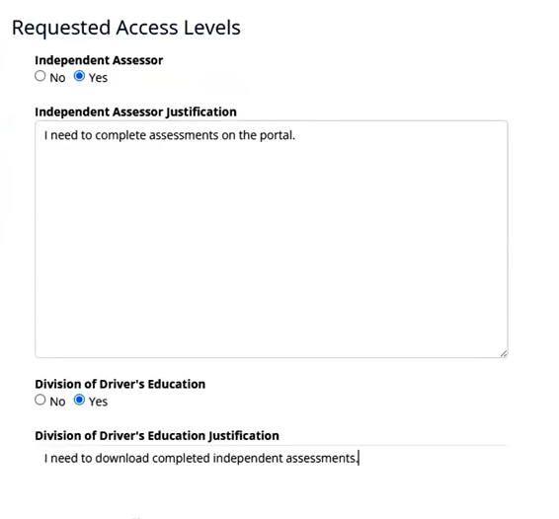
- The Approval Status section will be read-only. This will be updated by ADAD Help Desk
  - 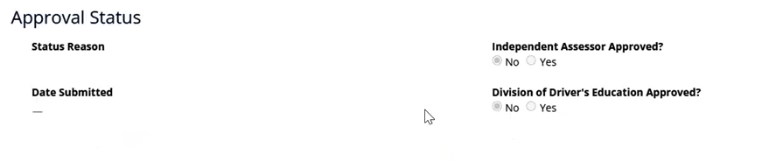
- Press Submit to submit your request to ADAD Help Desk
  - 
- Once you press submit, it will show you that the request is Processing
  - 
- Once that is processed, it will direct you back to the Access Requests page with the Status Reason of Submitted and the Submission Date
  - 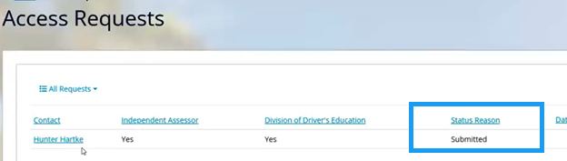

Independent Assessor Creates New Assessment
- Navigate back to the Provider Portal and refresh your browser
  - Once ADAD Approves the request, the status reason will be updated to Approved, Denied, or Partially Approved. If denied, ADAD will have to provide a denial reason. For this example, the Status Reason of the request has been updated to Approved
  - 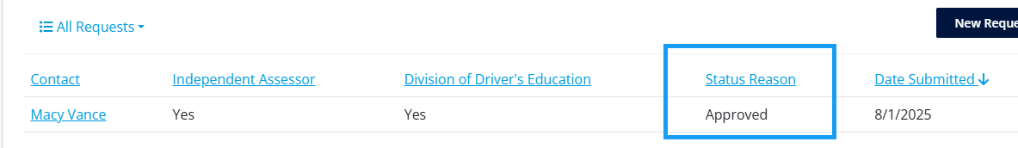
- A new tab appears called “Assessments”
  - Now, the Requestor can complete the Independent Assessment
  - 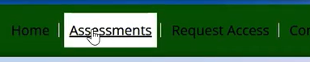
- Once navigated to the Assessments page, the Independent Assessor can create a new DENS-ASI Assessment
  - 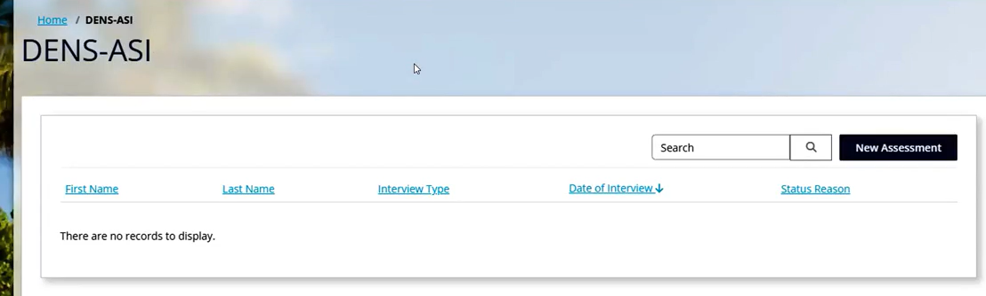
- Press New Assessment
  - 
- Navigate through the tabs to fill out fields of a DENS-ASI Assessment
  - 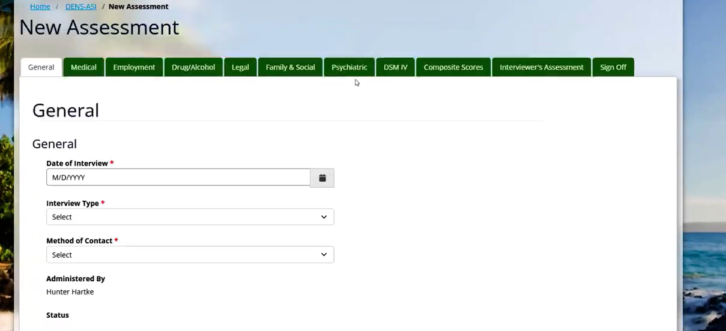
- Once filled out, navigate to the form to Save the record
  - 
- Once saved, the DENS-ASI has been successfully created
  - The Administered By and Status Reason will be updated
  - 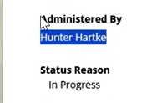
- The Status Reason will stay in Progress until the Assessor formally submits the DENS-ASI. Press Submit Assessment at the bottom of the form
  - 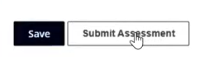
- You will get a popup that the Assessment has been submitted
  - 
- The Status Reason is updated to Completed
  - 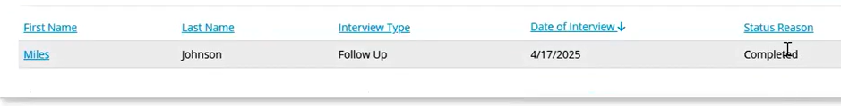

Driver’s Education Judiciary User Downloads DENS-ASI Assessment from the Portal
If the user is granted “Division of Driver’s Education,” they will be able to download Assessments from the Provider Portal. Driver’s education judiciary staff members need portal access so they can view private client assessments, download them, and bring them to court if necessary.
- In the top right corner of the Portal, click the “Assessments” button
- Open the Assessment created above
- Scroll to the bottom of the completed assessment and click “Export”
  - Note – This button will only appear if granted “Division of Driver’s Education”
  - 
- The DENS-ASI Assessment will export as a PDF in your browser. Press the download icon in the upper right hand corner of your browser
  - 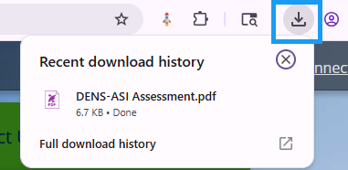
- Click the DENS-ASI Assessment for a PDF to open
  - 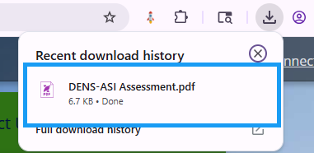
- The PDF includes the DSM IV results, the DENS-ASI Scores, and the Interviewer’s Assessment
