Hawaii CARES Receive Referrals
SECURITY: Hawaii CARES

Receive Referrals
- In the site map, navigate to Dashboards
  - 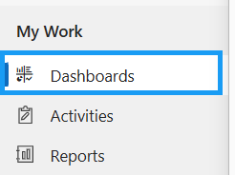
- You will be brought to the Hawaii CARES Dashboard
  - The top dashboard shows all of the actionable items in the Hawaii CARES network
  - 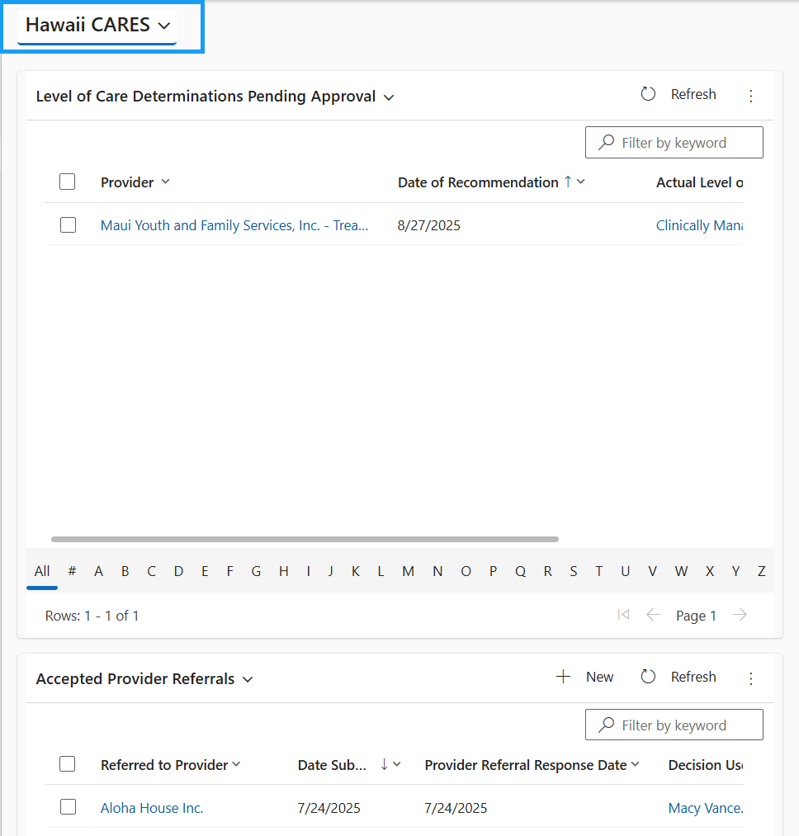
- Change the first sub-grid view to Level of Care Determinations Requesting Referral
  - 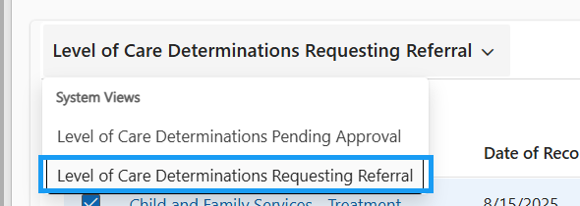
- All of the Level of Care Determinations that are in the Determination Status of “Referral Requested” will appear here
  - An LOC Determination is put in the “Referral Requested” status when a provider determines they cannot offer the appropriate level of care for a client based on the results of the ASAM Assessment. If the provider is unsure which agency to refer the client to, they rely on the Hawaii CARES team to identify and refer the client to the most appropriate provider.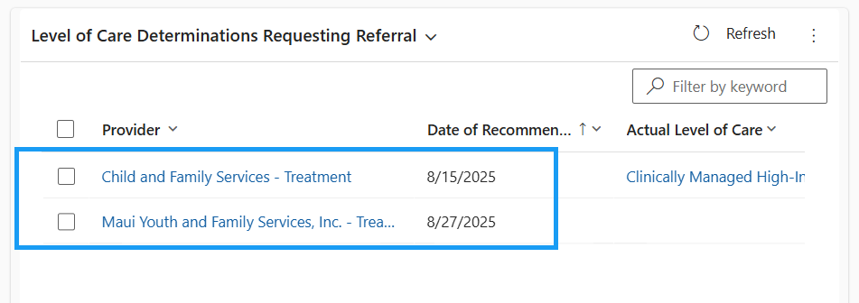
- Open the LOC Determination you would like to accept
  - 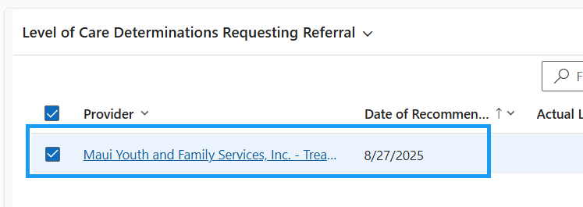
- Update the Determination Status to Referral Request Accepted if you would like to accept the referral request from a provider, indicating that you can help with finding a new provider for the Client.
  - When evaluating whether you can find the appropriate level of care, you’ll receive the following client information:
    - Level of Care Determination (i.e., ASAM)
    - Most recent DENS-ASI
    - Most recent Treatment Plan (if applicable)
  - 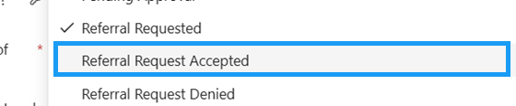
- Save the record
  - 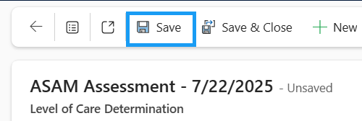
- Navigate back to the dashboard
  - 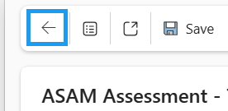
- Open the LOC Determination you need to deny
  - 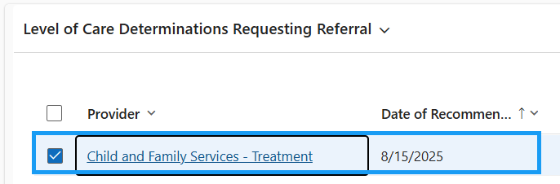
- Update the Determination Status to Referral Request Denied if you would like to deny the LOC determination referral request from a provider, indicating that the referring provider did not include the appropriate details in the referral
  - 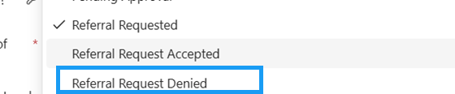
- You will need to provide a Denial Reason and a Denial Description
  - The options for Denial Reason are Missing Documentation or Other
  - Denial Description is a free text field
  - 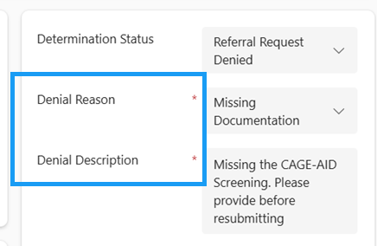

Send Client to Another Provider
After a accepting the referral from the original provider, Hawaii CARES will be able to refer this client to a different Provider in the Hawaii CARES network
- On the Level of Care Determination record, click the blue hyperlink to open the automatically created Consent record
  - 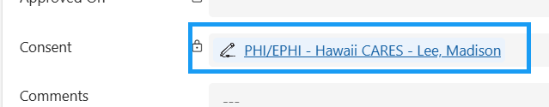
- The following fields are autopopulated.
  - Consent Type = PHI/EPHI – Hawaii CARES
  - Start Date = Date that the provider requested a referral from Hawaii CARES
  - Expiration Date = 6 months after the start date
  - Consent Grantor = Client
  - Consent Status = Draft
  - 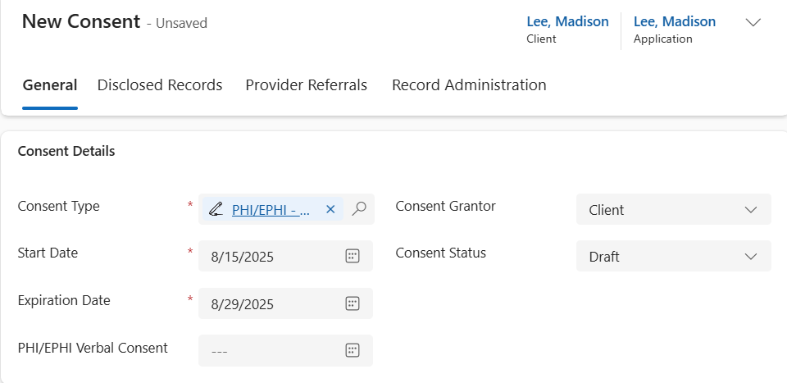
- The Consent Agreement will appear when the Consent Type is selected.
  - 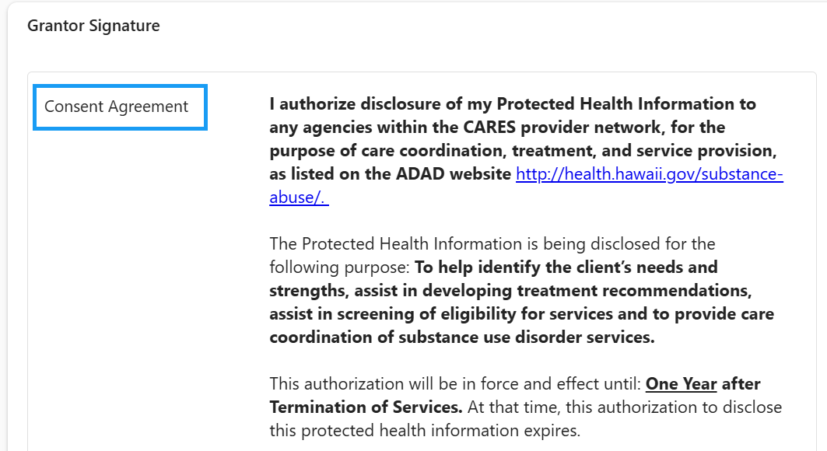
- Check any Hawaii CARES Protected Health Information
  - These will be checked based on what protected health information the Client agrees to disclose to agencies within the CARES provider network.
  - 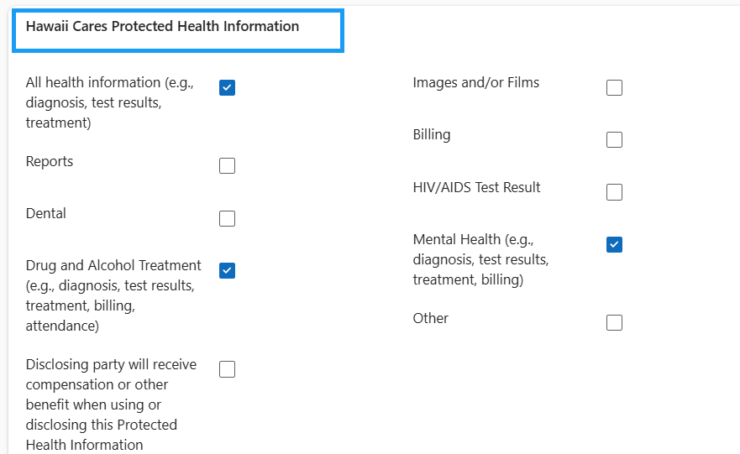
- The Client will Sign the Signature Box and Press Confirm
  - If the Client’s consent is captured over the phone, put a line through the signature box and press confirm.
  - 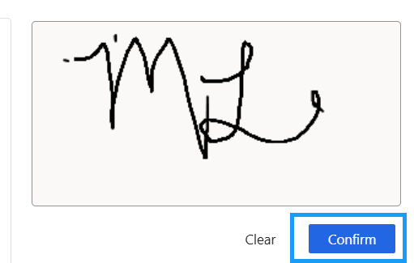
- If the Client is not able to sign directly in INSPIRE+, the signature can be captured physically and the consent can be given verbally.
  - 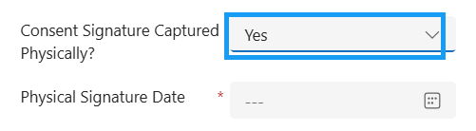
  - 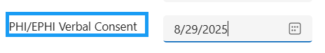
- Update the Consent Status to Active
  - 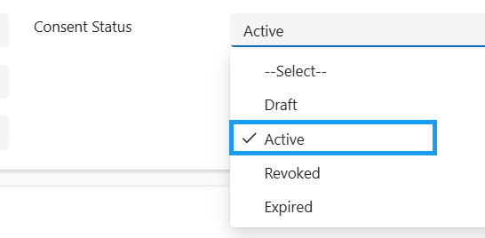
- Save the Record
  - 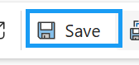
- Navigate to the Disclosed Records tab
  - 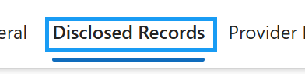
- The records on the Disclosed Records tab represent the client records that will be shared to the new provider agency.
  - 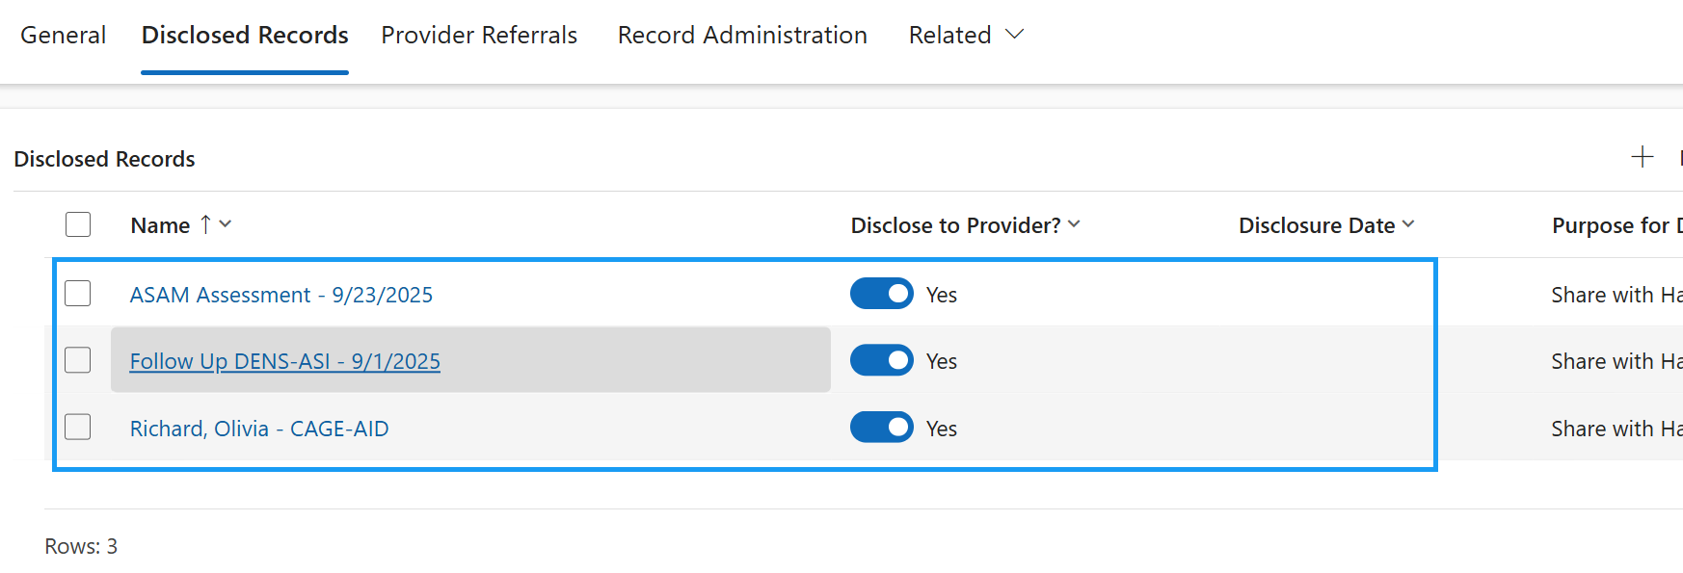
- On the Consent record, navigate to the Provider Referrals tab
  - 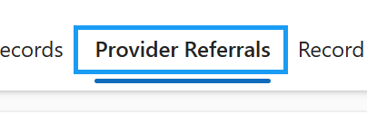
- Press + New Provider Referral in the sub-grid
  - 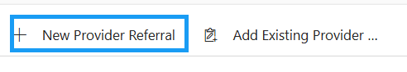
- Referred By and the Consent details will be populated on the new Provider Referral
  - Referred By = Hawaii CARES
  - 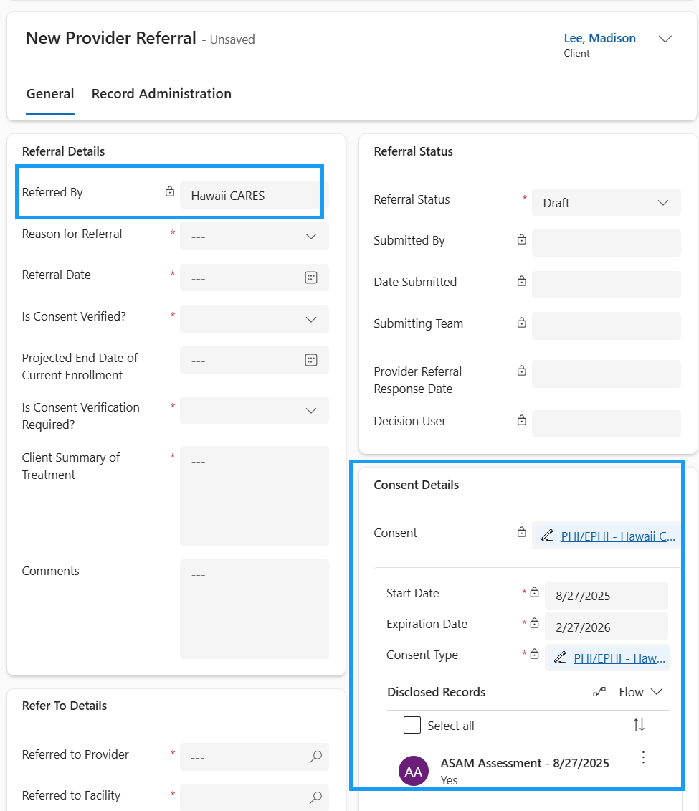
- Fill in the required fields.
  - Reason for Referral, Referral Date, Is Consent Verified, Is Consent Verification Required, Client Summary of Treatment, Referred to Provider, Referred to Program, and Referred to Facility are the required fields
  - 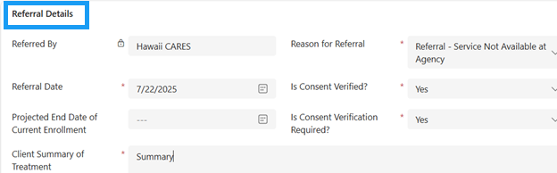
  - 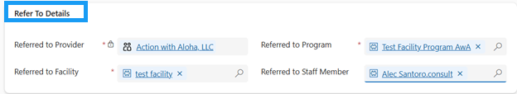
- Save the Record
  - 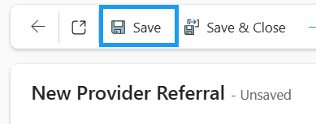
- Update the Referral Status to Submitted and save the record
  - Submitted By, Date Submitted, and Submitting Team are populated
  - 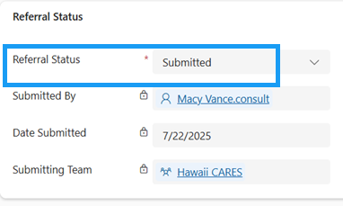

It is now in the hands of the Referred to Provider to either Accept or Reject this referral.

View your Submitted Referrals
- In the site map, navigate to Dashboards
  - 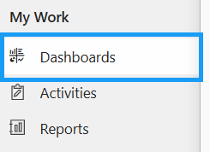
- Update the Dashboard to the “Hawaii CARES”
- Here, you will see all of the Accepted, Rejected, and Submitted Provider Referrals
  - This will allow you to keep track of all of the Provider Referrals you submitted
  - 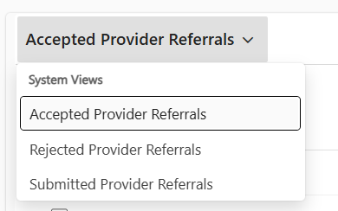
- Update the view to Accepted Provider Referrals
  - If a Provider has accepted the referral from Hawaii CARES to begin a new episode of care for the referred Client, it will be in the Accepted Provider Referrals view
  - 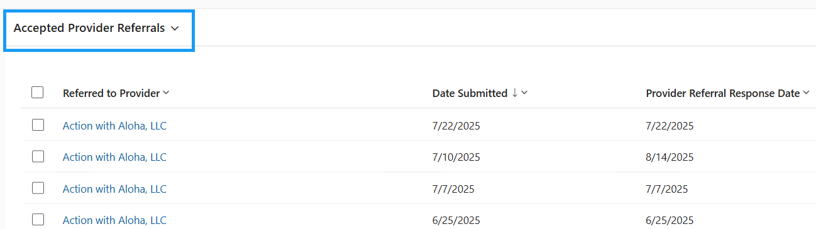
- Update the view to Rejected Provider Referrals
  - If a Provider has rejected the referral from Hawaii CARES, it will be in the Rejected Provider Referrals view
  - 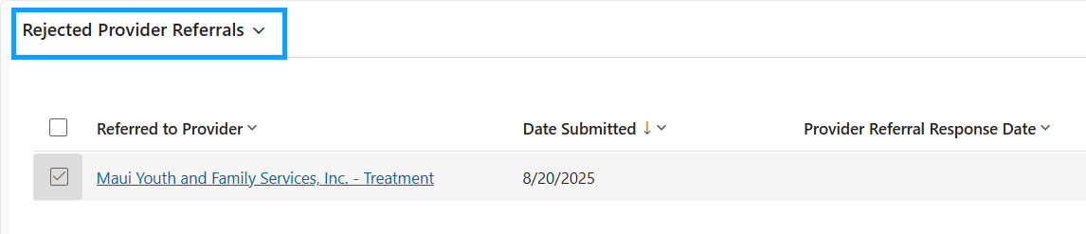
- Update the view to Submitted Provider Referrals
  - Submitted Provider Referrals shows all of the referrals you have submitted, but it has not been accepted or rejected by the Referred to Provider
  - 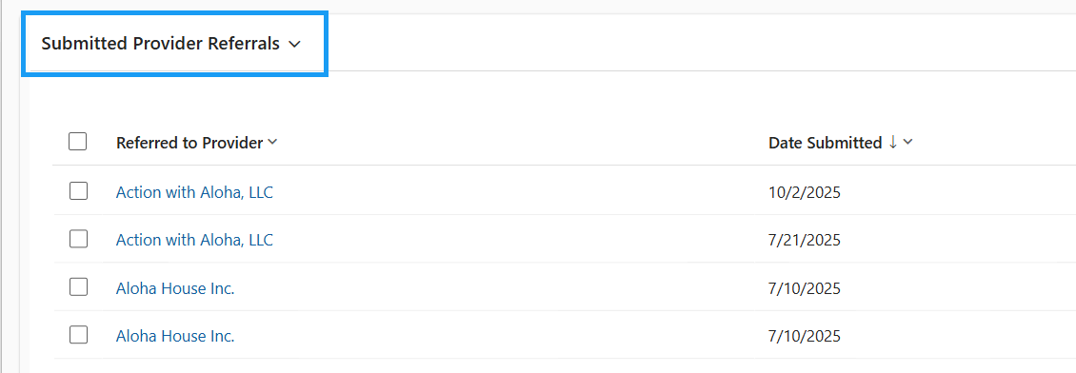
Hawaii CARES will retain access to the client profile and the Application they filled out, even after the referral has been accepted by a Provider.

USIS Intake Form
SECURITY: Hawaii CARES
Hawaii CARES users should be able to see all Treatment Clients in INSPIRE+
- In the site map, navigate to Clients
  - 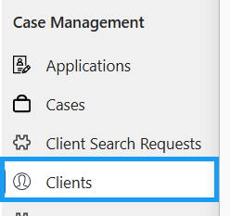
- Update to the view to Active Clients
  - 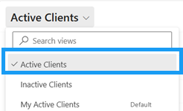
- You should be able to see ALL Active Treatment Clients in the System
  - 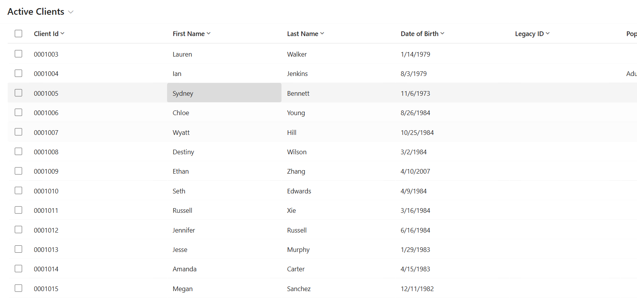

Once the client profile is found (or new one is, Hawaii CARES creates an Application (formally known as the USIS Intake Form)

Application
- Open an existing Client record if they already exist in the system.
  - 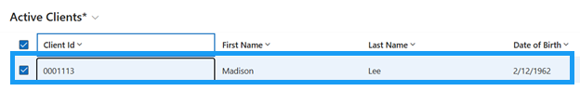
- If the client does not exist in the system, create a new client record. Press + New in the top ribbon.
  - 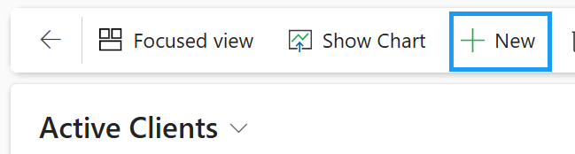
- Fill in the required fields:
  - First Name
  - Last Name
  - Date of Birth
  - Sex at Birth
  - Gender Identity
  - Sexual Orientation
  - Ethnicity/Hispanic Origin
  - Race
  - Address Type
  - 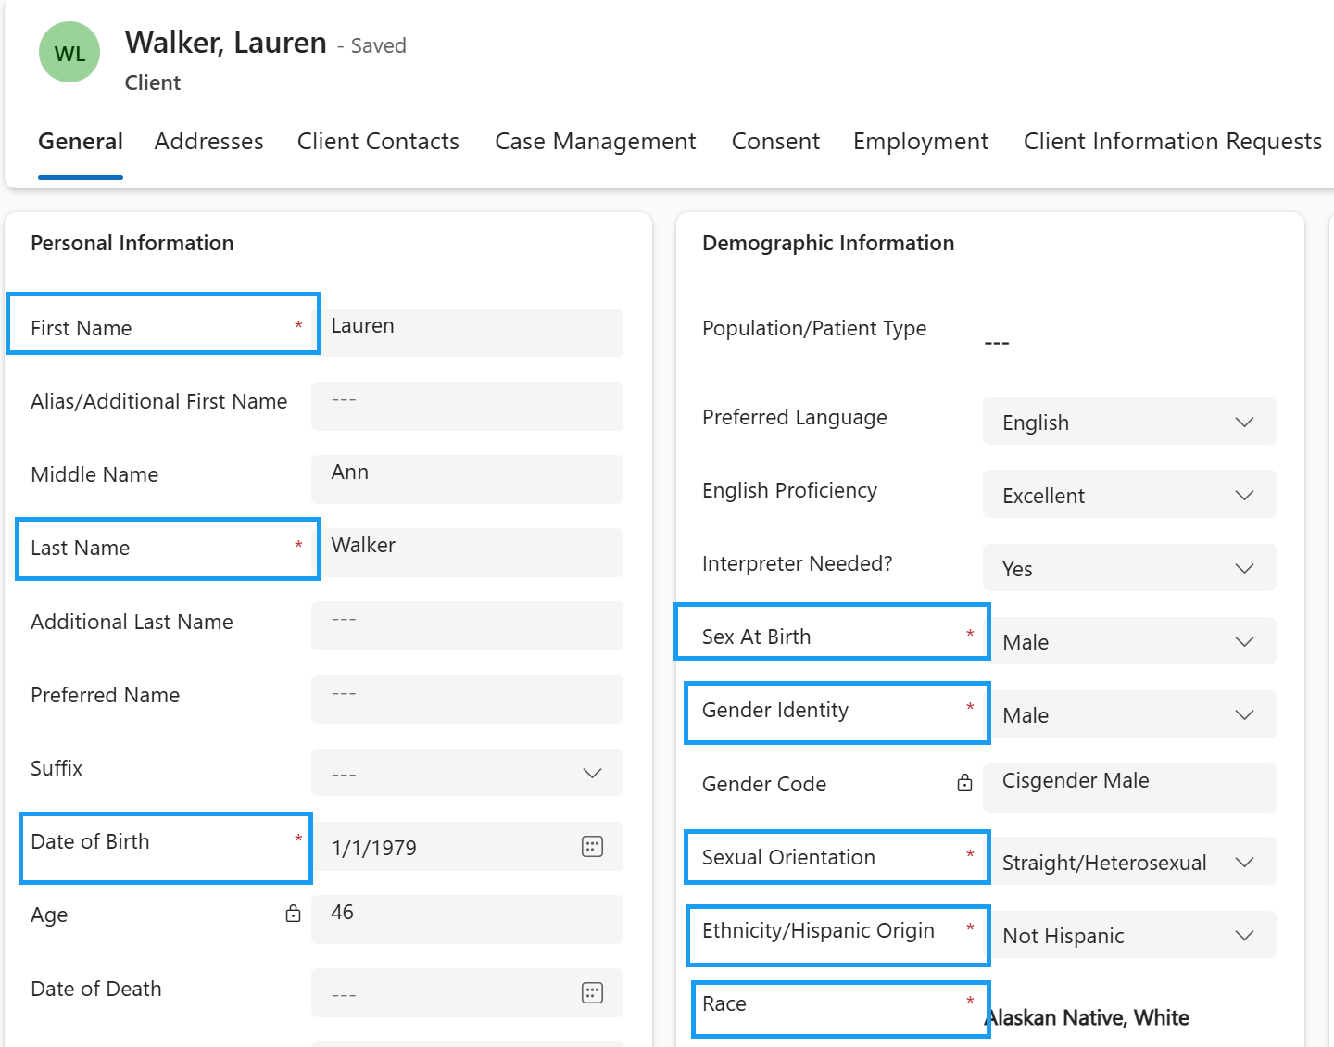
  - 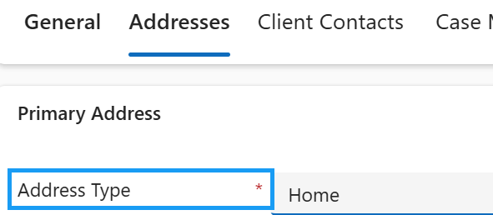
- Save the record
  - 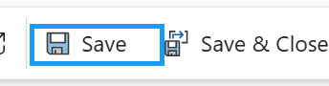
- Navigate to the Applications tab
  - Navigate directly to the applications tab if the client already exists in the system
  - 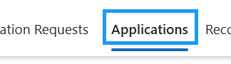
- + New Application in the sub-grid
  - 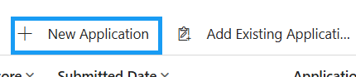
- The following Application Information fields should be auto-populated from the Client record (if filled out)
  - First Name
  - Last Name
  - Date of Birth
  - Sex at Birth
  - Ethnicity
  - Gender Identity
  - Citizenship
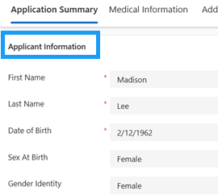

- Fill in the Start Date
  - 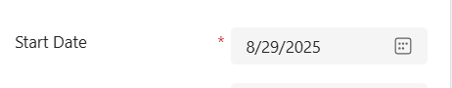
- If the Client has given consent to Hawaii CARES to contact other agencies and contact collateral contacts, toggle “consent to Hawaii CARES to Contact Other Agencies” and “Consent to Hawaii CARES to Contact Collateral Contacts” to Yes. Fill in any other applicable fields.
  - 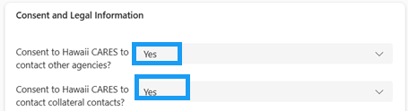
- Navigate to the Medical Information tab
  - 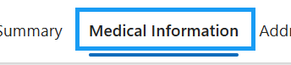
- Fill in any applicable fields on the Medical Information tab. Save the record
  - The priority score will be calculated based on the responses to “Are you Pregnant” and “Do you use IV Drugs”
  - Yes to Are you Pregnant, Yes to Do you Use IV Drugs = Priority Score 1
  - Yes to Are you Pregnant, No to Do you Use IV Drugs = Priority Score 2
  - No to Are you Pregnant, Yes to Do you Use IV Drugs = Priority Score 3
  - No to Are you Pregnant, No to Do you Use IV Drugs = Priority Score 4
  - 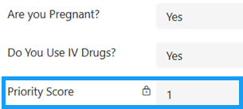
- Navigate to the Address & Contact Information tab
  - 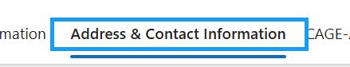
- Contact and Primary Address Information will be auto populated from the Client record. Fill in the living situation section.
  - 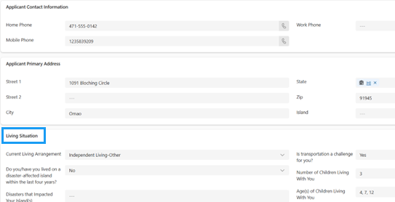
- Save the Application record
- Navigate to the CAGE-AID tab
  - 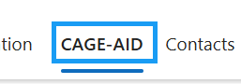
- The CAGE-AID Screening is pre-created for you.
  - 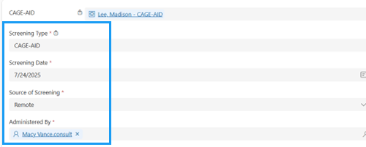
- Answer each of the four Yes/No questions by using the toggle switch
  - 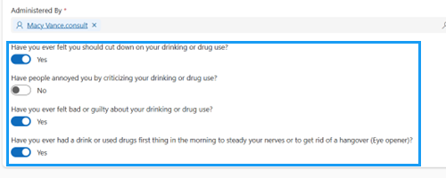
- Update the Status Reason to Completed.
  - 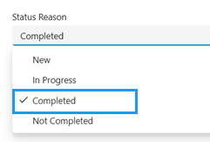
- Save the record
  - 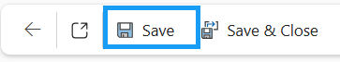
- Refresh the record
  - 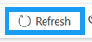
- The Result and Score will be calculated
  - The number of questions answered “Yes” is going to be the score (1-4)
  - If answered 1 or more Yes, the result will be Positive. If answered no to all, the result will be negative
  - 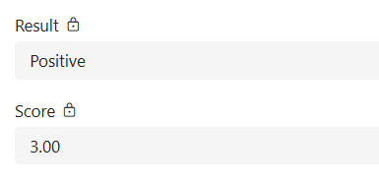
- Navigate to the Consents tab
  - 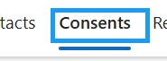
- Press + New Consent in the sub-grid
  - 
- Fill in the required fields.
  - Consent Type = PHI/EPHI – Hawaii CARES
  - Start Date
  - Expiration Date
  - Consent Grantor = Client
  - Consent Status = Draft
- The Consent Agreement will appear when the Consent Type is selected.
- Check any Hawaii CARES Protected Health Information
  - These will be checked based on what protected health information the Client agrees to disclose to agencies within the CARES provider network.
- The Client will Sign the Signature Box and Press Confirm
- If the Client is not able to sign directly in INSPIRE+, the signature can either be captured physically or consent can be given verbally.
- Update the Consent Status to Active
- Save the Record
- Save & Close the Consent record to navigate back to the Application
  - 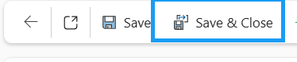
- On the Application Summary tab, update the Application Status to Submitted
  - 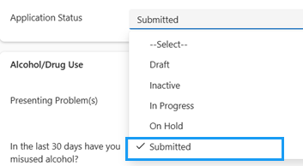

Hawaii CARES Route a Client’s Application
SECURITY: Hawaii CARES
Once the Application has been completed, Hawaii CARES will route the application to the appropriate provider.
- In the site map, navigate to Applications
  - 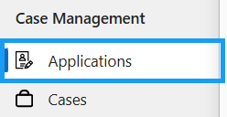
- Open the existing Application created in the last training session.
  - 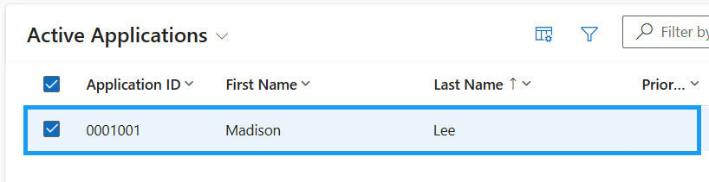
- Navigate to the Consents tab
  - 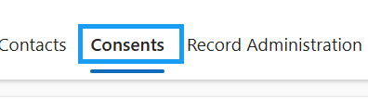
- Open the existing PHI/EPHI - Hawaii CARES consent
  - 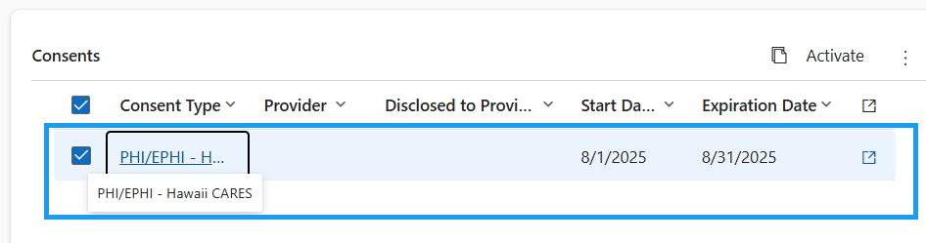
- Navigate to the Provider Referrals tab
  - 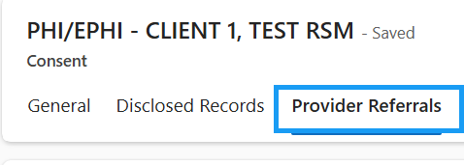
- + New Provider Referral in the sub-grid
  - 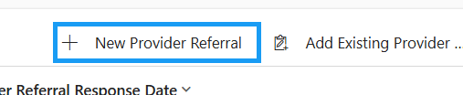
- Fill in all of the required fields in the Referral Details Section
  - Referred By will be auto-populated with Hawaii CARES
  - Referral Date, Reason for Referral, IS Consent Verified, Is Consent Verification Required, and Client Summary of Treatment are required.
  - 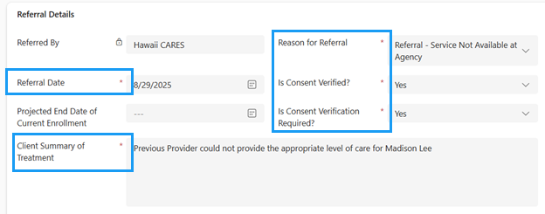
- Fill in the Refer to Details. This represents the Provider Agency you are referring your client to
  - 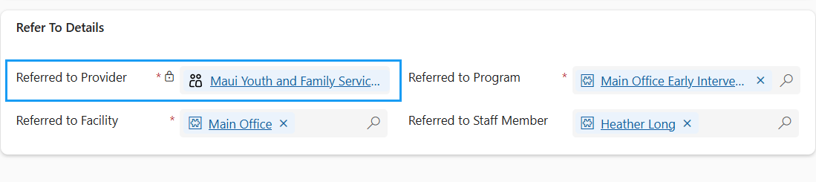
- Save the record
  - 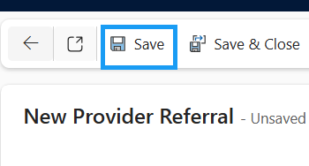
- Update the Referral Status to “Submitted” and save the record.
  - 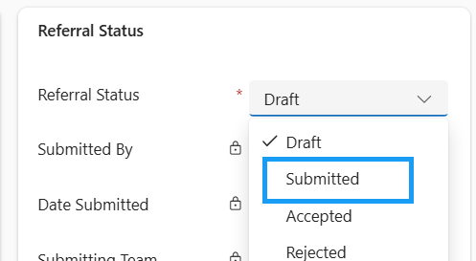
- Submitted By, Date Submitted, and Submitting Team will be populated
  - 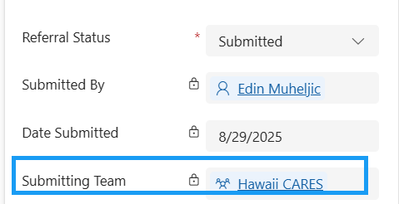
- Once the Application has been submitted, the Application information (including the CAGE-AID, the Consent, and the Application) is disclosed with the provider. This information is shared so that they can see the details that Hawaii CARES collected
  - 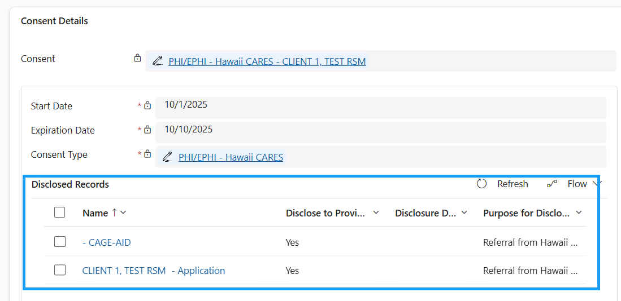
The Application has now been routed to the Referred to Provider. It is in their hands to provide the recommended Level of Care to the Client.

Hawaii CARES Approve/Deny Recommended Level of Care
SECURITY: Hawaii CARES
Hawaii CARES team will see a list of all Client Level of Care Determinations that are pending their review in their Dashboard
- In the site map, navigate to Dashboards
  - 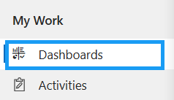
- You will be brought to the Hawaii CARES Dashboard
- All Level of Care Determination records in the Pending Approval Status will appear in the top sub-grid
  - 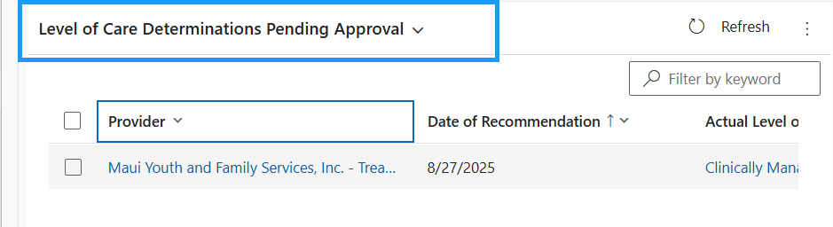
- Open the Level of Care Determination record that you need to approve
  - 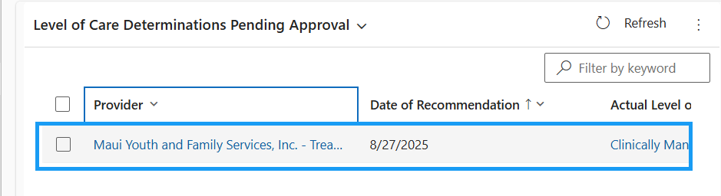
- You can review all of the Level of Care Determination details and the provider’s Recommended Level of Care
  - 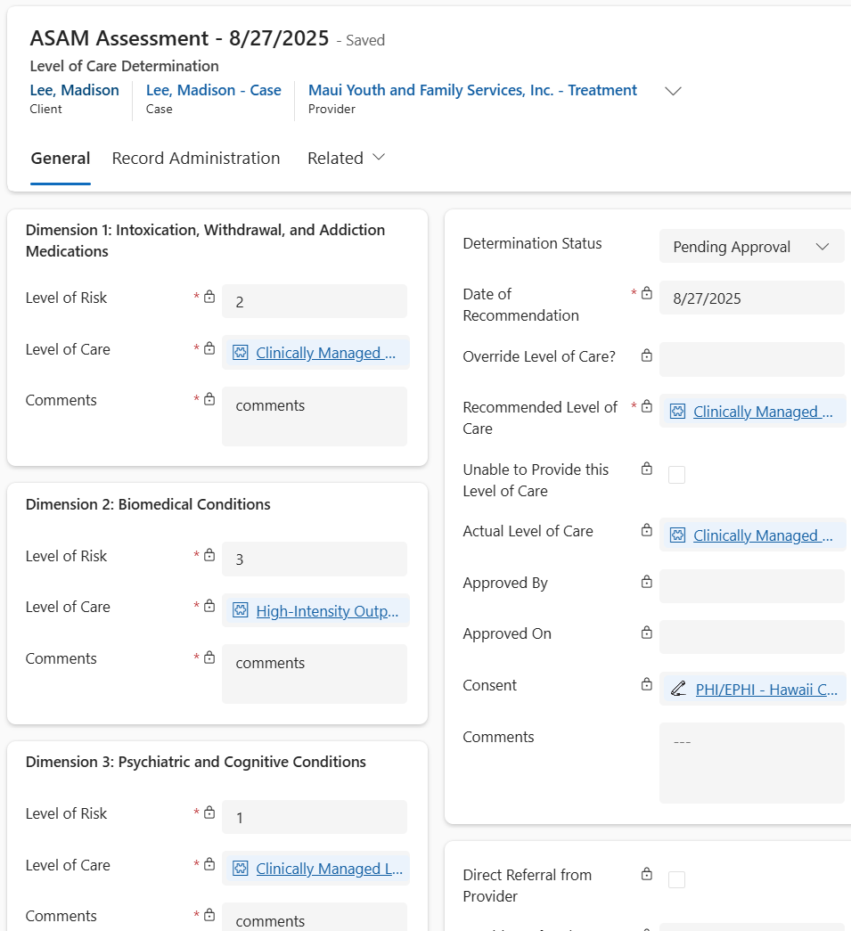
  - 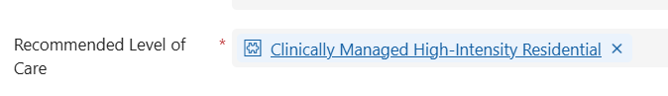
- If any revisions are required on the Level of Care Determination, update the Determination Status to Revisions Required
  - 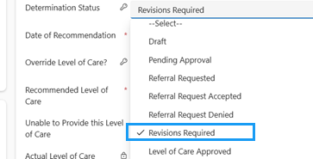
- Once the revisions are made and you are ready to approve the Level of Care, update the Determination Status to Level of Care Approved
  - 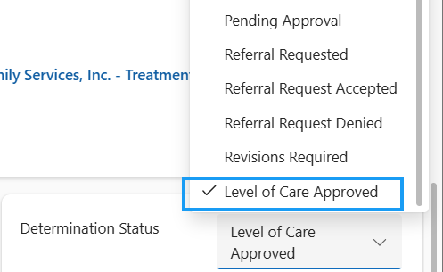
- Save the Record
  - 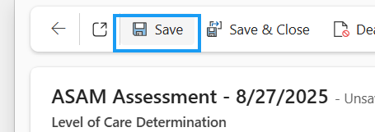
- Approved By and Approved On will be populated
  - Approved By = Hawaii CARES user
  - 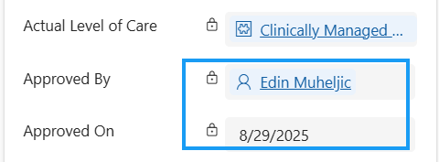
The System will prevent a provider from being able to enroll a client into a facility for a program until Hawaii CARES has approved the level of care recommendation.
The Hawaii CARES team will be able to see all information found within an client's episode of care.

