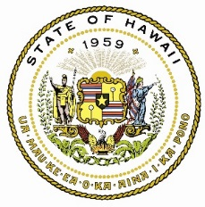
State of Hawaii
Office of Language Access

Withdrawal of Public Complaint

Contact Information
First Name Last Name Middle Initial

Street Address City State Zip Code

Phone E-mail

Complaint Information
Date complaint was filed

Nature of Complaint:
Interpreter was not provided Translation was not competent
Translated material was not provided Language assistance was not timely
Interpreter was not competent Other:___________________________________

Statement
I hereby withdraw my complaint against _______________________________________________________ .
(Name of the state agency or organization)
I make this withdrawal voluntarily and of my own free will, without coercion or duress from anyone.

Signature Date

Return Form to: For Help or Questions:
Office of Language Access E-mail: doh.ola@doh.hawaii.gov
1250 Punchbowl Street, Room 201 Call: (808) 586-8730
Honolulu, Hawaii 96813 Neighbor Islands: 1 (866) 365-5955

