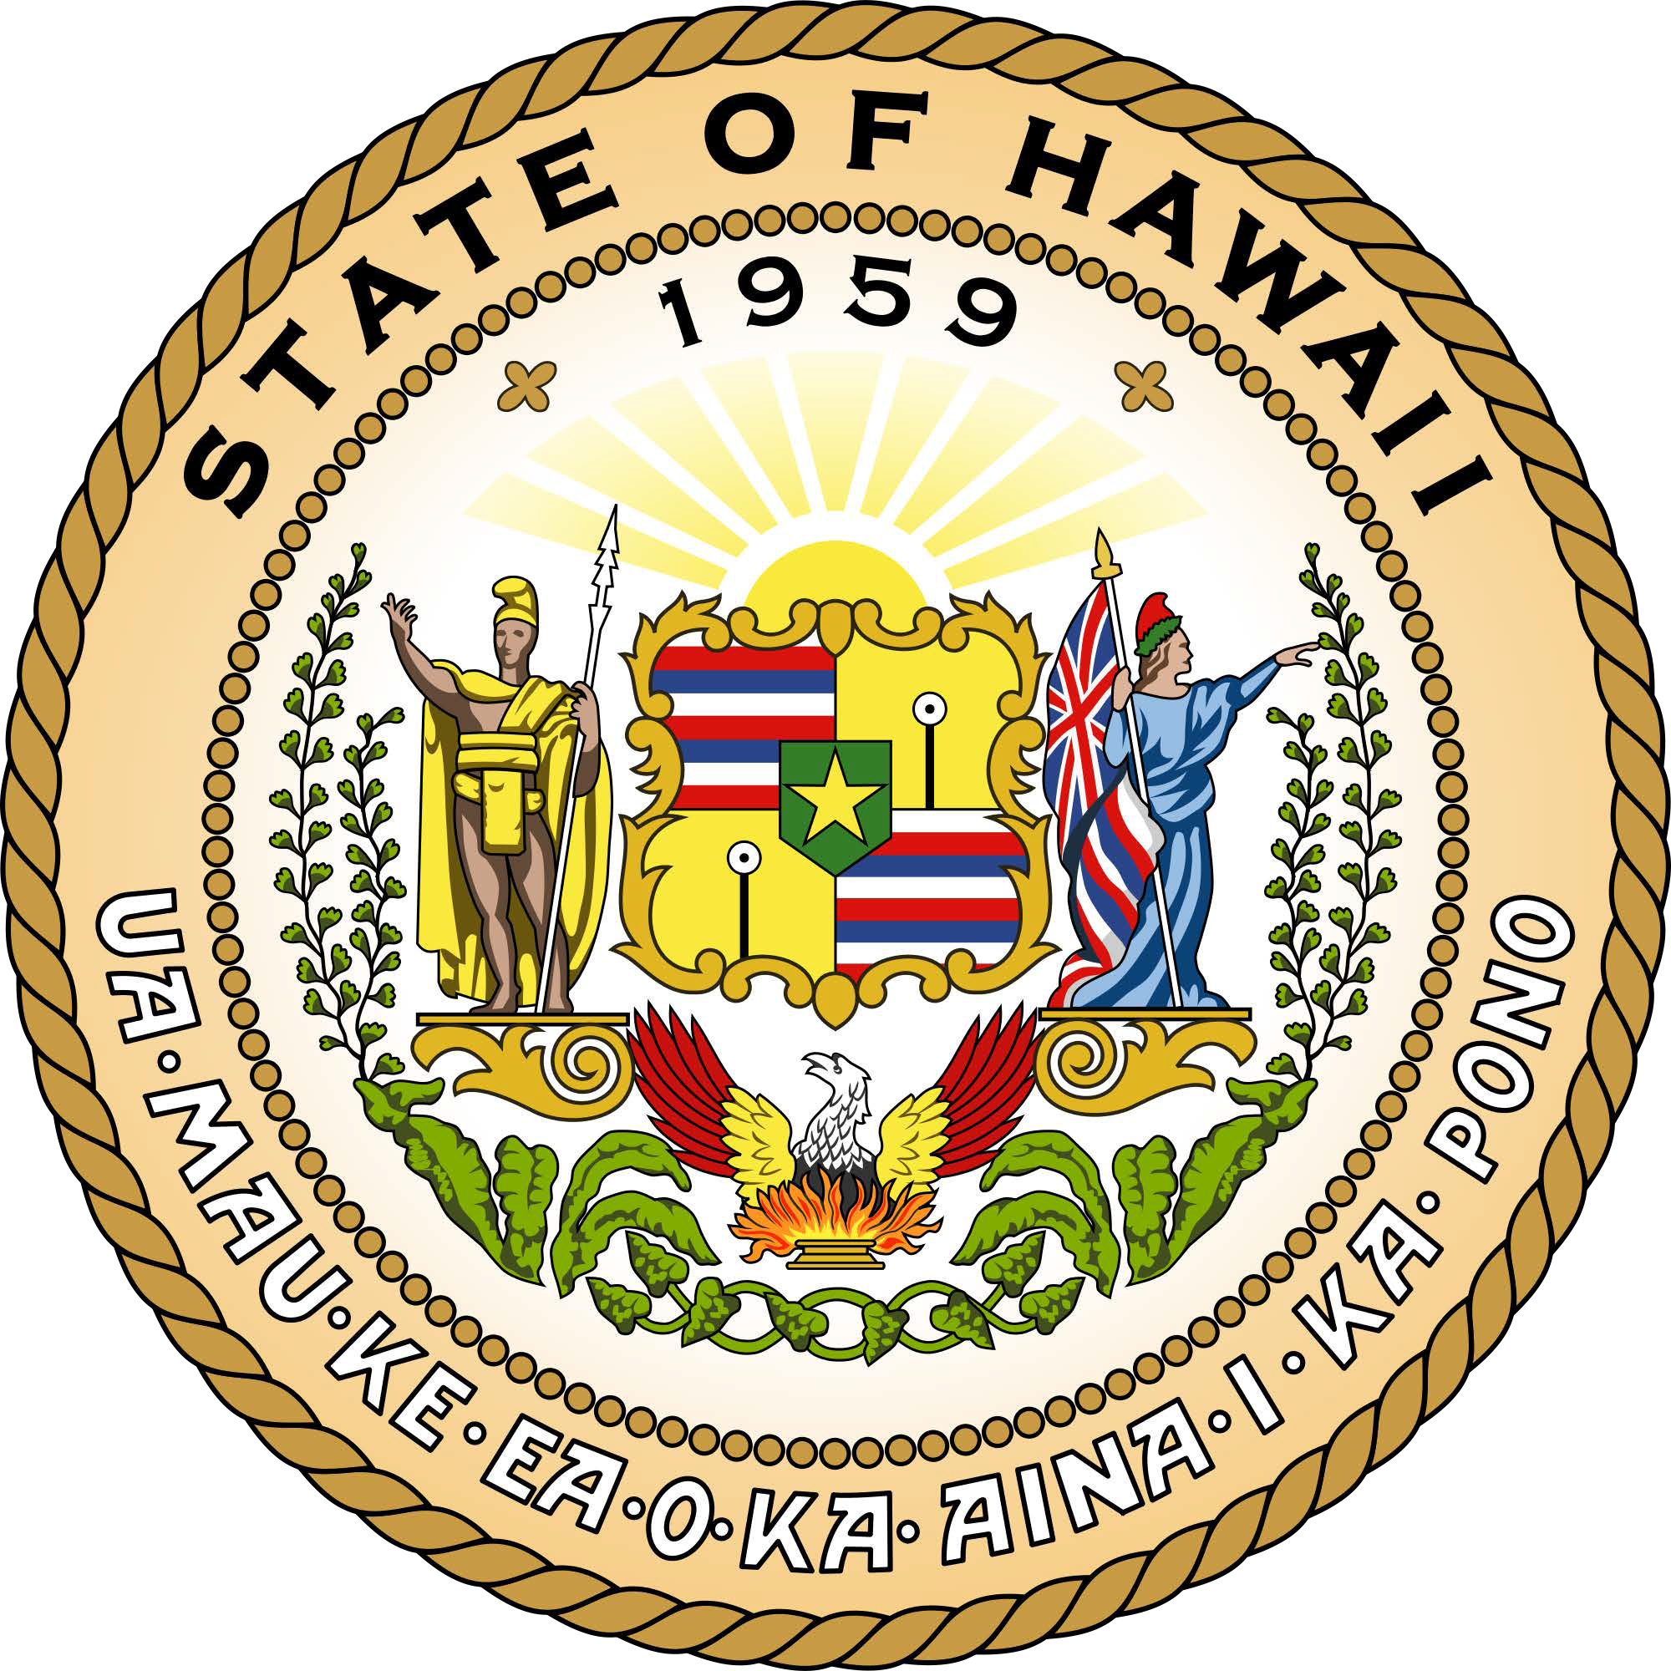
State of Hawaii Office of Language Access

Notice to Individuals Filing a Complaint

Individuals who are Limited English Proficient (LEP) have the right to access services, programs and activities provided by government agencies and other offices that receive State or federal funding. Any LEP person who is denied language assistance services by any of these agencies or offices may file a complaint with OLA.

Filing a Complaint. To file a complaint, you or your authorized representative may use the Complaint form available in fillable format or to download at:

https://health.hawaii.gov/ola/files/2020/08/ENG-Withdrawal-Complaint.pdf

To request a paper copy of the form, or if you need help completing the form, call OLA at (808) 586-8730 or 1 (866) 365-5955 for Neighbor Islands; or e-mail at doh.ola@doh.hawaii.gov

If you need help in your language, OLA will provide an interpreter at no cost to you.

Information needed on the form:

- Name, contact information and signature of person filing the complaint
- Date when the problem occurred
- Name of the agency where the problem occurred
- Name of the person involved when the problem occurred
- Detailed description of the problem
When to File. Your complaint should be filed with OLA as soon as possible or within a reasonable time after the problem occurred.
Where to File. Return completed and signed form by mail, email or in-person to: Office of Language Access
1250 Punchbowl Street, Room 201
Honolulu, Hawaii 96813
E-mail: doh.ola@doh.hawaii.gov

Investigation. A representative from OLA will review and investigate your complaint and work with you and the agency to resolve the problem using informal methods such as conference, conciliation, mediation or persuasion.

Consent to Release Information. To help OLA in investigating your complaint, you may need to complete and sign a Consent to Release Information form available in fillable format or to download at:

https://health.hawaii.gov/ola/files/2020/08/ENG-Consent-to-Release.pdf

Notification. OLA will inform you when your complaint is received and notify you of the result of the investigation, and what action is being taken to resolve the problem.

Withdrawing a complaint. You may withdraw your complaint at any time by submitting a Withdrawal of Complaint form available in fillable format or to download at:

https://health.hawaii.gov/ola/files/2020/08/ENG-Withdrawal-Complaint.pdf

Right to representation. You have the right to be represented by an attorney or other individual of your choice. However, under Hawaii’s Language Access Law (HRS 321C), you cannot file a lawsuit with OLA. OLA will try to resolve your complaint using conference, conciliation, mediation, persuasion or other informal methods.

Complaint of Discrimination. Although you cannot file a lawsuit with OLA, you may file a complaint of discrimination with the government agencies listed below.

State of Hawaii
Office of the Ombudsman 465 S. King Street, 4th Floor Honolulu, HI 96813
Phone: (808) 587-0770 (Voice)
Fax: (808) 587-0773
TTY: (808) 587-0774
E-mail: complaints@ombudsman.hawaii.gov

Federal

Hawaii Civil Rights Commission
830 Punchbowl Street, Room 411
Honolulu, HI 96813
Phone: (808) 586-8636 (Voice/TTD)
Fax: (808) 586-8655
E-mail: dlir.hcrc.infor@hawaii.gov

U.S. Department of Justice
Civil Rights Division
Federal Coordination and Compliance Section - NWB 950 Pennsylvania Avenue, N.W.
Washington, D.C. 20530
Phone: (888) 848-5306 - English and Spanish (Ingles y Español) (202) 307-2222 (voice)
(202) 307-2678 (TDD)

