**DEPARTMENT OF HEALTH**

**DAVID Y. IGE**  
GOVERNOR

**BRUCE S. ANDERSON, Ph.D.**  
DIRECTOR

**FOR IMMEDIATE RELEASE**

March 19, 2020                             20-020

**State of Hawai‘i Launches** [**www.HawaiiCOVID19.com**](http://www.hawaiicovid19.com) **website**

*Guidance about prevention, protecting at-risk individuals and identifying symptoms included along with printable materials and daily status update*

The State of Hawaii has launched a new website — [www.hawaiicovid19.com](http://www.hawaiicovid19.com) — to equip residents and visitors with information and resources to help prevent the spread of COVID-19 in our community. HawaiiCOVID19.com will serve as a hub for Hawai‘i’s inter-agency coordinated effort to combat the spread of the disease statewide and will be populated with more information to support Hawai‘i’s communities.

[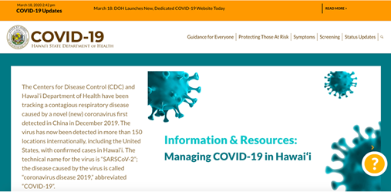](https://health.hawaii.gov/news/files/2020/03/state-launches-covid19-site-home.png)

“HawaiiCOVID19.com is part of an extensive inter-agency collaboration to keep our community safe and healthy,” said Hawai‘i State Governor David Ige. “The website currently provides accurate, easy-to-understand information that will help control the spread of COVID-19 in Hawai‘i and we are planning to add more resources to support our community’s needs.”

The website currently contains easy-to-access information on:

* Daily prevention for individuals and families
* Guidance and best practices for community spaces
* How to protect those most at risk
* Symptoms and testing protocols
* Daily updates from the Hawai‘i State Department of Health
* Printable materials for use in homes, businesses and institutions

[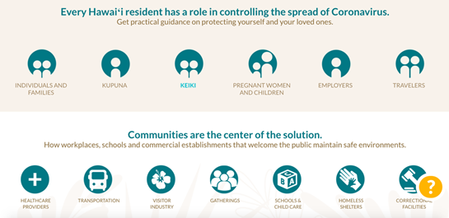](https://health.hawaii.gov/news/files/2020/03/state-launches-covid19-site-icons.png)

Users can quickly navigate to the information most relevant to their interest using icons on the homepage. The website will be shared across state agency websites and shared broadly as a resource for our statewide community. It will be updated regularly with health information on new guidance on prevention and mitigation.

“Staying informed with reliable, current guidance is a key priority for our community’s fight against COVID-19 in Hawai‘i,” said Bruce Anderson, Ph.D, director of the Hawai‘i State Department of Health. “As updated guidance comes out, this website will be a critical source of information.”

To get information about controlling the spread of COVID-19 and for the latest updates, please visit [www.hawaiicovid19.com](http://www.hawaiicovid19.com).

# # #