 | STATE OF HAWAII  DEPARTMENT OF HEALTH  4348 Waialae Avenue, #648  Honolulu, Hawaii 96816 | 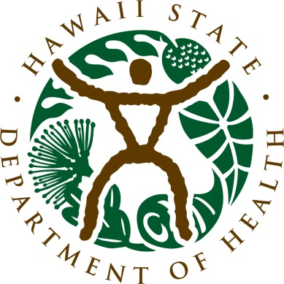
Medical Cannabis (329) Registry Program
The statistics presented in this report are based on Medical Cannabis Registry data as of
February 29, 2024

IN-STATE Patient Data

IN-STATE Patients with a Valid Medical Cannabis Registration
31,581 | Patients have a valid medical cannabis registration.
Applications Issued
527 | New patient applications were issued between February 1, 2024, to February 29, 2024.
1471 | Renewal patient applications were issued between February 1, 2024, to February 29, 2024.
Caregiver Totals
2,808 |  | Caregivers are caring for registered patients.
Physician/APRN Totals
426 |  | Physicians/APRNs have set up accounts to certify patients in Hawaii.
232 |  | Physicians/APRNs have certified one or more patients currently registered for the medical use of cannabis as of February 29, 2024.

Demographic Information

Table 1. Registered Patients by Age and Gender

Gender | Average Age | Percentage on Registry
Male | 52 | 56.83%
Female | 50 | 42.90%
X/non-binary | 38 | 0.27%

Table 2. Frequency of Conditions

Reported Condition | Number of Patients’ Certified Condition | Percentage of Patients’ Certified Condition*
Severe Pain | 26,064 | 82.53%
PTSD | 5,396 | 17.09%
Persistent Muscle Spasms | 1,958 | 6.20%
Severe Nausea | 1,867 | 5.91%
Malignant Neoplasm (Cancer) | 1,848 | 5.85%
Glaucoma | 581 | 1.84%
Rheumatoid Arthritis | 528 | 1.67%
Seizures | 372 | 1.18%
Cachexia/Wasting Syndrome | 315 | 1.00%
HIV | 217 | 0.69%
Epilepsy | 152 | 0.48%
Lupus | 130 | 0.41%
Multiple Sclerosis | 73 | 0.23%
ALS | 8 | 0.03%
*Does not add to 100% as some patients report more than one debilitating condition.

Table 3. Registered Patient Total and the Top 3 Certified Conditions by Age

Age  Group | Patient Total & % by Age | 1st Certified Condition | 2nd Certified Condition | 3rd Certified  Condition
0-10 | 9 (0.03%) | *Malignant Neoplasm (Cancer) | *Seizures | *Severe Pain, Severe Nausea & PTSD
11-17 | 41 (0.13%) | Severe Pain (16) | PTSD (14) | Seizures (10)
18-25 | 1,295 (4.10%) | Severe Pain (886) | PTSD (416) | Severe Nausea (138)
26-35 | 4,700 (14.88%) | Severe Pain (3,666) | PTSD (1,120) | Severe Nausea (449)
36-45 | 6,836 (21.65%) | Severe Pain (5,602) | PTSD (1,427) | Severe Nausea (457)
46-55 | 5,504 (17.43%) | Severe Pain (4,612) | PTSD (1,001) | Persistent Muscle Spasm (396)
56-65 | 6,082 (19.26%) | Severe Pain (4,937) | PTSD (746) | Malignant Neoplasm (Cancer) (453)
66-75 | 5,782 (18.31%) | Severe Pain (5,301) | Malignant Neoplasm (Cancer) (657) | PTSD (557)
76 & Older | 1,332 (4.22%) | Severe Pain (1,100) | Malignant Neoplasm (Cancer) (214) | PTSD (114)
*Patient count is not reportable

Table 4. Registered Patients, Caregivers, and Top 3 Certified Conditions by County
County | Number of Patients | Number of Caregivers | 1st Reported Condition | 2nd Reported Condition | 3rd Reported Condition
Honolulu | 15,473 | 1,506 | Severe Pain  (12,101) | PTSD  (3,229) | Malignant Neoplasm (Cancer) (1,067)
Hawaii | 8,451 | 645 | Severe Pain  (7,356) | PTSD  (1,228) | Persistent Muscle Spasms (774)
Maui | 5,750 | 508 | Severe Pain  (4,976) | PTSD  (717) | Persistent Muscle Spasms (375)
Kauai | 1,887 | 148 | Severe Pain  (1,618) | PTSD  (215) | Severe Nausea  (192)
Out of state* | 20 | 1 | Severe Pain  (13) | *PTSD | * Malignant Neoplasm (Cancer)

*Patient count is not reportable; *Registered using an out of state residential address

Graph 1. Number of Approved Applications: New Applications vs Renewal Applications,
January 2022 – February 2024

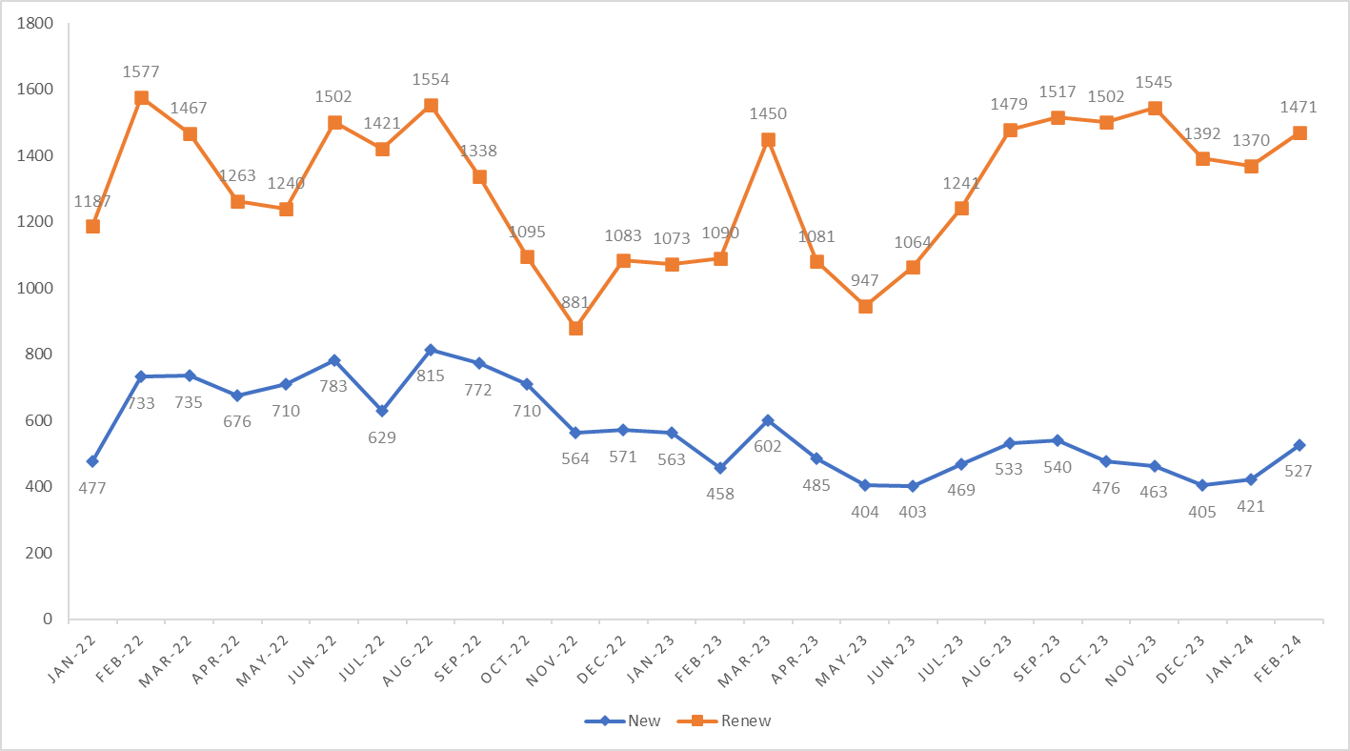

OUT-OF-STATE Patient Data

741 | Visitors from 30 states and the District of Columbia are registered as out-of-state patients.
251 | *Visitors have approved registrations that are waiting for activation.
825 | Year-to-date number of out-of-state registered patients (January 1, 2024 – February 29, 2024)
*Out-of-State patient registration cards are scheduled to become valid after February 29, 2024

Demographic Information

Table 1. Patients by Age and Gender

Gender | Average Age | *Percentage on Registry
Male | 49.00 | 59.92%
Female | 45.56 | 39.95%
*The number of X/non-binary applicants is not reportable at this time.

Table 2. Top 3 Certified Conditions*

1st Certified Condition  by number and percentage | 2nd Certified Condition  by number and percentage | 3rd Certified Condition  by number and percentage
Severe Pain (486, 65.59%) | PTSD (207, 27.94%) | Severe Nausea (96, 12.96%)
*Breakdown by age is not available at this time.

Table 3. Top 3 Visiting States

1st Visiting State  by number and percentage | 2nd Visiting State  by number and percentage | 3rd Visiting State  by number and percentage
Florida (78, 10.53%) | Utah (58, 7.83%) | Arizona (56, 7.59%)

Graph 1. Number of Approved Applications: February 2023 – February 2024

