Hawaii DOH E-Permitting System Instructions
- HI DOH e-Permitting System - Environmental Health Administration or
https://eha-cloud.doh.hawaii.gov/epermit

Sign in if you already have an account.
If using for the first time, please Register to create a User ID in order to establish an Account. A verification e-mail will be sent to you.
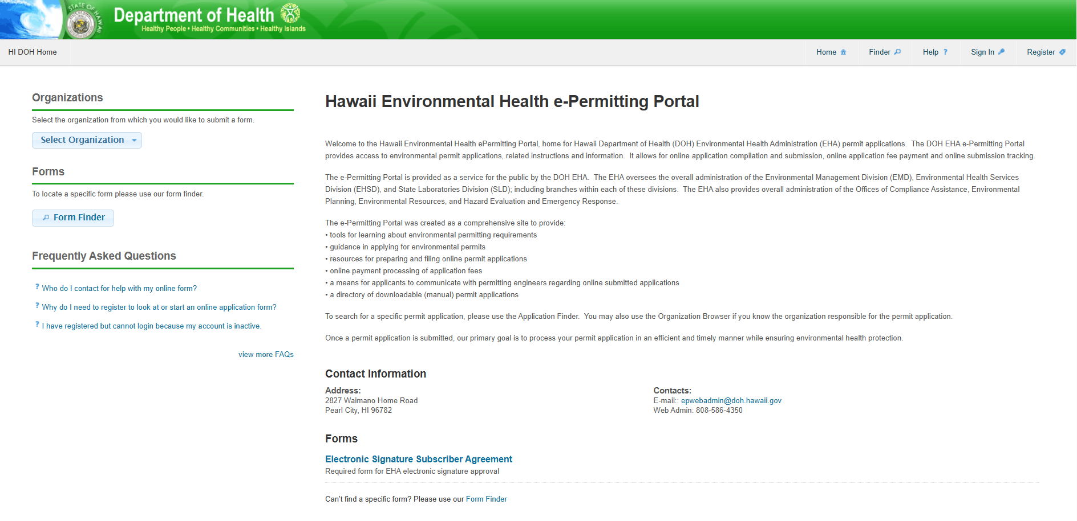
Register
Sign in

- Access HECRA Tier II. Search using Form Finder or Finder:
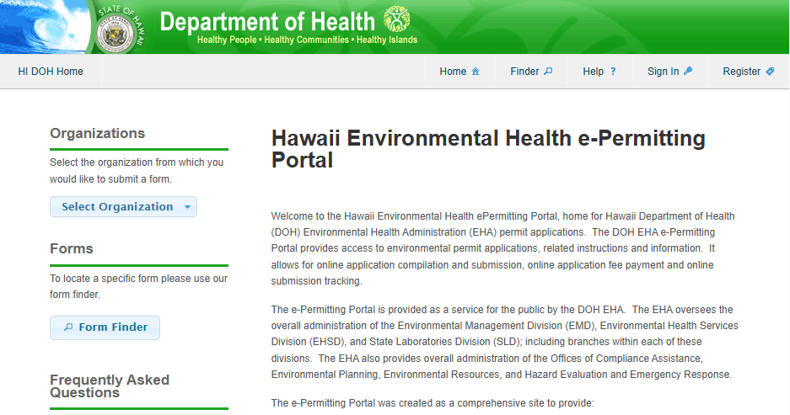
Finder
Form Finder

- Below Form Search, type in HEPCRA and Recommended Forms will appear automatically.
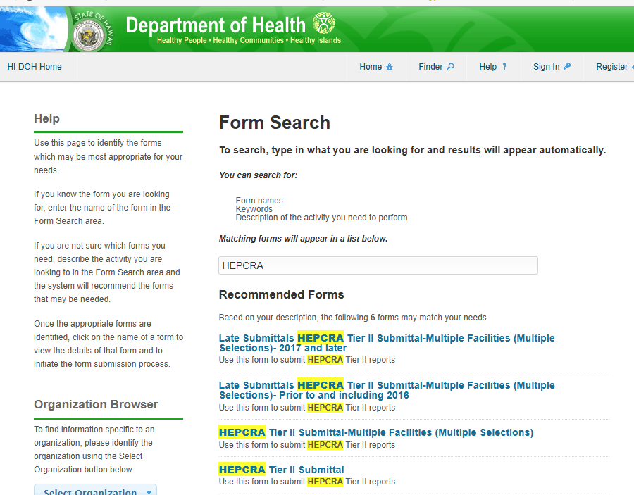
Form Search
Type in HEPCRA

- Click on one of the following forms:
- Late Submittals HEPCRA Tier II Submittal-Multiple Facilities (Multiple Selections)- 2017 and later – for late submittals for calendar years 2017 - 2024
- Late Submittals HEPCRA Tier II Submittal-Multiple Facilities (Multiple Selections)- Prior to and including 2016 – for late submittals for calendar years 2016 and earlier
- HEPCRA Tier II Submittal-Multiple Facilities (Multiple Selections) – for filing more than one facility for calendar year 2025
- HEPCRA Tier II Submittal – for filing a single facility for calendar year 2025

- Click on Begin Form Entry. Please take the time to read the HEPCRA Tier II Submittal Instructions.
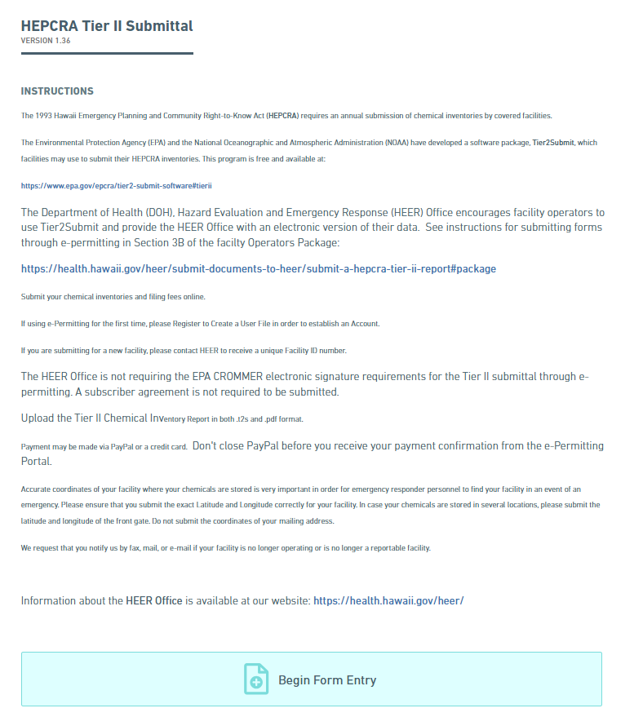
Begin Form Entry

- Processing Info – provide information. Submission Reason: New or Renewal will take you through the same steps. Click on the Arrow down for the Next Section.
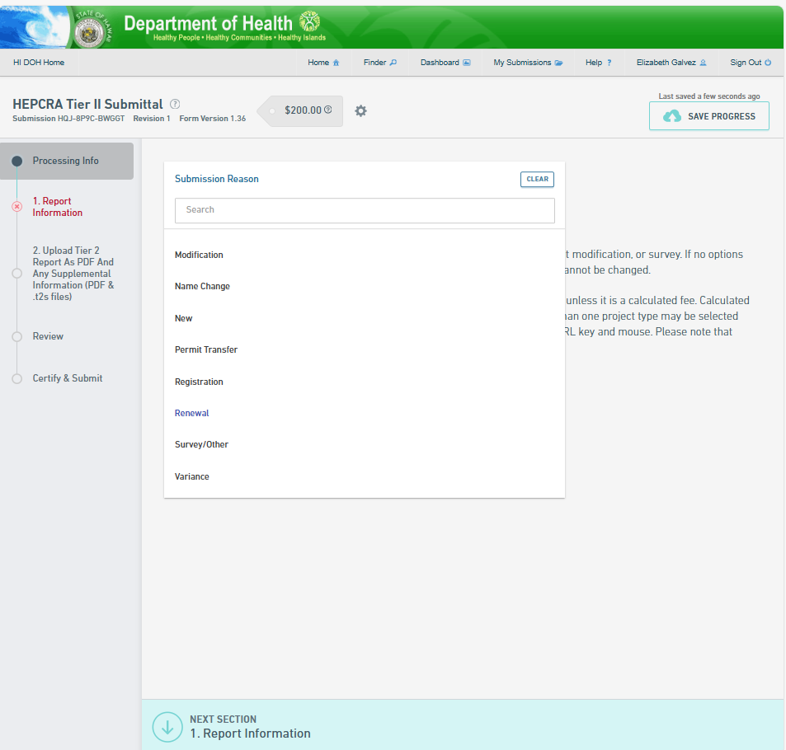
Next Section
Submission Reason
New
Renewal

- Provide facility information.

  - For existing facilities, there is a drop-down menu. Type the first three letters of facility name or the address. You may also type in the Facility ID. Please confirm that you have the correct facility name, facility address and the Facility ID before you proceed.

  - For a new facility, please obtain a Facility ID no. prior to completing the HEPCRA Tier II submittal. You may contact us at https//health.hawaii.gov/heer/contact-us/

  - Click on the Next Section.
Next Section
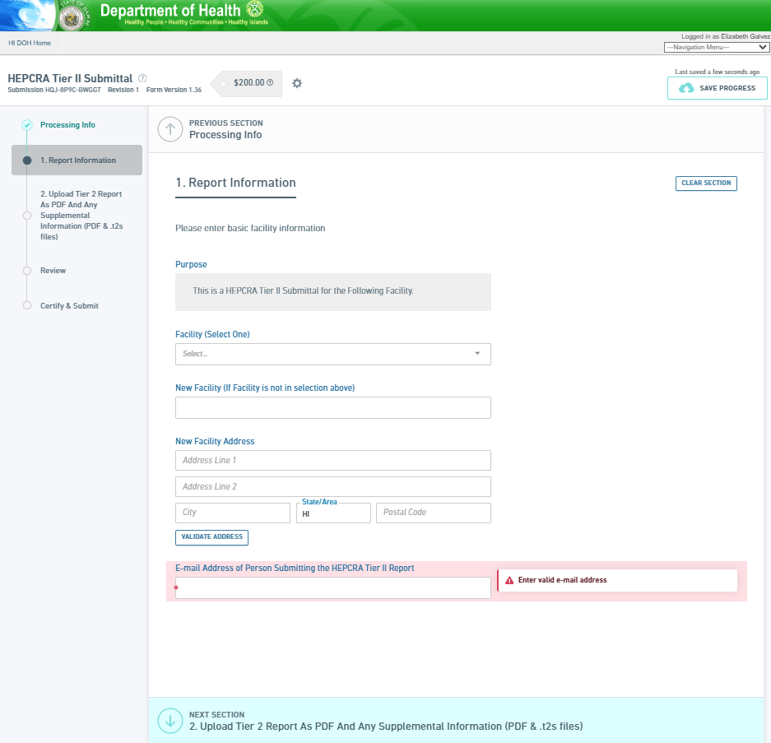
Facility (drop down)
New Facility
Next Section

- Upload Tier 2 Report as a pdf and .t2s files
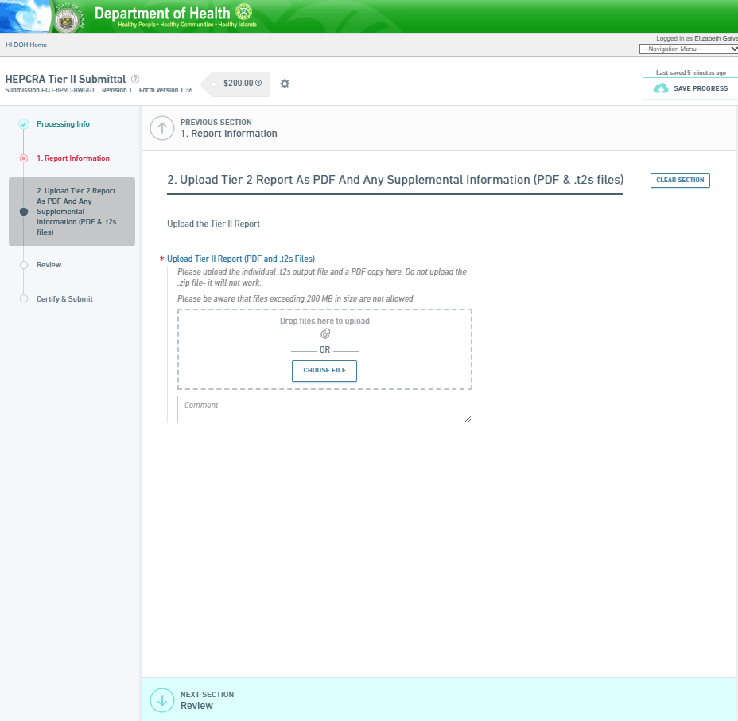
Upload Tier II Report
Next Section
  - Click on the Next Section.
Next Section

Facility (drop down)
New Facility
Next Section

- Review. You may print review and/or print to ensure that your online application is completed accurately.

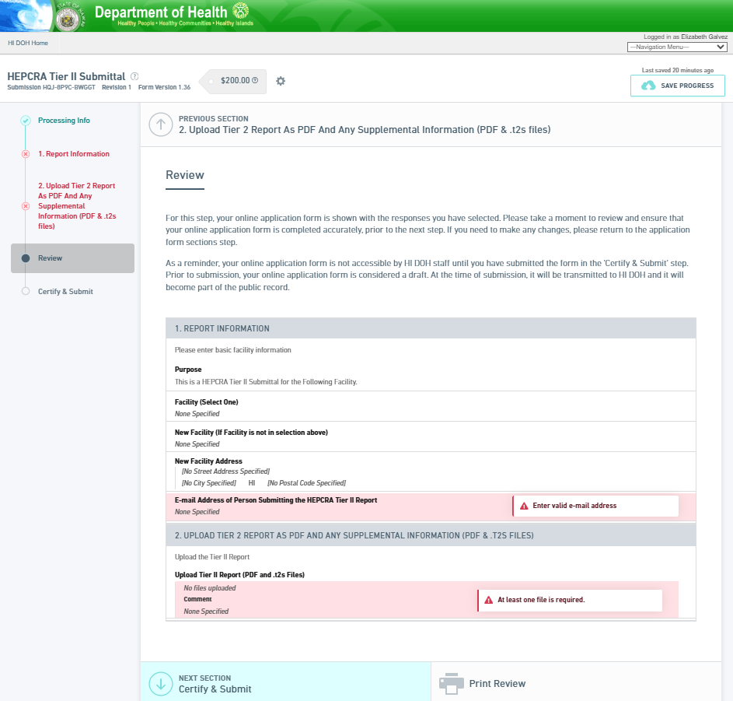
Print Review

- Certify and Submit.
Your submittal is not complete until you complete one or more fields of the form that are marked in red, you have submitted it and you have made the payment. Your submittal is not accessible by Hawaii Hazard Evaluation and Emergency Response (HEER) staff until you submit the form in this step.

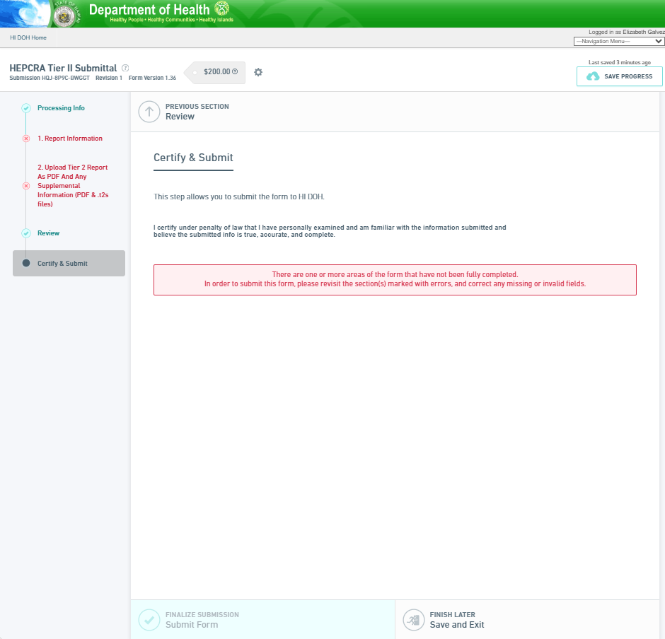
Certify and Submit
Submit Form
- Payment.
Once the Tier II form has been submitted, please make the appropriate payment, either Online or by Mail. Payment must be received before the submission can be processed.

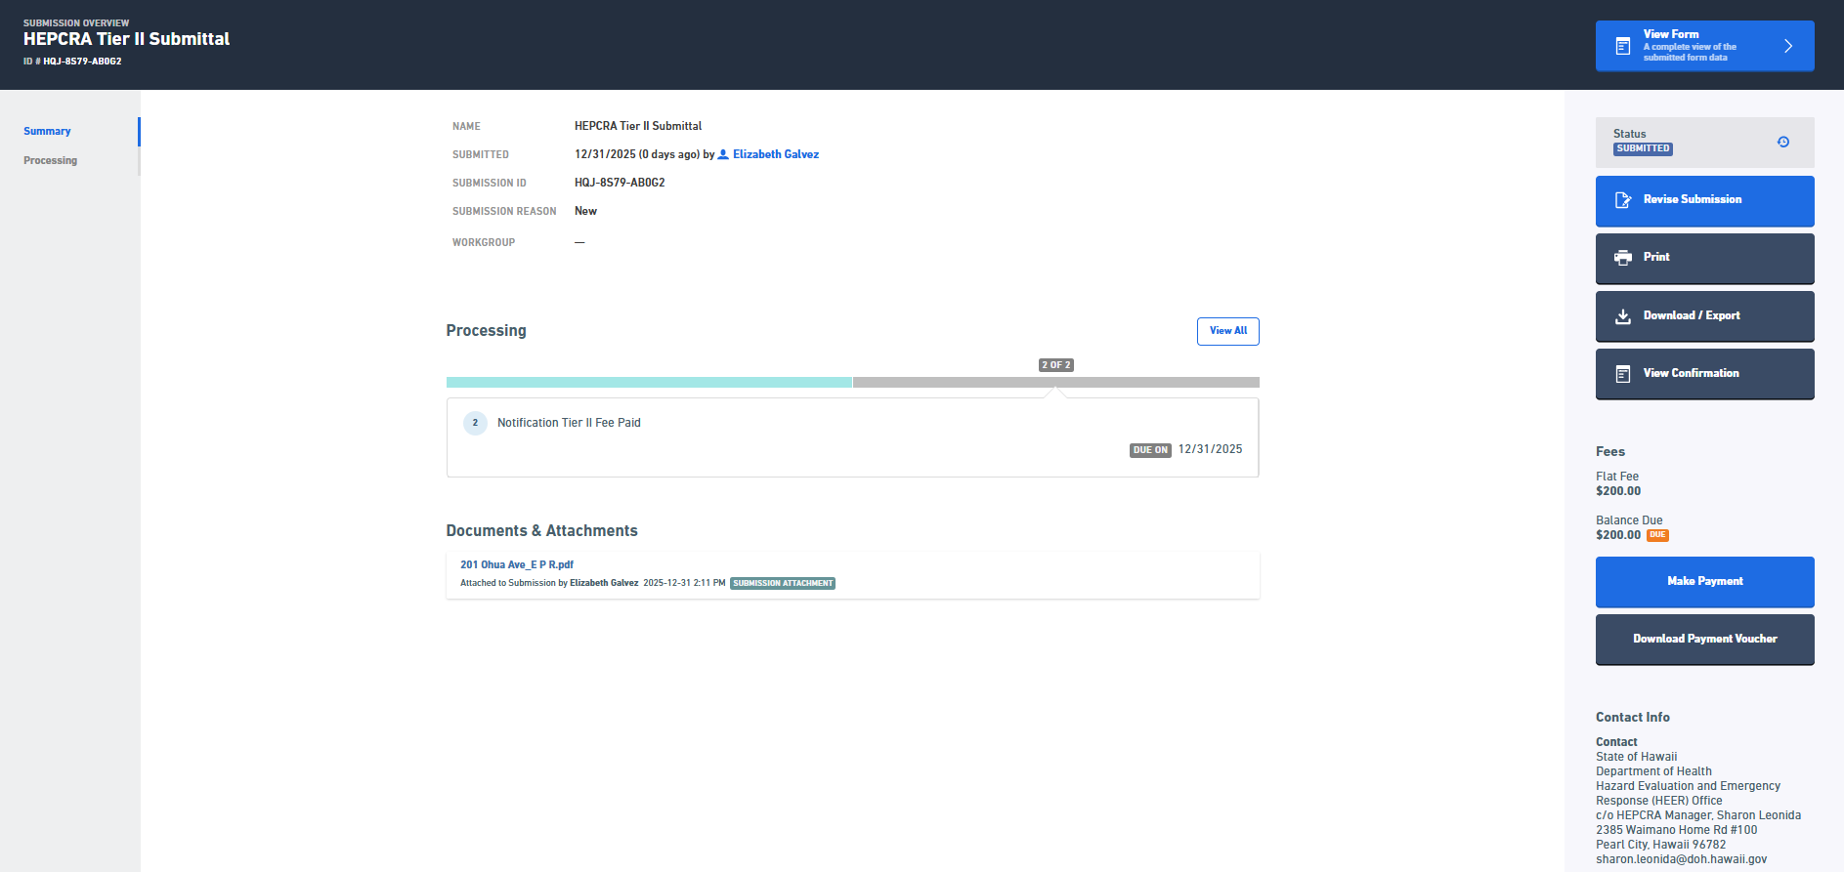
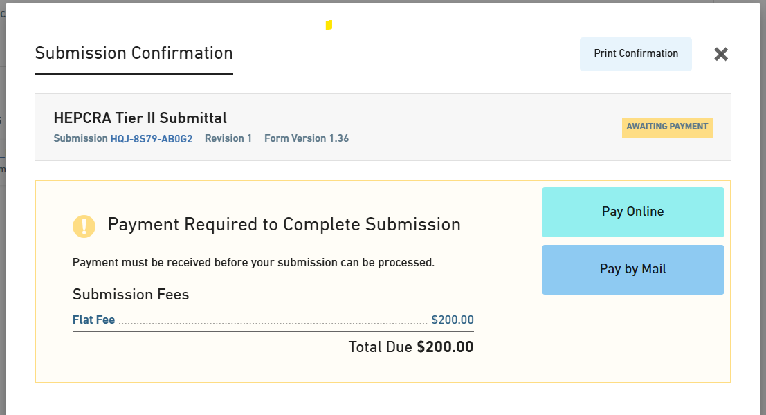
Payment

