Hawaii DOH E-Permitting System Instructions

- https://eha-cloud.doh.hawaii.gov/epermit/
Sign in if you already have an Account.
If using for the first time, Please Register to create a User ID in order to establish an Account. A verification e-mail will be sent to you.
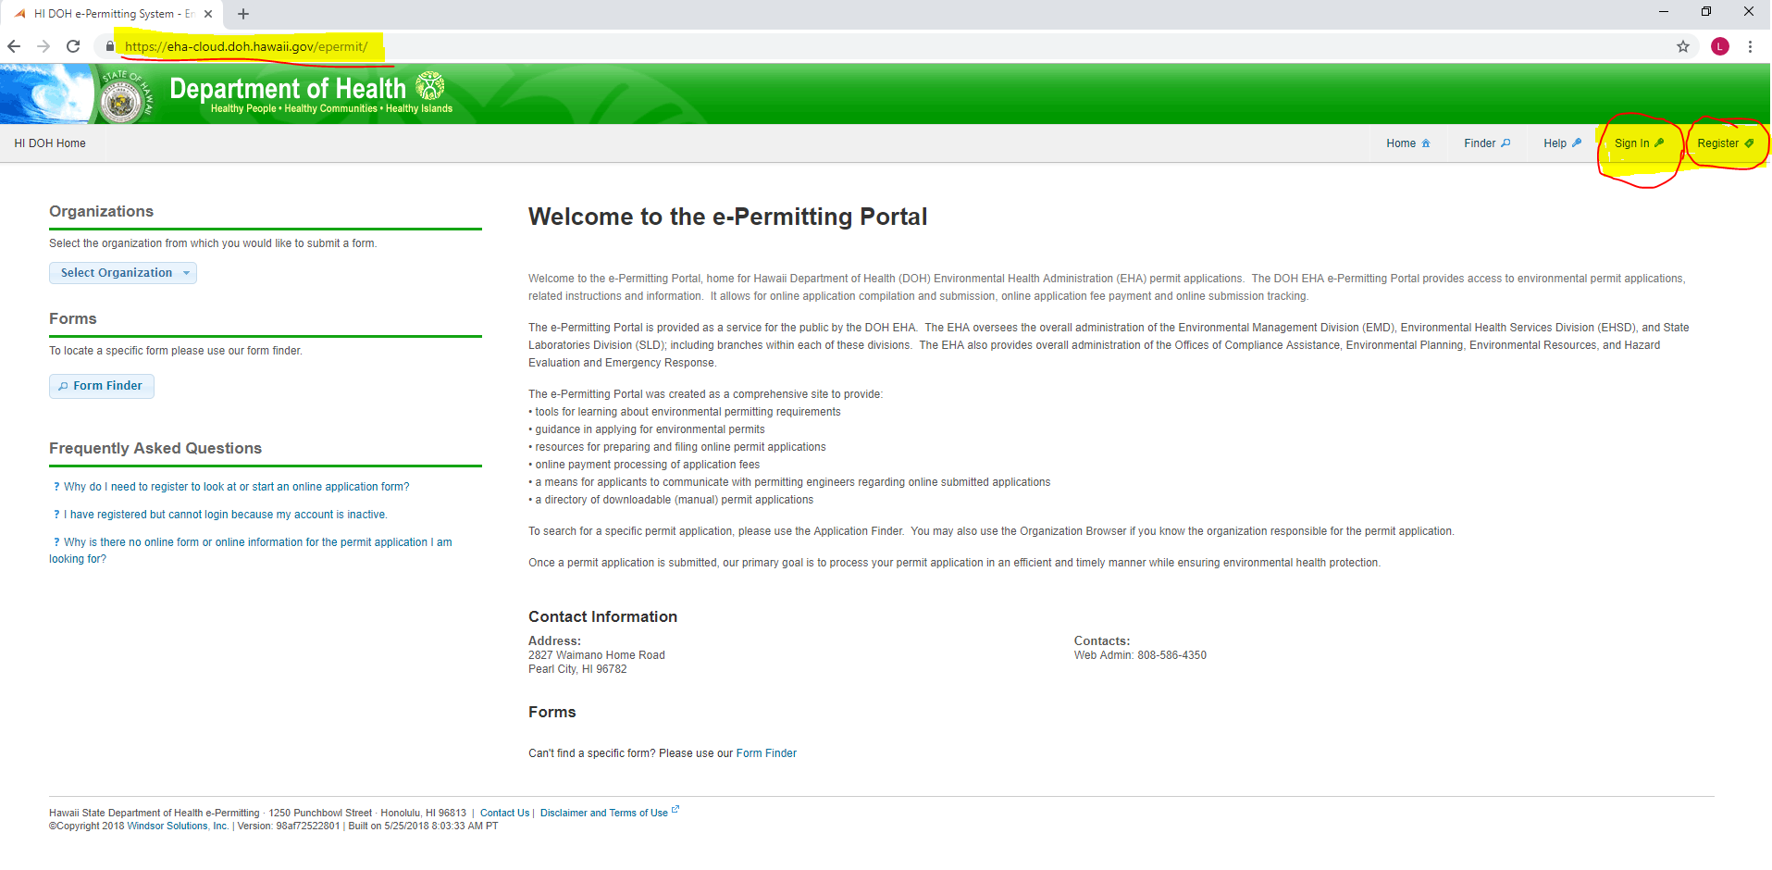
- To get into HEPCRA Tier II:
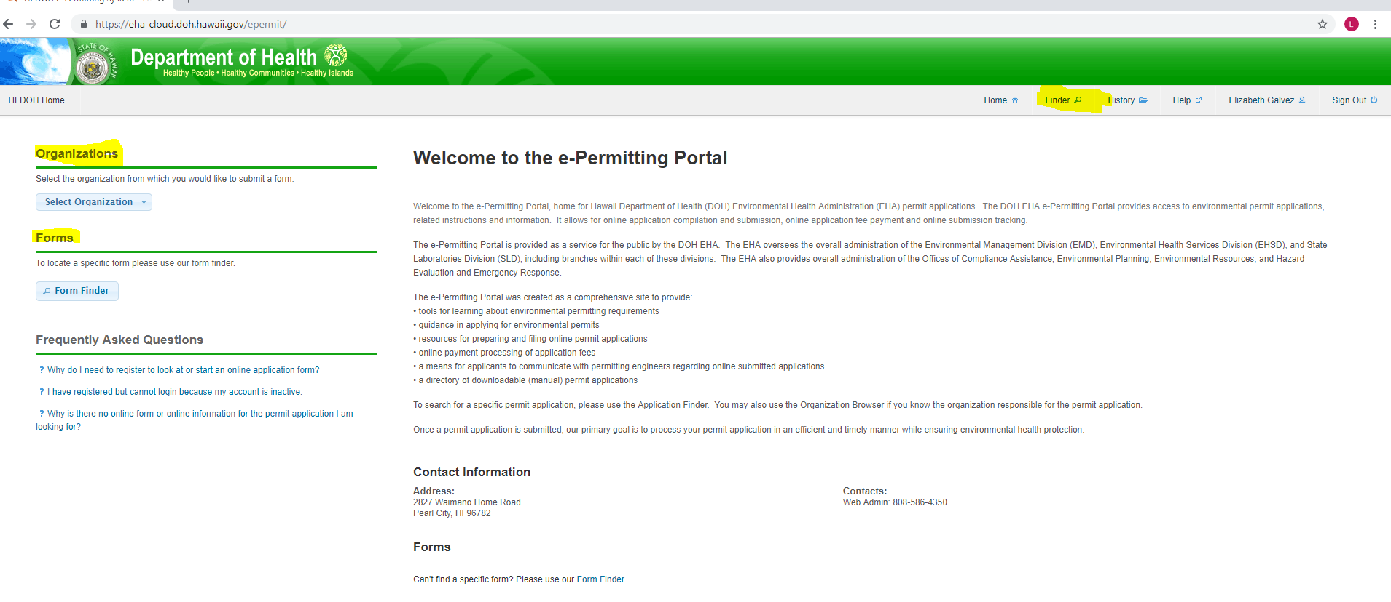
- Finder
c. Organizations
b. Forms

- Search using Finder. You will be forwarded to a screen with Form Search. Type in HEPCRA.

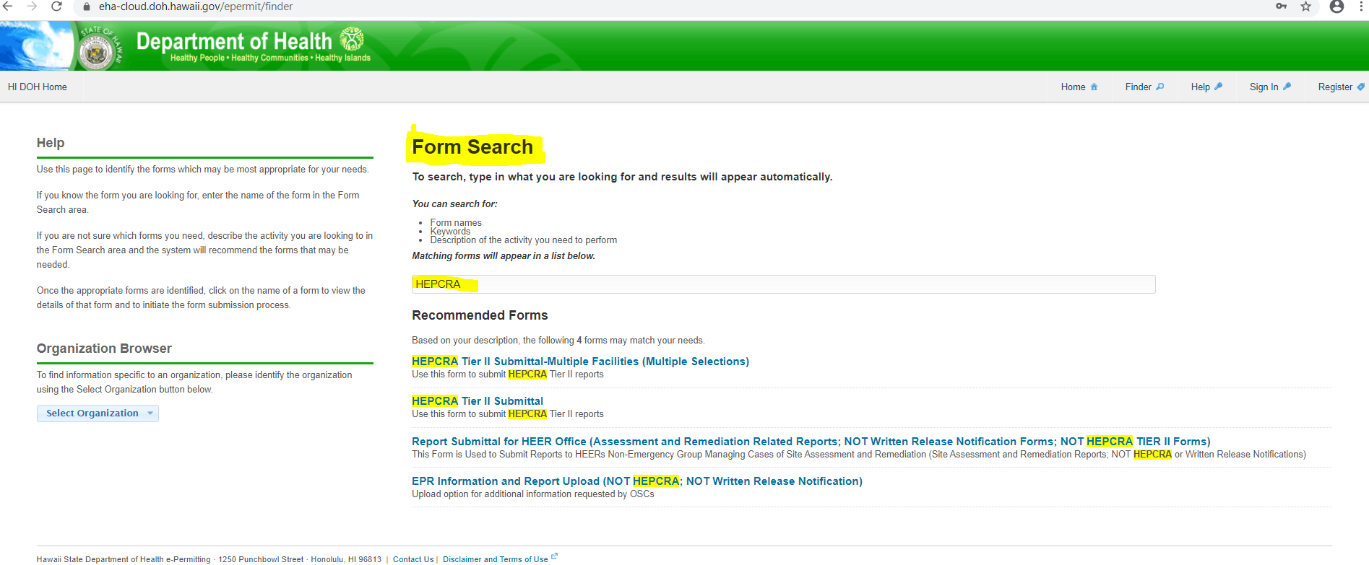

    - Select HEPCRA Tier II Submittal for a single facility; or,
    - Select HEPCRA Tier II Submittal-Multiple Facilities (up to 20 Facilities)

- Click on Begin Form Entry
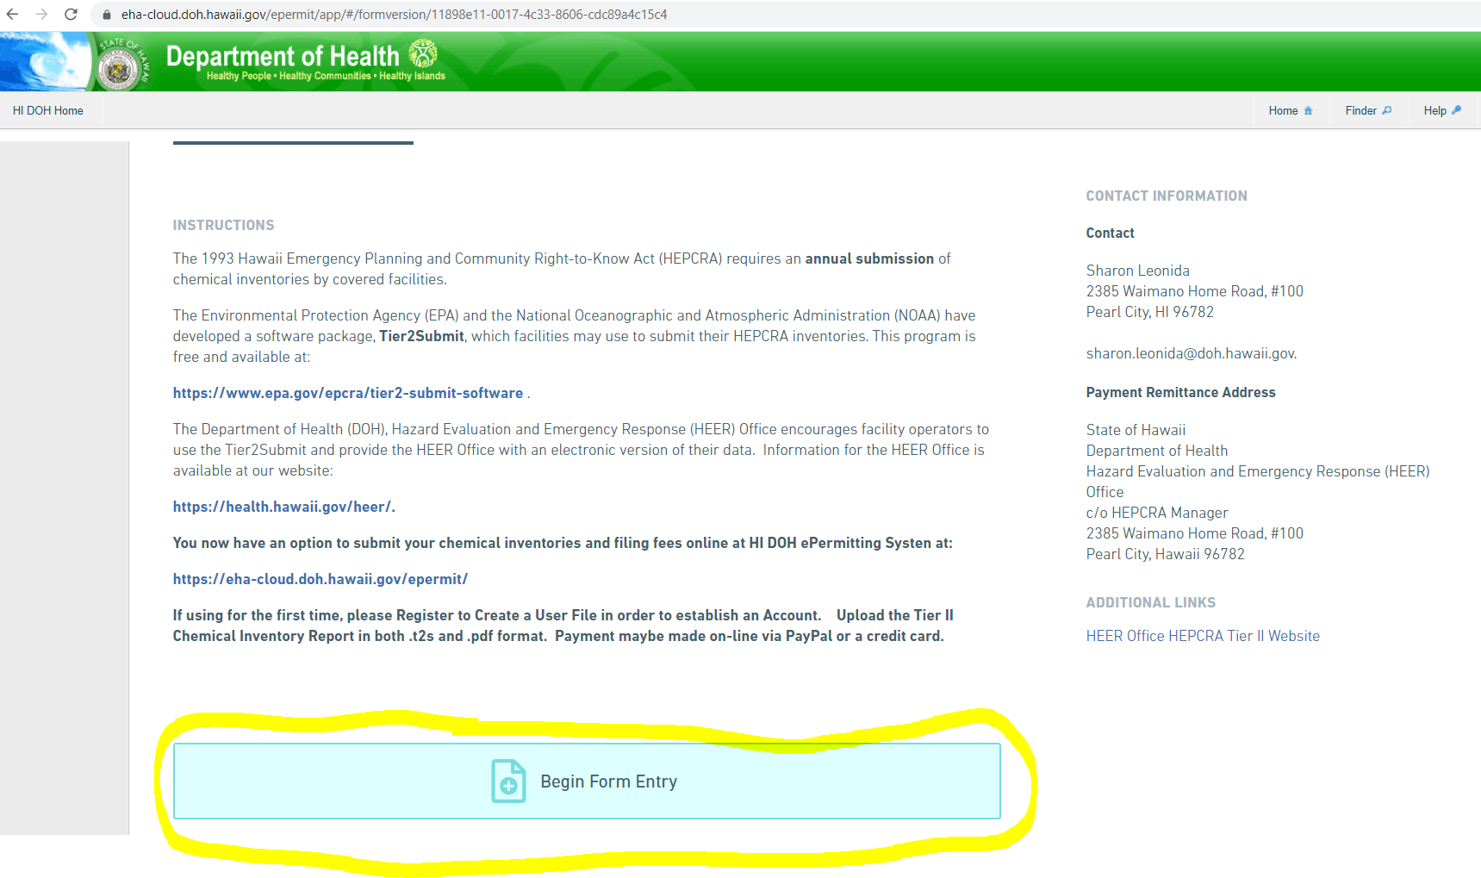
- Processing Info
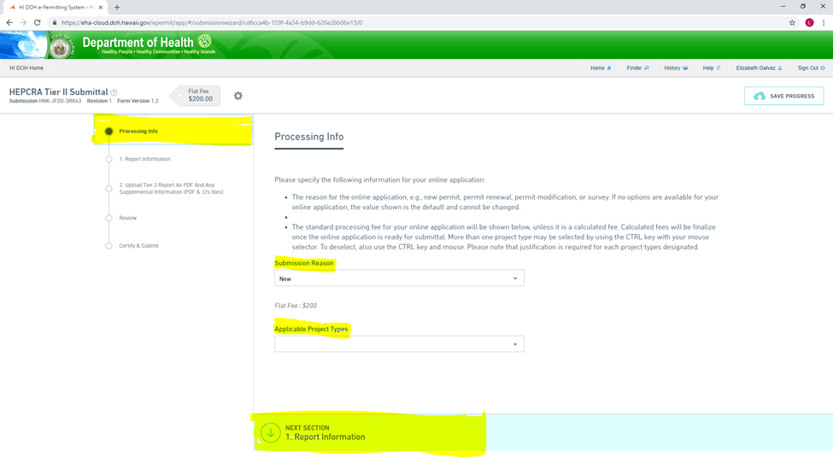
- Submission Reason ReaReasoSubmission Reason
c. Report Information
b. Applicable Project Types. Please leave blank.
- Submission

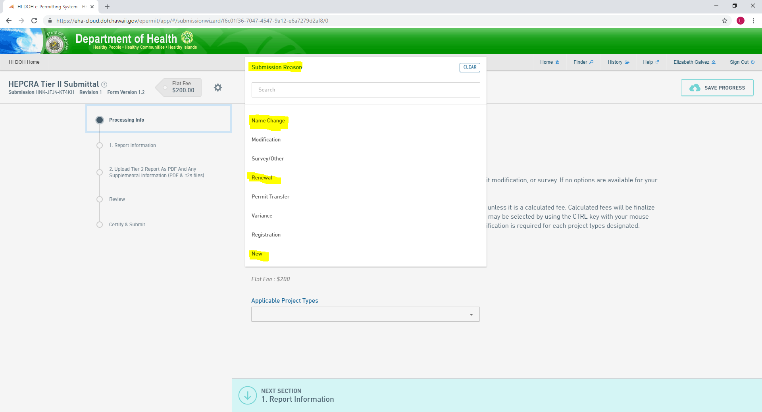
Submission Reason

- Applicable Project Types. Please leave blank.
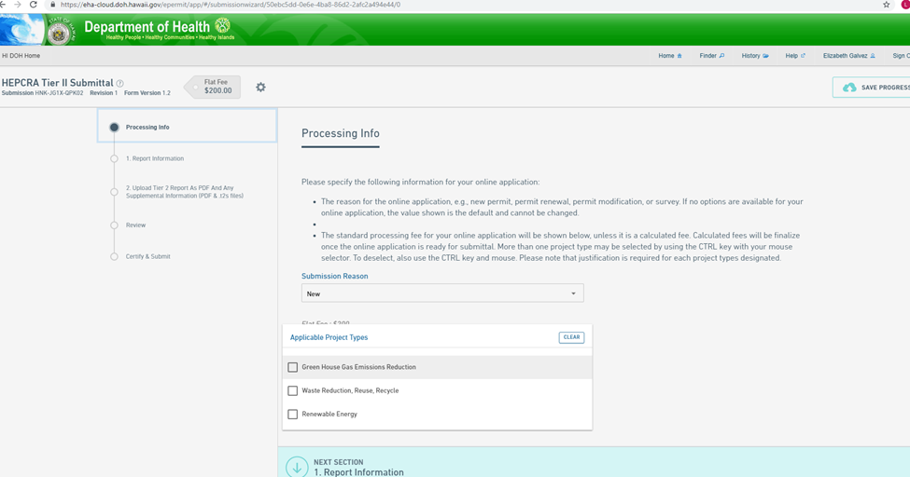
Applicable Project Types
- Click on Next Section 1.Report Information

- Report Information
a. Facility (Select One)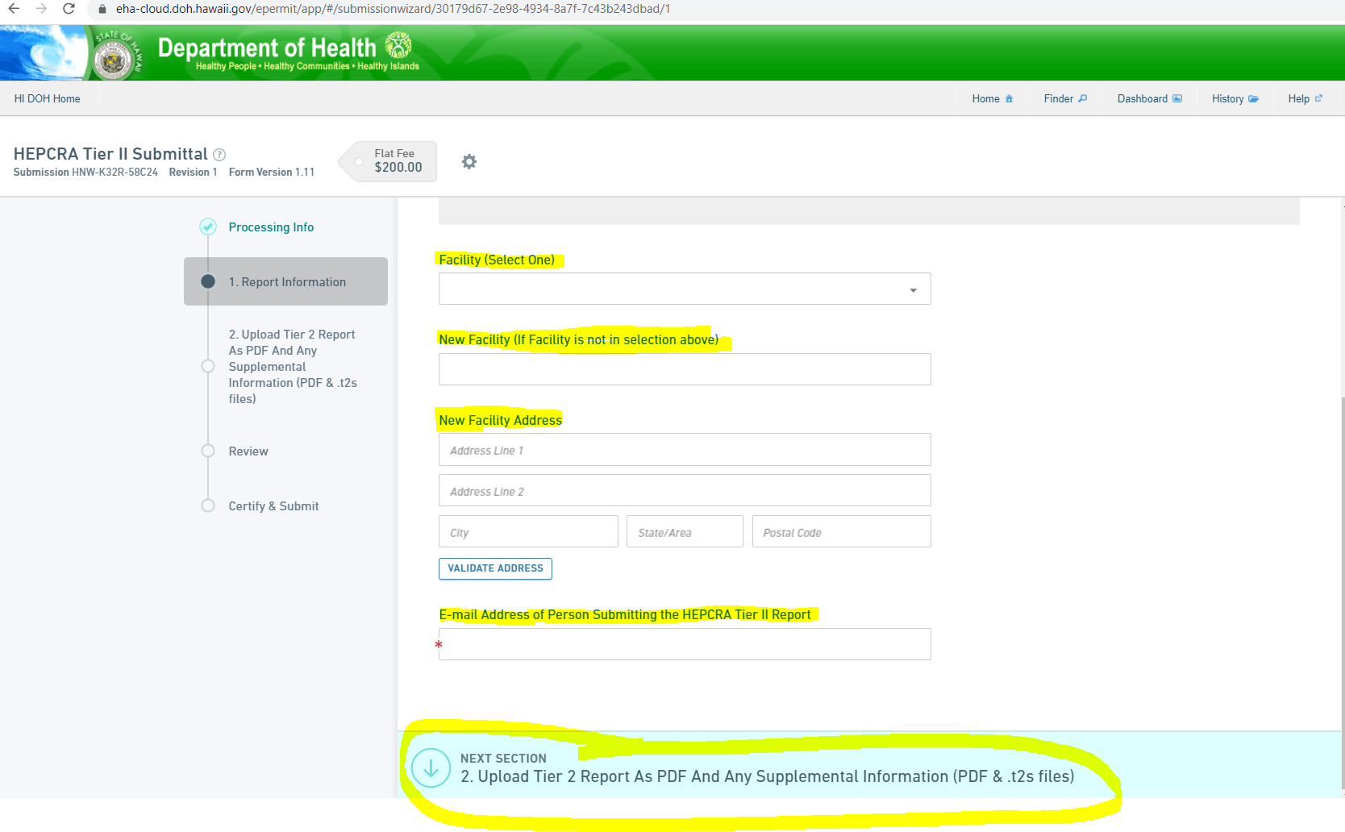
b. New Facility (If facility is not in selection above)

selection above
- Facility (Select One)
Type first three letters of facility
Type
e. Upload Tier 2 Report
c. New Facility Address
d. E-mail Address

Facility
- Facility
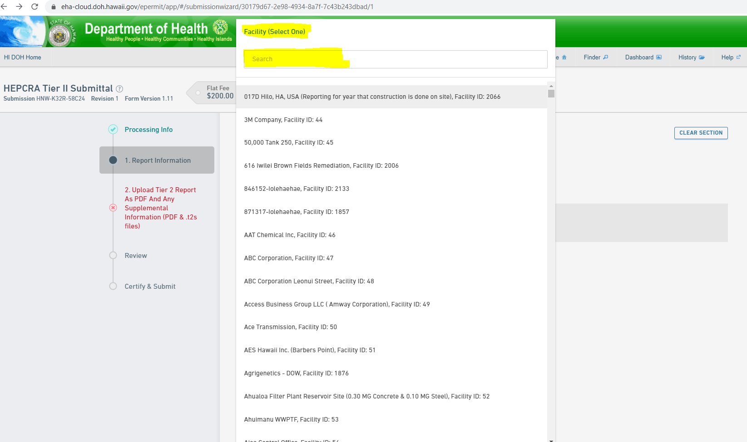

    - Type first three letters of facility name; or,
    - Select from a drop-down. Please note the unique Facility ID No.

- New Facility – Type in Facility Name if Facility is not in the Selection above. Notify the HEER Office as you will need to obtain a unique HEPCRA Facility ID number.

- New Facility Address

- E-mail address of Person Submitting the HEPCRA Tier II report.

- Click on Next Section 2. Upload Tier 2 Report As PDF and Any Supplemental Information (.pdf & .t2s files)

- Upload Tier 2 Report
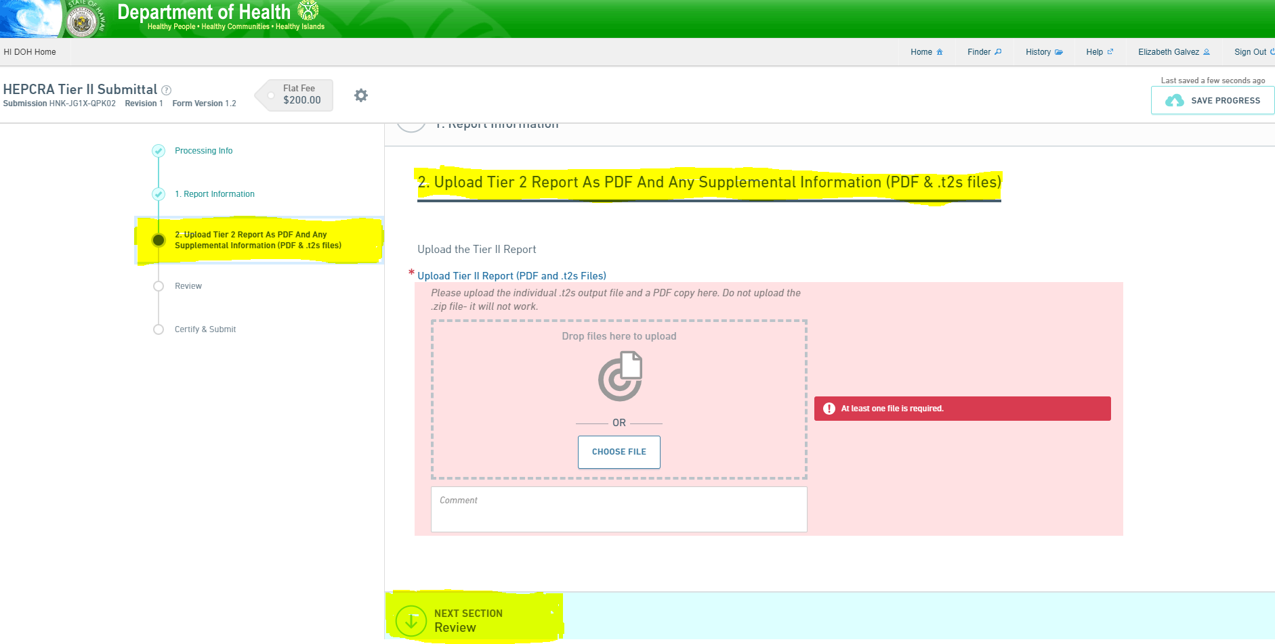
b. Review
- Upload .t2s and .pdf files
  - Upload .t2s output file and a .pdf copy. Do not upload a .zip file – it will not work. You may enter comments if you choose.

  - Click on Next Section Review.

- Review
- Please review and ensure that your entry is completed accurately, prior to the next step

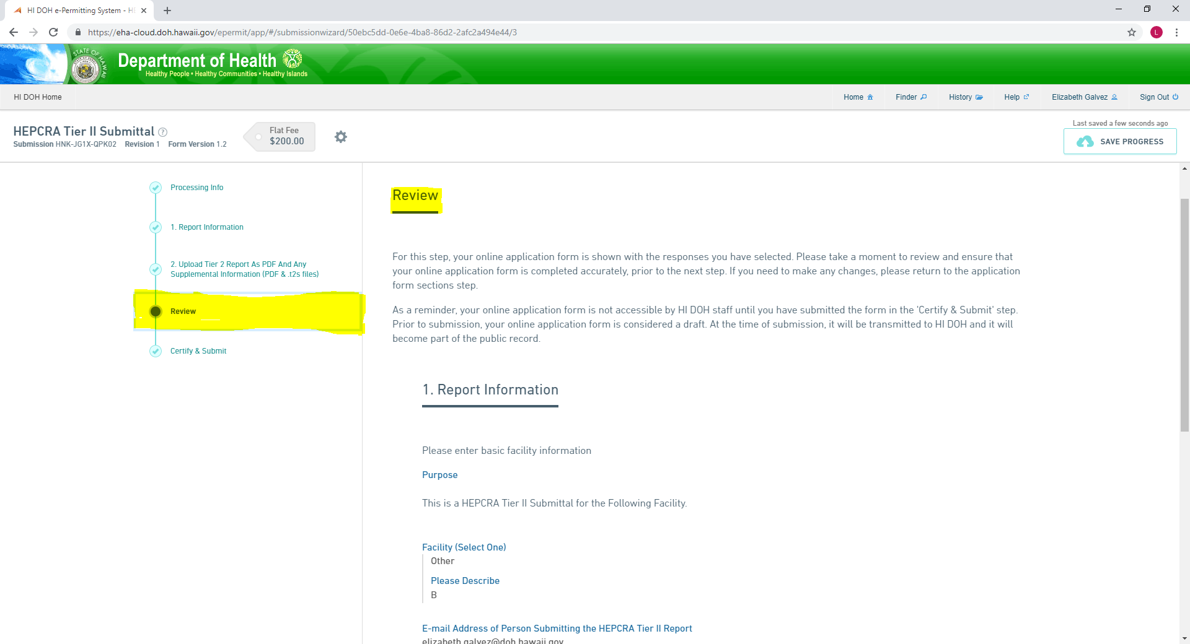
Review

- You may also click on Print Review if you want a print-out of your entry.
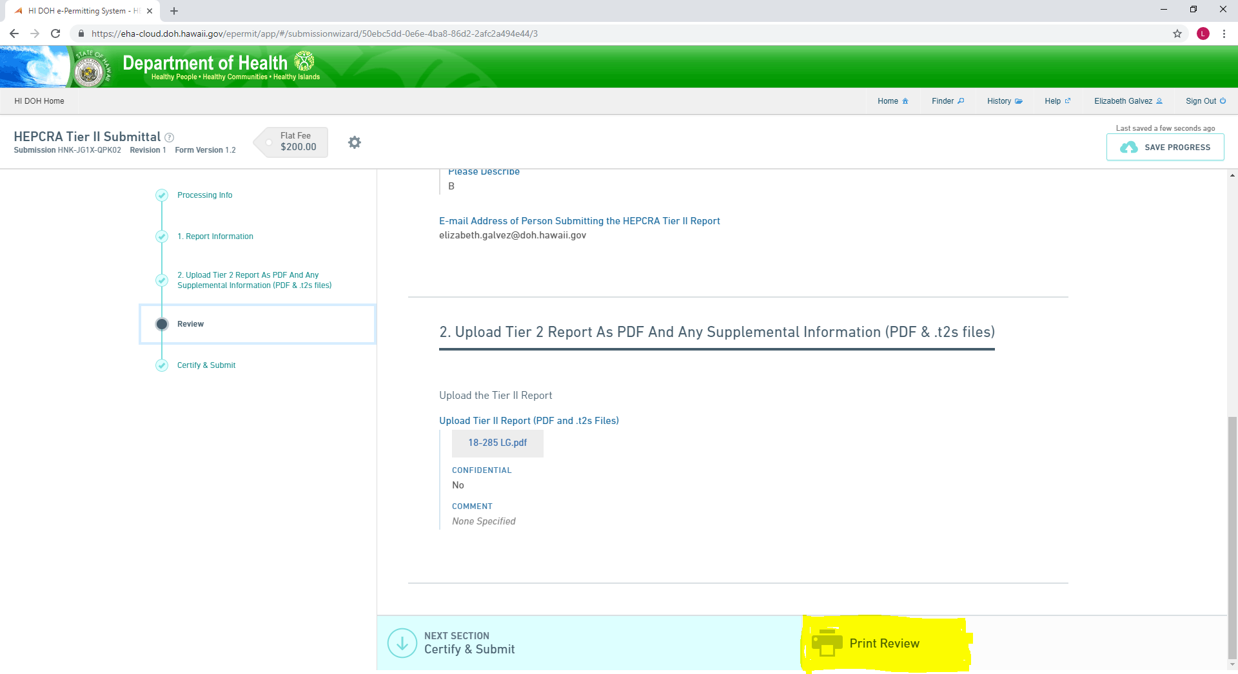
Print Review

- Certify and Submit
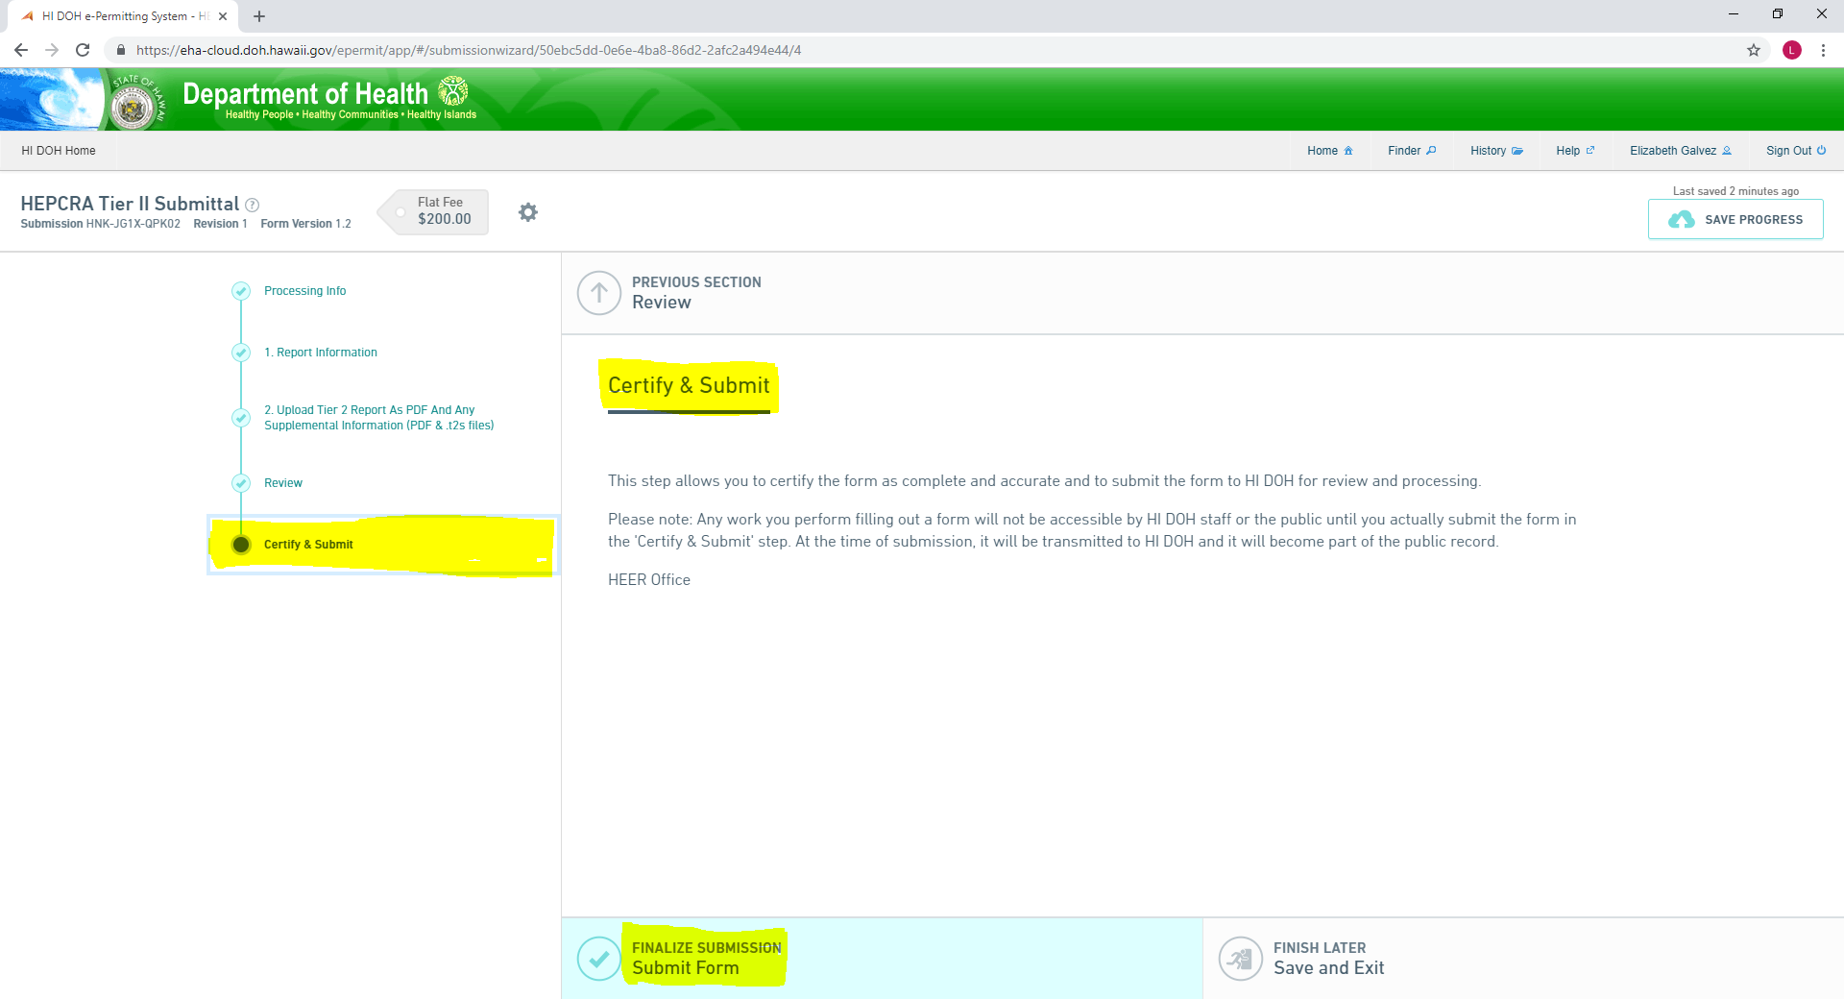 Once completed, please Click on Finalize Submission Submit Form for submission.
Submit Form

- Payment - $200.00 per facility
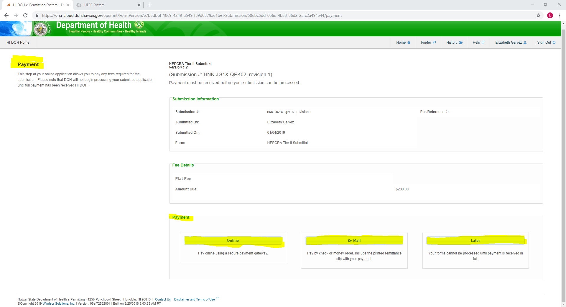
c. Later
b. By Mail
- Online
Payment
- Online
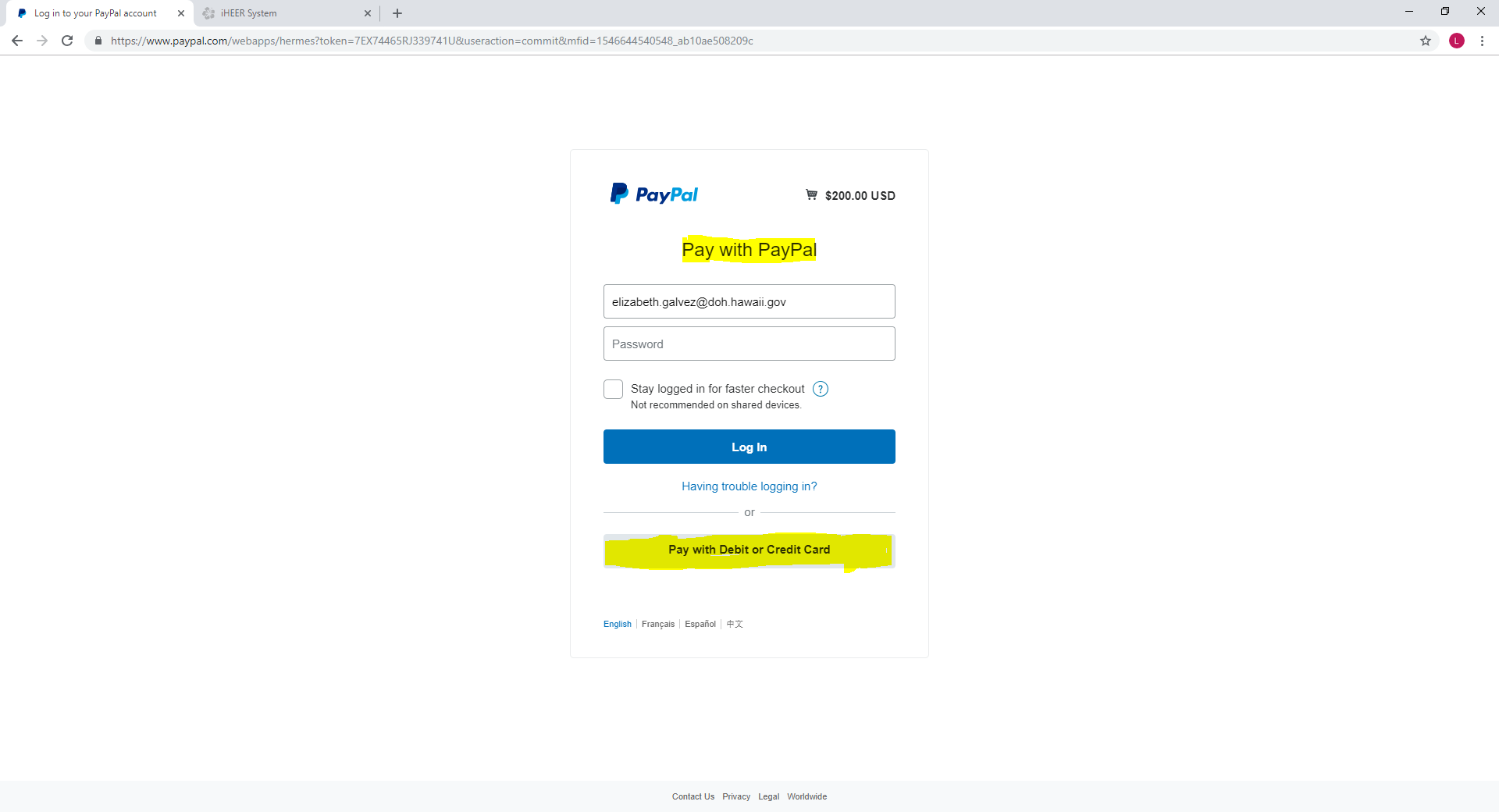
ii. Pay with Debit or Credit Card
- Pay with PayPal
  - Pay with PayPal or
  - Pay with Debit or Credit Card
After paying, please wait for the screen to return back to the previous page. This will allow the e-Permitting Portal to complete the process and the receipt will be sent to you and the HEER Office.

- By Mail – Please pay by check or money order. Include the remittance slip with your payment.

- Later - Your Tier II submittal forms cannot be processed until payment is received in full.

