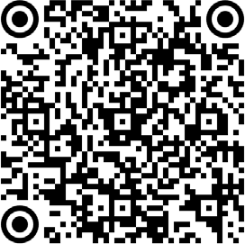
Lithium-Ion Battery Fire SAFETY INFORMATION
A Guide On What To Do If You Are Near A Lithium-Ion Battery Fire

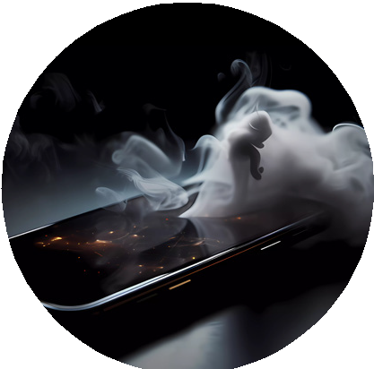
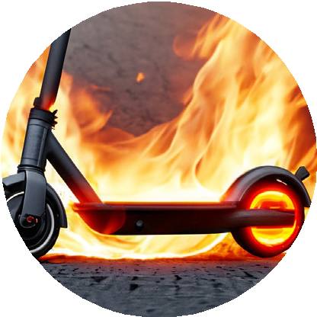
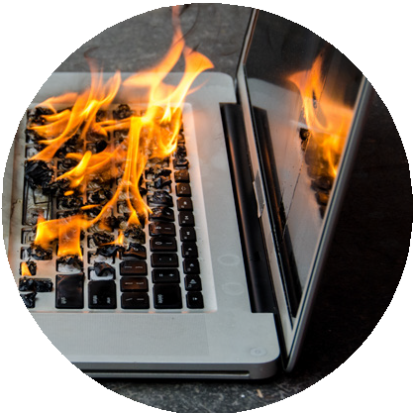
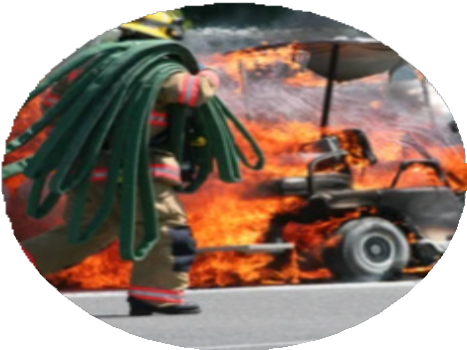
DETECTION

FACTS
Lithium-ion battery fires that resulted in fatalities have increased in recent years.
Fires involving lithium-ion batteries may result in rapid ignition and explosions strong enough to tear off walls, ceilings, windows and garage doors. Even after the fire has been extinguished, it can reignite at any given moment.

Thermal runaway, leading to a lithium-ion battery involved fire can be detected with a loud pop and hissing noise followed by a large amount of initially white smoke quickly followed by dark smoke that is highly toxic and flammable. The smoke can ignite within seconds.

SAFETY STEPS

EVACUATE
1
The fire cannot be extinguished by you. Evacuate safely upwind away from smoke (advised to be 330ft (100m) away from the device).
2

CALL 9-1-1
Call 9-1-1 to report a fire involving Lithium-ion batteries.

INFORM
3
Inform individuals nearby that there is a fire involving Lithium-ion batteries.

PREVENTION

- Ensure that the battery has undergone rigorous test- ing and has a trusted certification mark such as a UL (Underwriter Laboratory) or a CE marking.
- Only use the charger that came with the device.
- Do not overcharge devices.
- Do not store/charge on a bed, pillow or blanket.
- Do not use or charge damaged or wet batteries.
- Charge in a well ventilated area.
- Keep batteries at room temperature. Do not charge them at temperatures below 32°F (0°C) or above 105°F (40.5°C).
- Avoid throwing batteries in the trash. Take them to an accepted recycling facility instead such as but not limited to, Battery Bill LLC or Island Recycling for a small fee.

HAWAI’I STATE DEPARTMENT OF HEALTH HAZARD EVALUATION AND EMERGENCY RESPONSE OFFICE

Revised 09/11/23

