

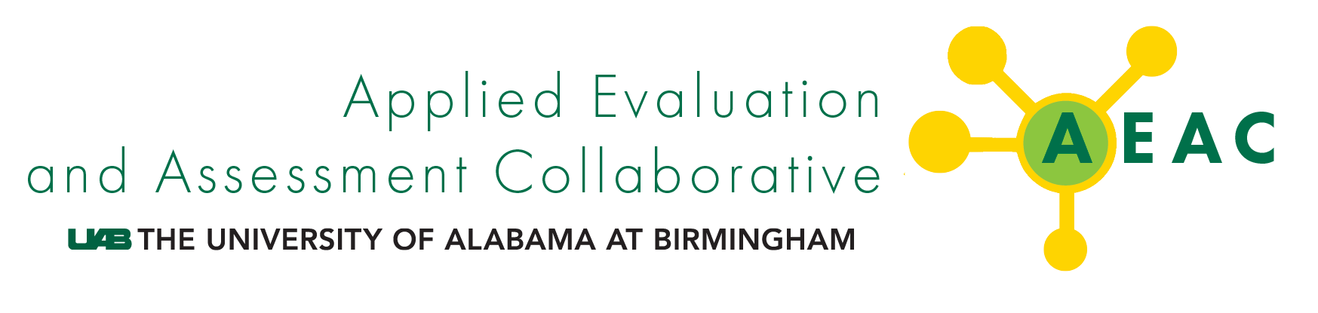

HDOH Title V MCH Needs Assessment May Partner Meeting
May 8-9, 2024
AC Marriott Hotel, Honolulu, HI

Background and Summary

Administered by the Hawaii Department of Health (HDOH) Family Services Division, the Title V MCH Needs Assessment is required to be conducted every five years. This process is used to identify needs, prioritize needs, allocate resources, and implement evidence-based strategies to solve issues. Extensive stakeholder engagement is required to make this process successful. HDOH staff conducted a two-day in-person meeting to present on secondary data findings, determine gaps in secondary findings, identify needs for primary data collection, establish a shared vision for engaging community partners, create community resource systems maps, pinpoint community resources to include in this process, and conclude potential gaps when collecting primary data with community partners.

The following describes highlights successes and limitations voiced by meeting attendees, including other HDOH staff, contracted HDOH agencies, and other community partners that serve the designated populations outlined by the Title V MCH Block Grant and Needs Assessment.

Day One: Review secondary data & identify needs for primary data collection

- Title V MCH Grant and Needs Assessment process and existing quantitative data for each of the Title V population domains (women/maternal, perinatal/infant, child, adolescent, CYSHCN).
  - Data Limitations
    - Additional context should be provided for disparity data, including clarifying where data are not available to assess disparities, and providing disclaimers that data are limited and that “no disparities” in these analyses does not mean with certainty that disparities do not exist.
    - Traditionally unheard voices should be centered. Many populations are left out of the existing quantitative data, including Native Hawaiian, Pacific Islanders, and Micronesian populations.
    - Qualitative data are needed to supplement the quantitative data, especially where data are scant, to make the stories and voices of the marginalized heard. We need to use a thoughtful, strengths-based, community-centered, and context-focused approach to speak directly to community members to understand their perspectives.
    - Data collection efforts should be intentional. It is important to consider the purpose and use of all data collected. How will we act upon what we learn?
      - This feedback is being used to revise the population domain overview documents and to inform our qualitative data collection plan. Specifically, we are focusing our efforts on centering the voices and stories of the marginalized and underrepresented.
- Prioritization of Health Indicators
- Domain: Maternal/Women
    - Priority Indicators: preventive health behaviors, including well-woman visit; general health status, including mental health status, and substance use
  - Domain: Perinatal/Infant
    - Priority indicators: preventive health behaviors, including early and adequate prenatal care, and postpartum visit; mental health, including postpartum depression, and postpartum mental health screening; maternal mortality and morbidity; preterm birth; and substance use
  - Domain: Child
    - Priority Indicators: mental health and related conditions, including children with mental health treatment; access to health care; preventive health behaviors, including developmental screening, physical activity, and preventive dental visit; child vaccination; and substance use and exposure.
  - Domain: Adolescent
    - Priority Indicators: adolescent mortality, including completed suicide; mental health and related conditions, including children with mental health treatment, depression, attempted suicides; teen births; bullying; preventive health behaviors, including adolescent well visit; access to health care; vaccination status; sexual behaviors, including sexually active, and used birth control; and substance use
  - Domain: CYSHCN
    - Priority Indicators: mental health and related conditions, including children with mental health treatment, and children diagnosed with autism spectrum disorder; access to health care, including medical home, and transition to adult health care; and preventive health behaviors
      - This feedback is being used to create a list of discussion topics and associated questions for use in qualitative data collection efforts.

Day Two: Establishing community standards and identifying partners for Title V MCH

- Engaging Those with Lived Experience
  - Who Should We Engage
- Native Hawaiian population
- Rural population/neighbor island residents
- Persons with substance use disorder
- Persons who are incarcerated
- Persons who are houseless
- Persons who identify as LGBTQIA+
  - System Mapping Exercise
    - Family characteristics
    - Collaborators
    - Support systems
    - Service system
    - Language considerations
    - Biases and myths
    - Barriers to care
    - Potential partners on each island
- This feedback is being used to identify priority population subgroups for qualitative data collection efforts and potential focus group community hosts and facilitators on each island.
  - Guiding Principles for Community Engagement
- Using data to tell a story, elevate unheard voices, create meaningful momentum, and improve population health
- Guarding against misinterpretation of data
- Leading with empathy, integrity, kindness, listening, and humility
- The feedback is summarized in two easy to reference handouts on data use and community engagement and is being used for the needs assessment and may also be helpful for others.

