Part C State Annual Performance Report (APR) for FFY 2006
Overview of the Annual Performance Report Development:
APR Process
The process to develop Hawaii’s Annual Performance Report for FFY 2006 included:
- HDOH identified a Part C Lead Agency Quality Assurance Team (LAQuAT) member to be responsible for specific indicators as identified in the approved State Performance Plan.
- On-going meetings with the identified LAQuAT members were held to prepare them for the statewide Stakeholders’ Meeting.
- There was broad dissemination regarding the Stakeholders’ Meeting to determine interest by agency, HEICC, and community members.
- Due to the available room, the number of attendees was limited to 75 and a cross-representation of participants was desired to ensure appropriate input into the review process.
- Based on the interest received and available space, invitations were sent to specific individuals to attend the APR Stakeholder meeting on December 18, 2007.
- Groups were separated based on the specific indicator. Each group was provided with copies of the SPP, the FFY 2005 APR, and the FFY 2006 data so that the group could determine:
  - The extent of progress/slippage for each indicator.
  - Whether target data, if a performance indicator, should be changed.
  - Whether Improvement Activities were appropriate as originally written or whether they needed to be revised, deleted, or if new activities were needed.
- Final recommendations by indicator were presented to all stakeholders.
- The LAQuAT met to discuss recommendations made and to determine which recommendations to include in the APR.
- Each LAQuAT drafted their specific indicator(s) for both the APR and the SPP if changes were made that required SPP changes.
- The APR draft was reviewed and revised, as necessary, by the Part C Coordinator.
- The APR was reviewed and approved by the HEICC Executive Committee which was authorized by the full HEICC. The HEICC Chairperson signed the APR certification form.
- The APR was sent to the Director of Health to review, approve, and sign the cover letter to accompany the APR to OSEP. While the report does not need to be signed by the Director of Health, it was decided that the Director should sign as the APR includes recommendations that could result in early intervention policy changes.
- The APR was submitted to OSEP as required.

Broad Representation

A stakeholder group of approximately seventy-five (75) individuals provided recommendations to the development of the APR and changes to the SPP. Because of Hawaii’s broad eligibility and geography, it was important that there was broad representation that included: Part C service providers and family members from all islands, from urban and rural areas, and the different ethnic and cultural groups that represent Hawaii’s population. The stakeholders were from the islands of Oahu, Hawaii, Maui, Kauai, and Molokai and included:

- Members of the Hawaii Early Intervention Coordinating Council (HEICC), Hawaii’s interagency coordinating council
- Members of the Part C Design Team which is responsible for directing Hawaii’s “What Counts” Early Childhood Outcomes grant (Indicators 3 and 4)
- Department of Health (DOH) administrators, service coordinators, direct service providers, quality assurance specialists, data staff, and personnel training staff from:
  - Family Health Services Division
  - Children with Special Needs Branch
  - Public Health Nursing Branch
  - Maternal Child Health Branch
  - Early Intervention Section
  - Early Childhood Services Programs
  - Healthy Start Programs
    - Department of Human Services administrators
    - Department of Education, Part B, Section 619 State and District Coordinators and Homeless representative
    - Purchase of Service Contracted Early Intervention Providers, including:

  - Early Intervention Section contracted providers
  - Healthy Start contracted providers
    - Community Members, including representatives from:

  - American Academy of Pediatrics (Hawaii Chapter)
  - Exceptional Family Member Program (military support program)
  - Foster Parent Association
  - Parent Information and Training Center
  - Head Start
  - Early Head Start
  - University of Hawaii
    - Parents

Reporting to the Public

The APR will be broadly disseminated in the State through: posting on the EIS website, providing information in various newsletters that reach providers and families (e.g., Hawaii’s Zero-to-Three newsletter, the Special Parent Information Network (SPIN) newsletter, and newsletters of Part C providers (e.g., Easter Seals Hawaii, Imua Family Services). Information will include the State’s progress and/or slippage in meeting the measurable and rigorous targets identified in the SPP and the performance of each early intervention program on the SPP targets.

Part C State Annual Performance Report (APR) for FFY 2006
Overview of the Annual Performance Report Development: Refer to Overview, pages 1-2.

Monitoring Priority: Early Intervention Services In Natural Environments
Indicator 1: Percent of infants and toddlers with IFSPs who receive the early intervention services on their IFSPs in a timely manner.
(20 U.S.C. 1416(a)(3)(A) and 1442)
Measurement: Percent = [(# of infants and toddlers with IFSPs who receive the early intervention services on their IFSPs in a timely manner) divided by the (total # of infants and toddlers with IFSPs)] times 100. Account for untimely receipt of services.

FFY | Measurable and Rigorous Target
2006 | 100%

Actual Target Data for FFY 2006:
Hawaii’s definition of timely services is consistent with OSEP’s direction as included in the FAQ document of 10/13/06. Timely services are defined as: “within 30 days from when the parent provides consent for the IFSP service or as projected based on the date provided in the IFSP and identified by the IFSP team.”

Monitoring Process

A total of 662 children were monitored within the time period 7/1/06 – 6/30/07 across the Part C programs, including the Early Intervention Section (20 programs), Public Health Nursing Branch (10 sections), and Healthy Start (16 sites). All programs/sections/sites utilized the Early Intervention Self Assessment Monitoring Tool which was developed by HDOH. Agency administrators of EIS, PHNB, and Healthy Start were first provided with drafts of the Early Intervention Self Assessment Monitoring Tool and provided an opportunity to give feedback as to format, readability, etc. When the tool was finalized, training was provided to Agency Administrators who in turn trained program managers and site supervisors.

Identification of Children. To ensure a random selection of children, the following criteria were followed:

- Names of all children with an Initial, Review or Annual IFSP between 7/1/06 – 4/1/07 were forwarded to HDOH. The timeframe was chosen to ensure that there were 3 months to confirm that services were provided in a timely manner within FFY 2006.

- HDOH identified 10% of children at each program/section/site, or a minimum of fifteen (15) children to be monitored, unless there were an insufficient number of children who met the above criteria. If there were an insufficient number of children, all were chosen to ensure as complete monitoring as possible.

Determination of Timeliness

Each program manager/supervisor was instructed to complete the Early Intervention Self Assessment Monitoring Tool for each selected child using the specified IFSP (Initial, Review, Annual). To be considered timely:

- For each child, all services on the Initial IFSP or all new service(s) on a Review or Annual IFSP must have met the above definition of “timely.”
.
For each child’s service:

- There must be confirmation via anecdotal notes in the official child’s record that the service(s) was provided and was timely.
- If the service was not timely due to a “family reason,” there must be confirmation of the family reason via an anecdotal note in the official child’s record (e.g., “child was sick; SLP cancelled.”)
- If the service was late, and there was no documented family reason (only a date of when the service occurred), “program reason” was checked and it was considered non-compliant with the provision of timely services.
- If there was no documentation that the service was provided, “program reason” was checked and it was considered non-compliant with the provision of timely services.

Self-Assessment Results

- Data were inputted into a database which was developed by HDOH and provided to each program/section/site.
- Each program/section/site forwarded their database with the self-monitoring results to HDOH as well as to their Agency administrator.
- HDOH analyzed the data for both correction of non-compliance with Timely Services (see Table 2 in Indicator 9) and to give back to each program/section/site as part of the identification of findings for FFY 2006.
- Any immediate corrective action needed (e.g., FERPA Notice not provided) was indicated on the monitoring form and shared with the appropriate individual with a due date for correction and follow-up.

Actual Target Data for FFY 2006:

Timely Services (FFY 2006)
No. of Children Who Received Services on their IFSP in a Timely Manner | 469
No. of Children with IFSPs | 662
Percent Timely | 71% (469/662)

Discussion of Data Results

- Family Circumstances for Documented Delays
Eighty-five (85) of the 469 children did not receive timely services, due to family reasons that were documented in the child’s chart. They are included in both the above numerator and denominator. Because many children received multiple services, these 85 children had 129 services that were late for the following family reasons:

Family Circumstances | #
Family cancellation | 25
Family/child sick | 24
Family missed appointment | 23
Family did not return calls | 20
Family schedule | 16
Family request | 10
Family vacation | 6
Other | 3
Family reason not explained | 2
Total | 129

Untimely Reasons for Delay

- Program Reasons for Delays
One hundred ninety-three (193) children (29%) did not receive timely services due to program reasons. Because many children received multiple services, there were 322 program reasons for delays in service provision:

Program Reasons | #
Lack of documentation in child’s chart | 268
Staff vacancy | 16
Staff not available | 15
Staff on extended leave | 8
Staff sick | 5
Obtained prescription late | 2
Schedule confusion | 1
Other | 7
Total | 322

Data Results by Service – Timely Services (83%)
Data on timeliness by service was also analyzed in order to better understand the possible reasons for lack of timeliness, as the majority of children generally have multiple services on their IFSP. The 662 children monitored had a total of 1,819 services listed on their IFSPs, of which 83% were timely (1,504/1,819) which includes the services late due to a family reason.

- Data Results by Service - Delays due to Program Reasons (17%)
322 services were not timely due to program reasons:
- 268 of the 322 (83%) late services were due to lack of documentation.
- 74 of the 268 (28%) late services due to lack of documentation were service coordination services.

Previously Identified Non-Compliance
FFY 2005 monitoring (on-site chart reviews) resulted in 6 findings for Timely Services (See Table 2 in Indicator 9). FFY 2006 monitoring (self-assessment) of these 6 findings resulted in correction of 1 finding.
Reasons for continuing non-compliance for the remaining 5 findings were analyzed both by Reason and by Type of Provider to determine if the reasons were specific based on Type of Provider.

The 5 findings included 42 separate services that were not timely. Reasons for non-compliance were:
- No documentation – 27
- Conflict with providers’ schedule – 5
- Position vacancy or contracted provider not available – 5
- Service scheduled late – 2
- Staff sick – 2
- Other – 1

Non-Compliance based on type of provider found that:

- Analyzing the above reasons by provider (Service Coordinator, SLP, OT, PT, Special Instructor, Assistive Technology staff, and Nurse) found similarities across providers; all were inconsistent in documenting the delivery of services.

- Monitoring instructions required that documentation must be in the child’s chart or in order to be counted as “timely served.”

- Documentation that was only found as part of the billing system was not sufficient.

Therefore, because of the lack of sufficient documentation, many services were counted as “late,” when in fact they might have been timely.

Corrective Actions:

For each of the 5 programs that did not correct their non-compliance for Timely Services, they must:

1. Analyze the reasons for lack of timely services.
2. Develop a Corrective Action Plan (CAP) specific to the reasons identified and submit it to both their Agency and HDOH for approval. The plan must include timelines and if necessary, identify technical assistance to support their correction.
3. Provide monthly documentation on Timely Services in each child’s Initial, Review, or Annual IFSP to its Agency.
4. HDOH will review monthly data to determine progress toward correction and provide feedback to support correction. CAP must be revised after 3 months if data does not show progress.
5. HDOH will do on-site chart reviews quarterly to assure progress.

Next year’s APR will include data on the correction of these 5 findings from FY 2005. In addition, data will be provided on the correction of any non-compliance resulting from the FFY 2006 monitoring process related to Timely Services.

Discussion of Improvement Activities Completed and Explanation of Progress or Slippage that occurred for FFY 2006:

Explanation of Progress
The current data on provision of Timely Services shows slight improvement over last year’s data.
- FFY 2005 compliance was at 69%.
- FFY 2006 compliance was at 71%.
Consistent with last year’s monitoring, the major issue this year was lack of consistent documentation.
Results of this year’s monitoring, including the analysis of the reported data, will be shared with all program managers/supervisors to emphasize the importance and urgency of timely services. Issues will continue to be discussed to problem-solve the around the lack of documentation as well as other identified issues that impact the delivery of timely services.
A current Improvement Activity has been revised to support the provision of Timely Services, specifically in the areas of increased self-monitoring and training in appropriate documentation.

Improvement Activities Completed

- Review and revise current guidelines for families moving from out-of-state to Hawaii and between programs regarding the use of their current IFSP:

- Guidelines for families moving to Hawaii with an IFSP and between programs were revised in March 2006 and have been incorporated into the mandatory EI Orientation Training. The guidelines were developed in response to a concern that there was a delay in services of children moving to Hawaii with an IFSP and children moving between EI programs.

Improvement Activities Continuing

Information is provided on the Improvement Activities included in the SPP and were implemented in FFY 2006. The following Improvement Activities supported the progress in increasing the percentage of infants and toddlers receiving timely services. Following is information for each Improvement Activity and how it supported progress.

- Develop centralized database to use with all Part C eligible children to avoid duplication of programs serving children:

- The Lead Agency has developed a system in which the Hawaii Keiki Information Service System (H-KISS), its central point of contact, has access to referral information on all children that are referred to the Hawaii Part C system.

- When H-KISS receives a referral for a child who may be Part C eligible, H-KISS will first check the EIS database, PHNB database, and Healthy Start database to determine if the child is already in service. If already enrolled, H-KISS will provide updated referral information to the program currently serving the child. Due to confidentiality, H-KISS will not inform the referral agent that the child is already in services, but will treat it as a new referral.

- Identify issues, develop strategies, and provide training to support timely services:

- The major issue identified in this year’s monitoring was lack of consistent documentation. While some programs verbally reported that many of the services were actually provided on time, because they were not documented, HDOH did not consider them timely. Below are additional challenges for proper documentation. Also refer to the revised Improvement Activity to support these challenges.

1. Some children receive services from more than one agency. Documenting and tracking services provided by other agencies is more challenging.
2. There are currently no guidelines requiring service providers to give the service coordinator information regarding the timeliness of services they provide to the child.
3. Vacant EIS Quality Assurance positions impacts supporting programs with documentation issues.

- High workload due to lack of staff contribute to lack of timely services.
.
- Review professional standard requirements in the current Early Intervention State Plan for adequacy in meeting service needs of Hawaii’s Part C population, and update if determined necessary:

- HDOH is encouraging the hiring of Certified Occupational Therapy Assistants and Physical Therapy Assistants to increase staff to provide early intervention services.

- Identify recruitment incentives for “difficult to serve” areas:

- Discussions were held with potential Purchase of Service agencies on their ability to provide increased salaries and recruitment bonuses, with justifications, for “difficult to serve” areas.
- Actions are in place to implement the “hire above minimum” protocol for state programs that have long-term vacancies.
- Continue to explore opportunities through the legislature to create incentives for “difficult to serve” areas.

- Explore staffing options (e.g., “loan” staff to other programs; collaborate with DOE/Head Start, etc):

- HDOH is partnering with Easter Seals Society to support a legislative bill for a loan forgiveness program to encourage Hawaii students on the mainland to return and work in Hawaii after receiving their professional therapy degrees.

- Evaluate the effectiveness of the improvement activities designed to support 100% compliance in providing timely services:

- The current Improvement Activities have been minimally effective as there has been limited increase in achieving compliance.

- Identify, implement, and evaluate new strategies as needed:

- Revised Improvement Activities have been developed to support increased compliance. The effectiveness of the new strategies will be evaluated and revised yearly, as indicated by the data on timeliness.

Revisions, with Justification, to Proposed Targets / Improvement Activities / Timelines / Resources for FFY 2007.

Revised Improvement Activities:
Improvement Activities | ‘05 | ‘06 | ‘07 | ‘08 | ‘09 | ‘10
Previous:  Identify issues, develop strategies, and provide training to support timely services. | X | X | X | X | X | X
Revised:  Identify issues, develop strategies, and provide training to support timely services. Strategies, including training, are:  - Include definition of “timely services” in EI Part C Orientation to assure that all staff is aware of the definition.  - Set up a schedule of, at a minimum, semi-annual self-monitoring utilizing the current monitoring tools.  - For any program/section with a finding, self-monitoring is increased to quarterly review.  - Include requirements for contracting agencies to regularly report to service coordinators on dates of when services were provided.  - Provide training to Managers, supervisors, QA staff on how to properly utilize the tools to ensure all are following the correct protocol.  - Develop and provide training to all Part C programs on acceptable documentation of provision of services |  |  | X  X  X  X  X  X | X  X  X  X  X  X | X  X  X  X  X  X | X  X  X  X  X  X

Justification:
Because data shows slight progress towards compliance, additional strategies were developed to support continued correction of non-compliance and to support increased compliance.

Part C State Annual Performance Report (APR) for FFY 2006
Overview of the Annual Performance Report Development: Refer to Overview, pages 1-2.

Monitoring Priority: Early Intervention Services In Natural Environments
Indicator 2: Percent of infants and toddlers with IFSPs who primarily receive early intervention services in the home or programs for typically developing children.
(20 U.S.C. 1416(a)(3)(A) and 1442)
Measurement: Percent = [(# of infants and toddlers with IFSPs who primarily receive early intervention services in the home or programs for typically developing children) divided by the (total # of infants and toddlers with IFSPs)] times 100.

FFY | Measurable and Rigorous Target
2006 | 74.5%

Actual Target Data for FFY 2006:
The following data is the percent of infants and toddlers with IFSPs who primarily received early intervention services in the home or community settings which for this reporting period is the same as programs for typically developing children, based on Section 618 Child Count data of 12/1/06:

Early Intervention Services in Natural Environments
Based on Child Count Data of 12/1/06

Part C Agencies | % | N
Early Intervention Section Programs | 89% | 1,383/1,552
Public Health Nursing Branch Sections | 96% | 480/500
Healthy Start Sites | 100% | 1,874/1,874
All Part C Children | 95% | 3,737/3,926

Based on this data, the target of 74.5% for FFY 2006 was surpassed for All Children in Hawaii’s Part C program. Further breakdown of the data showed that all Part C Agencies (EIS, PHNB, and Healthy Start) also surpassed the target.

Related Requirements
A related requirement and included as a Hawaii priority is ensuring that justifications are included in the IFSPs if services are not provided in a natural environment. Hawaii continues to monitor IFSPs to determine to what extent appropriate justifications are included in IFSPs when the children are not served in the natural environment. See Indicator 9 for data on timely correction in this area.

Discussion of Improvement Activities Completed and Explanation of Progress or Slippage that occurred for FFY 2006:
Explanation of Progress

In addition to surpassing the target, based on Child Count data, there was also an increase, when compared to last year’s data, in the percentage of all infants and toddlers with IFSPs who primarily received early intervention services in the home or programs for typically developing children. Data was also analyzed for children by Agency, including EIS, PHNB, and Healthy Start.

- All Children: Current data = 95%, an increase from the previous year’s 90%.
- EIS programs: Current data = 89%, an increase from the previous year’s 81%.
- PHNB sections: Current data = 96%, an increase from the previous year’s 92%.
- Healthy Start: Current data = 100%, the same as last year.

Healthy Start data continues to show 100% as children who are at environmental risk for developmental delays are always served in the home or through community activities.

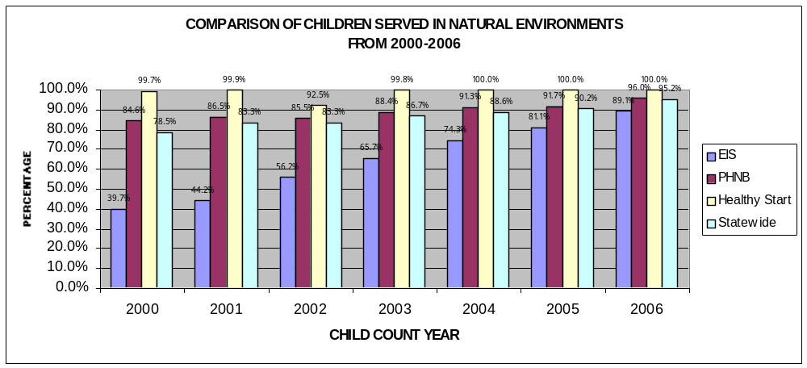The following table shows the on-going increase since 2000.

Improvement Activities Continuing
Information is provided on the Improvement Activities included in the SPP and were implemented in FFY 2006. The following Improvement Activities supported the progress in increasing the percentage of infants and toddlers served in natural environments this year. The following provides information for each Improvement Activity and how it supported progress.

- Closely analyze program data in order to target state efforts to improve services in natural
Environments (NE):

  - The analysis of the data shows continual increases in EIS, PHNB, and Healthy Start.

  - Of particular importance is the increase in EIS children served in NE (from 81.1% to 89.1%), as these children were traditionally served in center-based programs for children with developmental delays.

  - HDOH will continue to analyze the Child Count data to track trends.

- Develop guidelines and training on what it means to provide services in NE, including the
definition and philosophy of NE (e.g., not just a change in location but a change in professional practice):

- The required Part C Orientation for all new Part C staff includes information on the definition of NE, including the concept of how to utilize services to support family routines.

- During FFY 2006, a total of 105 staff participated in the Part C Orientation training.

- “Points of Clarification” on this topic have been developed and disseminated to all Part C programs and will be included on the EIS website.

- Develop partnerships with families to enhance their knowledge and ability to support their
child’s development:

- Service coordinators continue to be trained in the concept of NE so they can discuss this concept at Intake with families.

- Provide training in NE guidelines:

- As noted above, 105 staff participated in training on NE definitions and guidelines.

- Part of the training included what are appropriate justifications for services not provided in NE. Appropriate justifications for services not provided in NE is a Hawaii monitoring priority.

- Provide training on “location of services” indicator, as part of the Child Count data:

- Each year the instructions for the Child Count data are reviewed and updated to ensure that they are interpreted correctly by all programs/sections/sites and accurate data is reported.

- If questions are received as part of the collection of Child Count data in NE, the instructions are reviewed and updated the following year to clarify data collection procedures.

- Identify and provide support needed by community programs that serve the 0-3 population
(e.g., community preschools) to support their ability to serve children with special needs:

- By providing training via the Inclusion Project to community preschools and child care providers on how to successfully include infants and toddlers with special needs in their programs, the number served in these NE settings increased, which impacted the total number of children served in NE.

- The Inclusion Project, through financial support from the Hawaii Department of Human Services Child Care Development Block Grant (CCDBG), provides tuition support so Part C children with developmental delays can attend a community preschool or receive child care from a community provider.

- During FFY 2006, 46 children received tuition support to attend either a community preschool or receive child care from a community provider.

- During FFY 2006, 2 trainings were conducted to community programs on including children with special needs in their programs.

- During FFY 2006, the Inclusion Project provided 7 consultations to community programs on creating inclusive environments for children with special needs.

- Evaluate the effectiveness of the improvement activities designed to increase the
provision of services in NE: The effectiveness of the improvement activities is evaluated by the increase in compliance in meeting the target. Based on the increased percentages, the activities appear effective.

Revisions, with Justification, to Proposed Targets / Improvement Activities / Timelines / Resources for FFY 2007.
Revisions, with Justification, to Proposed Targets:
The Proposed Targets have been revised as follows:
- FFY 2007: from 75% to 80%
- FFY 2008: from 75% to 85%
- FFY 2009: from 75.5% to 90%
- FFY 1010: from 76% to 90%
Justification:
Because there has been a continual increase in serving children in their natural environment, the stakeholders recommended that the targets be revised to be consistent with the NE requirements as outlined in Early Intervention Program Purchase-of-Service contracts.

Revised Improvement Activities and Timelines

Improvement Activities | ‘05 | ‘06 | ‘07 | ‘08 | ‘09 | ‘10
Previous:  Develop guidelines and training on what it means to provide services in Natural Environment (NE), including definition and philosophy of NE, (e.g., not just a change in location, but a change in professional practice). | X | X
Revised:  Develop guidelines and training on what it means to provide services in Natural Environment (NE), including definition and philosophy of NE, (e.g., not just a change in location, but a change in professional practice), and what is an “appropriate” justification if services are not provided in the natural environment. |  |  | X | X | X | X
Justification:
The above Improvement Activity has been revised to address the issue of “appropriate” justifications that must be included on the IFSP if services are not provided in the NE. Discussion on “appropriate” justifications will be part of the ongoing Part C Orientation. Because of the continued change in staff, the training on providing services in natural environments needs to continue yearly through 2010.

Improvement Activities | ‘05 | ‘06 | ‘07 | ‘08 | ‘09 | ‘10
Previous:  Identify and provide support to community programs that serve the 0-3 population (e.g., community preschools) to support their ability to serve children with special needs. | X | X | X | X | X | X
Revised:  Identify and provide training/support, utilizing available resources (i.e., EI program staff, Inclusion Project) to community programs that serve the 0-3 population (e.g., community preschools) to support their ability to serve children with special needs. |  |  | X | X | X | X
Justification:
The Improvement Activity has been revised to increase the specificity of this activity and highlight the use of available resources to provide training/support to community programs.

Deleted Improvement Activity

Improvement Activities | ‘05 | ‘06 | ‘07 | ‘08 | ‘09 | ‘10
Previous:  Provide training in NE guidelines | X | X | X | X | X | X
Revised:
Delete Improvement Activity
Justification:
This has been deleted because it is encompassed in the above Improvement Activity, “Develop guidelines and provide training…”

New Improvement Activities:
Improvement Activities | ‘07 | ‘08 | ‘09 | ‘10
New:  Review and revise the EI brochure to include natural environments as part of the EI philosophy. | X
New:  Create a DVD for families about EI that staff may use as part of the intake process. |  | X
New:  Develop and provide training to Service Coordinators on how to share about EI to families during intake, which would include an explanation of providing services in the natural environments. | X | X | X | X
New:  Provide technical assistance as requested by Part C programs. | X | X | X | X
New:  Provide training on interpreting “natural environment” questions on monitoring tools/self-assessments/data base. | X | X | X | X

Justification for all new Improvement Activities:
New improvement activities have been added to support individual programs in maintaining and/or meeting the new state targets.

Part C State Annual Performance Report (APR) for FFY 2006
Overview of the Annual Performance Report Development: Refer to Overview, pages 1-2.

Monitoring Priority: Early Intervention Services In Natural Environments
Indicator 4: Percent of families participating in Part C who report that early intervention services have helped the family:
A. Know their rights;
B. Effectively communicate their children's needs; and
C. Help their children develop and learn.
(20 USC 1416(a)(3)(A) and 1442)
Measurement:
A. Percent = # of respondent families participating in Part C who report that early intervention services have helped the family know their rights divided by the # of respondent families participating in Part C times 100.
B. Percent = # of respondent families participating in Part C who report that early intervention services have helped the family effectively communicate their children's needs divided by the # of respondent families participating in Part C times 100.
C. Percent = # of respondent families participating in Part C who report that early intervention services have helped the family help their children develop and learn divided by the # of respondent families participating in Part C times 100.

FFY | Measurable and Rigorous Targets
2006 | A. 78% | B. 74% | C. 89%

Actual Target Data for FFY 2006
Statewide Family Survey Results
July 2006 – June 2007
Family Survey Question | % | #
- Percent of respondent families participating in Part C who report that early intervention services have helped the family know their rights. | 91% | 479/526
- Percent of respondent families participating in Part C who report that early intervention services have helped the family effectively communicate their children's needs. | 93% | 485/522
- Percent of respondent families participating in Part C who report that early intervention services have helped the family help their children develop and learn. | 93% | 487/526

Discussion of Survey Results

Based on FFY 2006 Family Survey results, which were used to develop the above targets, it appears that all targets were met and surpassed. However, due to the change in survey form (from the NSEAM Survey to the ECO Survey), a valid comparison of data results cannot be made as the processes to determine the percentage of families who agreed were different.

Survey Return Rates

Following are the return rates for each Part C Agency:

Statewide Family Survey Return Rates
July 2006 – June 2007
Agency | % | #
Early Intervention Section | 44% | 288/660
Public Health Nursing | 27% | 95/359
Healthy Start | 22% | 186/860
Statewide Total | 30% | 569/1,879

Survey Distribution Process

- The Family Survey was distributed to parents or primary caregivers of each child enrolled in Part C for at least 6 consecutive months.
- Surveys were either hand-delivered or mailed to parents/caregivers by care coordinators.
- The parent/caregiver was provided a self-addressed, stamped envelope with the survey in order to facilitate return it to SMS, the company which scanned results and created a database.
- SMS then sent the data to the Lead Agency Quality Assurance Team for analysis.
- All surveys are anonymous. ,Numbers on each survey form identify the program which distributed the survey, but not the individual care coordinator or family, allowing families to respond without fear of compromising their relationship with their service providers, as well as providing program specific data and the tracking of return rates by program.

Discussion of Improvement Activities Completed and Explanation of Progress or Slippage that occurred for 2006:
Explanation of Progress

Comparison of Family Survey Results FFY 2005 and FFY 2006
Family Survey Question | FFY 2005 | FFY 2006
A. Percent of respondent families participating in Part C who report that early intervention services have helped the family know their rights. | 78% | 91%
B. Percent of respondent families participating in Part C who report that early intervention services have helped the family effectively communicate their children's needs. | 74% | 93%
C. Percent of respondent families participating in Part C who report that early intervention services have helped the family help their children develop and learn. | 89% | 93%

As noted above, different surveys were used in FFY 2005 and FFY 2006, so while the above results appear to show progress, a true and valid comparison cannot be made as the differences may be due to survey form and analysis.

Explanation of Activities Completed
Investigate the Avatar scoring protocol to determine if it is appropriate for continued use in Hawaii.
- The Design Team reviewed the methodology used to score the NCSEAM Family Survey in relation to the three family outcome goals and the potential use of the results for program improvement.
  - The NCSEAM survey was not initially designed to measure the three Family Goals specified in A, B, and C above.
  - Avatar developed an experimental technique for analyzing data from the NCSEAM survey to reflect status on Family Goals A, B and C. While the analysis technique was based on measurement methods appropriate to academic test score analysis, the results were difficult for programs to use for program improvement.

- The Design Team decided that the ECO Family Survey would be used to measure the three Family Goals in FFY 2006.
- The ECO Family Survey includes questions specifically developed to measure the three Family Goals.
- The results of the ECO Family Survey are based on percentages, which is easier for programs to use for program improvement.

Improvement Activities On-Going
- Disseminate program specific family survey return rates and results to each program/section/site:
  - Results for the Family Survey were given to each program/site/section to allow for program improvement.
  - Programs should use their data as well as statewide results to see where they are in relation to other programs, what specific areas they can target for improvement, and in what areas they are doing well.

- Review dissemination materials for consistent language.
  - The cover letter for families was reviewed for ease of understanding for families with low literacy.
  - The cover letters to programs were also reviewed for completion of instructions as well as ease of understanding.

- Develop, disseminate, and train on guidelines to support service coordinators and other team members in discussing with families about their rights, how to effectively communicate their child’s needs and how to help their children develop and learn.
  - As part of the Early Intervention Orientation Training, new staff participated in group activities designed to help teach them ways to talk to families and assist them in advocating for their child.
  - Family rights in the “Dear Family” brochure were also reviewed during the orientation training.
- Identify programs with exceptionally high and low family survey return rates and facilitate information exchange to help improve return rates.
  - Based on the return rates for the Family Survey, several sites that were identified as having higher than average return rates were approached and queried as to what method(s) they used to improve their return rates.
  - Data shared revealed that informing families about the survey prior to its dissemination and reminding them at subsequent visits seemed to support higher than average return rates.
  - Programs with high return rates also shared that they followed up with families once surveys were distributed to remind them to complete and send in the survey if they had not done so.
  - Information on how higher return rates were achieved will be summarized and disseminated to all programs/section/sites to help improve overall return rates statewide.

- Review appropriateness of survey format to determine potential impact on return rates (e.g., readability, survey length, language barriers, and family-friendliness) and revise survey if indicated.
- The Design Team discussed the appropriateness of the NCSEAM Family Survey and determined that it did not meet Hawaii’s needs because of the difficulty in interpreting the results to programs as well as family feedback on the difficulty in understanding and completing the survey.
- It was then determined that Hawaii would utilize the ECO Family Survey.

- Evaluate and revise improvement activities as identified to meet targets as appropriate.
- Improvement activities were discussed at the Annual Stakeholders’ Meeting and subsequent activities were added.

- Review method of distribution of family surveys to improve return rates.
- Distribution of family surveys was discussed at the Stakeholders’ Meeting and suggestions were given on how to improve return rates.
- These suggestions will be taken into consideration by the Design Team in planning for next year’s family survey distribution.

Revisions, with Justification, to Proposed Targets / Improvement Activities / Timelines / Resources for 2007:
Previous Targets
FFY | Measurable and Rigorous Targets
2007  (2007-2008) | A. 78% | B. 74% | C. 89%
2008  (2008-2009) | A. 78.5% | B. 74.5% | C. 89.5%
2009  (2009-2010) | A. 79% | B. 75% | C. 90%
2010  (2010-2011) | A. 79.5% | B. 75.5% | C. 90.5%

Revised Targets
FFY | Measurable and Rigorous Targets
2007  (2007-2008) | A. 91% | B. 93% | C. 93%
2008  (2008-2009) | A. 91% | B. 93% | C. 93%
2009  (2009-2010) | A. 91.5% | B. 93.5% | C. 93.5%
2010  (2010-2011) | A. 92% | B. 94% | C. 94%

Justification:

Due to the change from the NCSEAM Family Survey to the ECO Family Survey, new baseline data has been established. Targets have been adjusted based on results from the ECO Survey. Targets for FFY 2007 and 2008 will remain the same to track results and get a better understanding of whether the results from FFY 2006 accurately represented family consensus.

New Improvement Activities:
Improvement Activity | ‘07 | ‘08 | ‘09 | ‘10
New:  Disseminate family survey to ALL families receiving early intervention services, clarifying length of time family has been receiving services by adding a question to the survey. | X | X | X | X
Justification:
In an effort to improve return rates statewide, it was determined that the family survey would be distributed to all families receiving early intervention services, regardless of length of time in the program. It was felt that this would simplify the distribution process as programs would not have to determine which families had received early intervention services for 6 months. A question will be added to the survey asking length of time family has been receiving services to differentiate new families from those that have been in the program for at least 6 months.

Improvement Activity | ‘07 | ‘08 | ‘09 | ‘10
New:  Acquire/develop survey in additional languages as needed. | X | X | X | X
Justification:
Although the ECO Family Survey was available in several different languages, including Spanish, Simplified Chinese, Vietnamese, and Laotian, the surveys were not translated into the languages most needed by Hawaii families such as any of the Micronesian languages, Japanese, Samoan, Ilocano, or Tagalog. Additional surveys will be translated into those languages or acceptable alternatives for families to complete the survey in their native language will be offered to families.

Part C State Annual Performance Report (APR) for FY 2006
Overview of the Annual Performance Report Development: Refer to Overview, pages 1-2.

Monitoring Priority: Effective General Supervision Part C / Child Find
Indicator 5: Percent of infants and toddlers birth to 1 with IFSPs compared to:
A. Other States with similar eligibility definitions; and
B. National data.
(20 U.S.C. 1416(a)(3)(B) and 1442)
Measurement:
A. Percent = [(# of infants and toddlers birth to 1 with IFSPs) divided by the (population of infants and toddlers birth to 1)] times 100 compared to the same percent calculated for other States with similar (narrow, moderate, or broad) eligibility definitions.
B. Percent = [(# of infants and toddlers birth to 1 with IFSPs) divided by the (population of infants and toddlers birth to 1)] times 100 compared to National data.

FFY | Measurable and Rigorous Target
2006 | Excluding environmentally at risk = 2.9%; including environmentally at risk = 7.1%

Actual Target Data for FFY 2006:
Based on 2006 Child Count data (see table below), Hawaii served:
- 1.97% (346/17,529) of infants under age 1, excluding infants at environmentally at risk
- 6.98% (1,224/17,529) of infants under age 1, including infants at environmental risk

- Compared to States with Similar Eligibility (based on OSEP 2006 data tables)
Hawaii is one of 23 states included in the “Broad Eligibility” category. Compared to other states with similar eligibility, Hawaii’s Part C program was:
  - Ranked second of all states, serving 1.97% of infants 0-1, when infants at environmental risk were excluded.
  - Ranked first of all states, serving 6.98% of infants 0-1, when infants at environmental risk were included.

- Compared to National Data (based on OSEP 2006 data tables)
Hawaii’s Part C program was:
- Ranked second in the nation, serving 1.97% of infants 0-1, when infants at environmental risk were excluded.
- Ranked first of all states, serving 6.98% of infants 0-1, when infants at environmental risk were included.

Although the current data does not reach the proposed target in the excluding at-risk category, Hawaii is in the top two States, percentage-wise, serving infants and toddlers 0-1 compared both with states with similar eligibility and national data.

The table below shows the trend of children, since 1999, under the age of 1 receiving services:

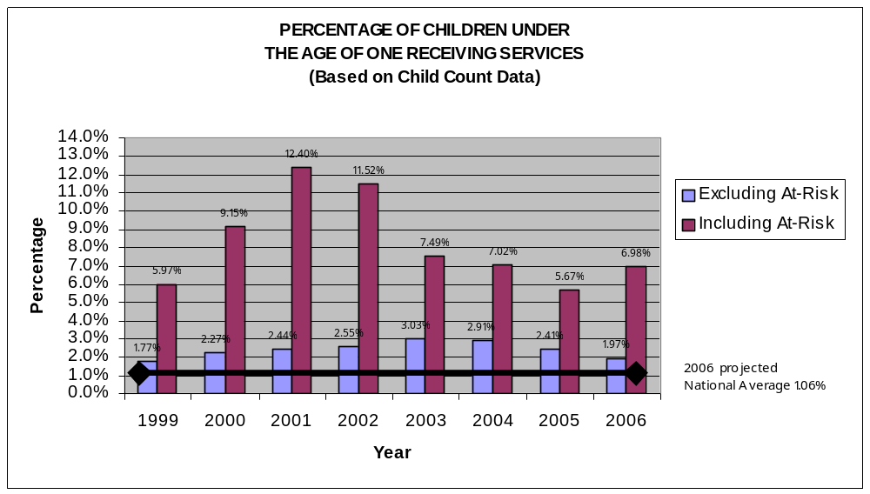

Discussion of Improvement Activities Completed and Explanation of Progress or Slippage that occurred for FFY 2006):

Explanation of Progress and Slippage

Progress

Including Environmentally At-Risk

- An increase from 5.67% in FFY 2005 to 6.98% (1,224/17,529) in FFY 2006.

Data Analysis

Based on information reported in the above section, “Actual Target Data for FFY 2006,” Hawaii continues to be ranked first in the percentage of 0-1 infants served, including children at environmental risk, and second in the nation excluding environmental risk. ,This is in comparison with states having similar eligibility and compared to national data. Progress was made this year with an increase in the number of children that were served, 0-1, including those environmentally at-risk. The percentage is an increase of approximately 1.3% in 2006 as compared to FFY 2005 data.

The overall 1.3% increase from FFY 2005 is due in part to corrections in Healthy Start’s data categorization in counting children environmentally at-risk as biologically at-risk (further discussed under the Slippage section below). The increase is largely due to public awareness activities with Child Welfare Service providers in coordinating mandated referrals from Child Welfare Services for children environmentally at-risk under the Child Abuse Prevention and Treatment Act (CAPTA).

Under CAPTA, these children are required to receive a developmental evaluation and related therapy and support services.

  - Total FFY 2005 Child Welfare Services Referrals to Part C: 23
  - Total FFY 2006 Child Welfare Services Referrals to Part C: 361

With this new influx of children involved in Child Welfare Services, there was a corresponding increase in the number of children served by Healthy Start who were environmentally at-risk.

- Total FFY 2005 number of children birth to 1 served by Healthy Start: 709
- Total FFY 2006 number of children birth to 1 served by Healthy Start: 892

Slippage

Excluding Environmentally At-Risk

- A decrease 2.41% from FFY 2005 to 1.97% (346/17,529) in FFY 2006.

Data Analysis

The percentage served, based on FFY 2006 Child Count data, was slightly lower than last year excluding children at-risk. The overall .44% decrease in children counted with developmental delay and biological risk is largely due to FFY 2005 erroneous counts by the Healthy Start program of children as biologically at-risk.

- Total FFY 2005 number of children birth to 1 counted as biologically at-risk by Healthy Start: 121
- Total FFY 2006 number of children birth to 1 counted as biologically at-risk by Healthy Start: 17

For FFY 2006 data, the Part C Data Manager worked closely with Healthy Start programs to ensure that children were counted under the correct risk or delay category. Therefore, children previously incorrectly counted as biologically at-risk were accurately counted as environmentally at-risk.

Also, the number of children birth to one counted with biological risk by Public Health Nursing decreased slightly due to the advent of a more accurate triaging and referral process. Children referred to Part C by Child Welfare Services are now referred to the most appropriate Part C program depending on the health and developmental needs of the child and not directly to a public health nurse as in the past. This has reduced the number of referrals going to Public Health Nursing, reserving referrals to PHNB for those children with complex medical needs.

- Total FFY 2005 number of children birth to 1 served by Public Health Nursing: 179
- Total FFY 2006 number of children birth to 1 served by Public Health Nursing: 163

Improvement Activities Continuing

Information is provided below on the Improvement Activities included in the SPP implemented in FFY 2006. The following Improvement Activities supported the progress in increasing the percentage of infants and toddlers, 0-1, receiving early intervention services.

- Review Hawaii’s Part C eligibility criteria for continued appropriateness:

- Some participants at the December 2007 Part C Stakeholders’ Meeting were concerned that Part C in Hawaii is under funded and proposed adopting a more narrow eligibility criteria. Further discussion is needed related to the pros and cons of this change.

- Other participants at the December 2007 Part C Stakeholders’ Meeting felt that Hawaii needs to continue to be committed to providing prevention as well as early intervention services to a broad population of infants and toddlers under age 1.

- Analyze data to identify new populations not currently served and underserved:

- From gathering community input at the December 2007 Stakeholders’ Meeting and reviewing information on referrals to Part C, new populations include Micronesian, Homeless, Spanish speaking, and Military populations.

- Further analysis is needed to identify populations by geographic area so that public awareness activities can be focused in the geographic areas of need.

- Analyze Child Count data by geographic area:

- Comparative census data is not available for infants 0-1 by island; it has only been analyzed by island for the entire 0-3 population (see Indicator #6).

- Feedback from the December 2007 Stakeholders’ Meeting and analyzing Child Count data, identified the following geographic areas that may be underserved: Oahu’s Leeward coast and the neighbor islands of Hawaii, Maui, Molokai, and Kauai.

- Public awareness activities for the above geographic areas, from July 1, 2006-June 30, 2007, included: public presentations to community groups; participation in community health fairs and conferences; and ongoing training and support to staff working in those specific geographic areas.

  - Target referral groups and geographic areas:
    - Early Intervention staff target individuals working in the identified communities and geographic areas to support increased referrals by identifying appropriate public relations activities they might initiate in their specific geographic areas.

  - Review current EI public awareness materials to determine additional brochures, etc. needed to support information to families about EI services:
- The current brochures have been reviewed for needed changes.
- Additional translations of brochures are in process to support the communication needs of the Micronesian and Spanish speaking populations.

  - Brainstorm and implement strategies to work with identified target groups and specific geographic areas:
- Public awareness activities for the above geographic areas, from July 1, 2006-June 30, 2007, included: public presentations to community groups; participation in community health fairs and conferences; and ongoing training and support to staff working in those specific geographic areas.

- Evaluate the effectiveness of the improvement activities and revise as necessary:

- Improvement activities appear to be somewhat effective because of the increase in children served including at-risk.

Revisions, with Justification, to Proposed Targets / Improvement Activities / Timelines / Resources for FFY 2007:

It was determined that there is no need at the current time for revisions of Proposed Targets, Improvement Activities, or Timelines. Hawaii prides itself on having a broad definition of Part C eligibility and expects to continue serving a high percentage of 0-1 age children. Although there has been a slight decrease in the percentage of children served excluding environmental risk, it is premature to revise the targets at this time. Targets will be reviewed next year for appropriateness. The current Improvement Activities continue to be appropriate to address any decrease in the number/percentage of children served.

Part C State Annual Performance Report (APR) for FFY 2006
Overview of the Annual Performance Report Development: Refer to Overview, pages 1-2.

Monitoring Priority: Effective General Supervision Part C / Child Find
Indicator 6: Percent of infants and toddlers birth to 3 with IFSPs compared to:
A. Other States with similar eligibility definitions; and
B. National data.
(20 U.S.C. 1416(a)(3)(B) and 1442)
Measurement:
A. Percent = [(# of infants and toddlers birth to 3 with IFSPs) divided by the (population of infants and toddlers birth to 3)] times 100 compared to the same percent calculated for other States with similar (narrow, moderate or broad) eligibility definitions.
B. Percent = [(# of infants and toddlers birth to 3 with IFSPs) divided by the (population of infants and toddlers birth to 3)] times 100 compared to National data.

FFY | Measurable and Rigorous Target
2006 | Excluding environmentally at risk = 4.4%; including environmentally at risk = 7.3%

Actual Target Data for FFY 2006:

Based on FFY 2006 Child Count data (see table below), Hawaii served:
- 4.2% (2,206/53,063) of infants and toddlers, birth through age 2, excluding those at environmental risk
- 7.48% (3,970/53,063) of infants and toddlers, birth through age 2, including those at environmental risk

A. Compared to States with Similar Eligibility (based on OSEP 2006 data tables)

Hawaii is one of 23 states included in the “Broad Eligibility” category. Compared to other states with similar eligibility, Hawaii’s Part C program was:
- Ranked third of all states, serving 4.2% of infants and toddlers, 0-3, when environmental risk was excluded.
- Ranked first of all states, serving 7.48% of infants and toddlers, 0-3, when environmental risk was included.

- Compared to National Data (based on OSEP 2006 data tables)

Hawaii’s Part C program was:
  - Ranked third in the nation, serving 4.2% of infants and toddlers, 0-3 when infants at environmental risk were excluded.
  - Ranked first in the nation, serving 7.48% of infants and toddlers, 0-3 when infants at environmental risk were included.

Although the current data does not reach the proposed target in the excluding at-risk category, Hawaii is in the top three States, percentage-wise, serving infants and toddlers 0-3 compared both with states with similar eligibility and national data. The chart below provides trend data since 1999.

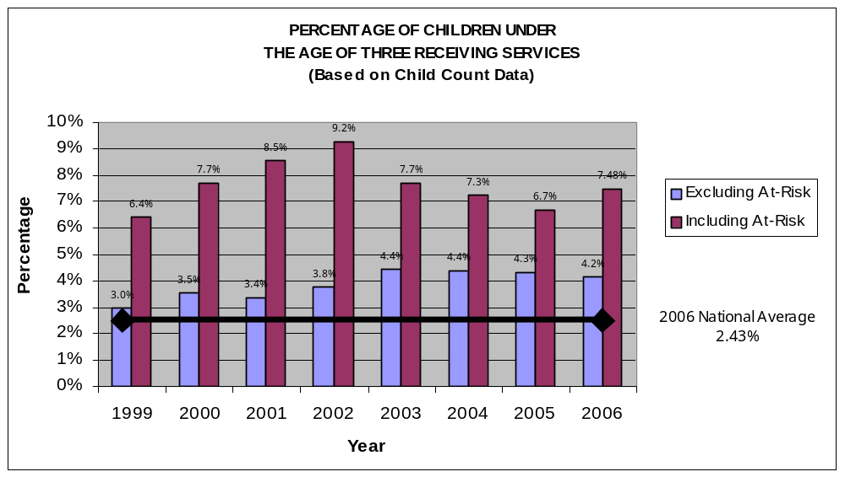
Additional Data: The following charts compare the percentage of children, 0-3, served by island, for FFY 2005 and FFY 2006 (See discussion under Improvement Activities).
EMBED Excel.Chart.8 \s 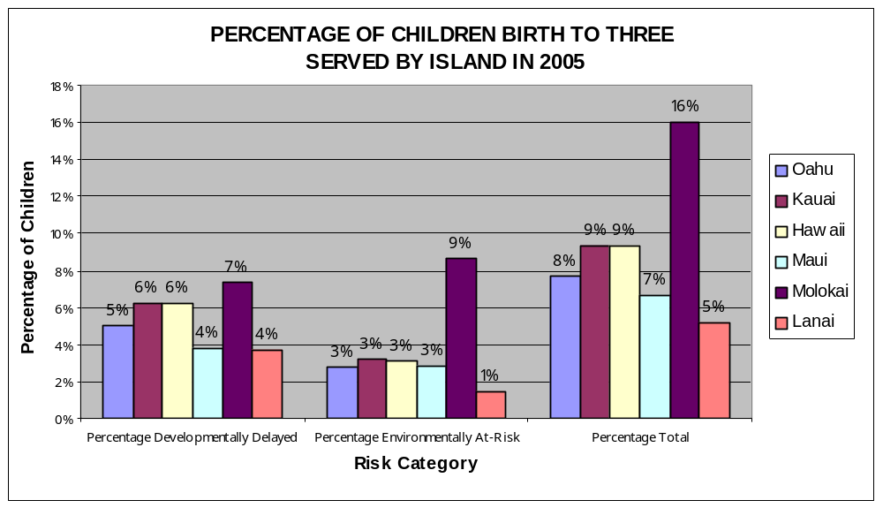
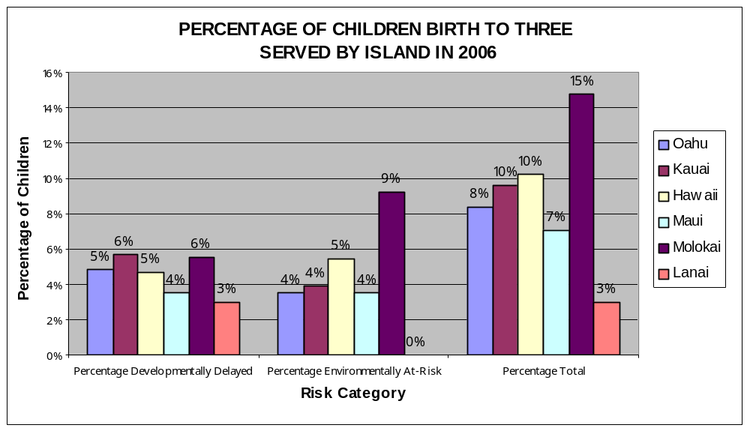

Discussion of Improvement Activities Completed and Explanation of Progress or Slippage that occurred for FFY 2006:

Explanation of Progress and Slippage

Progress

Including Environmentally At-Risk

- An increase from 6.7% in FFY 2005 to 7.48% (3970/53,063) in FFY 2006.

Data Analysis

Based on information reported in the above section, “Actual Target Data for FFY 2006,” Hawaii continues to be ranked first in the percentage of 0-3 infants and toddlers served, including children at environmental risk, compared with states with similar eligibility as well as compared to national data. Hawaii is also ranked third in the percentage of infants and toddlers served, excluding children at environmental risk, compared with states with similar eligibility as well as compared to national data.

The overall .78% increase from FFY 2005 is due in part to corrections in Healthy Start’s data categorization in counting children environmentally at-risk as biologically at-risk (further discussed under the Slippage section below). The increase is largely due to public awareness activities with Child Welfare Service providers in coordinating mandated referrals from Child Welfare Services for children environmentally at-risk under the Child Abuse Prevention and Treatment Act (CAPTA). Under CAPTA, these children are required to receive a developmental evaluation and related therapy and support services.

  - Total FFY 2005 Child Welfare Services Referrals to Part C: 23
  - Total FFY 2006 Child Welfare Services Referrals to Part C: 361

With this new influx of children involved in Child Welfare Services, there was a corresponding increase in the number of children served by Healthy Start who were environmentally at-risk.

- Total FFY 2005 number of children birth to 3 served by Healthy Start: 1,655
- Total FFY 2006 number of children birth to 3 served by Healthy Start: 1,874

Slippage

Excluding Environmentally At-Risk

- A very slight decrease from 4.3% in FFY 2005 to 4.2% (2,206/53,063) in FFY 2006.

Data Analysis

The overall .1% decrease in children counted with developmental delay and biological risk is largely due to 2005 erroneous counts by the Healthy Start program of children as biologically at-risk.

- Total FFY 2005 number of children birth to 3 counted as biologically at-risk by Healthy Start: 310
- Total FFY 2006 number of children birth to 3 counted as biologically at-risk by Healthy Start: 43

For FFY 2006’s data, the Part C Data Manager worked closely with Healthy Start programs to ensure that children were counted under the correct risk or delay category. Therefore, children previously incorrectly counted as biologically at-risk are being accurately counted as environmentally at-risk.

Also, the number of children birth to one counted with biological risk by Public Health Nursing decreased slightly due to the advent of a more accurate triaging and referral process. Children referred to Part C by Child Welfare Services are now referred to the most appropriate Part C program depending on the health and developmental needs of the child and not directly to a public health nurse as in the past. This has reduced the number of referrals going to Public Health Nursing, reserving referrals to PHNB for those children with complex medical needs.

- Total FFY 2005 number of children birth to 3 served by Public Health Nursing: 564
- Total FFY 2006 number of children birth to 3 served by Public Health Nursing: 500

Improvement Activities Continuing

Information is provided on the Improvement Activities included in the SPP and were implemented in FFY 2006. The following Improvement Activities supported the progress in increasing the percentage of infants and toddlers, birth through age 2, receiving early intervention services.

- Review Hawaii’s Part C eligibility criteria for continued appropriateness:

- Some participants at the December 2007 Part C Stakeholders’ Meeting were concerned that Part C in Hawaii is under funded and proposed adopting a more narrow eligibility criteria. Further discussion is needed related to the pros and cons of this change.

- Other participants at the December 2007 Part C Stakeholders’ Meeting felt that Hawaii needs to continue to be committed to providing prevention as well as early intervention services to a broad population of infants and toddlers under age 1.

- Analyze data to identify new populations not currently served and underserved:

- From gathering community input at the December 2007 Stakeholders’ Meeting, and reviewing information on referrals to Part C, new populations include Micronesian, Homeless, Spanish speaking, and Military populations.

- Further analysis is needed to identify populations by geographic area so that public awareness activities can be focused in the geographic areas of need.

- Analyze Child Count data by geographic area: A comparison by geographic areas (by islands) between 2005 and 2006 data (see above charts) found that there do not appear to be significant changes in percentages of children served by island.

- For children with a developmental delay/biological risk, there was a decrease in percentage served on the following islands:

  - Molokai from 7% to 6%, or from 24 to 18 children
  - Hawaii from 6% to 5%, or from 332 to 253 children
  - Lanai from 4% to 3%, or from 5 to 4 children

    - For children at environmental risk, there was a decrease in children served on the following island:

  - Lanai from 1% to 0%, or from 2 to 0 children

    - For children at environmental risk, the following increases in children served were found:

  - Oahu from 3% to 4%, or 925 to 1195
  - Kauai from 3% to 4%, or 66 to 82
  - Hawaii from 3% to 5%, or 168 to 293
  - Maui from 3% to 4%, or 133 to 164

    - Data will continue to be analyzed.

- Feedback from the December 2007 Stakeholders’ Meeting and analyzing Child Count data identified the following geographic areas that may be underserved: Oahu’s Leeward coast and the neighbor islands of Hawaii, Maui, Molokai, and Kauai.

- Public awareness activities for the above geographic areas, from July 1, 2006-June 30, 2007, included: public presentations to community groups; participation in community health fairs and conferences; and ongoing training and support to staff working in those specific geographic areas.

  - Target referral groups and geographic areas:
    - Early Intervention staff targeted individuals working in the identified communities and geographic areas to support increased referrals by identifying appropriate public relations activities they might initiate in their specific geographic areas.

  - Review current EI public awareness materials to determine additional brochures, etc. needed to support information to families about EI services:
- The current brochures have been reviewed for needed changes.
- Additional translations of brochures are in process to support the communication needs of the Micronesian and Spanish speaking populations.

  - Brainstorm and implement strategies to work with identified target groups and specific geographic areas:
- Public awareness activities for the above geographic areas, from July 1, 2006-June 30, 2007, included: public presentations to community groups; participation in community health fairs and conferences; and ongoing training and support to staff working in those specific geographic areas.

- Evaluate the effectiveness of the improvement activities and revise as necessary:

- Improvement activities appear to be somewhat effective because of the increase in children served including at-risk.

Revisions, with Justification, to Proposed Targets / Improvement Activities / Timelines / Resources for FFY 2007:

It was determined that there is no need at the current time for revisions of Proposed Targets, Improvement Activities or Timelines. Hawaii prides itself on having a broad definition of Part C eligibility and expects to continue serving a high percentage of 0-3 age children. Although there has been a slight decrease in the percentage of children served excluding environmental risk, it is premature to revise the targets at this time. Targets will be reviewed next year for appropriateness. The current Improvement Activities continue to be appropriate to address any decrease in the number/percentage of children served.

Part C State Annual Performance Report (APR) for FFY 2006
Monitoring Priority: Effective General Supervision Part C / Child Find
Indicator 7: Percent of eligible infants and toddlers with IFSPs for whom an evaluation and assessment and an initial IFSP meeting were conducted within Part C’s 45-day timeline.
(20 U.S.C. 1416(a)(3)(B) and 1442)
Measurement:
Percent = [(# of eligible infants and toddlers with IFSPs for whom an evaluation and assessment and an initial IFSP meeting was conducted within Part C’s 45-day timeline) divided by the (# of eligible infants and toddlers evaluated and assessed)] times 100.
Account for untimely evaluations.

FFY | Measurable and Rigorous Target
2006 | 100%

Actual Target Data for FFY 2006:
The following data, gathered from agencies’ database, for the time period July 1, 2006 – June 30, 2007, is the percent of eligible infants and toddlers with IFSPs for whom an evaluation and assessment and an initial IFSP meeting were conducted within Part C’s 45-day timeline:

Evaluation and Assessment and IFSP within Part C’s 45-day timeline

Part C Agencies | % | N
Early Intervention Section Programs | 99% | 1,582/1,600
Public Health Nursing Branch Sections | 95% | 260/274
Healthy Start Sites | 97% | 1,057/1,090
All Part C Children | 98% | 2,899/2,964

Late Initial IFSPs Due to Untimely Evaluations

For Early Intervention programs statewide, 13 Initial IFSPs were not completed within the Part C 45-day timeline due to late evaluations.

Late Initial IFSPs Due to Other Reasons

There were 52 other documented delays including, staff sick or on vacation, scheduling errors, and poor documentation that were responsible for other late Initial IFSPs.

Documented Delays due to Family Circumstances

Of the 2,964 IFSPs, there were 446 documented family reasons identified in the Agencies’ databases for late IFSPs (included in both the numerator and denominator):

Reason | #
Family not available/difficult to engage/no show | 126
Family schedule conflict (e.g., work, personal reason, etc.) | 115
Family did not return phone calls | 49
Child and/or family member sick | 44
Family cancelled IFSP meeting | 43
Family on vacation | 26
Family initially refused/not interested, then changed mind | 19
Other | 24
TOTAL | 446

Correction of Previously Identified Non-Compliance
FFY 2005 monitoring resulted in 8 findings for IFSPs within Part C’s 45-day timeline. As a result of the review of the databases in FFY 2006, all of the findings were corrected to 100% (see Indicator 9).
Previously identified non-compliance was corrected through the following improvement activities and resources:
- Through training and technical support, EI programs have an increased awareness of the Part C 45-day timeline.
- EI programs are able to query their databases for IFSP 45-day due dates.
- Quality Assurance Specialists worked with EIS programs to develop program procedures to ensure that IFSPs were done within the 45-day timeline.
- EI programs implemented strategies such as tentatively scheduling the IFSP meeting at intake.

FFY 2005 monitoring resulted in 4 findings for Evaluation and Assessments within Part C’s 45-day timeline. As a result of the review of the databases in FFY 2006, all of the findings were corrected to 100% (see Indicator 9).

Discussion of Improvement Activities Completed and Explanation of Progress or Slippage that occurred for FFY 2006:
Explanation of Progress

- 98% compliance was maintained for July 1, 2006 – June 30, 2007, which is the same as was reported in last year’s APR. While not at 100% compliance, Hawaii continues to have substantial compliance and correction of previous findings of non-compliance.

Improvement Activities Continuing

Information is provided on the Improvement Activities developed for FFY 2006. The following Improvement Activities continue yearly to support the improved compliance with timely IFSPs.

- Refine the statewide system to provide written clarification on IDEA Part C requirements for CDEs and IFSPs to all Agencies and Programs:
  - Written policies and procedures on Hawaii’s Part C system have been drafted and will be finalized for public review when the new regulations are finalized.
  - “Points of Clarification” are provided to all Early Intervention Agencies and Programs to ensure all are regularly updated with system revisions and clarifications related to CDEs and IFSPs. A “Points of Clarification” was distributed to address questions that arose during the CDE statewide training.
  - “Points of Clarification” will be posted on the EIS web-site.
- Develop and implement a mentoring system to support CDE providers:
- Two-day CDE trainings occurred statewide and 194 staff were trained to increase the pool of available evaluators. Newly trained staff participates in the mentoring process to complete their training in becoming evaluators.
- Identify training needs related to CDEs and IFSPs:
- Based on feedback from staff, the CDE training was expanded from a 1-day training to a 2-day training to provide more hands-on opportunities to practice specific skills in conducting an evaluation.
- To support therapy and other staff who may not have received sufficient child development training as part of their educational process, training in child development was provided to all staff by EIS and to all Public Health Nurses by a Pediatrician. The PHN training is available on DVD for all staff to view.
- The CDE process is embedded into the 4-day EI Orientation that all EI staff attends within 6 months of their hire date.
- Determine and develop strategies to support infrastructure needed that will result in timely CDEs and IFSPs:
- Service Coordination ratios have been lowered to 1:35.
- The fee-for-service provider contract is available to complete CDEs to ensure that CDEs and IFSPs are done within the 45-day timeline.
- The billable activities/reimbursement has been revised to support the mentoring process for newly trained evaluators.

- Ensure that the statewide Part C data system is sufficiently sensitive to collect required CDE and IFSP data:
- All three agencies (EIS, PHNB, Healthy Start) are able to provide data regarding CDE and IFSP timelines as well as reasons if it is late.
- Evaluate the effectiveness of the improvement activities designed to support 100% compliance in CDE and IFSP requirements: The effectiveness of the improvement activities is evaluated by the increase in compliance in meeting the target. Based on the increased data, the activities appear effective.

Revisions, with Justification, to Proposed Targets / Improvement Activities / Timelines / Resources for FFY 2007:
.Revised Improvement Activities:

Improvement Activities | ‘07 | ‘08 | ‘09 | ‘10
Previous:  Ensure that the statewide Part C data system is sufficiently sensitive to collect required CDE & IFSP data. | X | X | X | X
Revised:  Explore options to develop a statewide Part C data system for all Part C providers to collect required CDE & IFSP data. | X | X | X | X
Justification:
The above improvement activity has been revised from “ensure” to “explore options to develop” because currently all three agencies have their own databases. Although each database can provide the required data, it would be more efficient to have one database that all three agencies utilize. If it’s not possible to have one statewide system, HDOH needs to assure a process to collect the data from the separate systems and assure that the data remains accurate and valid.

Part C State Annual Performance Report (APR) for FFY 2006
Overview of the Annual Performance Report Development: Refer to Overview, pages 1-2.

Monitoring Priority: Effective General Supervision Part C / Effective Transition
Indicator 8: Percent of all children exiting Part C who received timely transition planning to support the child’s transition to preschool and other appropriate community services by their third birthday including:
- IFSPs with transition steps and services;
- Notification to LEA, if child potentially eligible for Part B; and
C. Transition conference, if child potentially eligible for Part B.
(20 U.S.C. 1416(a)(3)(B) and 1442)
Measurement:
A. Percent = [(# of children exiting Part C who have an IFSP with transition steps and services) divided by the (# of children exiting Part C)] times 100.
B. Percent = [(# of children exiting Part C and potentially eligible for Part B where notification to the LEA occurred) divided by the (# of children exiting Part C who were potentially eligible for Part B)] times 100.
C. Percent = [(# of children exiting Part C and potentially eligible for Part B where the transition conference occurred) divided by the (# of children exiting Part C who were potentially eligible for Part B)] times 100.

FFY | Measurable and Rigorous Target
2006 | 100%

Actual Target Data for FFY 2006:
Data was collected via the EIS, PHNB, and Healthy Start databases for the months of July 1, 2006 – June 30, 2007 on: Complete Transition Plans, Transition Notices, and Timely Transition Conferences:

Statewide Timely Transition Planning
July 1, 2006 – June 30, 2007
Transition Activity | % | N
A. Transition Plan (IFSP with transition steps and services).  Numerator = number of children who exited Part C with a complete Transition Plan.  Denominator = All children who exited Part C. | 99% | 1,462/1,477
B. Transition Notice (Notification to LEA)  Numerator = number of children who exited Part C who were potentially eligible for Part B with notification to the LEA.  Denominator = number of children who exited Part C who were potentially eligible for Part B. | 100% | 811/811
C. Transition Conference  Numerator = number of children who exited Part C with a timely Transition Conference.  Denominator = number of children who exited Part C with a Transition Conference. | 96% | 576/600

Analysis of Data: July 1, 2006-June 30, 2007

Transition Plan

All children in Hawaii’s Part C program are required to have a Transition Plan, which is a part of the IFSP. Transition planning, with steps on the IFSP, is an on-going process and begins during Intake and is documented at the Initial IFSP meeting. At each subsequent IFSP meeting, the Transition Plan is updated, leading up to the Transition Conference.

      - There were 1,477 children who exited Part C between July 1, 2006 - June 30, 2007.
      - Ninety-nine percent (99% or 1,462/1,477) of the children exiting Part C had a complete Transition Plan.
- The difference between the numerator and the denominator (11 or 1%) was because theTransition Plans were not considered complete, based on Hawaii’s requirements for a complete Transition Plan.
      - The data is from each Agency’s database, EIS, PHNB, and Healthy Start, from the most recent IFSP prior to transitioning out of Hawaii’s Part C program.

Transition Notices (Notification to LEA)

Notification to DOE Part B is required for any child in Hawaii’s Part C program who is potentially Part B eligible, unless the parent opted out of notifying DOE. Notification is provided to Part B via the Transition Notice form.

- There were 1,162 children who exited Part C who were considered potentially Part B eligible between July 1, 2006 – June 30, 2007. This includes families who opted out of sending the Transition Notice (see below).
- Three hundred fifty-one (351) parents elected to “opt out” of sending the Transition Notice to DOE.
- The LEA was informed regarding 100% (811/811) of the above children exiting Hawaii’s Part C program who were potentially eligible for DOE’s Part B program.
      - The data is from each Agency’s database, EIS, PHNB, and Healthy Start, at the time of exit from Hawaii’s Part C program.

Following is a description of the opt-out options used in Hawaii:

The following options are included in the Part C Transition Notice to DOE, which meets the above federal requirement of notification to the LEA of the child’s potential eligibility for preschool services under Part B of IDEA, P.L. 108-446:

1. Federally required directory information that includes the child’s name, birth date, and parent(s) contact information is sent to the DOE;
2. Federally required directory information, as well as the child’s diagnosis/areas of concern, is sent to the DOE.
3. No information is sent to the DOE.

The Transition Notice is shared with the family and explained at the IFSP meeting that is closest to the child’s 2nd birthday.

If the family chooses not to provide any information to the DOE, the family must check the appropriate box and sign as indicated on the Transition Notice form. In addition, the family’s service coordinator will provide the parent with the DOE “Operation Search” brochure (Part B’s Child Find brochure) to ensure that the family is aware of DOE Part B services. This brochure provides information and contact numbers to the family should they have questions or concerns at a later time regarding their child’s education. The parent initials receipt of the DOE brochure on the Transition Notice as indicated.

The family has ten (10) days to opt-out of sending the Transition Notice. After the 10-day period, which is referenced on the form, the required information will be sent to the DOE.

A new Improvement Activity has been developed to further investigate reasons for the high number of families opting out of the Transition Notice in order to determine how to increase the number of Transition Notices that are sent to DOE.

Transition Conferences

Hawaii’s policy is to offer a Transition Conference for all children exiting from Hawaii’s Part C program, regardless of the child’s potential eligibility for preschool services under Part B of IDEA, P.L. 108-446:

- A total of 1,477 families of children exiting Hawaii’s Part C program were offered a Transition Conference.

- Six hundred (600) families agreed to holding a Transition Conference, of which 576 (96%) were timely (at least 90 days prior to exit from Part C.) unless there were documented delays due to family circumstances.

        - There were were102 documented delays (included in the numerator and denominator above) due to family circumstances:

          - Difficult to schedule (e.g., family did not return calls, meetings cancelled and re-scheduled) (45)
          - Late referral to Part C – child older than 33 months at time of referral to Part C (32)
- Family originally declined, then changed their mind (25)

- Eight hundred seventy-seven (877) parents declined a Transition Conference out of the 1,477 families that were offered a Transition Conference. Analysis of data regarding declines found that:

- 642 children were in EIS programs and potentially eligible for preschool services under Part B of IDEA, P.L. 108-446.
  - 235 children were in Healthy Start programs. While the majority of children exiting Healthy Start are not eligible for DOE Preschool Special Education Programs, the Transition Conference is offered with programs for children at environmental risk (e.g., Head Start) and community preschools.

      - The data is from each Agency’s database, EIS, PHNB, and Healthy Start, at the time of exit from Hawaii’s Part C program.

A new Improvement Activity has been developed to further investigate reasons for the high number of families declining the Transition Conference in order to determine how to increase the number of Transition Conferences that are scheduled and completed.

The current data shows a steady improvement toward reaching compliance.

Correction of Previously Identified Non-Compliance
FFY 2005 monitoring resulted in no findings for either Transition Notice (8b) or Transition Conference (8c). Three (3) findings did occur for the monitoring item “Discussion re: transition out of EI,” which was a required component of the Transition Plan (8a). These 3 findings were corrected to 100% within one year. (See Indicator 9).
Previously identified non-compliance was corrected through the following improvement activities and resources:
- Through training and technical support, EIS programs have an increased understanding of when and how to develop timely transition plans with families.
- EIS programs are able to query their databases for transition timelines.
- Additional resources for service coordinators on the transition process and timelines include visual diagrams which were developed and disseminated by the Hawaii STEPS Project. These resources are: 1) Statewide Recommended Practice Guidelines: Transition Timeline for Children Possibly Eligible for DOE Preschool Special Education; and 2) Statewide Recommended Practice Guidelines: To Ensure Services by 3rd Birthday for Children Possibly Eligible for DOE Preschool Special Education.

Discussion of Improvement Activities Completed and Explanation of Progress or Slippage that occurred for FFY 2006:

Explanation of Progress
The current data on Timely Transition Planning shows continued compliance as compared to last year’s APR.

- Timely Transition Plans: Maintained compliance at 99%
- Timely Transition Notices: Met compliance (100%).
- Timely Transition Conferences: An increase from 94% to 96%

Improvement Activities Continuing
Information is provided on the Improvement Activities included in the SPP and were implemented in FFY 2006. The following Improvement Activities supported the progress in increasing the percentage of infants and toddlers receiving timely transition planning. Following is information for each Improvement Activity and how it supported progress.

- Provide written information to families on DOE preschool special education eligibility requirements to support families to better understand their options:
  - The “Steps to Transition” guide has been updated and is in the process of being added to the EIS website to support access to transition materials.
  - Many EIS programs have revised and updated their written information about “Transition Options” that is shared with families. “Transition Options” includes information about preschool options, financial assistance for preschool/childcare, therapy service options at age 3 and older, and other resources.
  - A presentation on the transition process was developed and will soon be available on the DOE SIG II website, as well as the EIS website.
- Review and adapt current data systems to include “tickler” system to alert service coordinators on transition timelines:

  - EIS programs are now able to query their databases for transition timelines. However, the need to report “Declines” separately (instead of included with “Family Reasons”) has resulted in further review of the Agencies’ databases to make this task easier.
- Identify additional training needs, review current training modules, adapt them as necessary to meet identified training needs, and implement training:
  - Based on identified training needs, there are continued opportunities to gain support and/or new information through: formal training, transition question/answer sessions, EI Orientations, STEPS meetings, Program Manager meetings, etc. These activities also provide an opportunity to identify new training needs.
  - A newly identified need is based on the high numbers of families declining the Part C Transition Conference and/or “opting out” of sending the Transition Notice to DOE. Further review of the reasons, as well as possible correlation to late referrals to DOE, will help determine how to adapt current transition training activities to support staff and families in timely transitions.

- Evaluate the effectiveness of improvement activities designed to support 100% compliance in transition requirements:
  - The effectiveness of the improvement activities is evaluated by the increase in compliance in meeting the target.
  - One improvement activity is revised, two improvement activities’ timelines are extended, and two new improvement activities are added to better support the current needs.

Revisions, with Justification, to Proposed Targets / Improvement Activities / Timelines / Resources for FFY 2007:

Revised Improvement Activity and Timeline:
Improvement Activity | ‘05 | ‘06 | ‘07 | ‘08 | ‘09 | ‘10
Previous:  Collaborate with DOE to identify common data needs to support transition from EI to Part B. | X | X | X
Revised:  Collaborate with DOE (State level Part B, Section 619) to compare transition data, procedures, and align training content and activities around Part C to Part B transition. | X | X | X | X | X | X
Justification:
This revision aligns Part C with Part B’s APR Improvement Activity and better reflects the on-going discussions with DOE Section 619 state and district staff that occur.

Revised Timeline:
Improvement Activity | ‘05 | ‘06 | ‘07 | ‘08 | ‘09 | ‘10
Previous:  Revise the Focused Monitoring tool to reflect transition requirements. | X | X | X
Revised:  Revise the Focused Monitoring tool to reflect transition requirements. | X | X | X | X | X

Justification:
EIS developed a new monitoring tool to be implemented as a self-assessment tool. An additional two years in the timeline for implementation and review will ensure the tool’s appropriateness.

New Improvement Activities:
Improvement Activity | ‘07 | ‘08 | ‘09 | ‘10
New:  Investigate reasons for high number of “opt outs” for the Transition Notice and determine how to increase the number of Transition Notices sent to the DOE. | X | X | X | X
New:  Investigate reasons for high number of “declines” for the Transition Conference and determine how to increase the number of scheduled and completed Transition Conferences. | X | X | X | X

Justification:
Recent stakeholder discussions identified the need to investigate the reasons why so many families are “opting out” of sending the Transition Notice to DOE and/or declining the Transition Conference. In addition, investigation is needed to determine if the data on these families can be linked to late referrals to DOE.

Revised Resources:
Previous: STEPS, STEPS “Transition to K Tool Kit”, NECTAC, WRRC, HI DOE Preschool Special Education staff.
Revised: STEPS, STEPS “Transition to K Tool Kit”, NECTAC, WRRC, HI DOE Early Childhood Special Education (ECSE) staff.
Justification: This revision aligns Part C language with Part B language.

Part C State Annual Performance Report (APR) for FFY 2006
Overview of the Annual Performance Report Development: Refer to Overview, pages 1-2.

Monitoring Priority: Effective General Supervision Part C / General Supervision
Indicator 9: General supervision system (including monitoring, complaints, hearings, etc.) identifies and corrects noncompliance as soon as possible but in no case later than one year from identification.
(20 U.S.C. 1416(a)(3)(B) and 1442)
Measurement:
Percent of noncompliance corrected within one year of identification:
- # of findings of noncompliance.
- # of corrections completed as soon as possible but in no case later than one year from identification.
Percent = [(b) divided by (a)] times 100.
For any noncompliance not corrected within one year of identification, describe what actions, including technical assistance and/or enforcement, that the State has taken.

FFY | Measurable and Rigorous Target
2006 | 100%

Actual Target Data for FFY 2006:
Monitoring Process

Hawaii’s Part C monitoring for FFY 2005 (July 1, 2005-June 30, 2006) consisted of both database analyses and on-site chart reviews (between 6 and 10 charts per program) of 21 EIS programs, 10 PHNB sections, and 6 Healthy Start contract sites. The monitoring resulted in a total of 82 “findings,” as defined by OSEP guidance, across 17 SPP/APR indicators and Hawaii priority areas (from now on called “monitoring priorities”).

To support the correction of these 82 findings across 17 monitoring priorities, HDOH met monthly with administrators from EIS, PHNB, and MCHB (which is responsible for the Healthy Start contracts) and:

- Reviewed the data from the data systems;
- Discussed the progress or slippage for each monitoring priority; and
- Identified appropriate and acceptable corrections of non-compliance.

Each finding by program/section/site was analyzed by HDOH to determine if could be immediately corrected (e.g., start date of IFSP left off), if it could not be immediately corrected (e.g., evaluation late), and/or whether the finding was systemic (e.g., happened only one time in a program or happened multiple times in a program). Rules were developed and shared with EIS, PHNB, and Healthy Start on the appropriate and acceptable corrections of non-compliance. This included:

- If the finding could be immediately corrected (e.g., start date of IFSP left off), the IFSP page with the correction had to be faxed to the Agency administrator with the parent’s signature to confirm an IFSP meeting was called to make the correction.
- If the finding could not be immediately corrected but was not systemic (e.g., evaluation late on one chart), a specific number of evaluations had to be faxed to the Agency from that program that indicated timely evaluations.
- If the finding was considered systemic (e.g., evaluation late on 9 of 10 charts), 3 additional consecutive months of data was collected that required 100% compliance. If 100% was not met in the first three months, the corrective action was extended to 3 consecutive months.

At subsequent HDOH meetings, EIS, PHNB, and Healthy Start presented data to support the correction of the non-compliance. Data was presented for 16 of the 17 priority areas. The only priority area without data was the SPP/APR Indicator 1, Timely Services. Results from the FFY 2006 monitoring were analyzed and utilized to determine if the previously identified non-compliance for Timely Services was corrected.

Actual Target Data for FFY 2006

Table 1. Correction of Non-Compliance (FFY 2005)

a. No. of Findings of Non-Compliance | 82
b. No. of Corrections Completed within One Year of Identification | 77
Percent Corrected | 94% (77/82)

Discussion of Data Results

- FFY 2005 monitoring resulted in a total of 82 findings across 17 monitoring priorities. Ninety-four percent ( 94% or 77/82) were corrected within one year of identification.

- Of the 17 monitoring priorities, only 1, Timely Services, was not corrected to 100%.

- Of the 6 findings in Timely Services, 1 was corrected, leaving 5 not corrected within one year of identification.

Table 2 below provides detailed correction of non-compliance data on:
- The number of findings per monitoring priority, by each Agency and Statewide.

- The number of findings per monitoring priority that were corrected within one year of identification, by each Agency and Statewide.

- The number of finds per monitoring priority that were not corrected within one year of identification, by each Agency and Statewide.

Table 2. Correction of Non-Compliance (FFY 2005)
SPP/APR Indicators | Monitoring Priorities  (that resulted in Findings of  Non-Compliance) | No. of Corrections & Findings of Non-Compliance  EIS | No. of Corrections & Findings of Non-Compliance  PHNB | No. of Corrections & Findings of Non-Compliance  Healthy Start | No. of Corrections & Findings of Non-Compliance  Statewide
1 | Timely Services | 0/3 = 0% | 1/3 = 33% | No Findings | 1/6 = 17%
7 | IFSP within 45 days of referral | 3/3 = 100% | 5/5 = 100% | No Findings | 8/8 = 100%
8a | Discussion re: transition out of EI | 2/2 = 100% | No Findings | 1/1 = 100% | 3/3 = 100%
Hawaii Priority | Timelines
1a | Evaluation w/in 45 days of referral | 1/1 = 100% | 3/3 = 100% | No Findings | 4/4 = 100%
1b | 1st Annual IFSP within 1 year of initial  IFSP | 4/4 = 100% | 1/1 = 100% | No Findings | 5/5 = 100%
 | IFSP Development
2a | Complete present levels of development | No Findings | No Findings | 1/1 = 100% | 1/1 = 100%
2b | Frequency, intensity, method, location, & payment | 2/2 = 100% | 4/4 = 100% | 3/3 = 100% | 9/9 = 100%
2c | IFSP objectives complete | 2/2 = 100% | 6/6 = 100% | 4/4 = 100% | 12/12 = 100%
2d | Justification for services in non-natural environments | No Findings | 3/3 = 100% | 1/1 = 100% | 4/4 = 100%
2e | Statement that present levels of development based on clinical opinion | No Findings | No Findings | 1/1 = 100% | 1/1 = 100%
2f | Start date included | No Findings | 1/1 = 100% | 3/3 = 100% | 4/4 = 100%
2g | Duration of service included | No Findings | 3/3 = 100% | 3/3 = 100% | 6/6 = 100%
2h | IFSP contains documentation that non-mandated services are listed | No Findings | 1/1 = 100% | 1/1 = 100% | 2/2 = 100%
2i | Documentation of funding sources for non-mandated services | 1/1 = 100% | 2/2 = 100% | 1/1 = 100% | 4/4 = 100%
2j | Complete service coordination information | No Findings | 1/1 = 100% | Compliant | 1/1 = 100%
2k | Team members listed | No Findings | No Findings | 1/1 = 100% | 1/1 = 100%
2l | Means by which team members participated | No Findings | 6/6 = 100% | 5/5 = 100% | 11/11 = 100%
 | TOTAL | 15/18 = 83% | 37/39 = 95% | 25/25 =100% | 77/82 = 94%

The State’s Plan for Correcting Non-Compliance

The following actions were taken for correcting non-compliance of Timely Services within one year of identification. This included providing technical assistance and support and analyzing the reasons for late services. Within the 5 programs (3 EIS, 2 PHNB) that had findings, there were 42 services that were late. Reasons for non-compliance were analyzed both by Reason and by Type of Provider to determine if there were reasons specific based on a type of provider.

Reasons for non-compliance were:
- No documentation – 27
- Conflict with providers’ schedule – 5
- Position vacancy or contracted provider not available – 5
- Service scheduled late – 2
- Staff sick – 2
- Other – 1

Non-Compliance based on type of provider found that:

- Analyzing the above reasons by provider – Service Coordinator, SLP, OT, PT, Special Instructor, Assistive Technology staff, and Nurse found similarities across providers; all were inconsistent in documenting the delivery of services.

- Monitoring instructions required that documentation must be in the child’s chart or elsewhere in the program’s notes in order to be counted as “timely served.”

- Documentation that was only found as part of the billing system was not sufficient.

Therefore, because of the lack of sufficient documentation, many services were counted as “late,” when in fact they might have been timely. The discovery of the lack of sufficient documentation will drive revisions to our Improvement Activities.

Corrective Actions:

For each of the 5 programs that did not correct their non-compliance for Timely Services, they must:

1. Analyze the reasons for lack of timely services.
2. Develop a Corrective Action Plan (CAP) specific to the reasons identified and submit it to both their Agency and HDOH for approval. The plan must include timelines and if necessary, identify technical assistance to support their correction.
3. Provide monthly documentation on Timely Services in each child’s Initial, Review, or Annual IFSP to its Agency.
4. HDOH will review monthly data to determine progress toward correction and provide feedback to support correction. CAP must be revised after 3 months if data does not show progress.
5. HDOH will do on-site chart reviews quarterly to assure progress.

Next year’s APR will include data on the correction of these 5 findings in the monitoring priority of Timely Services.

Discussion of Improvement Activities Completed and Explanation of Progress or Slippage that occurred for FFY 2006:

Explanation of Progress/Slippage

Correction of non-compliance in FFY 2005 was 97%.
Correction of non-compliance in FFY 2006 was 94%.

While the data appears to show slippage between the FFY 2005 and FFY 2006 data results, a valid comparison is difficult. The 97% correction of FFY 2005 data was based on charts corrected (as required by the Special Conditions designation), whereas the 94% correction of findings of FFY 2006 data was based on programs corrected, which is consistent with the current OSEP guidance. Because the basis of the analysis was not consistent across the two monitoring years, a true comparison of the correction of findings cannot be made.

However, there was actually significant progress in correction of findings of non-compliance as there was only one specific area, Timely Services, which resulted in a finding.

Reasons for progress:

- Increased program/section/contract monitoring

- On-going chart and IFSP review by the EIS Quality Assurance team to identify issues related to non-compliance and help problem-solve with their specific EIS programs

- Regular meetings with EIS, PHNB and Healthy Start Agency administrators to review corrective actions to determine when they were met

- Regular meetings with EIS Program Managers to discuss areas of non-compliance and problem-solve corrective actions

- Revision and updating of the monitoring tool to be consistent with the revised IFSP, with clear instructions

- Consistent training of all monitors to ensure accuracy of monitoring results

- Development of a database, to be used by all EIS, PHNB, and Healthy Start sites, to collect monthly data on OSEP identified priority areas

- Increased training of all Part C providers on Part C regulations

- Use of the Lead Agency Quality Assurance Team to verify data

- Development of new forms to support verification process

Improvement Activities Continuing
Information is provided on the Improvement Activities included in the SPP and were implemented in FFY 2006. The following Improvement Activities supported the progress in increasing the percentage of non-compliance identified and corrected within one year of identification. Following is information for each Improvement Activity and how it supported progress.
- Develop and implement a process to ensure all Part C providers are knowledgeable of Hawaii’s implementation procedures related to Part C requirements: There has been an intensive process to ensure that all Part C providers are knowledgeable of Part C requirements. The process included but was not limited to:
- Extensive, required training on Part C requirements as part of the Part C Orientation, to all Part C providers.
- Expansion of the training team to include staff from EIS, PHNB, and Healthy Start to ensure there is Agency “buy-in” to the training, which also provides an “in-house” expert to answer questions
- Expansion of the Part C training to include a separate day focused on IFSP development, especially in writing functional objectives
- Regular “Question and Answer” sessions to support staff knowledge
- Development and dissemination of “Points of Clarification” that provide consistent written information to all providers

- Place “Points of Clarification” on the EIS website to support increased knowledge by providers.
- Continue to develop Hawaii’s Part C procedural guidelines to support increased knowledge by providers.
  - Review monitoring systems of other state for information of how Hawaii can improve its monitoring system.
- NECTAC provided Hawaii with copies of monitoring systems from other states to assist Hawaii in developing its monitoring system. To date the information provided has been helpful in the continuing development of an appropriate system for Hawaii.
- Review and refine the monitoring process (CQIS), including HDOH and Agency and requirements.
- HDOH revised its monitoring process for FFY 2006.
- In addition to the required indicators, HDOH identified new priority areas that were monitored this year. HDOH will continue to review and refine its system. An area not yet implemented is to include quality indicators.
- Begin training Agencies on revised monitoring process to ensure accuracy of monitoring data and evaluate for effectiveness.
  - HDOH meets monthly with Agencies responsible for ensuring accuracy of monitoring data.
  - Data is reviewed and discussed and decisions are made on what is needed to ensure correction of non-compliance.
  - The results of the recently completed self-assessment will be shared with the Agencies. Results will be compared with last year’s monitoring to determine areas of continued compliance, new compliance, continued non-compliance, and new non-compliance.
  - Corrective procedures will be determined and Agencies will develop Corrective Action Plans based on the results.
- Implement statewide revised monitoring procedures.
- New monitoring procedures were implemented for FFY 2006. The data results are being summarized and will be shared with each specific program/section/site with a finding of non-compliance.
- Each program/section/site must develop a Corrective Action Plan and have it approved by its Agency lead (i.e., EIS, PHNB, Healthy Start).
- Agencies have one year to ensure that their programs/sections/sites have corrected their areas of non-compliance.

- Develop a statewide Part C data system for all Part C providers, to support monitoring and other data requirements:
  - The Lead Agency developed a database to collect required monitoring data from all programs/sections/sites. Each Agency (EIS, PHNB, Healthy Start) was required to collect the identified data, either via the Lead Agency database or their own database. Additional modifications to the database (and to be shared with Agencies) will be made to ensure consistency with any new data requirements.
  - EIS is developing a new database system to collect all required data which includes newly identified OSEP data.
  - Although a new statewide database system is the goal for all Part C providers, at this time it is unknown whether such a system is workable.
  - Therefore the Improvement Activity was revised to focus on “exploring options to develop a statewide data system.” Strategies need to be developed to determine how to successfully develop such a system.

Revisions, with Justification, to Proposed Targets / Improvement Activities / Timelines / Resources for FFY 2007:
Revised Improvement Activities:
Improvement Activity | ‘06 | ‘07 | ‘08 | ‘09 | ‘10
Previous:  Begin training Agencies on revised monitoring process to ensure accuracy of monitoring data and evaluate for effectiveness. | X | X | X | X | X
Revised:  Provide on-going training to agencies on revised monitoring process to ensure accuracy of monitoring data and evaluate for effectiveness. | X | X | X | X | X
Justification:
Language was changed as training on the revised monitoring process had already started and was on-going.

Improvement Activity | ‘07 | ‘08 | ‘09 | ‘10
Previous:  Implement a monitoring cycle based on monitoring results. | X | X | X | X
Revised:  Explore options to utilize a monitoring cycle based on monitoring results. | X | X | X | X
Justification:
HDOH needs to re-look at whether a monitoring cycle will be implemented. Therefore HDOH needs to explore options in this area.

Improvement Activity | ‘05 | ‘06 | ‘07 | ‘08 | ‘09 | ‘10
Previous:  Develop statewide Part C data system for all Part C providers to support monitoring and other data requirements. | X | X | X
Revised:  Explore options to develop a statewide Part C data system for all Part C providers to support monitoring and other data requirements. | X | X | X | X | X | X
Justification:
There currently is not a statewide data system for all Part C agencies, and it is doubtful if there will be a statewide system by the end of next year. Therefore HDOH needs to explore options to determine if a statewide system is possible, and if not, how to assure that the separate systems will provide accurate and valid data.
New Improvement Activities:
Improvement Activity | ‘07 | ‘08 | ‘09 | ‘10
New:  Develop a process to provide on-going updates of all procedural changes. | X | X

Justification:

To ensure consistency, it is important that as changes are made to procedures, all Part C Agencies and their programs/sections/site are provided this information. Therefore a process is needed to assure that this occurs.

Improvement Activity | ‘07 | ‘08 | ‘09 | ‘10
New:  Define, develop, and implement different levels of sanctions, based on monitoring results, to support timely correction of non-compliance. | X | X | X | X

Justification:

Currently, the major sanction for non-compliance is to provide assistance and technical assistance to the programs/sections/sites. However, based on the recent monitoring results, it is evident that assistance and technical assistance alone are not sufficient to correct non-compliance. HDOH must develop a system of sanctions that is successful and results in correction of non-compliance.

Improvement Activity | ‘07 | ‘08 | ‘09 | ‘10
New:  Gather and analyze data to determine reasons for vacancies, and make recommendations to support recruitment and retention. | X | X

Justification:

It appears that some of the reasons for lack of timely services are due to the lack of appropriate personnel. By analyzing vacancies (by discipline, geography, etc.), HDOH can make recommendations to the DOH administrative staff on what is needed to support recruitment and retention.

Improvement Activity | ‘07 | ‘08 | ‘09 | ‘10
New:  For any finding not corrected within 1 year of identification, identify reasons for lack of correction and identify appropriate sanctions. | X | X | X | X

Justification:

Before a sanction is implemented, it is necessary to determine why the non-compliance was not corrected, to ensure the sanction and the area of concern is appropriately matched.

Improvement Activity | ‘07 | ‘08 | ‘09 | ‘10
New:  Develop and implement a process to acknowledge programs for their improvement and/or compliance with Part C regulations. | X | X | X | X

Justification:

The focus of the monitoring has been to identify non-compliance and ensure corrections are made within one year. It was determined by the Stakeholders that there needs a system of acknowledging both compliance as well as improvement toward compliance. Building on success supports continued success.

Part C State Annual Performance Report (APR) for FFY 2006
Overview of the Annual Performance Report Development: Refer to Overview, pages 1-2.

Monitoring Priority: Effective General Supervision Part C / General Supervision
Indicator 10: Percent of signed written complaints with reports issued that were resolved within 60-day timeline or a timeline extended for exceptional circumstances with respect to a particular complaint.
(20 U.S.C. 1416(a)(3)(B) and 1442)
Measurement: Percent = [(1.1(b) + 1.1(c)) divided by 1.1] times 100.

FFY | Measurable and Rigorous Target
2006 | 100%
Actual Target Data for FFY 2006:
There were no signed written complaints during FFY 2006.

Discussion of Improvement Activities Completed and Explanation of Progress or Slippage that occurred for FFY 2006:

Explanation of Progress

The data for this year is consistent with last year’s data – there were no signed written complaints issued; therefore there was no need to resolve them.
Improvement Activities Continuing
Information is provided on the Improvement Activities included in the SPP and were implemented in FFY 2006. The following Improvement Activities supported the progress in continuing to have no signed written reports. Following is information for each Improvement Activity and how it supported progress.

- Develop and implement process to gather information on family concerns related to service delivery and other Part C requirements.

  - The Family Survey included questions to gather information on family concerns related to service delivery and other Part C requirements.

- Review training to ensure that it includes information on Part C complaint procedures so families and Part C staff are knowledgeable about this process.

- The required Part C Orientation has been reviewed and does include information about Hawaii’s Part C compliant process.

- Design and implement various creative strategies (e.g., videotapes, CDs, etc.) to support training on Part C requirements for families, including at parent conferences.

- Additional training on facilitating conversations with families is being developed.

- Develop and implement written guidelines to support Care Coordinators and other staff in explaining Part C procedural guidelines (including complaint procedures) to families.

- Written guidelines on how to successfully support families in understanding Part C procedural guidelines is being developed.

- Collaborate with the “What Counts” Design Team to ensure that the family survey includes questions that focus on the degree families understanding their rights under Part C.

- The Family Survey includes questions on the degree families understand their rights under Part C.

Revisions, with Justification, to Proposed Targets / Improvement Activities / Timelines / Resources for FFY 2007:
It was determined that there is no need at the current time for revisions of Proposed Targets, Improvement Activities, or Timelines as the data shows that 100% compliance was met.

Part C State Annual Performance Report (APR) for FFY 2006
Overview of the Annual Performance Report Development: Refer to Overview, pages 1-2.

Monitoring Priority: Effective General Supervision Part C / General Supervision
Indicator 11: Percent of fully adjudicated due process hearing requests that were fully adjudicated within the applicable timeline.
(20 U.S.C. 1416(a)(3)(B) and 1442)
Measurement: Percent = [(3.2(a) + 3.2(b)) divided by 3.2] times 100.

FFY | Measurable and Rigorous Target
2006 | 100%
Actual Target Data for FFY 2006:
There were no due process hearing requests.

Discussion of Improvement Activities Completed and Explanation of Progress or Slippage that occurred for FFY 2006:
Explanation of Progress

The data for this year is consistent with last year’s data – there were no due process requests; therefore there were no due process requests that had to be adjudicated within the applicable timeline.
Improvement Activities Continuing
The following Improvement Activities supported the progress in continuing to have no due process hearings. Following is information for each Improvement Activity and how it supported progress.

- Develop and implement process to gather information on family concerns related to service delivery and other Part C requirements.

  - The Family Survey included questions to gather information on family concerns related to service delivery and other Part C requirements.

- Review training to ensure that it includes information on Part C due process hearing procedures so Part C staff are knowledgeable about this process.

- The required Part C Orientation has been reviewed and does include information about Hawaii’s Part C due process hearing procedures.

- Develop and implement written guidelines to support Care Coordinators and other staff in explaining Part C procedural guidelines (including due process hearing procedures) to families.

- Written guidelines on how to successfully support families in understanding Part C procedural guidelines, including due process hearing procedures, is being developed.

- Collaborate with the “What Counts” Design Team to ensure that the family survey includes questions that focus on the degree families understanding their rights under Part C.

- The Family Survey includes questions on the degree families understand their rights under Part C.

Revisions, with Justification, to Proposed Targets / Improvement Activities / Timelines / Resources for FFY 2007:
It was determined that there is no need at the current time for revisions of Proposed Targets, Improvement Activities, or Timelines as the data shows that 100% compliance was met.

Part C State Annual Performance Report (APR) for FFY 2006
Overview of the Annual Performance Report Development: Refer to Overview, pages 1-2.

Monitoring Priority: Effective General Supervision Part C / General Supervision
Indicator 12: Percent of hearing requests that went to resolution sessions that were resolved through resolution session settlement agreements (applicable if Part B due process procedures are adopted).
(20 U.S.C. 1416(a)(3)(B) and 1442)
Measurement: Percent = (3.1(a) divided by 3.1) times 100.

FFY | Measurable and Rigorous Target
2006 | Not Applicable
Actual Target Data for FFY 2005:
Not applicable, as Part B due process procedures were not adopted.

Discussion of Improvement Activities Completed and Explanation of Progress or Slippage that occurred for FFY 2006:
Not Applicable

Revisions, with Justification, to Proposed Targets / Improvement Activities / Timelines / Resources for FFY 2007:
Not Applicable

Part C State Annual Performance Report (APR) for FFY 2006
Overview of the Annual Performance Report Development: Refer to Overview, pages 1-2.

Monitoring Priority: Effective General Supervision Part C / General Supervision
Indicator 13: Percent of mediations held that resulted in mediation agreements.
(20 U.S.C. 1416(a)(3)(B) and 1442)
Measurement: Percent = [(2.1(a)(i) + 2.1(b)(i)) divided by 2.1] times 100.

FFY | Measurable and Rigorous Target
2006 | N/A, as Hawaii does not have 10 or more mediation requests.

Actual Target Data for FFY 2006:
Continues to be N/A, as Hawaii continued to have 0 mediation requests.

Discussion of Improvement Activities Completed and Explanation of Progress or Slippage that occurred for FY 2006:
Information is provided on the Improvement Activities included in the SPP and were implemented in FFY 2006. The following Improvement Activities supported the progress in continuing to have no mediation agreements. Following is information for each Improvement Activity and how it supported progress.

- Develop and implement process to gather information on family concerns related to service delivery and other Part C requirements.

  - The Family Survey included questions to gather information on family concerns related to service delivery and other Part C requirements.

- Review training to ensure that it includes information on Part C mediation procedures so all Part C staff are knowledgeable about this process.

- The required Part C Orientation has been reviewed and does include information about Hawaii’s Part C mediation procedure.

- Develop and implement written guidelines to support Care Coordinators and other staff in explaining Part C procedural guidelines (including mediation procedures) to families.

- Written guidelines on how to successfully support families in understanding Part C procedural guidelines, including mediation procedures, is being developed.

  - Revise the “Dear Family” brochure and add the Parent Training Institute as a contact if families have questions about early intervention services.

- The “Dear Family” brochure is being reviewed for necessary changes.

- At the next update of the “Dear Family” brochure, the Parent Training Institute will be added as a contact for families if they have questions about early intervention services.

- Collaborate with the “What Counts” Design Team to ensure that the family survey includes questions that focus on the degree families understanding their rights under Part C.

- The Family Survey includes questions on the degree families understand their rights under Part C.

Revisions, with Justification, to Proposed Targets / Improvement Activities / Timelines / Resources for FY 2007:
It was determined that there is no need at the current time for revisions of Proposed Targets, Improvement Activities, or Timelines as the data shows that there continues to be no requests for mediation.

Part C State Annual Performance Report (APR) for FFY 2006
Overview of the Annual Performance Report Development: Refer to Overview, pages 1-2.

Monitoring Priority: Effective General Supervision Part C / General Supervision
Indicator 14: State reported data (618 and State Performance Plan and Annual Performance Report) are timely and accurate.
(20 U.S.C. 1416(a)(3)(B) and 1442)
Measurement: State reported data, including 618 data, State performance plan, and annual performance reports, are:
- Submitted on or before due dates (February 1 for child count, including race and ethnicity, settings and November 1 for exiting, personnel, dispute resolution); and
b. Accurate (describe mechanisms for ensuring error free, consistent, valid, and reliable data and evidence that these standards are met).

FFY | Measurable and Rigorous Target
2006 | 100%

Actual Target Data for FFY 2006:

The following required tables demonstrate that Hawaii’s Part C program met 100% compliance for timely and accurate data.

SPP/APR Data - Indicator 14
APR Indicator | Valid and Reliable | Correct Calculation | Followed Instructions | Total
1 | 1 | 1 | 1 | 3
2 | 1 | 1 | 1 | 3
3 | 1 | 1 | 1 | 3
4 | 1 | 1 | 1 | 3
5 | 1 | 1 | 1 | 3
6 | 1 | 1 | 1 | 3
7 | 1 | 1 | 1 | 3
8a | 1 | 1 | 1 | 3
8b | 1 | 1 | 1 | 3
8c | 1 | 1 | 1 | 3
9 | 1 | 1 | 1 | 3
10 | 1 | 1 | 1 | 3
11 | 1 | 1 | 1 | 3
12 | N/A | N/A | N/A | 0
13 | 1 | 1 | 1 | 3
 |  |  | Subtotal | 42
APR Score Calculation |  | Timely Submission Points - If the FFY2006 APR was submitted on-time, place the number 5 in the cell on the right. |  | 5
 |  | Grand Total - (Sum of subtotal and Timely Submission Points) = |  | 47

618 Data - Indicator 14
Table | Timely | Complete Data | Passed Edit Check | Responded to Data Note Requests | Total
Table 1 - Child Count  Due Date: 2/1/07 | 1 | 1 | 1 | 1 | 4
Table 2 - Program Settings  Due Date: 2/1/07 | 1 | 1 | 1 | 1 | 4
Table 3 - Exiting  Due Date: 11/1/07 | 1 | 1 | 1 | 1 | 4
Table 4 - Dispute Resolution  Due Date: 11/1/07 | 1 | 1 | 1 | 1 | 4
 |  |  |  | Subtotal | 16
618 Score Calculation |  |  | Grand Total (Subtotal X 3) = |  | 48

Indicator #14 Calculation
A. APR Grand Total |  |  | 47
B. 618 Grand Total |  |  | 48
C. APR Grand Total (A) + 618 Grand Total (B) = |  |  | 95
Total NA or N/A in APR |  |  | 3
Total NA or N/A in 618 |  |  | 0
Base |  |  | 95
D. Subtotal (C divided by Base*) = |  |  | 1.000
E. Indicator Score (Subtotal D x 100) = |  |  | 100.0
*Note any cell marked as N/A will decrease the denominator by 1 for APR and 3 for 618.

Discussion of Improvement Activities Completed and Explanation of Progress or Slippage that occurred for FFY 2006:
Explanation of Progress
Progress
- FY 2005 data showed 84% compliance.
- FY 2006 data shows 100% compliance, an increase from the 84% compliance reported in FFY 2005 APR.

Improvement Activities Continuing
Information is provided on the Improvement Activities included in the SPP and were implemented in FFY 2006. The following Improvement Activities supported the progress in having timely and accurate data. Following is information for each Improvement Activity and how it supported progress.

- Review and revised training for all Part C programs on 618 data submission, based on 618 data requirements:

  - Instructions on submitting the 618 data requirements were reviewed prior to distribution and revised based on feedback from last year’s instructions.

  - Hawaii’s Part C Data Manager responded personally to all questions regarding appropriate completion of the Part C Child Count table.

- Develop and implement a process to ensure reliability and validity of data submitted:

- The data table for this indicator was completed as required to determine accuracy and validity of data reported.

- Self-assessment results were reviewed by each Agency. Programs/sections/sites were contacted if concerned were raised regarding self-assessment results.

- Develop a statewide Part C database to replace current individual Agency databases (EIS, PHNB, Healthy Start):

- A statewide Part C database has not been developed due to costs and available funds. There are continuing discussions about the viability of a statewide, centralized database.

- EIS is developing a database to better support OSEP requirements. The specifics of the database are being shared with the other Agencies to support compliance with OSEP requirements.

- A self-assessment database was developed by HDOH and shared with all Agencies to utilize during the self-assessment process to ensure data was being reported in a uniform manner.

Revisions, with Justification, to Proposed Targets / Improvement Activities / Timelines / Resources for FFY 2007:
It was determined that there is no need at the current time for revisions of Proposed Targets, Improvement Activities, or Timelines as compliance was met. Additional strategies to support Improvement Activities are identified as needed.

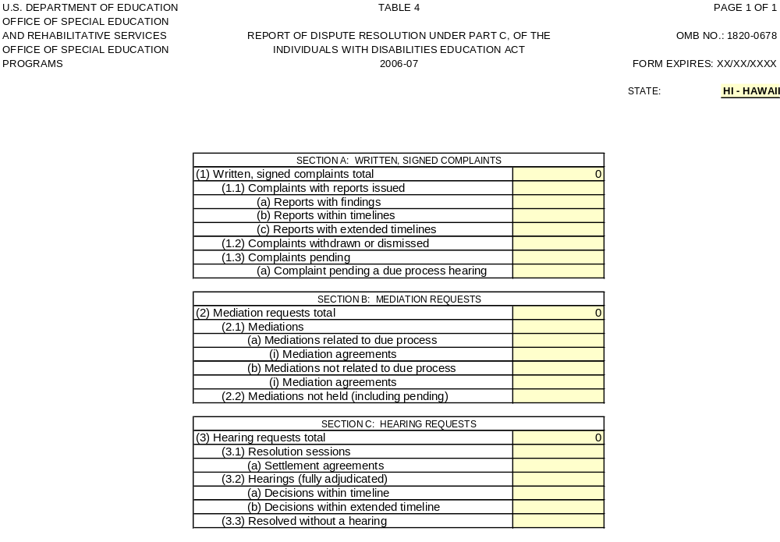

At the time of the release of this package, revised forms for collection of 618 State reported data had not yet been approved. Indicators will be revised as needed to align with language in the 2005-2006 State reported data collections.

