

Disability and Communication Access Board

Parking Program
for Persons with Disabilities

Annual Accomplishments
July 1, 2024 – June 30, 2025

State of Hawaii
Josh Green, M.D., Governor
Kenneth S. Fink, MD, MGA, MPH, Director of Health
Kirby L. Shaw, Esq., MPA, Executive Director
Overview

The Disability and Communication Access Board (DCAB) administers the Parking Program for Persons with Disabilities in the State of Hawaii. The program’s primary function is to ensure the issuance of “disability parking permits” pursuant to Chapter 291, Part III, Hawaii Revised Statutes and Hawaii Administrative Rules, Title 11, Chapter 219 “Parking for Persons with Disabilities.” Throughout this document, “disability parking permit” means a long term placard, a temporary placard, Disabled Paid Parking Exemption Permit (DPPEP), or special license plates.
To fulfill this function, DCAB, through a Memorandum of Agreement (MOA) with each County, established a mechanism to reimburse the Counties for the issuance of first time and replacement parking permits. Under the MOAs, DCAB reimburses the Counties for issuing the initial long term placard and for issuing a replacement of a mutilated placard. The Counties charge and retain fees for issuing temporary placards, replacement placards, and special license plates. DCAB issues long term placard renewals and DPPEPs by mail. A fee cannot be charged for a long term placard because it would be an illegal surcharge under the Americans with Disabilities Act (ADA), per the U.S. Court of Appeals for the Ninth Circuit. DCAB Parking Program staff ensure that all records, databases, and lists are current and consistent.
The Parking Program staff are Bryan Mick, Scott Castor, David Langille (to 8/24), Cody Miyasato (to 3/25), Romala “Sue” Radcliffe (to 2/25), Nikki Repercio.
DCAB’s Standing Committee on Parking provides guidance to the program staff in developing and meeting its goals and objectives. The Committee members are:
Summer Kozai, Chairperson
Dayne Green
Violet Horvath
Gerald Ohta
Charlotte Townsend

This report highlights the key activities for fiscal year 2024-2025.
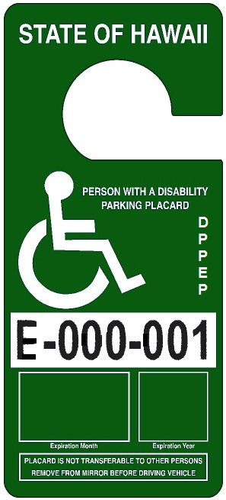
Disabled Paid Parking Exemption Permit
(DPPEP)
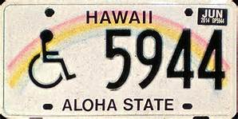
Special License Plate
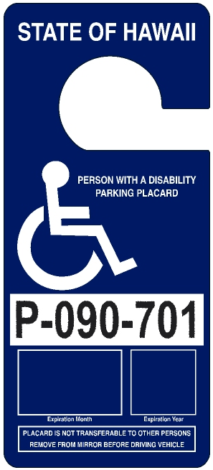
Long Term Placard
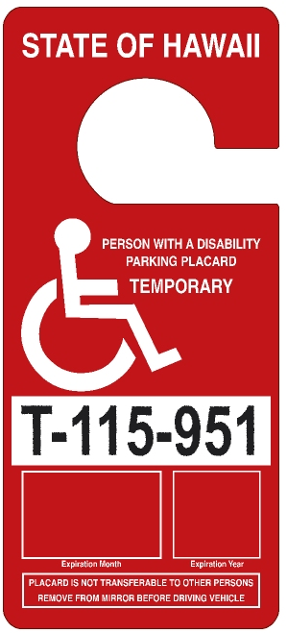
Temporary Placard

Reimbursement to and Amount Collected by the Counties
The Counties charge and retain all transaction fees for the issuance of temporary and replacement placards (excluding DPPEPs), and each set of special license plates. In fiscal year 2024-2025, reimbursement to the Counties totaled $122,676 and the transaction fees retained by the Counties totaled $135,942. The total of reimbursements to the Counties and fees retained by them in fiscal year 2024-2025 amounted to $258,618. A breakdown of reimbursement and transaction fees are shown in the chart below.

$135,942
$79,560
$90,540
$122,676
$17,502
$6,372
$21,528
$13,776
$22,380
$6,960
Parking Database Enhancements and Quality Assurance

- Tyler Hawaii continues to host the parking database that provides real-time access to permittee records for DCAB, the County issuing agencies, and parking enforcement.

- In October 2024, DCAB conducted a death records crossmatch of its database of active permittees with the Department of Health’s Vital Records database of deceased persons. The crossmatch identified 3,643 decedents with active placards, DCAB subsequently invalidated those placards in the database and mailed letters to the estates of the deceased permittees. In fiscal year 2024-2025, 1,241 placards were retrieved through this effort. In addition, 96 placards were surrendered by estates that had not received a letter.

- In addition to the placards returned due to the death of the permittee, 4,033 placards were surrendered. This includes placards that were mutilated, confiscated by parking enforcement, and returned upon renewal.

Issuance of Permits

In fiscal year 2024-2025, a total of 33,640 permits were issued, of which 32,094 were placards and 1,546 were special license plates. The pie charts to the right highlights the details of the issued permits.

Chart 1 shows the issuance by type of permit. Of the permits issued, 23,386 (70%) were long term placards that are valid for six years. Special license plates expire concurrently with the long term placards. One thousand five hundred forty six (5%) special license plates were issued. Temporary placards are valid in one month increments up to six months, according to the expected length of the disability. A total of 8,614 (26%) temporary placards were issued. DPPEPs are valid for one month to six months or if the disability is long term, for six years. Seventy four (0%) DPPEPs were issued.

Chart 2 shows the issuance of placards by type. There were 15,459 (48%) first time placards of all types issued. There were 3,570 (11%) replacement placards issued (long term, temporary, and DPPEP) and 13,262 (41%) renewal placards issued.

Chart 3 shows the number of placards issued by agency. The City and County of Honolulu issued 14,460 (45%), the County of Hawaii 3,748 (12%), the County of Maui 2,669 (8%), and the County of Kauai 1,113 (3%). This generally mirrors the population distribution in each County. The Counties issued first time and replacement placards (both long term and temporary) and renewals of temporary placards, while DCAB issued renewals of long term placards and all DPPEPs by mail. DCAB issued ten thousand one hundred four (31%) placards.

10,104 31%

8,614 26%
13,26241%
1,546 5%
3,57011%
Profile of Permittees

At the conclusion of the fiscal year on June 30, 2025, 109,703 people possessed a valid, non-expired permit. With a population of 1.45 million people in the State of Hawaii (as of 2024), this equates to approximately 8% of the population having a mobility disability significant enough to qualify for a disability parking permit.

The following two charts show a breakdown of permittees by County of residence and by gender.

49,583
45%

17,567
16%
75,516
69%
11,507
10%

The table below shows the number of individuals who were issued a permit per qualifying condition. Each individual’s qualifying condition is certified by a Hawaii licensed practicing physician, physician assistant, or Advanced Practice Registered Nurse. Note that not all qualifying conditions are readily apparent or visible. Cardiac, renal, oncologic, and neurological conditions are a few of the qualifying conditions that may not always be visually noticeable. The qualifying conditions are listed from highest to lowest based on the numbers of individuals who were certified for a permit based on a given qualifying condition. Permittees may also have multiple qualifying conditions.

Qualifying Conditions | # of Individuals | Qualifying Conditions | # of Individuals
Orthopedic Impairment | 45,882 | Oncologic Condition | 6,490
Arthritic Condition | 44,202 | Renal Condition | 4,183
Neurologic Condition | 24,358 | Use of a Brace(s) | 2,936
Use of a Cane(s) | 19,319 | Respiratory Disability | 2,654
Use of a Walker | 12,625 | Use of Portable Oxygen | 1,373
Use of a Wheelchair | 8,171 | Use of Crutches | 1,293
Heart Condition (Class III/IV) | 7,934 | Use of Other Assistive Devices | 1,170
Needs Another Person to Walk | 7,040 | Use of Artificial Lower Limb(s) | 528
Vascular Condition | 6,480

“Park with Aloha” Campaign

In fiscal year 2024-2025, DCAB continued to develop its “Park with Aloha” campaign to improve the experience that permittees have when using accessible parking spaces. The theme is, “You can’t just drive with aloha, you must also park with aloha.”

As part of DCAB’s advocacy efforts to educate and collaborate with the business community, letters were sent to the Retail Merchants of Hawaii and to the Chamber of Commerce of Hawaii with a request to forward the letter to their members. The letter asked the members to (1) determine whether their existing accessible parking spaces and accessible routes comply with the ADA Accessibility Guidelines (ADAAG) and State regulations, (2) add additional accessible and van accessible parking spaces beyond the ADAAG minimum requirements, and (3) voluntarily install “priority for side ramp and lift equipped vehicle” signs on their van accessible spaces.

A press release was issued regarding the voluntarily “park with aloha” signs as well.

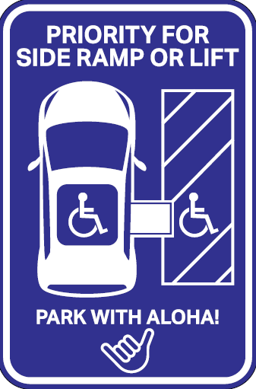

Enforcement Efforts

Act 111 was signed into law on May 29, 2025, by Governor Green. This authorizes, but does not require, the Counties to adopt and enforce ordinances requiring adherence to the design specifications for accessible parking spaces. DCAB will advocate for the counties to exercise their authority and adopt design ordinances relating to accessible parking spaces.

DCAB met with the Honolulu Police Department (HPD) to discuss enforcement related issues including the expansion of HPD’s volunteer special enforcement officer program to help enforce accessible parking laws.

DCAB published in Midweek, a public service announcement reminding permittees that temporary placards, long term placards, and special license plates no longer provide a meter fee exemption.

Administration of Policies and Procedures

DCAB drafted and issued procedures for the issuance of disability parking permits to ensure consistent administration by DCAB and all the Counties. DCAB also developed technical publications as references for county staff and parking enforcement officers.

- Upon request, DCAB provides a document to be placed on the dashboard of a vehicle next to Japan issued disability parking permits. The document informs law enforcement officers in English that the Japanese disability parking permit is a valid disability parking permit for use in Hawaii and indicates the travel start and end dates. This document is provided as a courtesy because Japan has not adopted the use of the International Symbol of Accessibility which would otherwise help Hawaii law enforcement recognize the authenticity of Japan issued disability parking permits.

- DCAB supplied the Counties with application forms (Form PA3). The application form is also available on DCAB’s website to download, or a hard copy may be picked up at any County issuing site, including Honolulu Satellite City Halls, Department of Motor Vehicles, and the Office on Aging (County of Hawaii).

- Application forms for renewal of a long term parking permit (blue placards) or for a DPPEP must be mailed to: DCAB, P.O. Box 3377, Honolulu, HI 96801. The placard will be mailed to the applicant.

- DCAB continued to maintain two webpages for the public to submit photos and report issues relating to the parking program. One webpage is for the misuse of disability parking permits and the other is for parking space design related issues. Examples of this are parking lots and spaces that lack the minimum number of required accessible parking spaces, access aisles, or signage.

.


Disability and Communication Access Board
1010 Richards Street, Room 118
Honolulu, HI 96813
Phone: (808) 586-8121
FAX: (808) 586-8129
Email: dcab@doh.hawaii.gov
Website: http://health.hawaii.gov/dcab

NONDISCRIMINATION STATEMENT
The Hawai‘i Department of Health (DOH) is committed to maintaining an environment free from discrimination, retaliation, or harassment on the basis of race, color, sex, national origin, age, or disability, or any other class as protected under federal or state law, with respect to any program or activity. For more information, including language accessibility and filing a complaint, please contact Acting Non-Discrimination Coordinator Valerie Kato at (808) 586-4400, doh.nondiscrimination@doh.hawaii.gov, or visit HDOH’s website at http://health.hawaii.gov.

