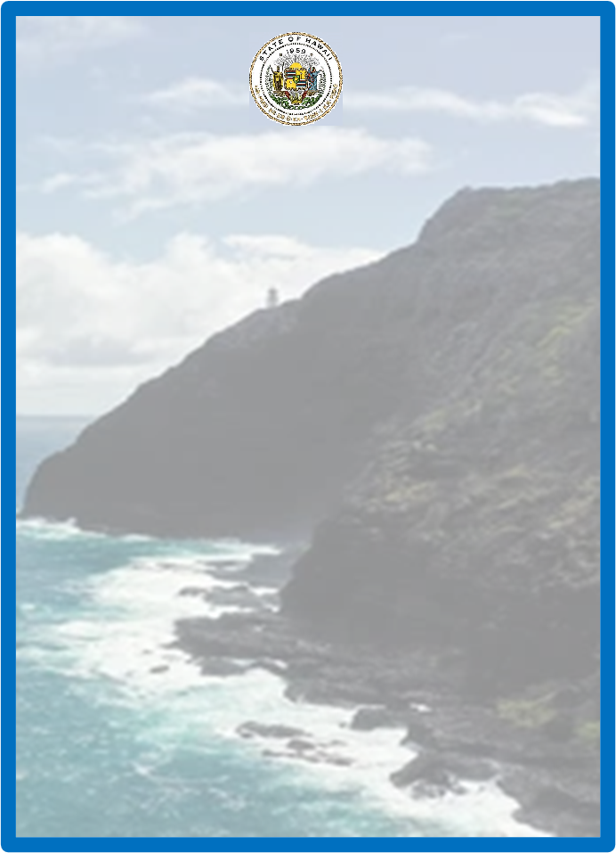

Disability and Communication Access Board
Parking Program
for Persons with Disabilities

Annual Accomplishments
July 1, 2021 – June 30, 2022

State of Hawaii
David Y. Ige, Governor
Elizabeth A. Char, M.D., Director of Health
Kirby L. Shaw, Executive Director
Overview

The Disability and Communication Access Board (DCAB) administers the Parking Program for Persons with Disabilities in the State of Hawaii. The program’s primary function is to ensure the issuance of “disability parking permits” pursuant to Chapter 291, Part III, Hawaii Revised Statutes and Hawaii Administrative Rules, Title 11, Chapter 219 “Parking for Persons with Disabilities.” Throughout this document, “disability parking permit” means a long term placard, a temporary placard, Disabled Paid Parking Exemption Permit (DPPEP), or special license plates.
To fulfill this function, DCAB, through a Memorandum of Agreement (MOA) with each County, established a mechanism to reimburse the Counties for the issuance of first time and replacement parking permits. Under the MOAs, DCAB reimburses the Counties for issuing the initial long term placard and for issuing a replacement of a mutilated placard. The Counties charge and retain fees for issuing temporary placards, replacement placards, and special license plates. DCAB issues long term renewals and DPPEPs by mail. A fee cannot be charged for a long term placard because it would be an illegal surcharge under the Americans with Disabilities Act, per the U.S. Court of Appeals for the Ninth Circuit. DCAB parking program staff ensure that all records, databases, and lists are current and consistent.
The parking program staff members are: Bryan Mick, Scott Castor, Christine Holmes, Cody Miyasato, and Romala “Sue” Radcliffe.
DCAB’s Standing Committee on Parking provides guidance to the program staff in developing and meeting its goals and objectives. The Committee members are:
Summer Kozai, Chairperson
Pauline Aughe
Violet Horvath
Gerald Ohta
Charlotte Townsend (1/20/2022)

This report highlights the key activities for fiscal year 2021-2022.
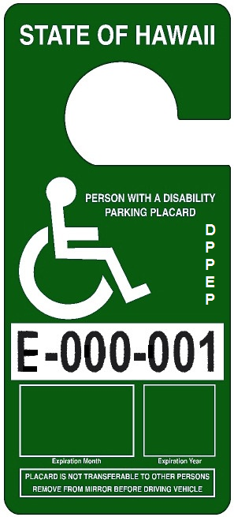
Disabled Paid Parking Exemption Permit
(DPPEP)
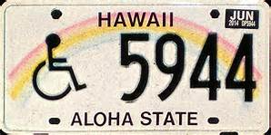
Special License Plate
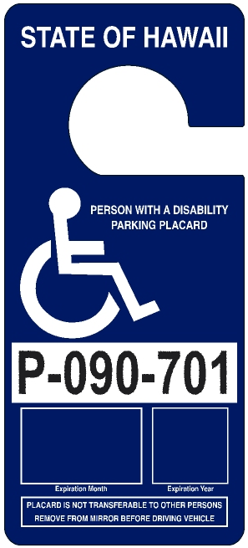
Long Term Placard
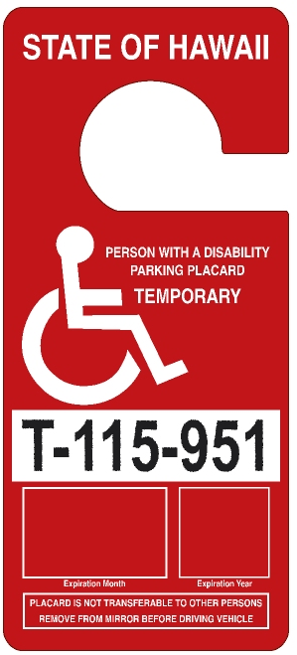
Temporary Placard

Reimbursement to and Amount Collected by the Counties
The Counties charge and retain all transaction fees for the issuance of temporary and replacement placards (excluding DPPEPs), and each set of special license plates. In fiscal year 2021-2022, reimbursement to the Counties totaled $90,528 and the transaction fees retained by the Counties totaled $100,620. The total of reimbursements to the Counties and fees retained by them in fiscal year 2021-2022 amounted to $191,148. A breakdown of reimbursement and transaction fees are shown in the chart below.

$100,620
$4,146
$11,556
$14,850
$70,068
$9,720
$90,528
$15,504
$3,804
$61,500
Parking Database Enhancements and Quality Assurance

- NIC Hawaii continues to host the parking database that provides real-time access to permittee records for DCAB, the County issuing agencies, and parking enforcement.

- In August 2021, DCAB conducted a death records crossmatch of its database of active permittees against the Department of Health’s Vital Records database of deceased persons. The crossmatch identified decedents with active placards, DCAB subsequently invalidated those placards in the database and mailed letters to the estates of the deceased permittees to retrieve invalidated placards. In fiscal year 2021-2022, 1,510 placards were retrieved through this effort. In addition, 182 placards were surrendered by estates that had not received a letter.

- In addition to the placards returned due to the death of the permittee, 6,460 placards were surrendered. This includes placards that were mutilated, confiscated by parking enforcement, and returned upon renewal.

Issuance of Permits
In fiscal year 2021-2022, a total of 22,682 permits were issued, of which 21,654 were placards and 1,028 were special license plates. The pie charts to the right highlights the details of the issued permits.

Chart 1 shows the issuance by type of permit. Of the permits issued, 15,046 were long term placards that are valid for six years. Special license plates expire concurrently with the long term placards. One thousand twenty eight special license plates were issued. Temporary placards are valid in one month increments up to six months, according to the expected length of the disability. A total of 6,281 temporary placards were issued. DPPEPs are valid for one month to six months or if the disability is long term, for six years. Three hundred nineteen DPPEPs were issued.

Chart 2 shows the issuance of placards by type. There were 11,972 first time placards of all types issued. There were 2,498 replacement placards issued (both long term and temporary) and 7,186 renewal placards issued.

Chart 3 shows the number of placards issued by agency. The City and County of Honolulu issued 11,294, Hawaii County 2,587, Maui County 1,805, and Kauai County 724. This generally mirrors the population distribution in each County. The Counties issued first time and replacement placards (both long term and temporary) and renewals of temporary placards, while DCAB issued renewals of long term placards and all DPPEPS by mail. Five thousand two hundred forty four placards were issued by DCAB.

5,244
24%
7,186 33%

1,028 6%
2,498 12%
6,281 28%
Profile of Permittees

At the conclusion of the fiscal year on June 30, 2022, 106,867 people possessed a valid, non-expired permit. With a population of 1.45 million people in the State of Hawaii (as of 2020), this equates to approximately 7% of the population having a mobility disability significant enough to qualify for a permit.

Who are the 106,867 people with valid permits? The following two charts show a breakdown of permittees by County of residence and gender.

58,864
55%
16,490
15%
74,609
70%
10,920
10%

The following table shows the number of individuals who were issued a permit per qualifying condition. Each individual’s qualifying condition was certified by a Hawaii licensed practicing physician or Advanced Practice Registered Nurse. Note that not all qualifying conditions are readily apparent or visible. Cardiac, renal, oncologic, and neurological conditions are a few of the qualifying conditions that may not always be visually noticeable. The qualifying conditions are listed from highest to lowest based on the numbers of individuals who were certified for a permit based on a given qualifying condition. Permittees may have multiple qualifying conditions.
Qualifying Conditions | # of Individuals | Qualifying Conditions | # of Individuals
Arthritic Condition | 43,296 | Oncologic Condition | 6,071
Orthopedic Impairment | 42,888 | Renal Condition | 4,027
Neurologic Condition | 23,366 | Use of a Brace(s) | 2,776
Use of a Cane(s) | 18,466 | Respiratory Disability | 2,430
Use of a Walker | 10,896 | Use of Crutches | 1,306
Use of a Wheelchair | 7,487 | Use of Portable Oxygen | 1,235
Needs Another Person to Walk | 6,490 | Use of Other Assistive Devices | 977
Heart Condition (Class III/IV) | 6,466 | Use of Artificial Lower Limb(s) | 525
Vascular Condition | 6,418

Disabled Paid Parking Exemption Permits

Act 87 (2019) made several changes to Chapter 291 Part III, Parking for Disabled Persons, Hawaii Revised Statutes. The most significant change to the statute became effective on July 1, 2021, which was the repeal of the meter fee exemption for all parking permits and the issuance of a new type of parking permit, the Disabled Paid Parking Exemption Permit (DPPEP). The DPPEP is a green placard with an identical design to the existing temporary and long term placards. The DPPEP alone provides a fee exemption when parking at a space where payment is made via a meter or unattended pay station. The fee exemption is in addition to the ability to park in reserved accessible parking spaces that all disability parking permits confer. To qualify, an applicant must have a qualifying mobility disability, a valid driver’s license, and a disability that prevents them from reaching or operating a parking meter or unattended pay station.

In advance of the effective date, DCAB notified permittees of the change through television, newspapers, and emails. Staff and parking enforcement agencies placed warning flyers on vehicles, especially in the urban Honolulu and the Waikiki areas. In recognition that many permittees were unaware of the change, the County law enforcement agencies agreed to issue warnings in lieu of citations until August 15, 2021.

For fiscal year 2021-2022, a total of 316 first time and 3 replacement DPPEPs were issued.

Staff fielded many inquiries during the first few months of the fiscal year about the new law and permit type from various stakeholders, including permittees who had received warnings or citations, elected officials, and the media. Anyone applying for a first time, replacement, or renewal of a temporary or long term placard receives written notice that their permit does not provide any sort of parking fee exemption.

On February 25, 2022, DCAB staff met with representatives from various parking enforcement agencies, including the County police departments. They did not indicate any issues with the enforcement of the new placard.
Administration of Policies and Procedures

DCAB drafted and issued procedures on the issuance of disability parking permits to ensure consistent administration among all issuing agencies. DCAB also developed technical publications as references for issuing agencies’ staff and parking enforcement officers. Due to the ongoing COVID-19 pandemic, the Counties continued to allow applications to be submitted by mail.

- DCAB continued to have available a dashboard document for use with Japan-issued disability parking permits. While Hawaii recognizes disability parking permits issued by other states and countries, permits issued by Japanese governmental entities are often misidentified by law enforcement officers because they are printed in a foreign language and do not display the International Symbol of Accessibility (wheelchair figure). Upon request, DCAB provides a document to be placed on the dashboard of a vehicle next to the Japan-issued parking permit. The document informs law enforcement officers in English that the adjacent permit is a valid disability parking permit and indicates the start and end dates of validity.

- DCAB continued supplying the Counties with application forms (Form PA3). The form is available for downloading from DCAB’s website and or at any County issuing site, including Honolulu Satellite City Halls, Department of Motor Vehicles, and the Office on Aging (County of Hawaii). DCAB issues long term renewal permits (blue placards) and DPPEPs, therefore, applications to renew long term permits or for DPPEPs must be mailed to: DCAB, P.O. Box 3377, Honolulu, HI 96801.

Webpages for the Public to Report Placard Abuse or
Non-Compliant Parking Spaces

DCAB launched two webpages which allow members of the public to anonymously report issues and submit photos so that staff may follow up when appropriate.
- Misuse of Disability Parking Permits – This webpage is primarily used to report vehicles with permits that have parked in an access aisle and permits that are expired or mutilated.
- Accessible Parking Space Inquiry – This webpage is primarily to report parking lots that lack the minimum number of required accessible parking spaces, access aisles, or signage.

Parking Special Fund ~ In Memory of Francine Wai

Act 161 (2022) established a parking program account within the DCAB special fund. Starting January 1, 2023, all motor vehicle registrations will include an additional $1 fee. This fee will be deposited into the parking program account. Starting July 1, 2023, all funding for the parking program will come from this account. DCAB estimates about $1.2 million will be generated annually.

This bill was originally proposed by former DCAB Executive Director Francine Wai. She passed away unexpectedly in 2020, however, her family was able to join DCAB staff and Board members at the signing ceremony for Act 161 (2022).
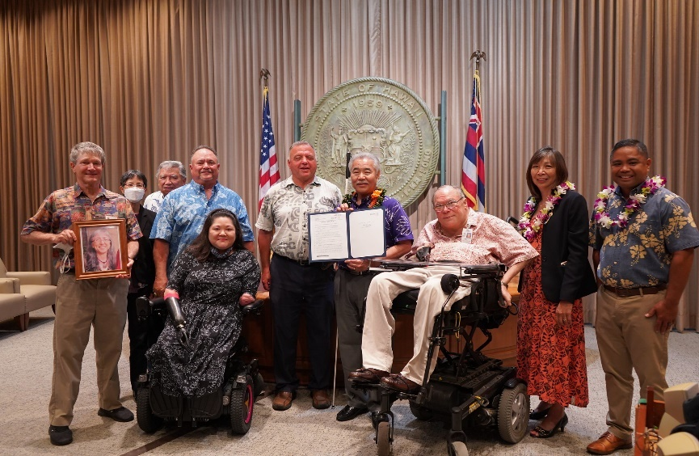

Left to right: Charles “Chip” Cox; Elizabeth A. Char, M.D., Director of Health; Richard Wai; Robert Wai, Jr.; Summer Kozai, DCAB member; Dean Georgiev, DCAB member; Governor David Ige; Kirby Shaw, DCAB Executive Director; Senator Joy San Buenaventura; and Representative Henry Aquino.
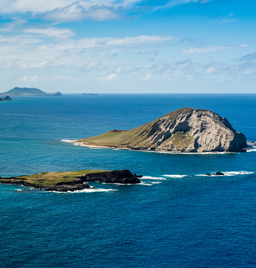
Disability and Communication Access Board
1010 Richards Street, Room 118
Honolulu, HI 96813
Phone: (808) 586-8121
TTY: (808) 586-8162
FAX: (808) 586-8129
Email: dcab@doh.hawaii.gov
Website: http://health.hawaii.gov/dcab

NONDISCRIMINATION STATEMENT: We provide access to our activities without regard to race, color, national origin (including language), age, sex, religion, or disability. If you have a concern, write or call the Disability and Communication Access Board or the Department of Health Affirmative Action Officer at P.O. Box 3378, Honolulu, HI 96801-3378 or call (808) 586-4614 (v) within 180 days of a problem.

