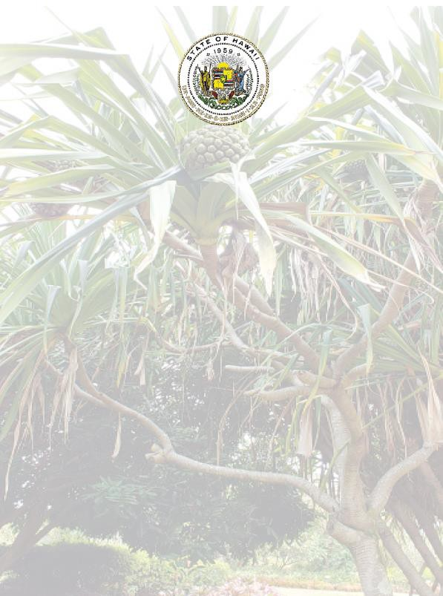

Disability and Communication Access Board Parking Program for Persons with Disabilities Annual Accomplishments

July 1, 2020 – June 30, 2021

State of Hawaii
David Y. Ige, Governor Elizabeth A. Char, M.D., Director of Health
Kirby L. Shaw, Executive Director

Overview

The Disability and Communication Access Board (DCAB) administers the Parking Program for Persons with Disabilities in the State of Hawaii. The program’s primary function is to ensure the issuance of “disability parking permits” pursuant to Hawaii Revised Statutes, Chapter 291, Part III, and Hawaii Administrative Rules, Title 11, Chapter 219. Throughout this document, “disability parking permit” means a long term placard, a temporary placard, Disabled Paid Parking Exemption Permit (DPPEP), or special license plates.
To fulfill this function, DCAB, through a Memorandum of Agreement (MOA) with each County, established a mechanism to reimburse the Counties for the issuance of first time and replacement parking permits. Under the MOAs, DCAB reimburses the Counties for issuing the initial long term placard and for issuing a replacement of a mutilated placard. The Counties may charge and retain fees for issuing temporary placards, replacement placards, and special license plates. DCAB issues long term renewals and DPPEPs by mail. A fee cannot be charged for a long term placard because it would be an illegal surcharge under the Americans with Disabilities Act, per the U.S. Court of Appeals for the Ninth Circuit. DCAB parking program staff ensure that all records, databases, and lists are current and consistent.
The parking program staff members are: Bryan Mick, Kamaile Hopfe, Geraldine “Gerry” Kealoha, Romala “Sue” Radcliffe, and Sean Shinshiro.
DCAB’s Standing Committee on Parking provides guidance to the program staff in developing and meeting its goals and objectives. The Committee members are:
Summer Kozai, Chairperson Pauline Aughe
Violet Horvath Gerald Ohta

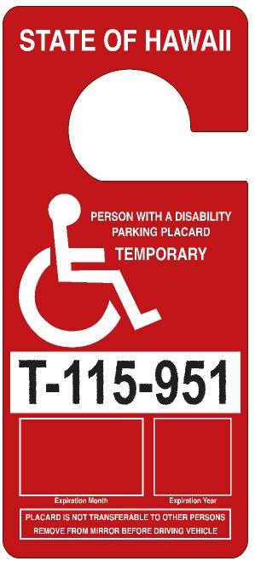
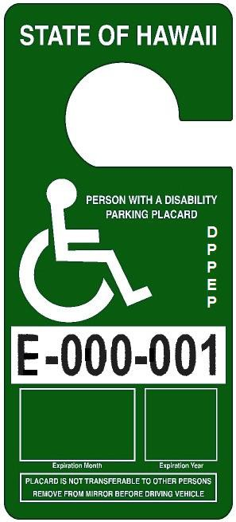
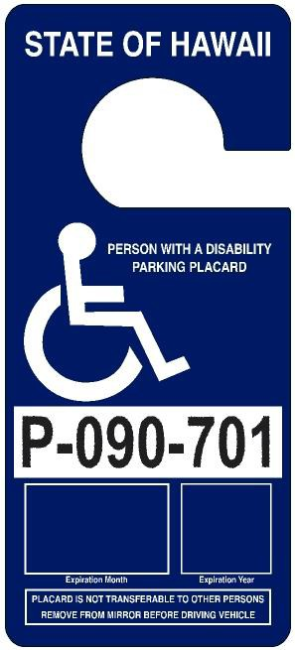
This report highlights the key activities for fiscal year 2020-2021 (FY 20-21).

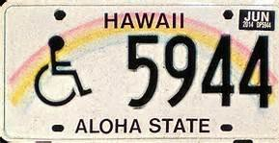
Special License Plate

Temporary Placard
Long Term Placard
Disabled Paid Parking Exemption Permit

Reimbursement to and Amount Collected by the Counties
The Counties charge and retain all transaction fees for the issuance of temporary and replacement placards (excluding DPPEPs), and each set of special license plates. In FY 20-21, reimbursement to the Counties totaled $83,424 and the transaction fees retained by the Counties totaled $84,498. The total of reimbursements to the Counties and fees retained by them in FY 20-21 amounted to
$167,922. A breakdown of reimbursement and transaction fees are shown in the chart below.

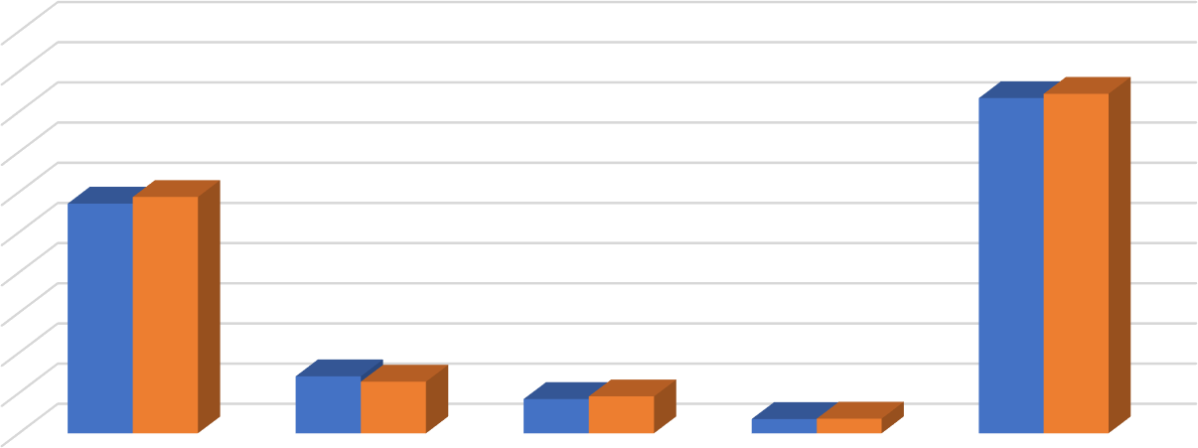
Reimbursements to and Amounts Collected by the Counties
$84,498
$100,000
$90,000
$80,000
$70,000
$60,000
$50,000
$40,000
$30,000
$20,000
$10,000
$0
$57,168 $58,824
$14,184 $12,840
$8,520 $9,186
$3,552 $3,648
HONOLULU HAWAII MAUI KAUAI TOTAL
Reimbursement to Counties by DCAB
Transaction fees collected by the Counties
$83,424

Parking Database Enhancements and Quality Assurance

- NIC Hawaii (formerly known as Hawaii Information Consortium, LLC) continues to host the parking database that provides real-time access to permittee records for DCAB, the County issuing agencies, and parking enforcement. Prior to the start of DPPEP issuance on July 1, 2021, several changes to the parking database were made.

- In September 2020, DCAB conducted a death records crossmatch of its database of active permittees against the Department of Health’s Vital Records database of deceased persons. The crossmatch identified decedents with active placards, DCAB subsequently invalidated those placards in the database and mailed letters to the estates of the deceased permittees to retrieve invalidated placards. In FY 20-21, 1,984 placards were retrieved through this effort. In addition, 172 placards were surrendered by estates that had not received a letter.

- In addition to the placards returned due to the death of the permittee, 4,333 placards were surrendered. This includes placards that were mutilated, confiscated by parking enforcement, and returned upon renewal.

Issuance of Permits

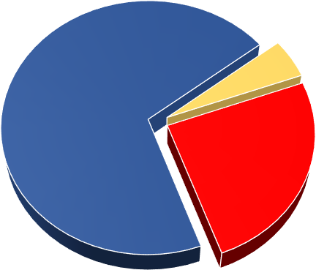In FY 20-21, a total of 21,358 permits were issued, of which 20,384 (95%)
Chart 1 Type of Permit
15,003
70%
974
5%
5,381
25%

Temporary Placard Long Term Placard Special License Plate
were placards and 974 (5%) were special license plates. The pie charts to the right highlight the details of the issued permits.
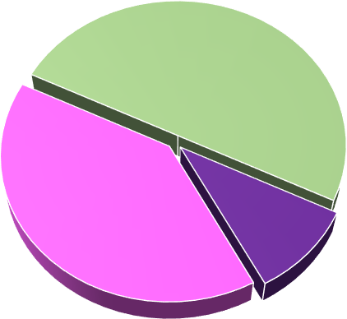Chart 1 shows the issuance of temporary placards, long term placards, and special license plates. Of the permits issued, 15,003 (70%) were long term (blue color) that are valid for six years. Special license plates are also valid for six years and expire concurrently with the long term placard. Temporary placards (red color) are valid in one month increments up to six months, according to the expected length of the permittee’s disability. A total of 5,381 (25%) were issued.
Chart 2 Types of Issuance

10,259
50%

8,067
40%
2,056
10%

Renewal 1st Time Issuance Replacement

Chart 2 shows the issuance of placards by type. There were 10,259 (50%) first time placards (both long term and temporary issued. There were 2,056 (10%) replacement placards issued (both long term and temporary), and 8,067 (40%) renewal placards issued.

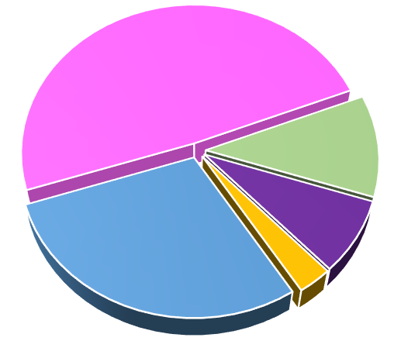Chart 3 shows the number of placards issued by agency. The percentages generally mirror the population of the Counties: City and County of Honolulu with 9,897 (49%), Hawaii County with
Chart 3 Placards Issued by Agency
9,897
49%
2,327
11%
City and County
of Honolulu
Hawaii
Maui

Kauai
1,530
8% DCAB
5,987
29%
643
3%
4
2,327 (11%), Maui County with 1,530
(8%), and Kauai County with 643 (3%). The Counties issued first time and replacement (temporary and long term) placards and renewals of temporary placards, while DCAB issued renewals of long term placards by mail. There were 5,987 (29%) long term renewal placards issued.

Profile of Permittees

At the conclusion of the fiscal year on June 30, 2021, 104,611 people possessed a valid, non- expired permit. With a population of 1.41 million people in the State of Hawaii (as of 2019), this equates to approximately 7% of the population having a mobility disability significant enough to qualify for a permit.

Who are the 104,611 people with valid permits? The following two charts show a breakdown of permittees by County of residence and gender.

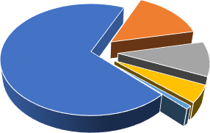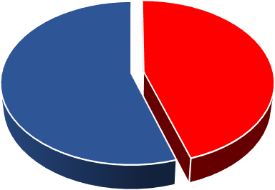
County of Residence
16,112
15%
73,053
70%
10,674
10%

4,747
5%
25
0%
Honolulu Hawaii Maui Kauai
Out of State
57,666
55%
Gender
46,945
45%
Male
Female

The following table shows the number of individuals who were issued a permit per qualifying condition. Each individual’s qualifying condition was certified by a Hawaii licensed practicing physician or Advanced Practice Registered Nurse (APRN). Note that not all qualifying conditions are readily apparent or visible. Cardiac, renal, oncologic, and neurological conditions are a few of the qualifying conditions that may not always be visually noticeable. The qualifying conditions are listed from highest to lowest based on the numbers of individuals who were certified for a permit based on a given qualifying condition. Permittees may have multiple qualifying conditions.

Qualifying Conditions | # of Individuals | Qualifying Conditions | # of Individuals
Arthritic Condition | 41,888 | Oncologic Condition | 6,110
Orthopedic Impairment | 41,789 | Renal Condition | 3,864
Neurologic Condition | 22,811 | Use of a Brace(s) | 2,711
Use of a Cane(s) | 17,720 | Respiratory Disability | 2,371
Use of a Walker | 10,279 | Use of Crutches | 1,320
Use of a Wheelchair | 7,089 | Use of Portable Oxygen | 1,167
Needs Another Person to Walk | 6,331 | Use of Other Assistive Devices | 914
Vascular Condition | 6,225 | Use of Artificial Lower Limb(s) | 498
Heart Condition (Class III/IV) | 6,211

Amendments to Hawaii Administrative Rules Title 11, Chapter 219

Act 87 (2019) made several changes to Hawaii Revised Statutes 291, Part III, Parking for Disabled Persons. The most significant change to the statute was effective July 1, 2021, the repeal of the meter fee exemption for all parking permits and the issuance of a new type of parking permit, the Disabled Paid Parking Exemption Permit (DPPEP). The DPPEP is a green placard with an identical design to the existing temporary and long term placards. The DPPEP alone provides a fee exemption when parking at a space where payment is made via a meter on unattended pay station. The fee exemption is in addition to the ability to park in reserved accessible parking spaces that all disability parking permits confer. To qualify, an applicant must have a qualifying mobility disability, a valid driver’s license, and a disability that prevents them from reaching or operating a parking meter or unattended pay station.

In advance of July 1, 2021, DCAB worked with the database vendor to make updates to the parking database, combined the existing two parking application forms (one for renewal of long term placards, the other for all other transactions), into one multi-use form, met with representatives from the four County issuing agencies, met with State and County parking enforcement representatives, designed and procured the DPPEP, and prepared various public education efforts.

The statutory changes necessitated making amendments to Hawaii Administrative Rules, Title 11, Chapter 219. Amendments were made to the rules in the sections that govern the following areas, definitions, the disability parking permit application form, the issuance, replacement, and renewal of the DPPEP, and the meter fee exemption. Amendments were also made to exempt accessible parking spaces that have been assigned to a specific employee from the signage requirements, exclude a temporary accessible parking space or access aisle (defined as in use for 7 or less consecutive days) from striping requirements, and to add an option to paint “No parking” in access aisles.

DCAB presented the draft amended rules to the Small Business Regulatory Review Board (SBRRB) on February 18, 2021. The SBRRB approved the proposed rules, clearing the way for DCAB to hold a public hearing on the rules. A virtual public hearing was held on April 8, 2021. Several members of the public offered testimony in support. A post public hearing presentation was provided to SBRRB on May 20, 2021. The SBRRB voted to recommend that Governor Ige sign the rules into law. On June 15, 2021, Governor Ige signed the rules.
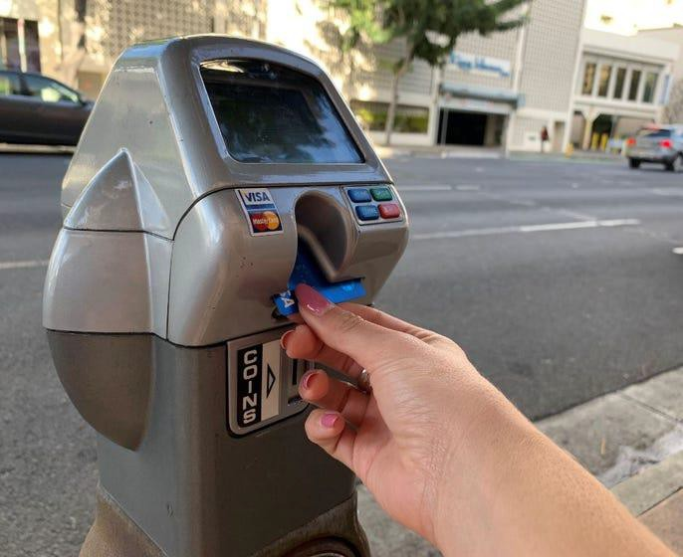

Administration of Policies and Procedures
DCAB drafted and issued procedures on the issuance of disability parking permits to ensure consistent administration among all issuing agencies. DCAB also developed technical publications as references for issuing agencies staff and parking enforcement officers. Due to COVID-19, the procedures were adjusted by each County to minimize risk to staff and applicants and in recognition that many medical appointments were being conducted virtually.

- DCAB continued to have available a dashboard document for use with Japan-issued disability parking permits. However, due to travel restrictions, none were issued. While Hawaii recognizes disability parking permits issued by other states and countries, permits issued by Japanese governmental entities are often misidentified by law enforcement officers because they are printed in a foreign language and do not display the International Symbol of Accessibility (wheelchair figure). Therefore, upon request, DCAB provides a document to be placed on the dashboard of a vehicle next to the Japan-issued parking permit. The document informs law enforcement officers in English that the adjacent permit is a valid disability parking permit and indicates the start and end dates of validity. The document has instructions in Japanese on the reverse side.

- DCAB continued supplying the Counties with application forms (Form PA-1) for first time (long term and temporary), replacement, temporary (renewal) permits and special license plates; and application forms (Form PA-2) for long term renewal permits (blue placards and special license plates). The forms were replaced by the PA-3 form starting July 1, 2021. The forms were available for downloading from DCAB’s website and or at any County issuing site, including Honolulu Satellite City Halls, Department of Motor Vehicles, and the Office on Aging (County of Hawaii). DCAB issues long term renewal permits (blue placards) therefore, applications to renew long term permits must be mailed to: DCAB, P.O. Box 3377, Honolulu, HI 96801.

- DCAB worked with the four Counties to modify the application process for first time, temporary, and replacement parking permits. As all four Counties prohibited in person transactions at some point during the fiscal year, applicants could mail in the form, a copy of a valid identification card, and any applicable fees. On the DCAB website, a separate webpage for each County was created so that the information could be updated as each County modified its procedures.

- Governor Ige extended the expiration dates of several types of permits and licenses during the fiscal year due to the pandemic. At the request of DCAB, the expiration dates for parking permits that expired on or after the date the state of emergency was declared were extended. This extension ended February 14, 2021.

- In advance of the commencement of DPPEP issuance on July 1, 2021, DCAB conducted several interviews with print and television media outlets. Warning flyers were printed and left on vehicles parked in metered parking spaces. Parking enforcement agencies agreed to issue the flyer in lieu of citations until August 15, 2021.

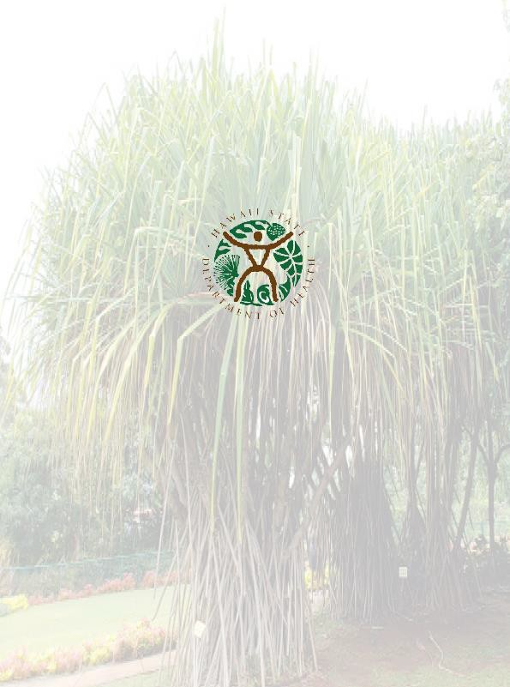

Disability and Communication Access Board 1010 Richards Street, Room 118
Honolulu, HI 96813
Phone: (808) 586-8121
FAX: (808) 586-8129
Email: dcab@doh.hawaii.gov Website: http://health.hawaii.gov/dcab

NONDISCRIMINATION STATEMENT: We provide access to our activities without regard to race, color, national origin (including language), age, sex, religion, or disability. If you have a concern, write or call the Disability and Communication Access Board or the Department of Health Affirmative Action Officer at P.O. Box 3378, Honolulu, HI 96801-3378 or call (808) 586-4614 (v) within 180 days of a problem.
8

