EXHIBIT 3

TYPICAL ACCESS AISLE SIGN
(10/1/11)

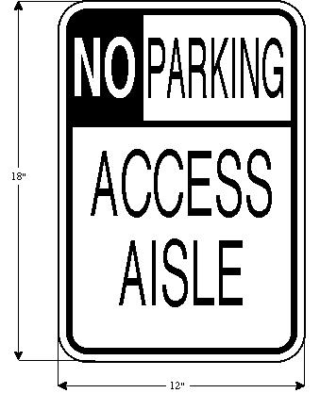

This is a picture of a parking sign for access aisles. It says no parking access aisle. Around the picture there are measurements of how wide and tall the sign needs to be. The sign needs to be eighteen inches in height, twelve inches wide.

219-21

