EXHIBIT 1
This is a picture of a reserved parking sign. It says Reserved Parking. Under that text there is a picture of the universal symbol of access. Beneath the symbol of access is this text: Placard or special license plates required, maximum fine $500. Around the picture there are measurements of how wide and tall the sign needs to be. The sign needs to be eighteen inches in height, twelve inches wide. The universal symbol of access needs to be four inches high between six inches of square footage.

TYPICAL RESERVED PARKING SIGN FOR PERSONS WITH DISABILITIES
(10/1/11)

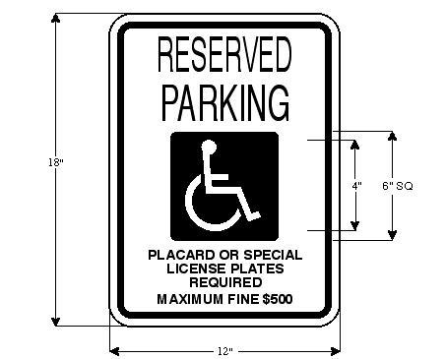

219-19

