APPLICABLE MONITORING AND ASSESSMENT PLAN GENERAL INSTRUCTION
July 10, 2015
Version 1

A. Legal Requirements:

1. CWA, Section 401 (d) requires that:

(d) Any certification provided under this section shall set forth any effluent limitations and other limitations, and monitoring requirements necessary to assure that any applicant for a Federal license or permit will comply with any applicable effluent limitations and other limitations, under section 301 or 302 of this Act, standard of performance under section 306 of this Act, or prohibition, effluent standard, or pretreatment standard under section 307 of this Act, and with any other appropriate requirement of State law set forth in such certification, and shall become a condition on any Federal license or permit subject to the provisions of this section. (33 U.S.C. 1341)

2. HRS, §342D-55 requires that:

§342D-55 Recordkeeping and monitoring requirements. (a) The director may require the owner or operator of any effluent source, works, system, or plant; any discharger of effluent; the applicant for written authorization under this chapter for such sources or facilities; or any person engaged in management practices to:
(1) Establish and maintain records;
(2) Make reports and plans that shall cover existing situations and proposed additions, modifications, and alterations;
(3) Install, use, and maintain monitoring equipment or methods;
(4) Sample effluent, state waters, sewage sludge, and recycled water; and
(5) Provide such other information as the department may require.
(b) The director may require that information and items required under subsection (a) be complete and detailed, in a prescribed form, made or prepared by a competent person acceptable to the director, and at the expense of the owner, operator, or applicant.
(c) Management practices covered in this section are those for domestic sewage, sewage sludge, and recycled water, whether or not such practices cause water pollution.

B. "Water quality certification'' or "certification" means a statement which asserts that a proposed discharge resulting from an activity will not violate applicable water quality standards and the applicable provisions of sections 301, 302, 303, 306 and 307 of the Act. A water quality certification is required by section 401 of the Act from any applicant for a federal license or permit to conduct any activity, including the construction or operation of facilities which may result in any discharge into navigable waters. (HAR, §11-54-9.1)
C. HAR, Chapter 11-54 titled Water Quality Standards (WQS) is an administrative rule adopted, and revised from time to time, by the DOH under the authorization of CWA, §303 and HRS, §342D-5. It consists of:
1. General policy of water quality antidegradation (HAR, §11-54-1.1).
2. Designated Uses (Beneficial Uses. HAR, §11-54-3).
3. Water Quality Criteria:
(a) Basic water quality criteria applicable to all waters (HAR, §11-54-4).
(b) Specific Water Quality Criteria for:
(1) Uses and specific criteria applicable to inland waters (HAR, §11-54-5).
(2) Uses and specific criteria applicable to marine waters (HAR, §11-54-6).
(3) Uses and specific criteria applicable to marine bottom types (HAR, §11-54-7).
(c) Recreational criteria for all State waters (HAR, §11-54-8).
D. Definition
"Discharge" means the discharge of a water pollutant (HAR, §11-54-1).
“Water pollutant" means dredged spoil, solid refuse, incinerator residue, sewage, garbage, sewage sludge, munitions, chemical waste, biological materials, radioactive materials, heat, wrecked or discarded equipment, rock, sand, soil, sediment, cellar dirt and industrial, municipal, and agricultural waste. (HRS, §342D-1)
"Water pollution" means:
(1) Such contamination or other alteration of the physical, chemical, or biological properties of any state waters, including change in temperature, taste, color, turbidity, or odor of the waters, or
(2) Such discharge of any liquid, gaseous, solid, radioactive, or other substances into any state waters,
as will or is likely to create a nuisance or render such waters unreasonably harmful, detrimental, or injurious to public health, safety, or welfare, including harm, detriment, or injury to public water supplies, fish and aquatic life and wildlife, recreational purposes and agricultural and industrial research and scientific uses of such waters or as will or is likely to violate any water quality standards, effluent standards, treatment and pretreatment standards, or standards of performance for new sources adopted by the department. (HRS, §342D-1)
"State waters", as defined by section 342D-1, HRS, means all waters, fresh, brackish, or salt ground and within the State, including, but not limited to, coastal waters, streams, rivers, drainage ditches, ponds, reservoirs, canals, ground waters, and lakes; provided that drainage ditches, ponds, and reservoirs required as part of a water pollution control system are excluded. This chapter applies to all State waters, including wetlands, subject to the following exceptions:
(1) This chapter does not apply to groundwater, except the director may in the director's discretion take appropriate actions when the director believes that the discharge of pollutants to the ground or groundwater has adversely affected, is adversely affecting, or will adversely affect the quality of any State water other than groundwater.
(2) This chapter does not apply to drainage ditches, flumes, ponds and reservoirs that are required as part of a water pollution control system.
(3) This chapter does not apply to drainage ditches, flumes, ponds, and reservoirs that are used solely for irrigation and do not overflow into or otherwise adversely affect the quality of any other State waters, unless such ditches, flumes, ponds, and reservoirs are waters of the United States as defined in 40 C.F.R. section 122.2. The State of Hawai'i has those boundaries stated in the Hawai'i Constitution, art. XV, §1. (HAR, §11-54-1)
"Waste" means sewage, industrial and agricultural matter, and all other liquid, gaseous, or solid substance, including radioactive substance, whether treated or not, which may pollute or tend to pollute the waters of this State (HRS, §342D-1).
E. Content of AMAP – Applicable for e-Permitting NWP Blanket WQC Notification Form
The AMAP shall be properly designed and implemented to ensure that any applicant for a work authorization verification under DA 2012 – 2017 Nationwide Permits (NWPs) Nos. 3, 5, 6, 12, 13, 14, or 33 will comply with any applicable effluent limitations and other limitations, under section 301 or 302 of CWA, standard of performance under section 306 of CWA, or prohibition, effluent standard, or pretreatment standard under section 307 of CWA, applicable State WQS as adopted by the DOH in HAR, Chapter 11-54 under CWA, section 303 and HRS, §342D-5, and with any other appropriate requirement of State law or conditions set forth in the conditional blanket Section 401 WQC under File No. WQC0804.
A properly designed and well executed AMAP should be able to provide:
- Affected existing project site physical, chemical and biological environmental information and identify the potential short/long term and construction/operations related physical, chemical and/or biological environmental effects as the result of the proposed construction activities.
- Accurate representative monitoring results that allow the timely management decision in implementing mitigative/corrective measures to the potential water pollution issues attributable to the equipment operations, construction methods, construction sequence, material used, effectiveness of the installed BMPs or the improperly installed or maintained BMPs, etc.
- Sufficient information to identify the expected/unexpected long term adverse impacts that may require additional mitigation measures to restore the affected physical, chemical and biological environment.
- Sufficient information on the existing uses at the project site, and assure that existing uses and the level of water quality necessary to protect the existing uses, shall be maintained and protected.
For It is highly recommended that information contained in the AMAP be formatted in the following sequence:
1. Title Page – provide name, company, qualification and contact information of the author of AMAP and date and version of the AMAP.
2. Introduction – Provide:
a. Project name and purposes of preparing this AMAP.
b. Specific statutory and legal requirements, rules, regulations that applicable to this project and guidelines, matrix, rationale/justifications used as the basis of preparing this AMAP.
c. Project location, project site Tax Map Keys & project site centroid coordinates (using datum WGS84) and project site contact person information.
d. Receiving State waters name and classification (See HAR, Chapter 11-54); CWA, §303(d) listing; TMDL status and pollutant(s) of concerns (POC, specified in DOH September 2, 2014 Integrated Report to the U.S. Environmental Protection Agency and the U.S. Congress Pursuant to §303(d) and §305(b), Clean Water Act (P.L. 97-117) and can be downloaded at: http://health.hawaii.gov/cwb/files/2014/11/Final-2014-State-of-Hawaii-Water-Quality-Monitoring-and-Assessment-Report.pdf), if any.
3, Project scope, potential water pollutant producing and discharge activities and pollutant of concerns (POC). Please:
a. Describe overall project scope and construction activities. (***Note: need to add WQC Application Item #7 requirements in Item #XX of this e-Permitting NWP Blanket WQC Notification Form. Information provided here shall be consistent with details and construction drawings provided in Item # XX of this e-Permitting NWP Blanket WQC Notification Form)
b. Provide project boundary, structure foot print, proposed BMPs and location with Coordinates (WGS84) on a scaled construction drawing.
c. Identify location and dimension of the proposed sampling Control and Impact station decision units (DUs) with Coordinates on the same scaled construction drawing, above.
d. Provide potential water pollutant producing activities that may result in water pollutants enter/re-enter State waters.
e. List and provide physical, chemical, biological, thermal, and any other pertinent characteristic of each of the potential water pollutants that may result from the potential pollutants producing activities.
4. Description of existing environment and potential environmental effects may result from the construction and operation of the proposed construction activities
Provide:
a. Project site existing physical, chemical and biological environment information or submit the survey reports as an attachment to this AMAP.
b. Discuss the potential effects to the existing physical, chemical and biological environment as the result of the proposed construction activities.
c. Appropriate monitoring protocol to properly identify the extent of adverse effects.
d. Sufficient information on the existing uses at the project site and assures that existing uses and the level of water quality necessary to protect the existing uses shall be maintained and protected.
5. Monitoring Program
a. Provide organizational responsibility in a table form that includes name, responsibility and qualification of each and every person or firm that will be involved in the proper execution of this AMAP.
b. Sampling locations - provide narrative description and place on a scaled construction drawing all control and impact station DU, specific DU when turbidity plume exists, Coordinates (WGS84) of all DUs.
c. BMPs locations – show the proposed structure foot print and BMPs location on the same scaled construction drawing contains the sampling station DUs and demonstrates the adequacy of the proposed sampling station DUs location.
d. Parameter to be monitored – All potential water pollutants resulting from the potential pollutant producing activities, POC of the affected receiving State waters, potential water pollutant release from the operation of the construction equipment, etc. shall be properly monitored and analyzed. Water pollutants not disclosed in the e-Permitting NWP Blanket WQC Notification Form will not be permitted to discharge into the affected State waters.
e. Sampling and frequencies – provide detailed pre, during and post construction sampling requirements and see Condition 5.b(9) of WQC0804 for the minimal during construction sampling frequency requirements. More frequent sampling frequency may be warranted on a project specific and on a case-by-case basis.
f. Sampling and Analytical methods: provide detailed analytical methods and instruments to be used for the project, analytical holding time, preservation in a table form.
g. Quality Assurance Plan
h. Data Quality Objective - Download and Read the DQO Guidelines from http://www.epa.gov/quality/qs-docs/g4-final.pdf. Also see guideline below.
i. Chain of Custody Procedures
k. Field Analysis Quality Control
l. Report and Assessment

AMAP GUIDELINES (DQO format)
Example: The WQC application identifies the discharge of Water Pollutant A. After the WQC is issued, it is discovered that Water Pollutant B is also being discharged. Water Pollutant B is not covered by the WQC. The WQC is now invalid, and the discharger faces enforcement action.
- A Water Quality Certification (WQC) does not exempt a discharger from compliance with the Clean Water Act or State Water Quality Standards (WQS) requirements. A WQC only provides the framework within which work may be performed, and must include the best degree of treatment or controls. The controls are generally referred to as the best management practices (BMPs). Samples are taken to verify that the BMPs are adequate to prevent any pollution of the surrounding receiving State waters.

Applicable Monitoring and Assessment Plans (AMAPs) are documents that address the sampling component of a given project. AMAPs explain in detail what you are doing and why you are doing it. AMAPs shall follow the standard approach utilized in the Scientific Method. AMAPs shall include some basic information that would allow someone unfamiliar with the project to understand what was done.

A well written and properly executed AMAP will produce representative data that is legally defensible. It is the sole responsibility of the discharger to obtain and provide representative data and demonstrate their compliance with their WQC conditions and/or environmental laws. The Department of Health (DOH), Clean Water Branch (CWB) is not responsible for checking or double checking your AMAP. Poorly written AMAPs, poor sample design or unrepresentative sampling cannot produce data of sufficient quality to demonstrate compliance with applicable WQS and environmental laws. If you have poor sample design, data that is not representative, and/or cannot demonstrate your compliance with your WQC conditions or environmental laws, your WQC may be revoked and you may be subject to civil and/or criminal penalties. Therefore, it is in your best interests to produce an AMAP of the highest quality.

- The objective of taking samples is to obtain the most accurate information in order to make the correct decision. On a macro scale, the Data Quality Objectives (DQO) are utilized to ensure that representative data is collected using a systematic approach. On a micro scale, proper Quality Control (QC) is applied to ensure that accurate data is collected. Following these guidelines will help to ensure that representative data is collected resulting in the best decision(s) being made.

- Read and understand the AMAP Sampling Notes in Exhibit 1. This will assist you in developing your AMAP and in fulfilling the requirements in the remainder of this document.

- You are required to utilize the DQO to develop your AMAP. (Download and Read the DQO Guidelines: http://www.epa.gov/quality/qs-docs/g4-final.pdf. Also see www.QE3C.com.)
The DQO is a seven step planning process that addresses the problem(s) (or issues) that will be encountered during the project.
INTRODUCTION – a brief description of the project.

- STATE THE PROBLEM - The first, and most critical step, is to define the problem. This is a description of the problem in one or two sentences that will be the focus of the AMAP. Everything else in the AMAP will seek to resolve this problem.

  - The problem statement describes the problem as it is currently understood and predicted/anticipated, and the conditions that are causing, or may have potential of causing the problem.
  - The general format of a problem statement: In order to [support/understand/establish/determine/confirm/reduce/prevent] (some issue) data regarding [pollutant/contaminant] [in/on/above/below] (the medium) are needed.
  - Example: In order to confirm that BMPs are preventing sediment in the work area from impacting marine waters, data regarding turbidity in the ocean are needed.
  - There can be more than one problem statement that must be addressed.

- IDENTIFY THE GOAL OF THE STUDY - Principal Study Questions (PSQs): Identify the issue(s) or condition(s) that will allow you to reveal the solution to the problem. State the alternative actions for each PSQ. For each PSQ, formulate a Decision Statement.

- The general format of a decision statement: Determine whether [PSQ] and requires [Alternate Action A] or [Alternate Action B].
- Example: Determine whether BMPs are ineffective and requires modification or no further action is necessary.
- State how data will be used.
      - Pre-construction (pre-con) data will be used to establish the baseline (existing) levels for each parameter. A minimum of 10 sets of data shall be collected at the Control and Impact station Decision Units (DUs). If 10 sets cannot be collected (e.g. dry stream bed) and there is insufficient data to establish action levels, then the DUs shall be photo-documented, and corrective actions shall be taken whenever water is present. MULTI INCREMENT samples or equivalent shall be collected over a minimum of a two week period immediately before commencing any proposed construction activity. Impact station DUs shall be sampled in triplicate with the highest pre-con means serving as the action levels (turbidity and Total Suspended Solids (TSS)). The highest and lowest pH means shall serve as the pH action levels. Dissolved Oxygen (DO), Temperature and Salinity means may also serve as action levels where these parameters are impacted by the project. The percent Relative Standard Deviation (%RSD) shall be calculated for all triplicate samples. The %RSD should be maintained as low as possible, and in no case should exceed 20%. (An exceedance of 20% indicates that the sampling procedure is not capturing the variability adequately.) Standard distance of the Control DUs from the Impact DU is within 50 feet. (See Figure 3 for an example.)
      - Submit pre-con data to the CWB prior to the start of any construction activities.
      - Pre-con data (turbidity and TSS highest triplicate means) will be compared to during-construction data to demonstrate that there are no impacts to water quality during the project construction.
      - Pre-con data will be compared to post construction data to demonstrate that there are no long term adverse impacts to water quality from construction activities.
      - For streams, during construction, the upstream control station data will be compared to the impact and downstream control stations to demonstrate that there are no impacts to water quality.
      - For open coastal and oceanic waters, during construction, the up-current control station data will be compared to the impact and down-current control stations to demonstrate that there are no impacts to water quality.
      - If a plume emanates from the work area, the plume should also be sampled as a separate DU.

- IDENTIFY INFORMATION INPUTS - Specify the parameters that will be measured. State detection limits, action levels, instruments/measuring devices, references, calibration procedures, precision, accuracy, etc.

- General Information

- State who will take the samples.
- Photos shall be taken by the samplers of the sampling sites, BMPs and general work area. Photos shall be date/time stamped with a narrative description of what is being documented. The standard date format is MM/DD/YY and the standard time format is the 24 hour clock. Include a photo orientation map that shows the location and orientation of photos taken.
- Station locations (i.e. DUs) shall be identified with GPS coordinates (latitude/longitude with datum (WGS84)).
- Include a plan view map that shows the project location, a delineation of all BMPs and DUs, the location of all inputs that may impact the DUs, and GPS coordinates (WGS84) of all DU boundaries.
- All sampling activities shall be documented in a field notebook/logbook (Standard Methods 20th Ed. 1060B).
- Contractor/duly authorized representative’s responsibilities:
- Knowledgeable of their responsibilities as specified in the AMAP.
- Inspect and maintain BMPs, document in a logbook and include photos (follow procedure in step 2 above).

- Sampling

- Clearly indicate the sampling locations for Pre-, During- and Post-construction monitoring. (Inside of BMP containments, outside of BMP containments, impact DU, upstream/up-current, and downstream/down-current control DUs, etc.)
- Specify the number of DUs (by phase if it changes).
- Note the importance of the pre-construction sample results for establishing baseline conditions, in establishing action levels, and for comparison to post-construction values to determine long term project impacts. Take at least 10 sets of MULTI INCREMENT pre-con samples (or equivalent) in triplicate and calculate the percent relative standard deviation (%RSD). %RSD should be maintained as low as possible, and not exceed 20%.
- State the sampling frequency(ies) (by phase if it changes).
- State the Parameters that will be measured, Units, Methods, Instruments, Minimum Detectable, Minimum Sensitivity, Hold Times, and Field Preservation (present this information in a table). See Exhibit 2 for the Matrix for minimum standard parameters and frequencies.
- State that parameters are measured from MULTI INCREMENT samples or equivalent.
- Describe the sampling procedure (or include a Sampling Standard Operating Procedure (SOP)).
- Samplers shall include a narrative of site conditions that may impact sample results.
- Include an example of the Chain of Custody form, Data Sheet form, and Report form.
- Specify calibration standards and ranges for instruments including any expiration dates for supplies.
- State that samples must be taken during work operations (i.e. at the time when the potential for pollution is greatest).
- Address specific QA/QC issues associated with the sampling. Lab QC should be described. Improper field sampling is usually the largest source of error. Field measurement QC must be as rigorous as lab QC.
- Calibrate all field instruments/probes, as applicable.
- Perform Secondary (QC) checks prior to, and after, each day’s sampling. These procedures should be documented in specific SOPs, along with the acceptable ranges for each check. Submit QC data with field measurements.
- Streams: For projects in streams, the standard requirement is to conduct post-con erosion assessment of the downstream banks and beds quarterly, for 2 years, to verify no long term adverse impacts as a result of the project.
- Beach nourishment: For beach nourishment projects, the standard requirement is to conduct post-con beach profile measurements of the nourished beach quarterly, for 2 years, to verify that nourished beach performs effectively as proposed and there will be no long term adverse impacts as a result of the project.
- Personnel
- Specify Name, Title, Organization, Responsibilities and Qualifications of ALL personnel involved with this document (in a table). Samples should be collected by a Qualified Sampler. ("Qualified Sampler" means a person who actively practices environmental science, or has formal training in sampling theory, practices and techniques. Qualified Samplers must be experienced in, and thoroughly knowledgeable of, all aspects of the sampling including all equipment, instruments, SOPs, calibrations, secondary checks, limits, and reporting requirements. Samplers must be able to recognize unobvious or potential problems. The concern here is that problems are best addressed if they are immediately recognized when the samples are taken. The chances of correcting problems are reduced with delay and the further the data gets passed on.)

- Reports and Assessments
- Field data (raw) shall be submitted to DOH-CWB within 24 hours (or by the end of the next business day). Include photos and site conditions/comments in the field data report. Sample results for TSS shall be submitted by the end of the next business day after TSS results become available.
- The project owner (Certifying person of the Section 401 WQC Application) or their duly authorized representative (the representative must meet 40 CFR § 122.22 requirements) is responsible for sending the reports to CWB.
- All reports and assessments shall be submitted to the DOH-CWB in accordance with your WQC requirements. Refer to your WQC for details.

- DEFINE THE BOUNDARIES OF THE STUDY - Specify the boundaries: Define the population of interest, spatial boundaries, temporal boundaries, and scale of decision making. (The scale of decision making means the DU.)
  - Example: The DU consists of all of the water along the length of the installed BMP measures (i.e. turbidity barrier) out to one meter, from the surface to the bottom. The temporal boundaries are from the beginning of the project (March 1, 2011) to the end of the project (April 30, 2011).
  - Include a scaled map or construction drawing of the project site with the BMPs and indicate where the DUs are located. Note that because of the nature of water sampling, samplers may have to choose between addressing the spatial or temporal components.

- DEVELOP THE ANALYTIC APPROACH - State the Decision Rule(s) as “if...then...else...” statements that incorporate the parameter of interest (or pollutants of concern (POC)), the unit of decision making, the action level and the alternative actions.
  - The general format of a Decision Rule: If the [parameter of interest] within [DU] is > [the action level] then [alternate action A] else [alternate action B].
  - Example: If the mean turbidity value of the Impact DU is greater than the value at the upstream control DU, or the highest mean pre-con value, then stop work and inspect/repair BMPs, else no further action required.
  - Since you may have multiple parameters of interest and multiple DUs, you will probably have multiple Decision Rules.

- SPECIFY PERFORMANCE OR ACCEPTANCE CRITERIA - Specify Error Tolerances. (Depending on the project, this section can be quite involved. The more critical the consequences of an incorrect decision, the greater the importance of this section.)
- MULTI INCREMENT samples are a cheaper, alternative means of obtaining representative and more accurate sample values than traditional (grab or composite) samples. MULTI INCREMENT samples cannot determine statistical values such as the range or standard deviation; however MULTI INCREMENT samples do provide values at, or very close to the mean which are the most important values for determining impacts. Decision errors are far less likely with this method.
- To verify that MULTI INCREMENT samples are providing accurate values, they should be taken in triplicate and the percent Relative Standard Deviation (%RSD) should be calculated. %RSD should be maintained as low as possible, and in no case should exceed 20%.
- The action levels should be established and recorded on the data recording sheet so that the samplers will know when an exceedance has occurred and the project owner and/or general contractor needs to take appropriate corrective actions. (Example: Typical action levels could be “the highest mean pre-con turbidity value”.)

- DEVELOP THE PLAN FOR OBTAINING DATA - Optimize the Sample Design. Identify the most resource effective data collection and analysis design that satisfies the DQOs specified in the last 6 steps.

  - Collect MULTI INCREMENT samples.
- Usually, MULTI INCREMENT samples are more accurate and a cheaper alternative to traditional sampling methods.

- Attachments

- List all technical documents used in preparation of this document.
- List all technical documents associated with equipment and instruments in the AMAP.
- List all procedural documents that will be used in the AMAP.
- Include copies of applicable SOPs, as referenced in the AMAP. See http://www.epa.gov/quality/qs-docs/g6-final.pdf.
- Include example copies of the Chain of Custody form, Datasheet form and Report form.

Additional AMAPs may be required to assess impacts upon biota or for erosion (e.g. beaches and streams).

Exhibit 1 – AMAP Sampling Notes

Error correction - when an error is made, the person making the correction shall cross out the incorrect information with a single line strikethrough, then adding their signature (minimum of first initial and last name) and date.

Sample Results - Sample results must be of sufficient quality for proper analysis. If the sample results do not accurately reflect water quality conditions, then any conclusions based on those results are not defensible. Sampling consists of more than just producing a "number". There must be a plan for when, where and how samples are collected. Instruments must be calibrated and then checked for accuracy. To ensure consistency, there should be a sampling Standard Operating Procedure (SOP) that the sampler should follow. (CWB has SOPs for sampling, taking photographs, and for each instrument used.)

EPA provides a guideline for preparing SOPs (QA/G-6) here:
http://www.epa.gov/quality/qa_docs.html

In-situ measurements – set the instrument to record data and average it over a long period of time (e.g. 1 minute). Or collect data for 1 minute if it cannot average over that time. Set the instrument to log data every 15 minutes 24/7.
Remotely deployed instruments may be acceptable under certain conditions (water is flowing like in a stream, there is adequate mixing of the flow and the flow is narrow enough to ensure that the probe is exposed to a representative quantity of water). If the instrument records values every 15 minutes, that should provide 96 values in a 24 hour period. A histogram can be plotted to verify the shape of the distribution, and a 96 sample moving average can be constructed to establish the trend over time. Action level criteria must be developed to determine when an exceedance has occurred and triggers corrective actions.
In practical applications, the use of remotely deployed instrumentation has not been very successful. Instruments have failed, personnel who service the instruments have been unable to identify when the instrument was failing or how to address the failures, management oversight was lax or non-existent or otherwise unable to direct corrective actions in a timely manner, data analysis was based on non-existent or poorly defined criteria, comparability of the different probes was not established, etc. These deficiencies must be addressed before these instruments are considered for use again.
Field instruments – Field instruments should have written Standard Operating Procedures (SOPs) governing their operation. The SOPs should be based upon the manufacturer’s instrument manual, but should also include step-by-step instructions on secondary checks, frequency of calibrations and secondary checks, safety issues, precautions, troubleshooting, etc. Guidelines for writing SOPs can be downloaded from EPA’s QA website http://www.epa.gov/quality/qs-docs/g6-final.pdf.
Calibration – Calibrations are performed on instrument probes to reset them back to factory settings. Documentation of the calibration is required. One caution about calibrating too frequently is that you lose comparability between readings. The probe is only operated for a short time before being reset so degradation is harder to detect.
Secondary (QC) Check – Secondary checks are performed by placing a probe into a known standard solution. The probe must accurately measure the standard (within a preset range, e.g. +/- 5%). Secondary checks should be performed prior to, and after, taking actual field measurements. Satisfactory checks help to ensure that the probe was functioning properly during the measurements. Failure of a check should require a recalibration of the probe. Failure of a check after measurements are taken should result in the data being discarded since they do not meet the QC requirements. Documentation of these actions is required.
Typical accuracy ranges for the five (5) standard field measured parameters are as follows:
Parameter | Range | Compare Against
Temperature | ± 1⁰ C | NIST thermometer
Salinity | ± 5% | Standard seawater or equivalent
pH | ± 0.2 SU | Standard calibration solution
DO | ± 5% | Use same procedure as for calibration
Turbidity | ± 5% | Known standard

Documentation – In addition to calibrations and secondary checks, maintenance and other actions that may affect instrument and/or probe response must be documented.
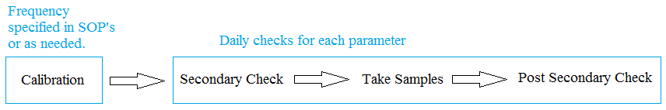

Data quality indicators (DQIs - accuracy, precision, bias, completeness, representativeness, comparability, and sensitivity) refer to quality control criteria established for various aspects of data gathering, sampling, or analysis activity. In defining DQIs specifically for the project, the level of uncertainty associated with each measurement is defined.

When an organization contracts for analytical work it has two options. In Option 1 DQIs for laboratory work are defined in the AMAP. These DQIs are provided to the laboratory which then acknowledges that it is capable of meeting these criteria, and also states it is willing to meet them. In Option 2, the sampling organization reviews the information from the laboratory on its QA/QC Program and DQIs and determines whether the laboratory can meet project needs.

If the first approach is taken, the organization writing the AMAP should include the appropriate DQI tables in the AMAP. A QA Plan and/or SOPs from the laboratory should be included with the AMAP and the AMAP should state explicitly that the laboratory has agreed to meet the defined DQI criteria.

If the second approach is taken, the sampling organization must acknowledge that it understands and agrees to the DQIs defined by the contract laboratory which will be used for the project. DQIs for work performed by the laboratory will be found in either the laboratory’s QA Plan and/or its SOPs which must be included with the plan.

Definitions of the different terms are provided below:

Accuracy is the degree of agreement of a measurement with a known or true value. In a limiting case where random errors are very tightly controlled, bias dominates the overall accuracy. In general, however, both precision and bias contribute to accuracy. A measurement result with zero bias may not be accurate if the measurement process is not precise. To determine accuracy, a laboratory or field value is compared to a known or true concentration. Accuracy is determined by such QC indicators as: matrix spikes, surrogate spikes, laboratory control samples (blind spikes) and performance samples.

In a given DU, a parameter will have a mean value that must be determined. How closely the measurement value is to the actual (unknown) value depends on the accuracy of the measurement. Conducting secondary checks prior to and after measurements will help to define the accuracy of the measurements. For example, if a pH probe were checked in a standard pH 7 solution and the acceptance criteria was 7.00 ± 0.20, then your sample results should have an accuracy of no less than ± 0.20.

The accuracy can also be affected by how the samples are taken (e.g. grabs vs MULTI INCREMENT). Here, the sampling procedure itself can introduce error due to non-representativeness (e.g. grab samples will tend to under represent the mean values).

Precision is the degree of agreement between independent measurements of a similar property under identical or substantially similar conditions (usually reported as a standard deviation [SD], relative standard deviation [RSD] or relative percent difference [RPD]). Precision is calculated from the analysis of replicate laboratory or field samples. Typically, field precision is assessed by co-located samples, field replicates, and laboratory precision is assessed using laboratory replicates, matrix spike duplicates, or laboratory control sample duplicates).

A minimum of three sample results (a sample and two replicates) are required to determine the RSD.
For MULTI INCREMENT samples, the Relative Standard Deviation (RSD) is the typical measurement of precision. An RSD of up to 20% may be acceptable (depending on the criteria developed in the DQOs). RSDs over the acceptable value (e.g. 20%) may indicate that the sampling procedure is inadequate to capture the variability. An adjustment to the sampling procedure may be required. (Note that a much lower RSD may be required when the sample results are very close to the action level, as determined during the DQO process.)

Bias is systematic or persistent distortion of a measurement process that causes errors in one direction. Bias may originate from sources such as calibration errors, response factor shifts, unaccounted-for interferences, or chronic sample contamination. The sample itself may generate real or apparent bias caused by a matrix effect or variation in physical properties such as particle size. Bias can be in the positive (high) or negative (low) direction from the true value.

Individual parameter probes can be checked against known standards with values at or near values that will be measured to minimize bias. If the probes produce values that are at or near the standard values, then the effects of bias can be controlled.

Completeness is expressed as percent of valid usable data actually obtained compared to the amount that was expected. Due to a variety of circumstances, sometimes either not all samples scheduled to be collected can be collected or else the data from samples cannot be used (for example, samples lost, bottles broken, instrument failures, laboratory mistakes, etc.). The minimum percent of completed analyses defined in this section depends on how much information is needed for decision making. Generally, completeness goals rise as the number of samples taken per event falls, or the more critical the data are for decision making. Goals in the 75-95% range are typical.

While the CWB matrix provides some guidance on the minimum level of sampling, the applicant must remain aware of the guiding information and documentation that the monitoring results provide. The concern is that as the expected amount of data is reduced, the ability to address the problem statement in step 1 of the DQO process is also diminished.

Representativeness is the expression of the degree to which data accurately and precisely represent a characteristic of an environmental condition or a population. It relates both to the area of interest and to the method of taking the individual sample. The idea of representativeness should be incorporated into discussions of sampling design. Representativeness is best assured by a comprehensive statistical sampling design, but it is recognized that this is usually outside the scope of most one-time events.

AMAPs should focus on issues related to judgmental sampling and why certain areas are included or not included and the steps being taken to avoid either false positives or false negatives. MULTI INCREMENT sampling is specifically designed to help ensure that sample results are representative.

Comparability expresses the confidence with which one data set can be compared to another. The use of methods from EPA or “Standard Methods” or from some other recognized sources allows the data to be compared facilitating evaluation of trends or changes in a site, a river, groundwater, etc. Comparability also refers to the reporting of data in comparable units so direct comparisons are simplified (e.g., this avoids comparison of mg/L for nitrate reported as nitrogen to mg/L of nitrate reported as nitrate, or ppm vs. mg/L discussions).

Using different instruments may produce different values that could be interpreted as increases or decreases in the parameter when the differences are actually due to the different instruments instead. Different instruments must demonstrate the ability to produce the same values to ensure that the measurements are comparable.

Differences can also occur due to instrument adjustments (i.e. calibrations) where readings taken before calibration do not match readings taken after.

AMAPs require the applicant to specify the parameters, units, methods, instruments, hold times, field preservation, minimum detection and minimum sensitivity in a table to ensure comparability. This information helps to ensure that the data generated will be of sufficient quality to determine if the objectives are met.

Sensitivity is the capability of a method or instrument to discriminate between measurement responses representing different levels of the variable of interest. The term "detection limit" is closely related to sensitivity and is often used synonymously. In practical applications, sensitivity is the minimum attribute level that a method or instrument can measure with a desired level of precision. Sensitivity is often a crucial aspect of environmental investigations that make comparisons to particular action levels or standards.

Detection Limits are usually expressed as method detection limits (MDLs) or Quantitation Limits for all analytes or compounds of interest. These limits should be related to any decisions that will be made as a result of the data collection effort. A critical element to be addressed is how these limits relate to any regulatory or action levels that may apply.

Minimum Detectable is the smallest value that can be measured accurately by the instrument.
Minimum Sensitivity is the smallest incremental difference that can be distinguished by the instrument.

Make sure that the Minimum Detectable level (MDL) is less than the typical levels of a parameter that will be measured. If the MDL is too high, the results will be non-detectable. Such results would be useless for evaluations.

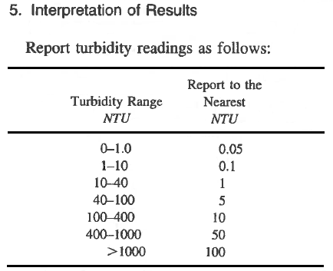
Example: Some turbidity instruments can display values to the nearest 100th place (e.g. 1.05 NTU). The Minimum Sensitivity for this instrument would be 0.01 NTU. One might assume that the Minimum Detectable is also 0.01 NTU. However, according to Standard Methods, “Uncertainties and discrepancies in turbidity measurements make it unlikely that results can be duplicated to greater precision than specified [in the table to the right].” In this case, the Minimum Detectable should be denoted as 0.05 NTU.
Standard Methods 2130 B (20th Ed., 1998)
Also note that the table specifies that readings are reported to the nearest 0.05, therefore readings of 0.03 NTU to 0.07 NTU are reported as “0.05 NTU”. Readings of <0.03 NTU are reported as “<0.05 NTU”.
The actual reporting levels may vary depending on the instrumentation used and should be defined in the respective instrument SOP.
Example: The minimum detectable level in the laboratory for TSS is above the actual levels expected in the field. This will result in the sample results being reported as “non-detect”. If all results are reported as “non-detect”, then no comparisons can be made to determine if there were impacts from a project. It is important that the lab be made aware of the expected levels in the field so that they can adjust accordingly.

Discussion on pH Probes

Always use fresh buffer solution to calibrate or conduct secondary checks. DO NOT REUSE BUFFER SOLUTIONS. (Used buffer solutions may be used for rinsing as it does not involve measurements.)

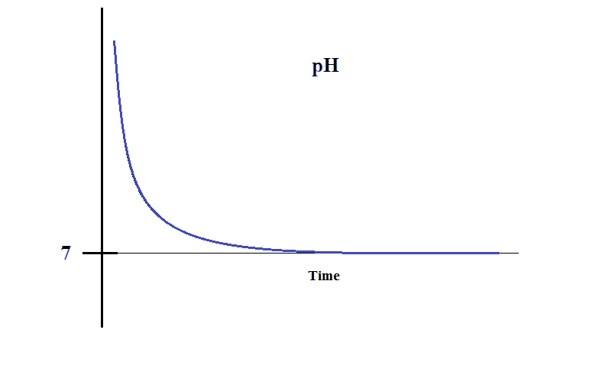
When a pH probe is new, it responds quickly to the solution that it is placed in. The chart to the right illustrates the typical response (blue line) of a pH probe immersed into a pH 7.00 solution.

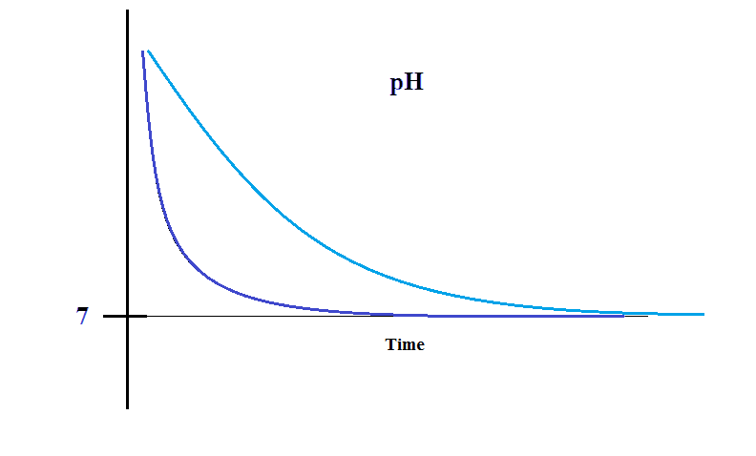
Gradually, over time, the response of the pH probe becomes slower (light blue line), but the probe still manages to measure the value of the solution accurately.

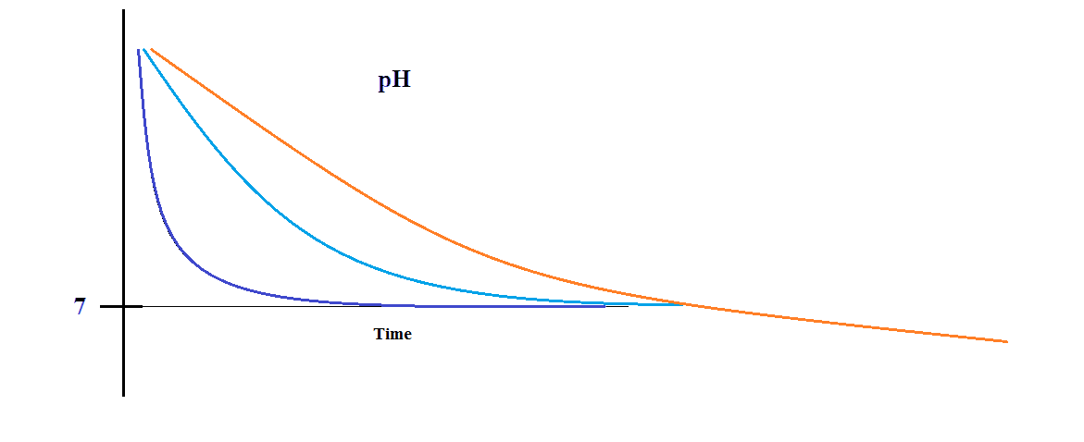
Eventually, the response of the probe degrades to the point where it takes a long time to respond and never stabilizes at any value.

pH probes have a typical lifespan of approximately one year. This one year period is independent of usage (i.e. the probe decays regardless if the probe is used or not). For this reason, it is not advantageous to “stockpile” spare probes.

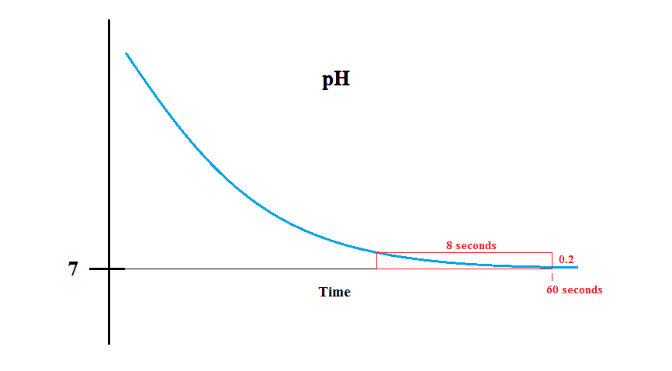
Knowing that the pH probes degrade over time, the question is, at what point should a probe be replaced? The acceptance criteria should be something like the following: “pH readings must stabilize for 8 seconds at the standard value (i.e. 7.00 ± 0.20) within 60 seconds of immersion.” (The acceptance criteria are shown in the chart to the right as a red box.) Note that if the drift of the box to the right is tracked over time, the decay of the pH probe can be identified well in advance of it becoming an issue.

pH probes may come in 2 “flavors” – high ionic and low ionic. The high ionic probes are designed for operation in marine environments; and low ionic, for fresh waters. They will both work regardless of the salinity of the waters being tested, but the difference is that they will deplete (i.e. die) faster when used in waters for which they were not intended.

The following is from the YSI website:
http://blog.ysi.com/blog/bid/176844/pH-Meter-Calibration-Problems-Check-out-these-12-tips?mkt_tok=3RkMMJWWfF9wsRolsqTBZKXonjHpfsX56u0vXqOxlMI%2F0ER3fOvrPUfGjI4DRMdjI%2BSLDwEYGJlv6SgFS7DEMbh6y7gMXBQ%3D
1. Check the age of the probe.

Probes for your pH meter generally last 12-18 months. This holds true whether the probe is being used or not. The lot code will determine the age of your pH probe. A lot code is two numbers then a letter. The numbers indicate the year of manufacture and the letter indications the month, i.e.-A=January, B=February, C=March etc. Please note that the letter “I” is not used, this means H=August and J=September and so on.

Lot code ex:12A*

*probe was manufactured in January 2012

2. Perform routine maintenance.

Keeping your pH probe clean can also help eliminate pH calibration problems. If the reference junction on the probe is not clean the probe may become unresponsive. Soak your probe with 1:1 bleach water solution for about 30 minutes regularly to reduce the chances of this happening. If hard deposits have built up on your probe, you can clean these by soaking the pH probe in vinegar or 1M (molar) HCL (hydrochloric acid) for about 3 minutes. pH probes usually require weekly or monthly cleanings.

Always check your pH meter manual for calibration and routine maintenance information.

3. Check for physical damage to the probe.

If your probe is damaged, broken glass bulb, crack in the glass etc., the probe must be replaced.

4. Confirm that the pH probe has never dried out.

Always store your pH probe in a moist environment or submerged in buffer 4 solution. If you find your pH probe has dried out, it will have to be replaced.

5. Check the temperature probe used with your instrument.

Check your probe’s temperature specifications. pH will not function accurately if the temperature probe is out of specification.

6. Always use fresh, unused, unexpired pH buffers for calibration.

You never want to re-use buffers for calibration. Once buffers are used for calibration, they are assumed contaminated. Re-using buffers can lead to slow responding pH probe performance or the inability to calibrate at all. This re-use can also make it difficult to determine whether the probe or the buffers are causing the pH calibration failure.

A good way to use re-used buffers is for probe rinsing only.

7. Perform at least a 2-point calibration - Buffer 7 MUST be one of these two points.

8. Always start with Buffer 7 when calibrating your instrument even though it is not always required.

9. Reset the calibration to factory default is possible.

Not all instruments are equipped with this ability. It is a good idea to consult the user manual. The user manual will also supply the proper process to do this task because this process can vary depending on the instrument.

10. Confirm the pH probe response time in each buffer.

Response time should be no longer than 60 seconds. Response time can depend on the age and cleanliness of your probe.

11. Check the millivolts in each buffer.
•Buffer 7 should be 0+/-50 mV.
•Buffer 4 should be 165 to 180 mV away from the buffer 7 mV value, in the positive direction.
•Buffer 10 should be 165 to 180 mV away from the buffer 7 mV value in the negative direction.

12. NEVER accept out-of-range calibrations.

If you accept an out-of-range calibration, your probe will not calibrate. It is highly likely you will not collect any usable pH data if an out-of range calibration is accepted.

Calibration - pH calibration procedures are generally detailed in the manufacturer’s manuals, however, a specific SOP should be written to describe the actual procedure since the procedure may vary according to the type of waters being monitored. For example, marine waters tend to be alkaline thus requiring the use of pH 7 and 10 buffer solutions, whereas fresh waters may be slightly acidic requiring pH 4 and 7 buffer solutions. The SOPs should discuss the proper buffers to use under different scenarios. Due to drift, pH probes should be calibrated at least monthly.

Secondary (QC) checks – secondary checks should be performed prior to and after each day’s sampling. Checks should be conducted at a value close to the values measured in the field, and/or at pH 7 (neutral value). An acceptable range must be established prior to conducting the checks (e.g. ±0.15 pH units).

Discussion on Salinity

HAR Chapter 11-54 water quality standards specifies the measurement of salinity in Parts Per Thousand (PPT). Standard Methods (20th Ed., 1998) states that for seawater measurements, salinity should be determined by using the Practical Salinity Scale (PSS). While discussions of these two methods state that they are approximately equal, there is no documentation of the exact relationship between the two.

In practice, field instruments that display readings in PSS tend to under estimate the salinity readings in PPT by approximately 2 PPT at 35 PPT (i.e. 33 vs 35 PPT). Samplers must be cautious when using field instruments and documenting results to ensure that they do not confuse PSS for PPT and vice versa. Additionally, the SOP must be very clear in describing the calibration and secondary check procedures to ensure that the probe measures correct values and in the correct units.

Calibration – Document the specific calibration procedure in a SOP. Recalibrate at set schedule (e.g. every 6 months) using a standard seawater solution.

Secondary check – Conduct secondary checks prior to and after each day’s sampling. Use a standard to verify that the instrument is reading correctly. Use DI/distilled water to verify the lower (i.e. zero) end of the scale. Establish acceptable ranges for each (e.g. ±5% at 34.99 PPT and 0 to 1.0 PPT at the lower end).

Discussion on Dissolved Oxygen (DO)

The traditional DO probe consists of a sensing element protected by an oxygen-permeable plastic membrane. The sensing element produces a current that is directly proportional to the DO concentration. This process can deplete the oxygen near the membrane surface, therefore the probe may be equipped with a stirrer to provide a constant flow of water to the membrane surface. This probe may be calibrated in water-saturated air. Some DO instruments do not automatically correct for temperature and salinity differences (i.e. corrections must be done manually). Probes must be checked frequently for leaking reference solution, corroded elements, damaged membranes/o-rings and air bubbles in the electrode chamber. Unaddressed problems can lead to erroneous readings.

A newer development is the Luminescent DO (LDO) probe. This probe requires much less user maintenance and does not deplete the oxygen at the probe face. Calibration may be in water-saturated air or with the probe fully immersed in water. If calibration is conducted with the probe immersed in water, do not use tap water straight from the faucet. (This water is under pressure, probably at a lower temperature than ambient and of lower oxygen content. Calibration with this water will result in DO readings much higher than actual levels.) To address this issue, Hydrolab tech support recommends that a bottle be half-filled with tap water, covered, and then vigorously shaken for 30 seconds. The bottle should be opened to release any pressure and for air exchange, then recovered and reshaken for another 30 seconds. This will bring the oxygen content of the water back to 100% so that it may be used for calibration of the LDO probe.

After calibration, tests of the LDO probe versus the membrane DO probe showed close agreement.

Typical DO% readings are in the range of 80% to high 90%. Readings above 100% are possible, but occur rarely. Conditions that may contribute to readings above 100% include intense sunlight, calm and shallow waters, and an abundance of oxygen producing algae. Under such conditions, the excess oxygen will tend to strip free H⁺ ions from the water column, resulting in slightly higher pH levels as well. Multiple readings in excess of 100%, and/or readings above 130% with no obvious causes for the elevated levels are more likely due to an instrument defect and/or a calibration error.

Calibration – DO readings can be impacted by differences in barometric pressure, and therefore, the probe should be calibrated daily.

Secondary (QC) checks – secondary checks should be performed prior to and after each day’s sampling. Check the DO reading using the same setup as for calibration. The readings should fall within the range of 95% to 105% (±5%).

Discussion on Turbidity

In general, most turbidity meters measure light scattered 90° from an incident beam. These instruments are called Nephelometers, and the resulting measurements are reported in Nephelometric Turbidity Units (NTU). However, different companies manufacture instruments that may produce different readings when compared against each other. The design criteria are not stringent enough to ensure that a standardized result is produced.

Additionally, some instruments measure the turbidity in-situ, while others measure a collected sample. Natural agitation of the ambient water (e.g. waves or flow) can produce higher in-situ readings versus a collected sample due to settling.

Because of these differences, it is important to consider the instruments that will be used to take measurements and to use identical instruments for comparable results.

Some turbidity probes are sensitive to sunlight (i.e. the probes cannot distinguish sunlight from scattered light). This will result in higher turbidity readings. Do not purchase these probes.

Calibration – Some instruments (e.g. Hach 2100p) tend to be very stable and do not require frequent calibration (e.g. once/year) provided that secondary checks are performed frequently to verify accuracy.

Secondary (QC) checks – secondary checks should be performed prior to and after each day’s sampling. Establish an acceptable range (e.g. ±5%) for the check standard(s), including a DI/distilled water sample to check the zero value (e.g. 0 to 0.25 NTU).

Discussion on Total Suspended Solids (TSS)

TSS is determined by filtering a sample, then drying and weighing the filter paper. While TSS generally varies with turbidity, they are not directly comparable. Direct correlations should not be attempted.

Follow established laboratory procedures for calibration and QC checks.

Discussion on Temperature

Calibration – Field instruments are generally equipped with thermistors that are factory calibrated and cannot be adjusted by the end user.

Secondary (QC) checks – secondary checks should be performed periodically (e.g. every 90 days). Place the temperature probe and an NIST thermometer into a water bath. Verify that the thermistor value is within range of the NIST thermometer value (e.g. ±1⁰C).

Multiple deployed instruments

Calibrate and conduct secondary checks on multiple instruments at the same time (i.e. in the same bucket). Ensure that for each parameter measured, they both produce identical results. If they are not the same, there is a problem. If the results are identical, then direct comparisons can be made with the probes deployed in different locations.

Pre-Construction Monitoring

The purpose of the pre-construction monitoring is to establish the pre-existing condition of the waterbody prior to any disturbance. Because of natural variability, a minimum of 10 sets of samples are required. MULTI INCREMENT samples or equivalent are taken in triplicate at the Control DU(s) and, if possible, at the Impact DU. The Percent Relative Standard Deviation (%RSD) is calculated for the triplicate samples to ensure that the variability is adequately captured. The acceptable %RSD should be determined (lower is better), but in no case should it exceed 20%. If the %RSD is regularly exceeded, then the sampling plan is not sufficient to capture the variability and revisions may be required.
The 10 sets of samples are typically taken over 10 business days due to time constraints, but in general, sampling over a longer period of time will capture more variability. Samples should only be collected under “normal” conditions (e.g. no storm events, impacts from other activities, high surf, etc.)
Turbidity and TSS – each set of triplicate samples should be averaged. The highest of these averaged values (i.e. the highest mean) shall be used as the action level for during construction monitoring.
pH – each set of triplicate samples should be averaged. The highest and lowest of these averaged values shall serve as the acceptable range for during construction monitoring.
Temperature, DO and Salinity – may need to be assigned action levels depending on the impacts of the project. Even if they are not directly affected, the sampler can use the information from these parameters to evaluate site conditions (e.g. ground water discharges may result in lower temperature, DO and salinity).

During Construction Monitoring
MULTI INCREMENT samples or equivalent are taken at the Control DU(s) and in triplicate at the Impact DU. Triplicate values are averaged and compared to their respective action levels. If the action level is exceeded, then the average value is compared to the current Control DU values. If the Control DUs values are also exceeded, then corrective actions should be taken.

Post Construction Monitoring

Take MULTI INCREMENT samples or equivalent at the Control DU(s) and in triplicate at the Impact DU. Triplicate values are averaged and compared to their respective Pre-Construction action levels. The Post Construction results should demonstrate “no net increase” in the pollutants of concern.

Qualified Samplers

The largest source of error is usually a result of the sampling activity itself. This document, and the information contained herein will help to minimize error and achieve representative results. However, the proper execution of the plan ultimately lies in the hands of the field personnel (and their supervisors). Having read the instrument operating manual is not enough. Neither is being briefed on the sampling plan. The samplers must be “qualified”.

But what does “qualified” mean? For recent projects, CWB has been using the following definition to try to provide some guidance:

“Samples shall be collected by Qualified Samplers. "Qualified Sampler", as used in this AMAP, means a person who actively practices environmental science, or has formal training in sampling theory, practices and techniques. Qualified Samplers must be thoroughly knowledgeable of all aspects of the sampling in this AMAP including all equipment, instruments, SOPs, calibrations, secondary checks, limits, and reporting requirements.”

In his book, “Outliers”, author Malcolm Gladwell observes that the mastery of a subject tends to occur after a person has practiced the activity for at least 10,000 hours. (Basically, 8 hours a day for 5 years.) Using this as a guideline, it could be reasoned that someone with no experience cannot be considered “qualified”. They would need to study the documentation and apprentice with a more experienced sampler for a period of time. Someone with 6 months to a year of experience (1000 to 2000 hours) might be considered “minimally qualified” (i.e. sample under close supervision); and with at least one (1) year of experience, “qualified”. A person with more than five (5) years of experience may be considered “highly qualified” and would be considered an “expert”.

Despite the vague definition, the bottom line will be how well the sampler can correctly execute the sampling protocol. The intent is to obtain the most accurate results possible. Using a “qualified sampler” is one of the key elements to ensuring that this objective is met.

(Note that the same experience criteria may be applied to document preparers who write the QAPPs, SAPs and AMAPs.)

So why must samplers be qualified? Does it really matter? “Qualified” samplers (those with many years of experience) have encountered many different situations and problems. They are more likely to produce quality work and avoid making simple mistakes.

Here are some examples of actual mistakes made by samplers:
    - Remote probe deployed incorrectly (probes mistakenly stuck into mud). This resulted in water with turbidity of <10 NTU, but readings of >3000 NTU. Neither the sampler, nor the reviewer recognized a problem.

    - Incorrect date/time/time zone on date/time stamp on pictures taken. The purpose of taking pictures is to document conditions at specific points in time. Documenting incorrect information defeats that purpose.

    - Triplicate samples taken at the wrong location (not at Impact station). The assumption was that as long as triplicates were taken at one of the stations, it would be acceptable. The purpose of taking triplicates (and running a %RSD) is to verify that the variability is being captured adequately. While it would be helpful to take all samples in triplicate, at the very least, the Impact station should be taken in triplicate because this is the most important location for determining if an exceedance occurs.

    - On a number of occasions, pH readings were incorrect. pH is one of the harder parameters to measure correctly. It takes a lot of practice (difficult for a novice to get it right from the beginning). Potential causes include reusing calibration solutions, defective probe, imprecise calibration, not recognizing when probe goes bad, not recognizing drift in readings, not cleaning the probe prior to calibration (see item f. below), etc. Note that calibration solutions go bad quicker upon opening the bottle (do not rely solely on the expiration date). Mark the open date on the bottle and discard after 6 months if not used by then.

    - Failure to read and comprehend all of the requirements of the AMAP. The requirements remain fairly consistent from one project to the next so those who have participated in multiple projects are more practiced than novices in the execution of the AMAP.

    - Unclean/fouled remotely deployed equipment/probes. Debris has caused spikes in turbidity readings, and on occasion, completely prevented data from being recorded. Dirty instruments can interfere with calibration, resulting in poor readings.

Additional tips:
        - Keep the instrument/probes clean.
        - For multi-probe instruments, rinse between calibration of different probes (reusing pH calibration solution for rinsing is ok).
        - Use the proper standards.
        - Calibrate for the expected range of values anticipated. If the range is unknown, calibrate the full range.
        - Have maintenance kits and spare parts available to service the instruments.
        - Properly handle and store instruments.
        - Store pH probes in tap water (or pH 4 solution). Do NOT store in DI water or allow probes to dry out.

There is much more that a sampler must know and be able to perform in order to produce quality data.

Fundamentals of MULTI INCREMENT Sampling

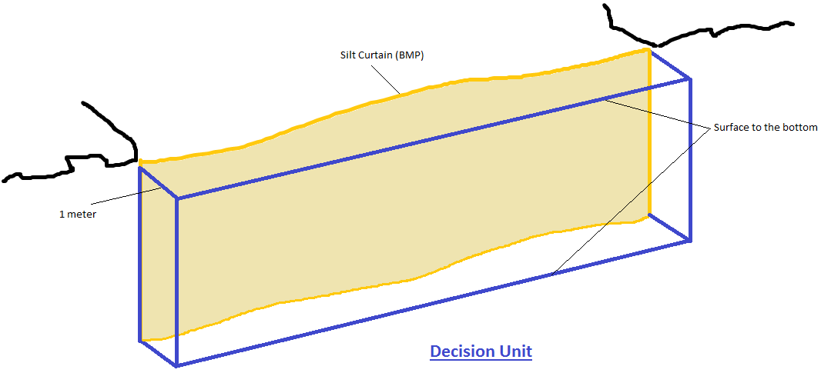
Figure 1 - Establishing a DU Under No/Low Flow Conditions

Figure 1 displays a typical DU (in blue) outside of a silt curtain. The DU extends out one (1) meter from the silt curtain, from the surface to the bottom, along the entire length of the silt curtain. This DU is chosen because if the silt curtain fails to isolate and contain pollutants, the water within the DU will be the most likely affected.
When the DU is sampled, the sampler must provide every drop of water in the DU an equal opportunity of being collected. (Within reason – in practice, bottom sediments and silt curtain deposits should not be disturbed since doing so will impact sampling results.) The sample collection bottle should be moved throughout the entire DU in a random manner.
When sampled correctly, a MULTI INCREMENT sample will provide results that are at, or very close to, the mean of the parameters being measured. To verify the accuracy of the sample results, the DU should be sampled in triplicate, and the percent Relative Standard Deviation (%RSD) calculated for each parameter. The results are in control (i.e. the variability has been properly captured) if the %RSD < 20%. (The lower the %RSD, the better.)
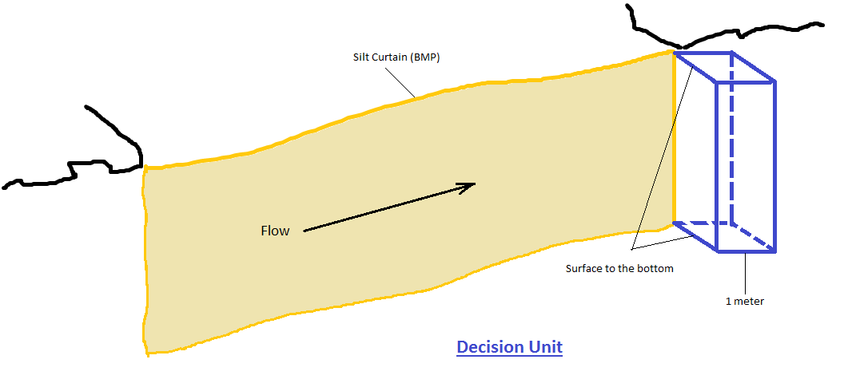
Figure 2 - DU when the water is flowing.

When the water is flowing, the DU can be situated at the downstream end of the silt curtain since any pollutants leaking out will flow through the DU. The sample bottle is moved throughout the entire DU, providing each drop of water an equal opportunity of being sampled.

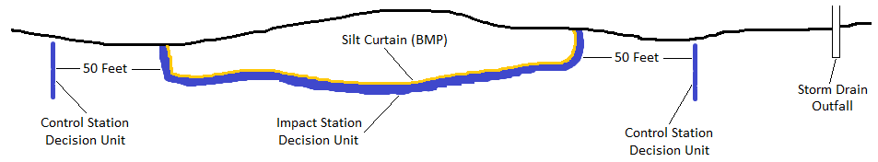
Figure 3 - Typical layout (standing water)

Control Station DUs should be established about fifty (50) feet away from the Impact Station. The intent of the Control Stations is to document the ambient conditions in the general vicinity of the project. In addition, the Control Stations should be situated such that they will detect any contributions from non-project related sources that could impact sample results.

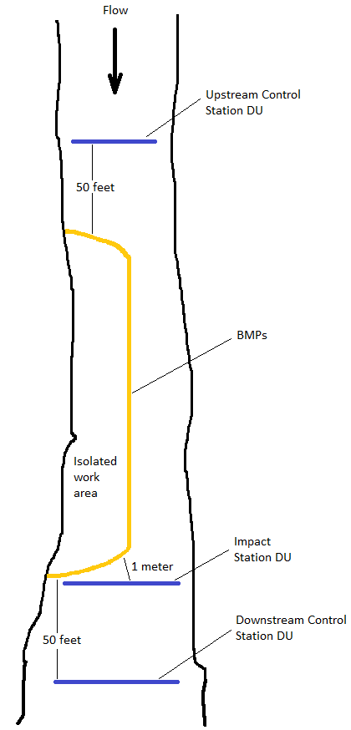
Figure 4 - Typical layout (flowing water)
Triplicate samples means three separate samples taken sequentially. It does not mean one large sample split into 3 parts (split samples), nor does it mean three samples taken simultaneously (co-located samples).

Red Flags – “Grab samples”, “Outliers” and “Hot spots” are terms that are generally used when sampling is not representative. When sampling procedures or data analyses include these terms, care should be taken to ensure that the data are accurate.

The in-water work area is 10 feet from the toe of the active Activity Decision Unit boundary. A vessel/barge may be operated outside of the isolated and confined in-water work area only if it is surrounded by a boom.

The Aloha Sampler ™
(The following is from the Envirostat website.)

The Aloha Sampler ™ was developed as a tool for collecting MULTI INCREMENT samples. The Aloha Sampler ™ consists of a standard one (1) liter high density polyethylene (HDPE) sample bottle with two (2) quarter inch holes drilled in the cap. The bottle is immersed horizontally with the holes aligned vertically (one above the other). This arrangement allows for the bottle to fill slowly (it takes approximately one (1) minute to fill completely). The sampler must move the bottle throughout the entire DU during this time window. Care must be taken to ensure that the bottle is neither under-filled, nor completely filled before the entire DU is traversed.
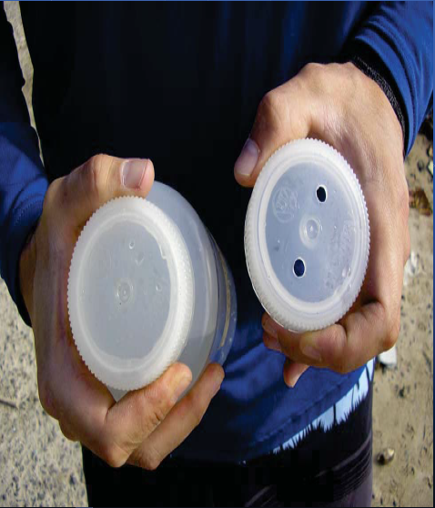
Figure 5 - The Aloha Sampler ™

Purchase and/or use of The Aloha Sampler ™ is not required. This information is solely intended to provide an option for samplers who do not prefer to manufacture their own sampler.

Multi IncremenT is a registered trademark of EnviroStat, Inc.
Aloha SamplerTM is a trademark of EnviroStat, Inc.
Liquid Sampler is a patent (7571657) of EnviroStat, Inc.

The term MULTI INCREMENT was trademarked to separate it from all the other sampling methods that exist.

EnviroStat consents to and encourages the fair use of the MULTI INCREMENT trademark to all who are performing MULTI INCREMENT sampling. There is no need to utilize any other terminology when performing MULTI INCREMENT sampling. EnviroStat only requests that proper attribution be given. If you have any questions about using the term MULTI INCREMENT, please contact EnviroStat, Inc.

Users of MULTI INCREMENT must ensure that they do not pick and choose only certain components of the method for their own convenience as that will not lead to a representative sample.

Exhibit 2 – Matrix
